MyMovie

1. Create a single view Project and Name it **MyMovies,** Swift, Universal, No Core Data, Or Tests  
   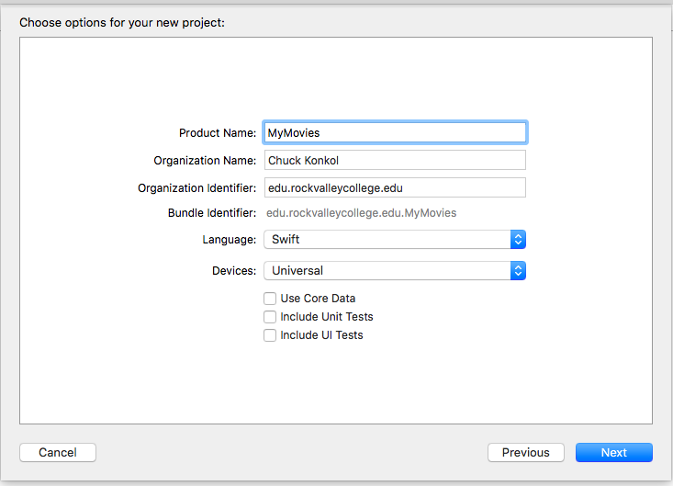
2. UnCheck Portrait  
   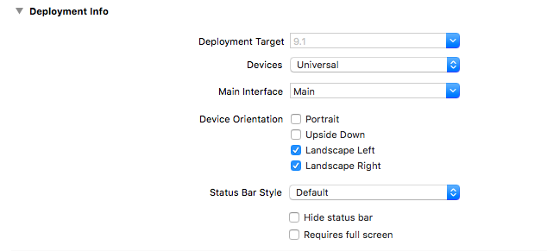
3. Choose View > Attributes Inspector > Simulated Matrix (as below)

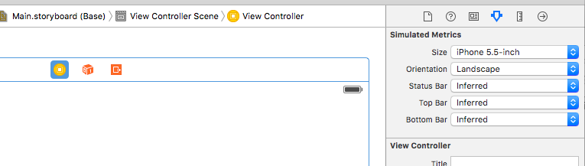

1. Select **MyMovies** **> Build Phases** > Expand **Link Librraries**  > Tap the **+**  symbol and add **AvKit.Framework**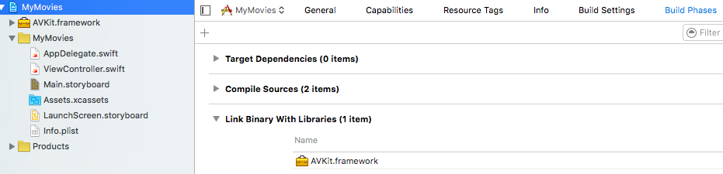
2. You should now have AVKit.Framework in your project files list  
   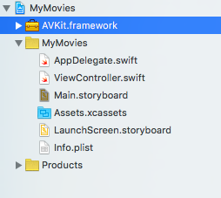
3. Add to StoryBoard **AVKit Player ViewController**
4. Make sure Simulated Matrics matches below:  
   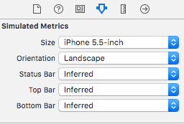
5. Add Navigation bars to **ViewController** and make Title “My Movies”  
   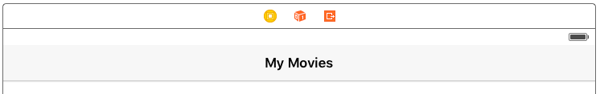
6. Add **Horizontal** **Stack View** and fill **ViewController**
7. Add **View** to left column and make height fill column then [command] + D to duplicate twice to fill the other two columns.
8. Add **Button** in the middle of all 3 Views  
   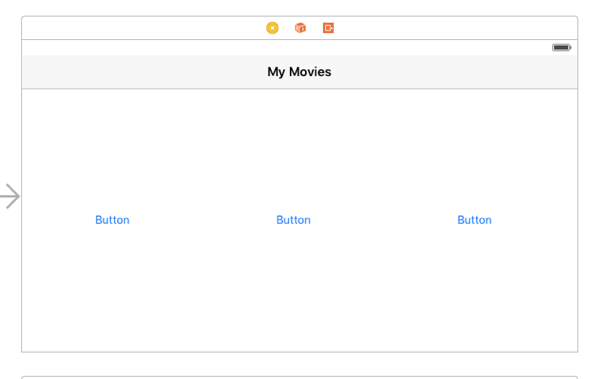
9. Download DVD image covers from your 3 favorite movies and name **trailer1.png, trailer2.png, and trailer3.png**
10. Download **mp4** trailers from YouTube using plugin “Download Youtube Videos as Mp4” and save as **trailer1.mp4, trailer2.mp4, and trailer3.mp4**
11. Create Group named  **Trailers**  and add [Control] click on and select **“Add files to…”** and import the 3 trailerS (SELECT OPTION TO **COPY ITEMS IF NEEDED**)  
    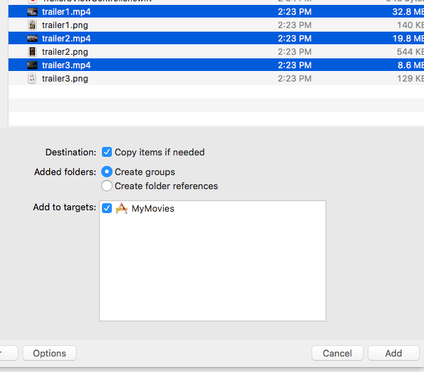
12. Create Group **Images**  and add [Control] click on and select **“Add files to…”** and import the 3 images (SELECT OPTION TO **COPY ITEMS IF NEEDED**)
13. Add images to Buttons and resize to fit into view  
    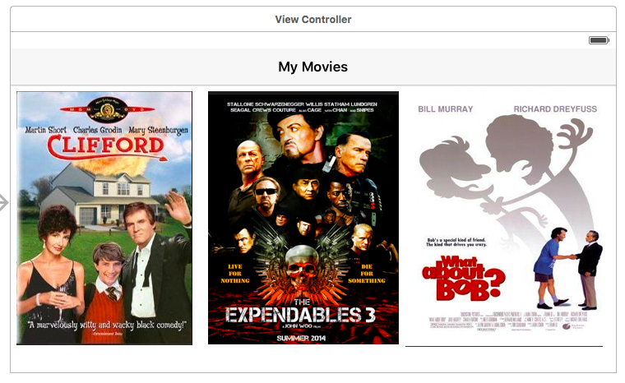
14. Do a [Control} + Drag on each button to **AVI Player View Controller** and choose action  **Show**
15. Name the **Storyboard Identifier** first, second, third (starting from left button)
16. Import Statements to **View Controller**

Import UIKit

import AVKit  
 import AVFoundation

1. Add code for Segway

override func prepareForSegue(segue: UIStoryboardSegue,

sender: AnyObject?) {

if segue.identifier == "first"

{

let destination = segue.destinationViewController as!

AVPlayerViewController

//Change to match you video filename in supporting files

let termsPath:String? = NSBundle.mainBundle().pathForResource("trailer1", ofType: "mp4")!

let url = NSURL(fileURLWithPath: termsPath!)

destination.player = AVPlayer(URL: url)

destination.player!.play()

}

if segue.identifier == "second"

{

let destination = segue.destinationViewController as!

AVPlayerViewController

//Change to match you video filename in supporting files

let termsPath:String? = NSBundle.mainBundle().pathForResource("trailer2", ofType: "mp4")!

let url = NSURL(fileURLWithPath: termsPath!)

destination.player = AVPlayer(URL: url)

destination.player!.play()

}

if segue.identifier == "third"

{

let destination = segue.destinationViewController as!

AVPlayerViewController

//Change to match you video filename in supporting files

let termsPath:String? = NSBundle.mainBundle().pathForResource("trailer3", ofType: "mp4")!

let url = NSURL(fileURLWithPath: termsPath!)

destination.player = AVPlayer(URL: url)

destination.player!.play()

}

}

1. Resize ViewController. Select ViewController: **Editor** > **Resolve Auto Layout Issues** > **Reset to Suggested Constraints**
2. Test App