**MyFavBands**

1. Create a Master/Detail iPhone App
2. Mimic Below Screen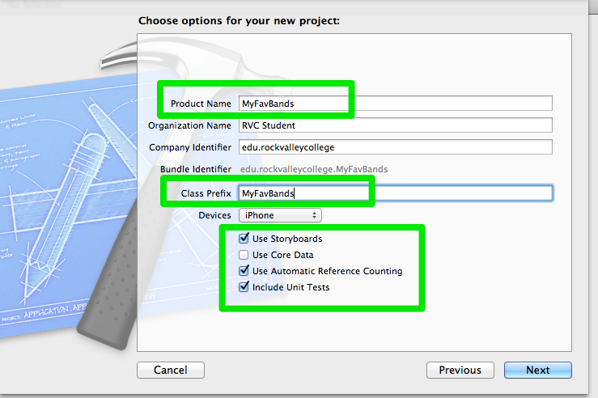
3. Delete label from Detail View Controller
4. Add UIImage to Detail View Controller  
     
   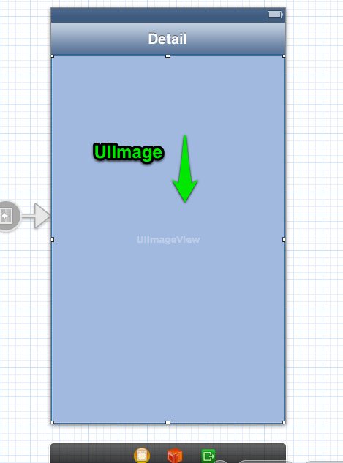
5. CTRL + DRAG from ViewController (Left Bottom Object) to UiIMage and Select **ProductImageView**

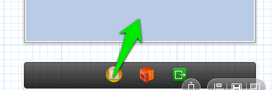

1. Edit // MyFavBandsMasterViewController.h

//

// MyFavBandsMasterViewController.h

// MyFavBands

//

// Created by Charles Konkol on 2/25/13.

// Copyright (c) 2013 RVC Student. All rights reserved.

//

#import <UIKit/UIKit.h>

@interface MyFavBandsMasterViewController : UITableViewController

{

NSArray *list;

}

@property (strong, nonatomic) NSArray *list;

@end

1. Edit …..MasterViewController.m

//

// MyBan1MasterViewController.m

// MyBan1

//

// Created by Charles Konkol on 2/27/13.

// Copyright (c) 2013 RVC Student. All rights reserved.

//

#import "MyBan1MasterViewController.h"

#import "MyBan1DetailViewController.h"

@interface MyBan1MasterViewController () {

NSMutableArray *_objects;

}

@end

@implementation MyBan1MasterViewController

//1) Add Synthesize

@synthesize list;

- (void)awakeFromNib

{

[super awakeFromNib];

}

- (void)viewDidLoad

{

[super viewDidLoad];

// Do any additional setup after loading the view, typically from a nib.

//2) Replace existing code with below array load

self.title = @"My Favorite Bands";

NSArray *listArray = [[NSArray alloc] initWithObjects:@"Joe Cocker", @"Leonard Skynard", @"Eagles",@"Journey",@"38 Special", @"Miranda Lambert",@"Little Big Town",@"Band Perry",nil];

self.list = listArray;

}

- (void)didReceiveMemoryWarning

{

[super didReceiveMemoryWarning];

// Dispose of any resources that can be recreated.

}

- (void)insertNewObject:(id)sender

{

if (!_objects) {

_objects = [[NSMutableArray alloc] init];

}

[_objects insertObject:[NSDate date] atIndex:0];

NSIndexPath *indexPath = [NSIndexPath indexPathForRow:0 inSection:0];

[self.tableView insertRowsAtIndexPaths:@[indexPath] withRowAnimation:UITableViewRowAnimationAutomatic];

}

#pragma mark - Table View

- (NSInteger)numberOfSectionsInTableView:(UITableView *)tableView

{

return 1;

}

- (NSInteger)tableView:(UITableView *)tableView numberOfRowsInSection:(NSInteger)section

{

//3 Modify Return for menu array

return [list count];

//return _objects.count;

}

- (UITableViewCell *)tableView:(UITableView *)tableView cellForRowAtIndexPath:(NSIndexPath *)indexPath

{

//4) Replace existing code with below code

static NSString *CellIdentifier = @"Cell";

UITableViewCell *cell = [tableView dequeueReusableCellWithIdentifier:CellIdentifier];

cell.textLabel.text = [list objectAtIndex:[indexPath row]];

return cell;

}

- (BOOL)tableView:(UITableView *)tableView canEditRowAtIndexPath:(NSIndexPath *)indexPath

{

// Return NO if you do not want the specified item to be editable.

return YES;

}

- (void)tableView:(UITableView *)tableView commitEditingStyle:(UITableViewCellEditingStyle)editingStyle forRowAtIndexPath:(NSIndexPath *)indexPath

{

if (editingStyle == UITableViewCellEditingStyleDelete) {

[_objects removeObjectAtIndex:indexPath.row];

[tableView deleteRowsAtIndexPaths:@[indexPath] withRowAnimation:UITableViewRowAnimationFade];

} else if (editingStyle == UITableViewCellEditingStyleInsert) {

// Create a new instance of the appropriate class, insert it into the array, and add a new row to the table view.

}

}

/*

// Override to support rearranging the table view.

- (void)tableView:(UITableView *)tableView moveRowAtIndexPath:(NSIndexPath *)fromIndexPath toIndexPath:(NSIndexPath *)toIndexPath

{

}

*/

/*

// Override to support conditional rearranging of the table view.

- (BOOL)tableView:(UITableView *)tableView canMoveRowAtIndexPath:(NSIndexPath *)indexPath

{

// Return NO if you do not want the item to be re-orderable.

return YES;

}

*/

- (void)prepareForSegue:(UIStoryboardSegue *)segue sender:(id)sender

{

//5 Replace existing code with below to setproductname and send to seque object item user clicked on menu

// Error will go away soon...keep going

[segue.destinationViewController setProductName:[list objectAtIndex:[self.tableView.indexPathForSelectedRow row]]];

}

@end

1. Edit …DetailViewController.h

//

// MyBan1DetailViewController.h

// MyBan1

//

// Created by Charles Konkol on 2/27/13.

// Copyright (c) 2013 RVC Student. All rights reserved.

//

#import <UIKit/UIKit.h>

@interface MyBan1DetailViewController : UIViewController

{

//1) Add Default initializers

NSString *productName;

CGFloat previousScale;

CGFloat previousRotation;

CGFloat beginX;

CGFloat beginY;

}

//2) Modify.

//This will get rid of error on MasterViewConrtoller:

//- (void)prepareForSegue:

@property (strong, nonatomic) IBOutlet UIImageView *productImageView;

@property (strong, nonatomic) NSString *productName;

//3 Delete Below

//@property (strong, nonatomic) id detailItem;

//@property (weak, nonatomic) IBOutlet UILabel *detailDescriptionLabel;

@end

1. Edit …DetailViewController.m  
     
   //

// MyBan1DetailViewController.m

// MyBan1

//

// Created by Charles Konkol on 2/27/13.

// Copyright (c) 2013 RVC Student. All rights reserved.

//

#import "MyBan1DetailViewController.h"

//1) Delete or comment out next three line

//@interface MyBan1DetailViewController ()

//- (void)configureView;

//@end

@implementation MyBan1DetailViewController

//2) Add sythesize

@synthesize productName;

#pragma mark - Managing the detail item

//3) Delete or Comment Out - (void)setDetailItem Section

//- (void)setDetailItem:(id)newDetailItem

//{

//...

// }

//}

//4) Delete or Comment Out - (void)configureView Section

//- (void)configureView

//{

//...

// }

//}

- (void)viewDidLoad

{

[super viewDidLoad];

// Do any additional setup after loading the view, typically from a nib.

//5) Modify/Delete ViewDidLoad

self.title = productName;

NSString *imageName = [NSString stringWithFormat:@"%@.jpg", productName];

self.productImageView.image = [UIImage imageNamed:imageName];

//[self configureView];

}

- (void)didReceiveMemoryWarning

{

[super didReceiveMemoryWarning];

// Dispose of any resources that can be recreated.

}

@end

1. Add Images
   1. Right-Click on Project Name > Select **New Group**

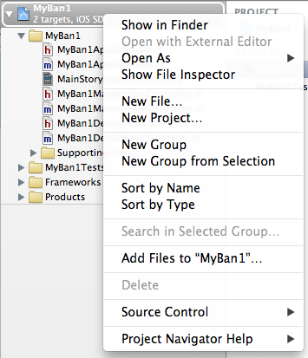

* 1. Right-Click on new Group and add .needed .jpg images. These images MUST match the same name as your menu array and MUST end in .jpg. You can find these photos from the web.
  2. Here is how your screen should look:  
     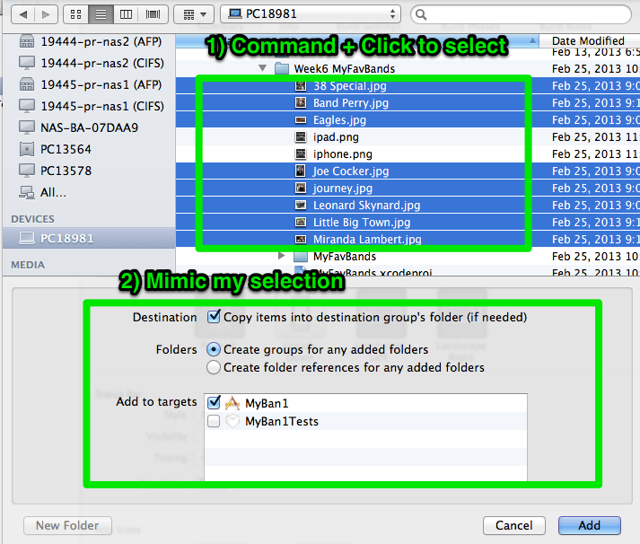

1. Add icons to **Supporting Files** folder (57X57, 72X72) .PNG Images. I suggest using pixlr.com
2. Modify plist to add 2 icon files
3. Make project Universal
4. Run (Command + R) and Test
5. That’s IT!