Lab\Administrator
Attack map Tracker using Microsoft Sentinel
This project demonstrates an understanding of an attack map with real time monitoring of hacker activities using both Log Analytics Workspace and Microsoft Sentinel (SIEM).
Objective
We simulate how logs from activities across our environment are collated by the Log Analytics Workspace and forwarded to Microsoft Sentinel (SIEM). In this lab, we would see how attacker(s) threat activity(s) use the internet as a honeypot and how logs are forwarded to a central repository in Azure and then, integrate Microsoft Sentinel to analyze real-world attack data with the geolocation where the attack is coming.

Tools Used
- Azure subscription
- Azure Virtual Machine
- Log Analytics Workspace
- Microsoft Sentinel (SIEM)

Lab Environment
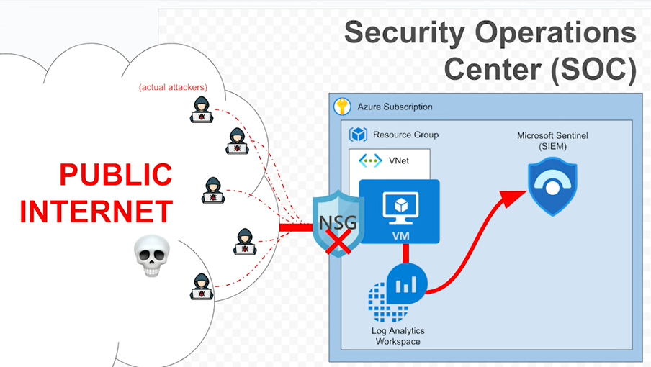

Steps:
- Create a Free Azure Subscription
https://azure.microsoft.com/en-us/pricing/purchase-options/azure-account

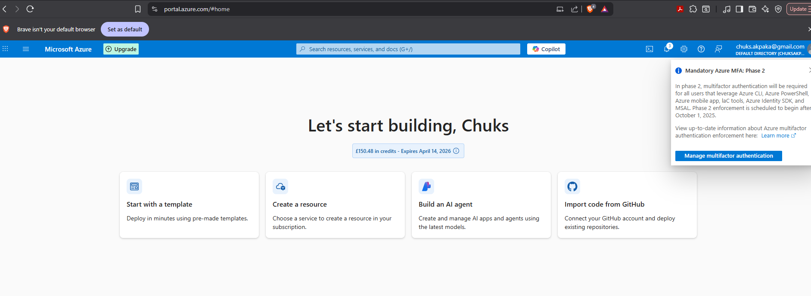

- Create the Honey Pot (Azure Virtual Machine)
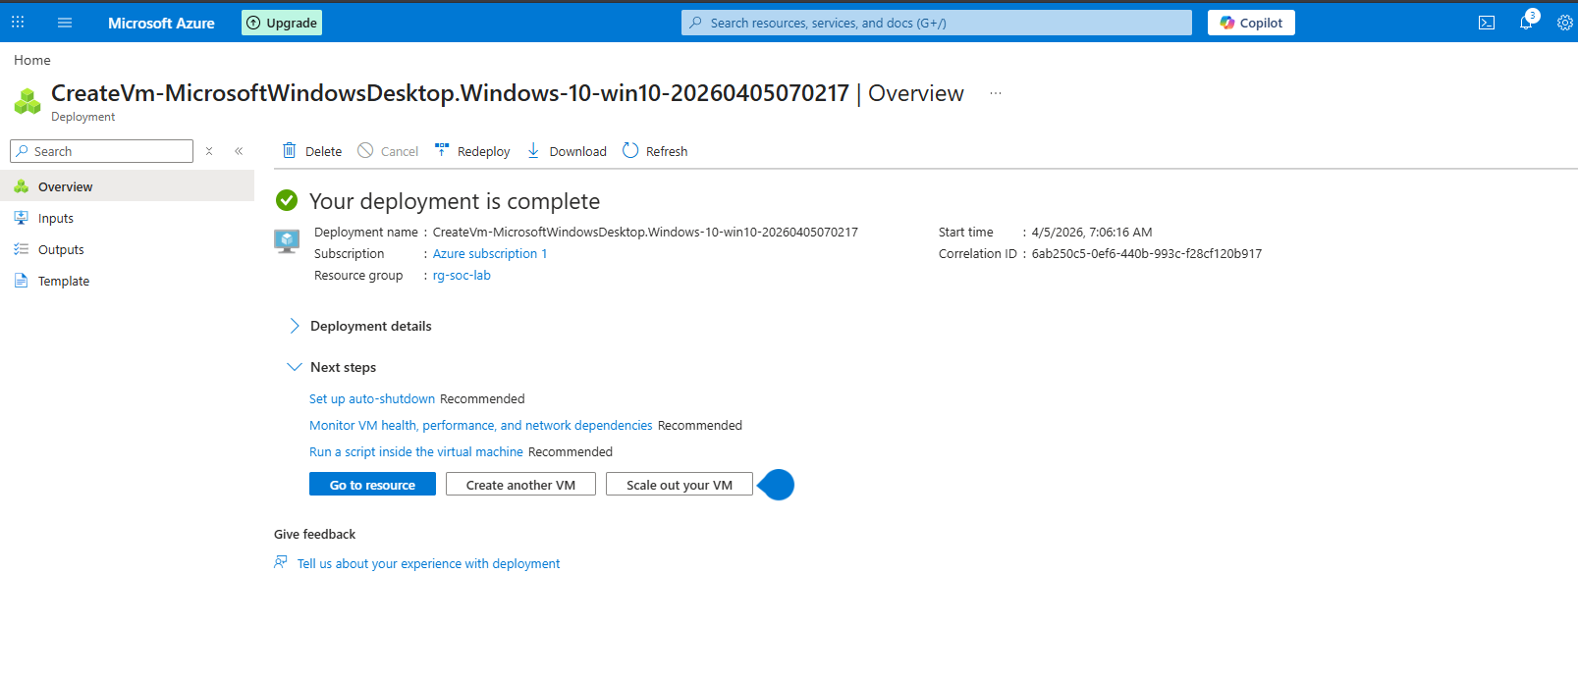

Create a new Windows 10 virtual machine (size)
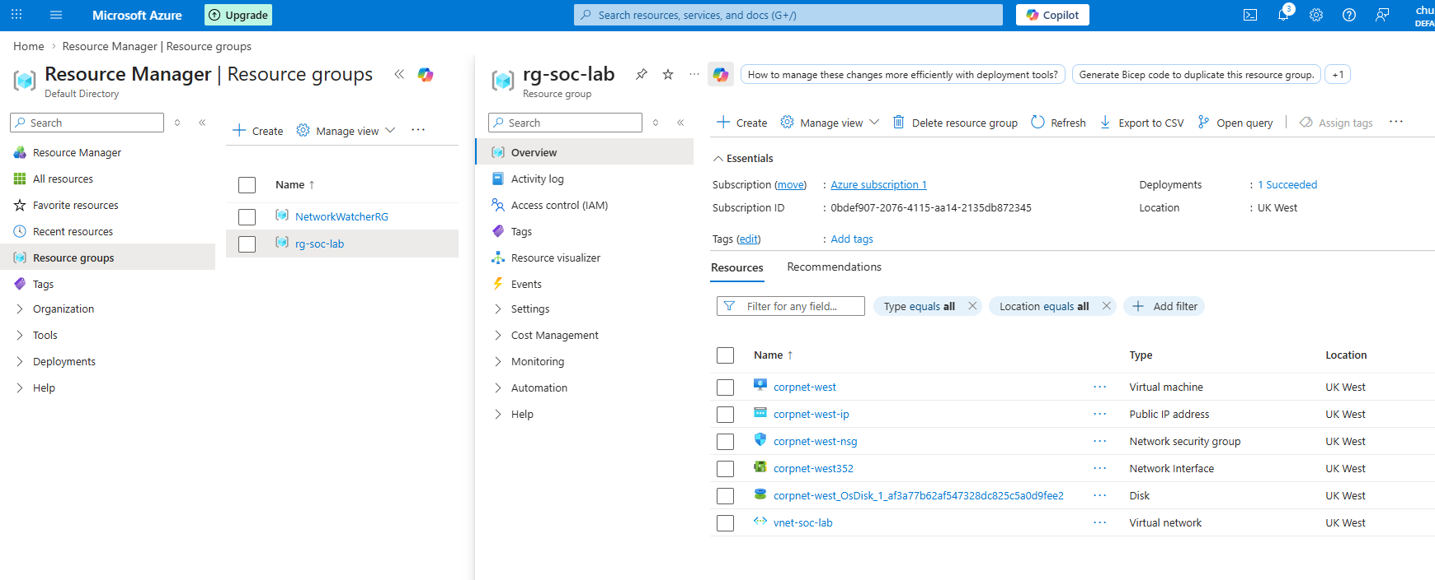
Go to the Network Security Group (NSG) for your virtual machine and create a rule that allows all traffic inbound (honeypot)
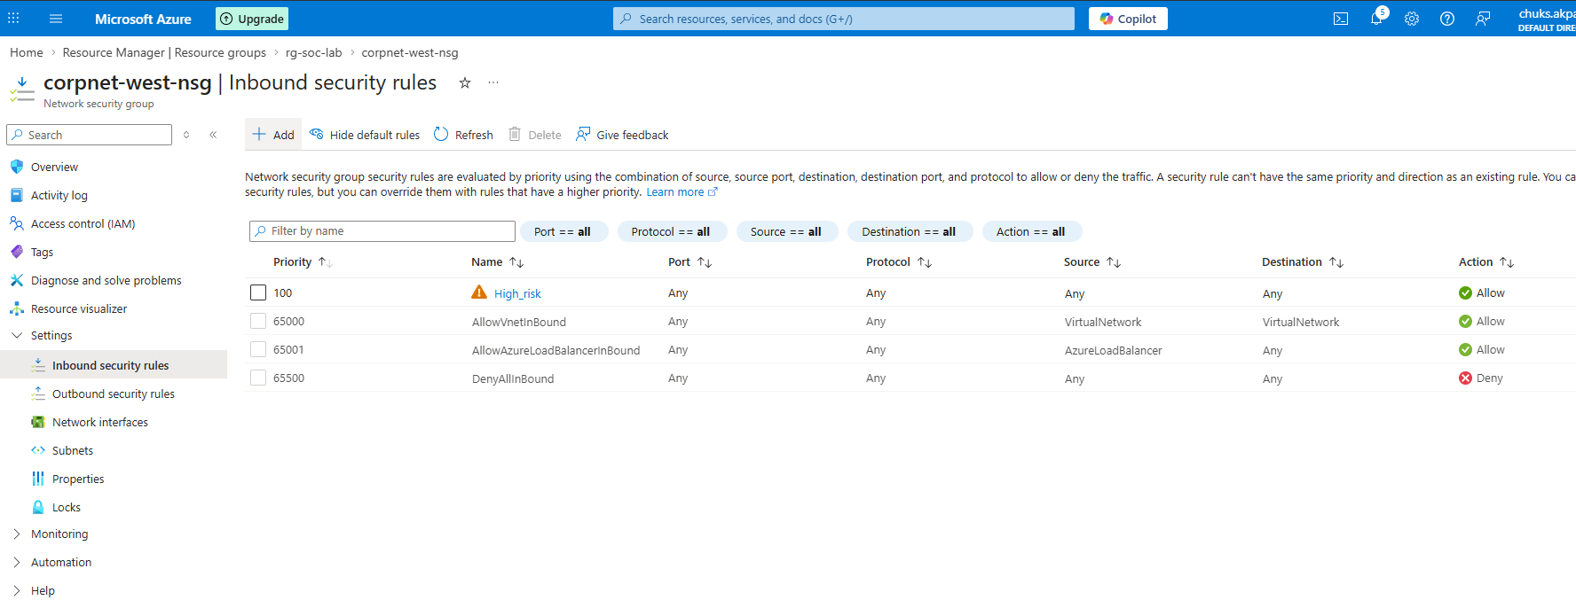

Log into your virtual machine and turn off the windows firewall ( start -> wf.msc -> properties -> all off)
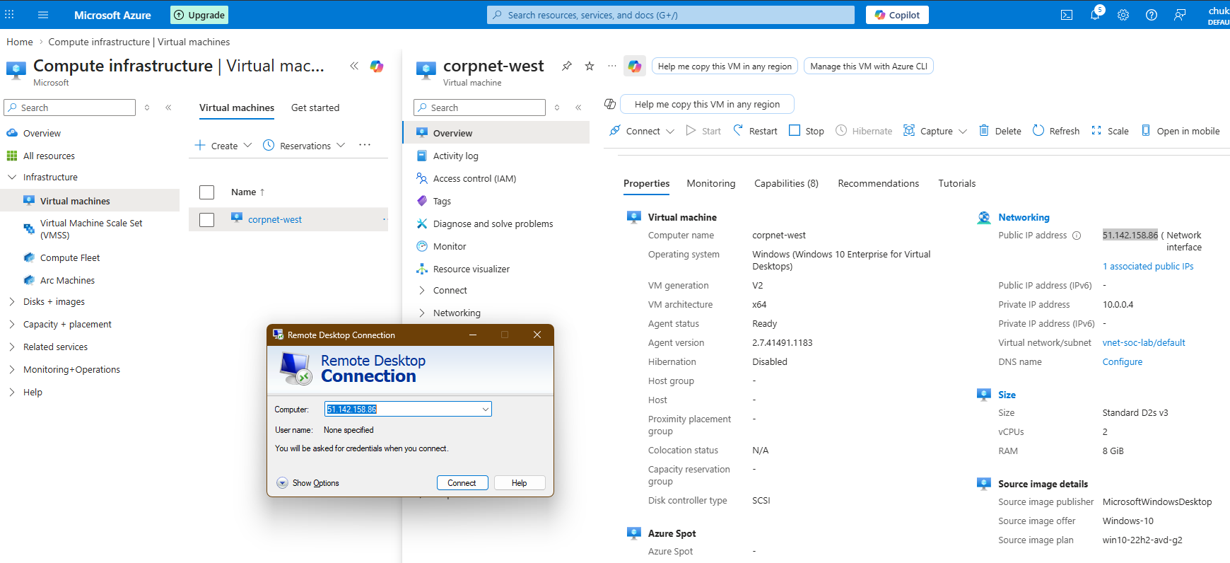

- Logging into the VM and inspecting logs
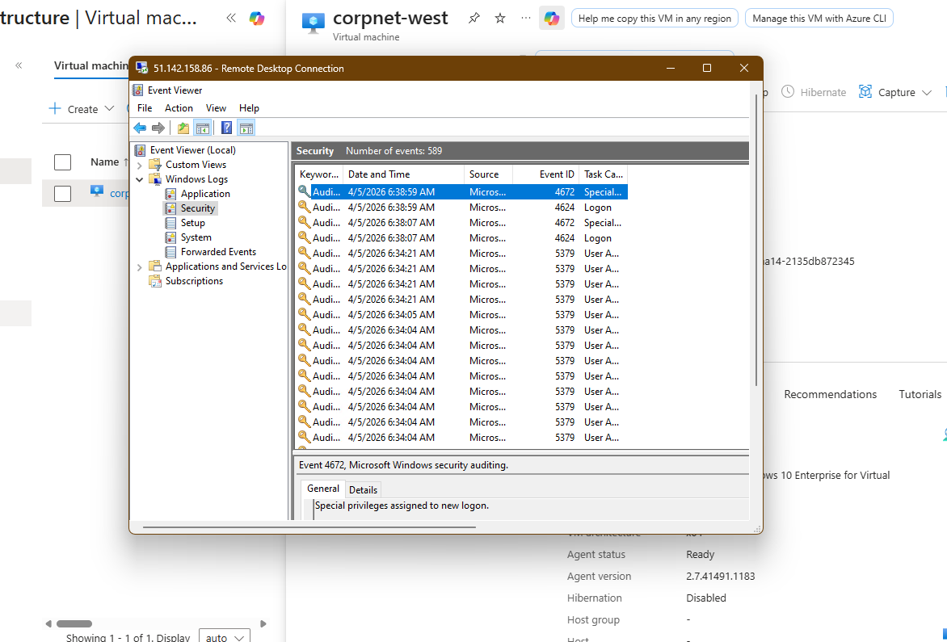

- Try fail 3 logins using any credentials
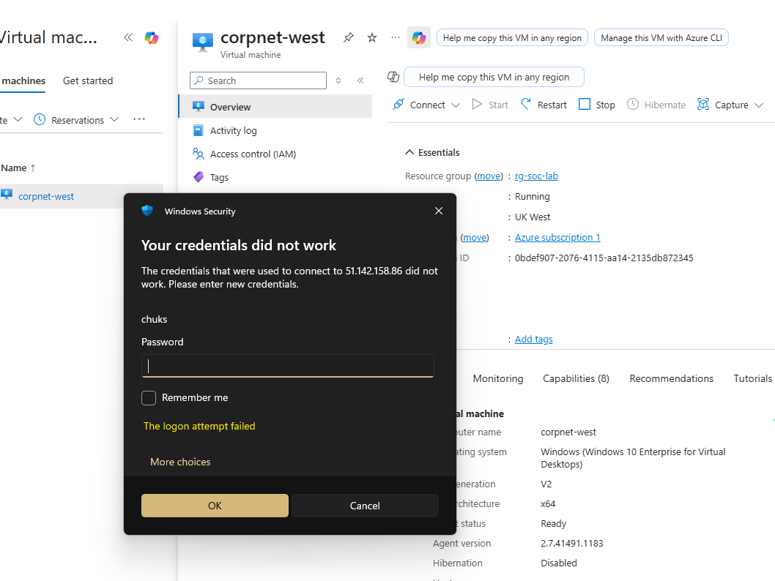

Login to your virtual machine
Open Event Viewer and inspect the security logs (can be found on your local machine start menu)
Find the 3 filed logins with event ID 4625
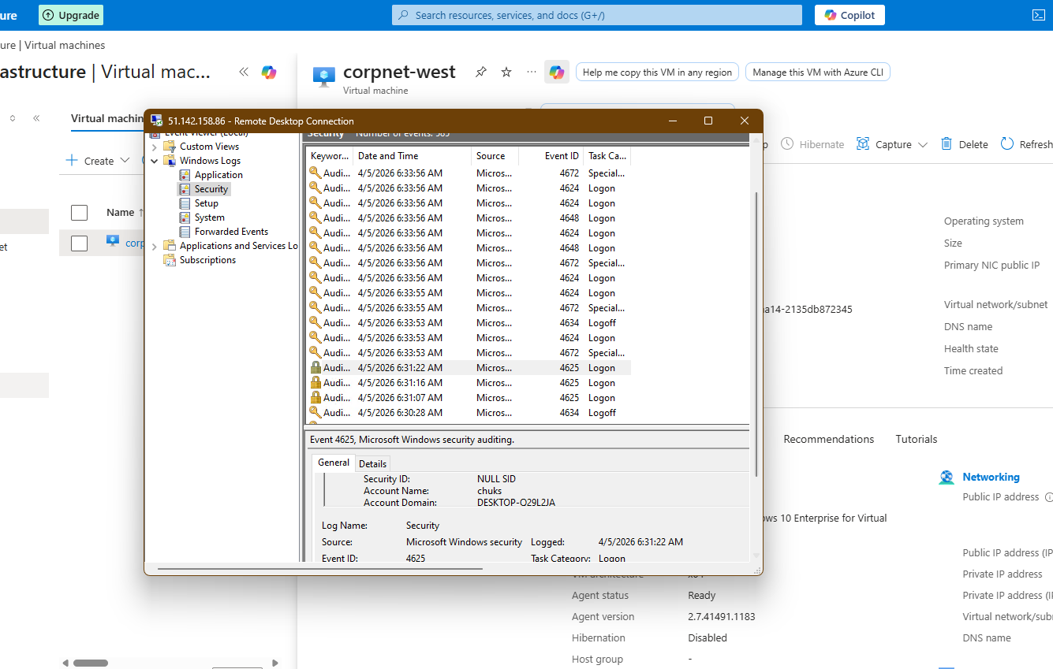

- Create Log Analytics Workspace
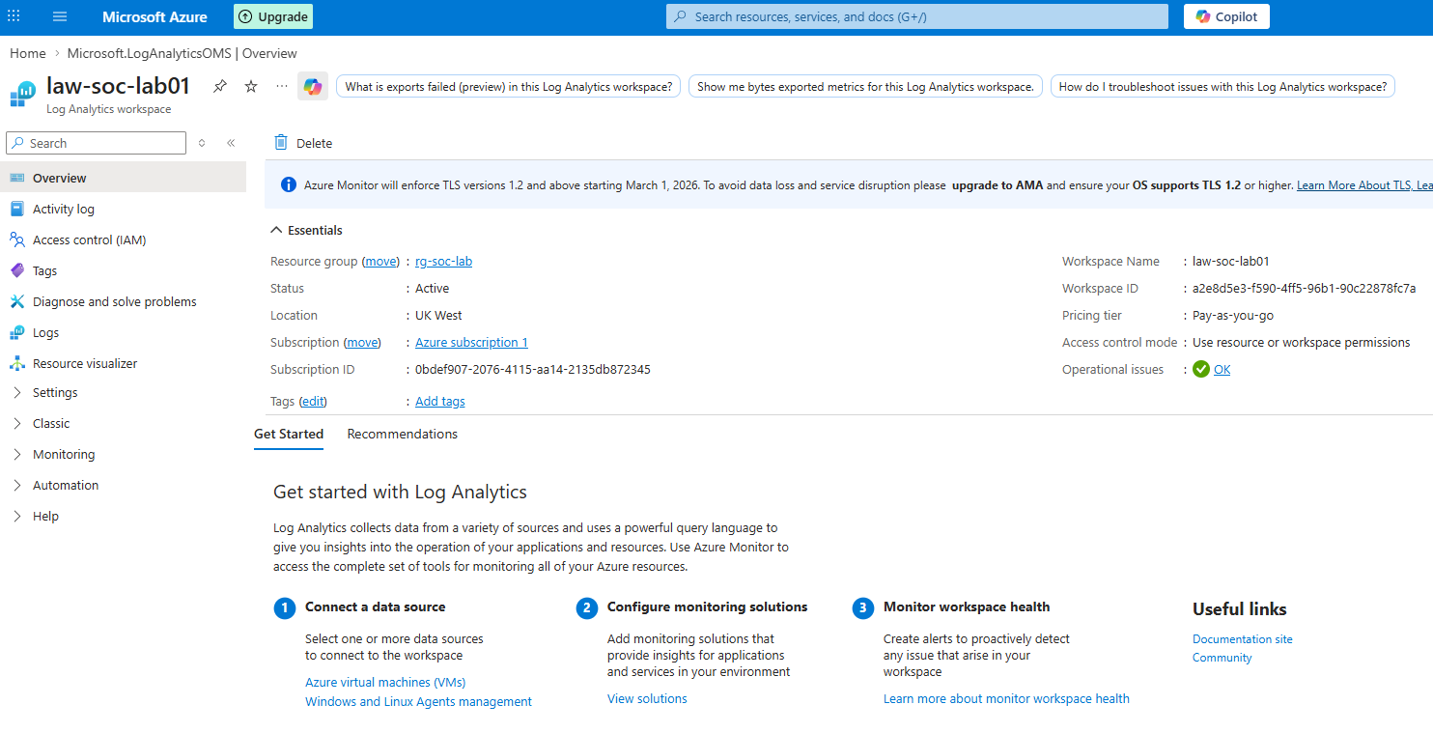

Create a Sentinel Instance and connect it to a Log Analytics
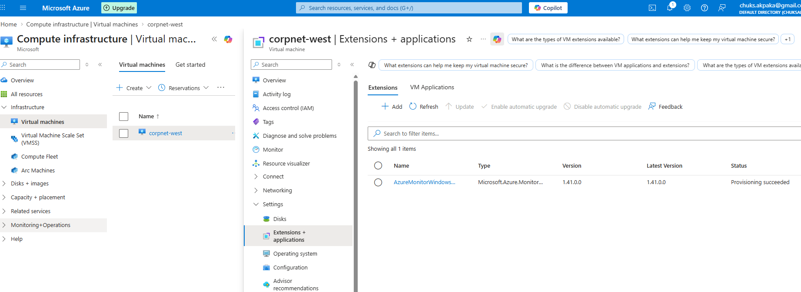

Configure the ‘Windows Security Events via AMA’ connector
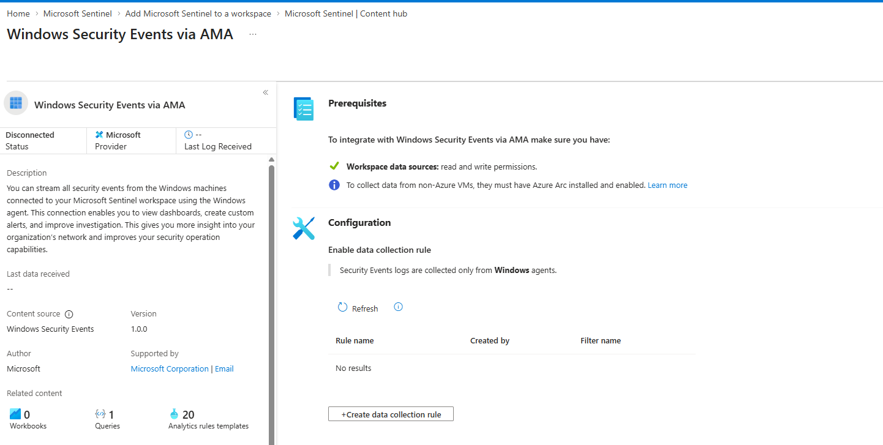

Create the DCR within sentinel, watch for extension creation
Query for logs within the LAW (Log Analytics Workspace)
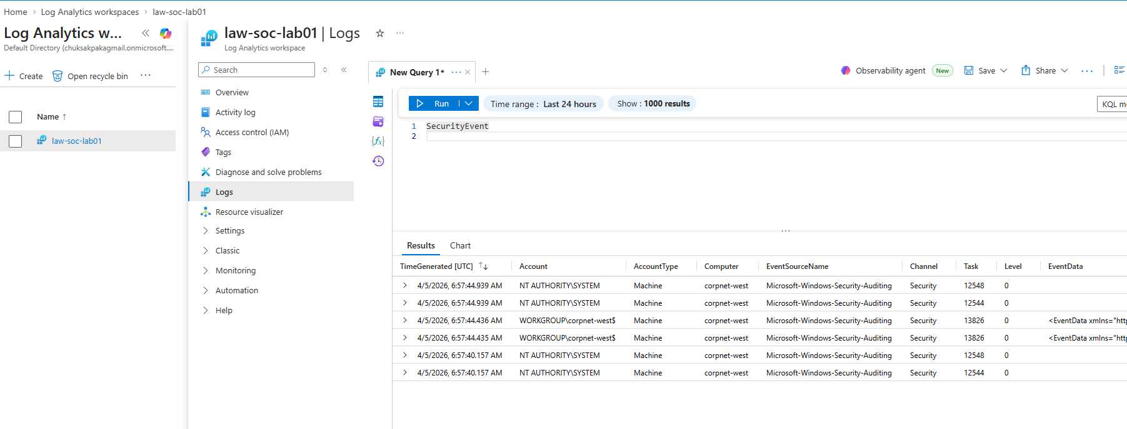

Log Forwarding and KQL

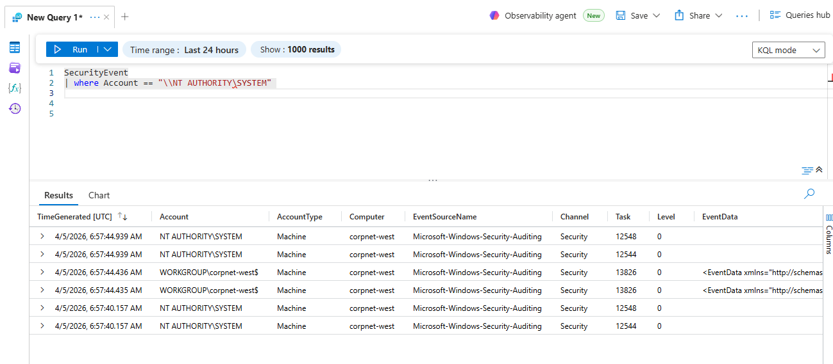

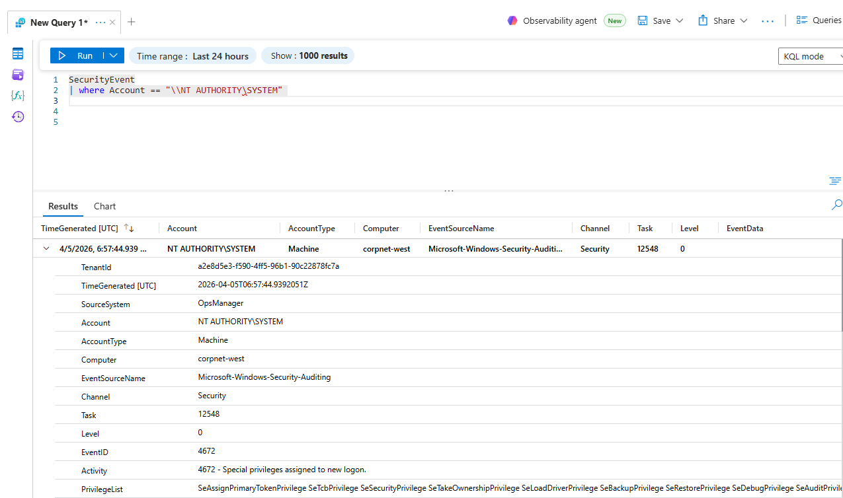

8. Microsoft Sentinel | Watchlist page has been moved to the Defender portal for optimal, unified SecOps experience
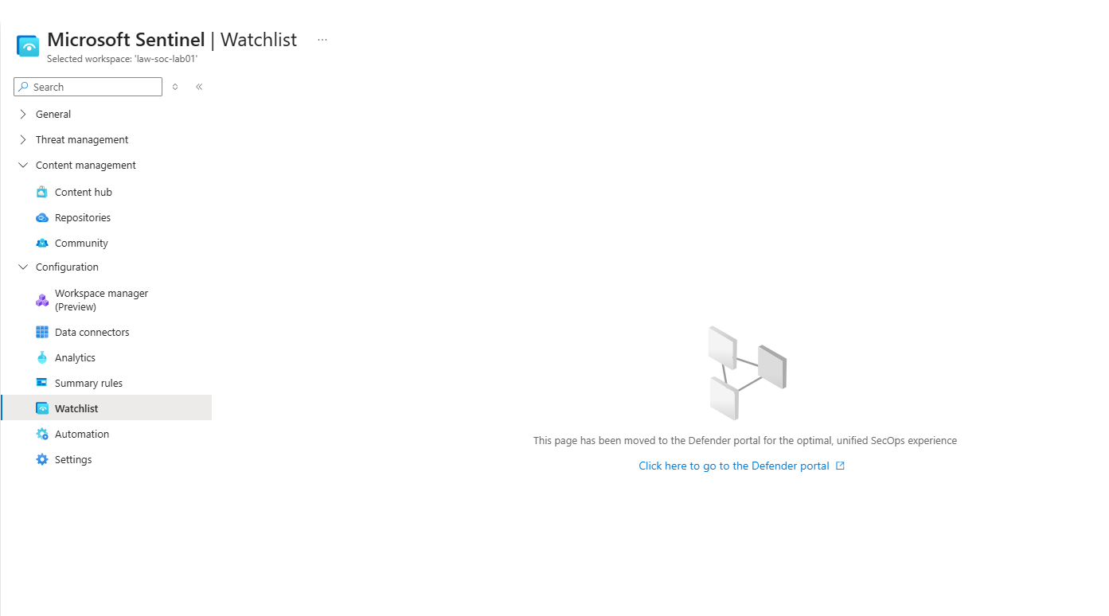

Generate logs with geoip watchlist to view Ip country of origin
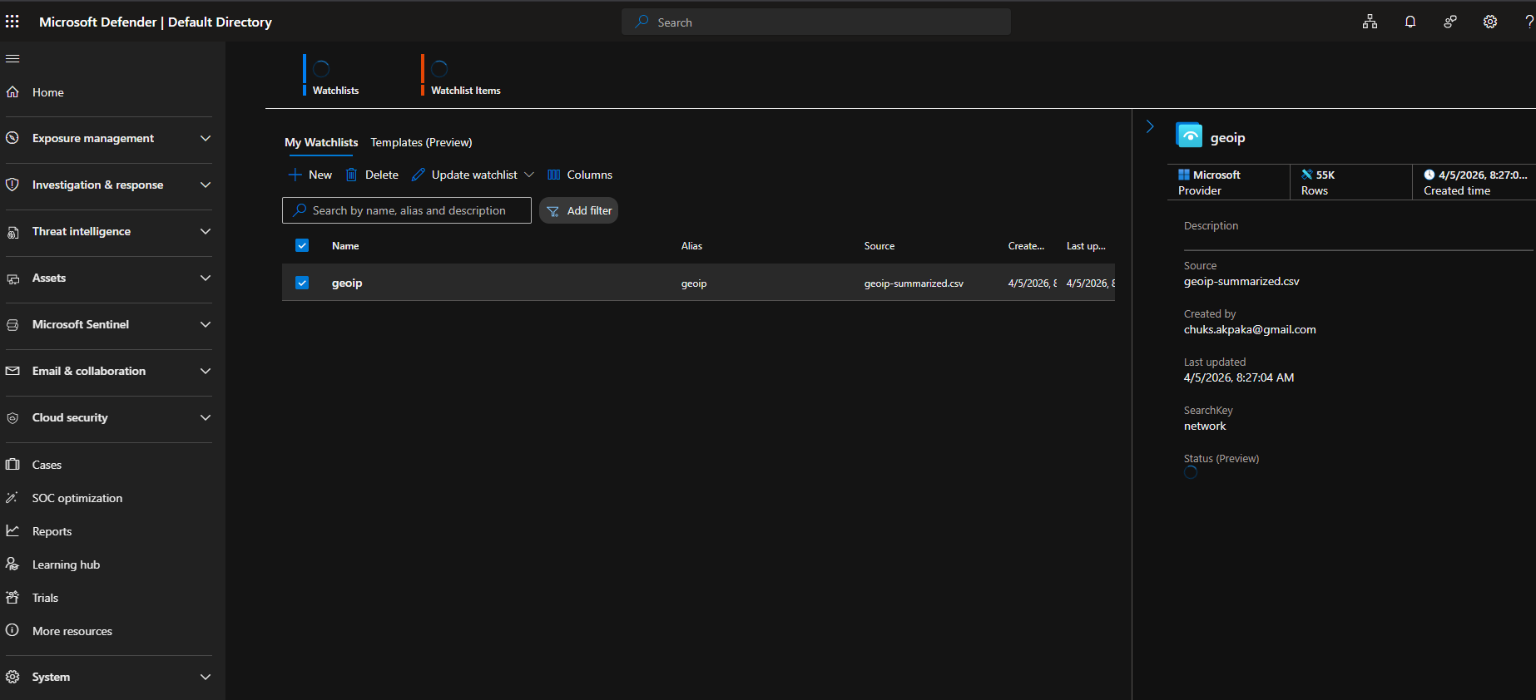
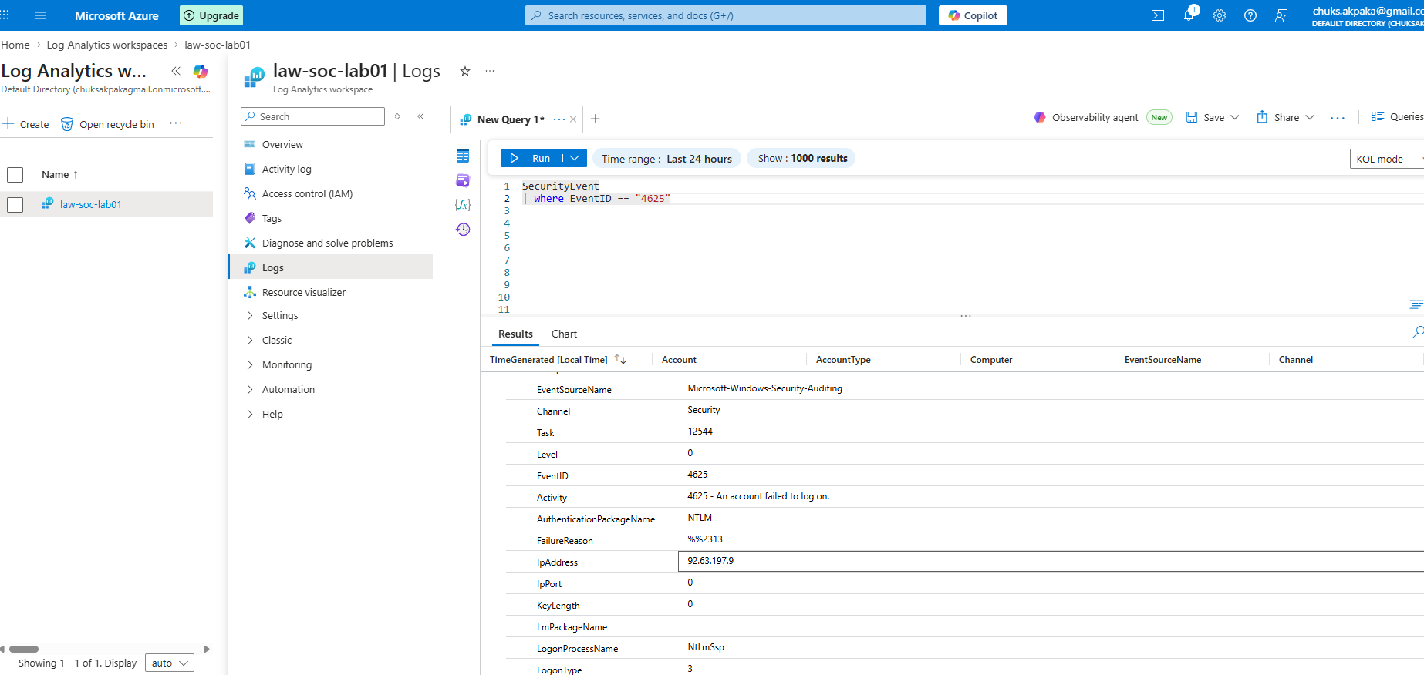
Map the location of attackers
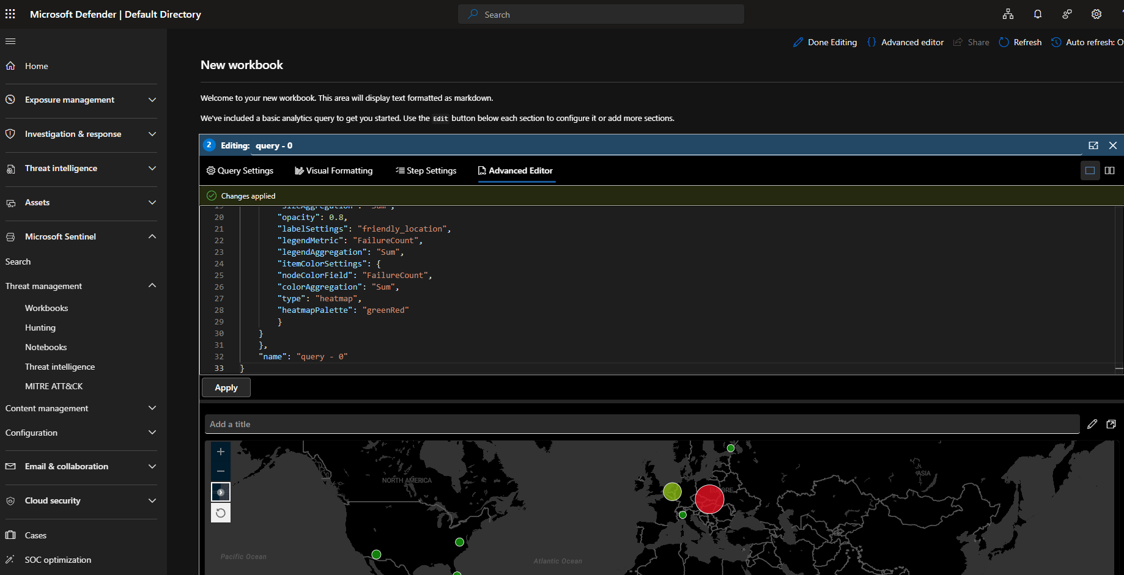
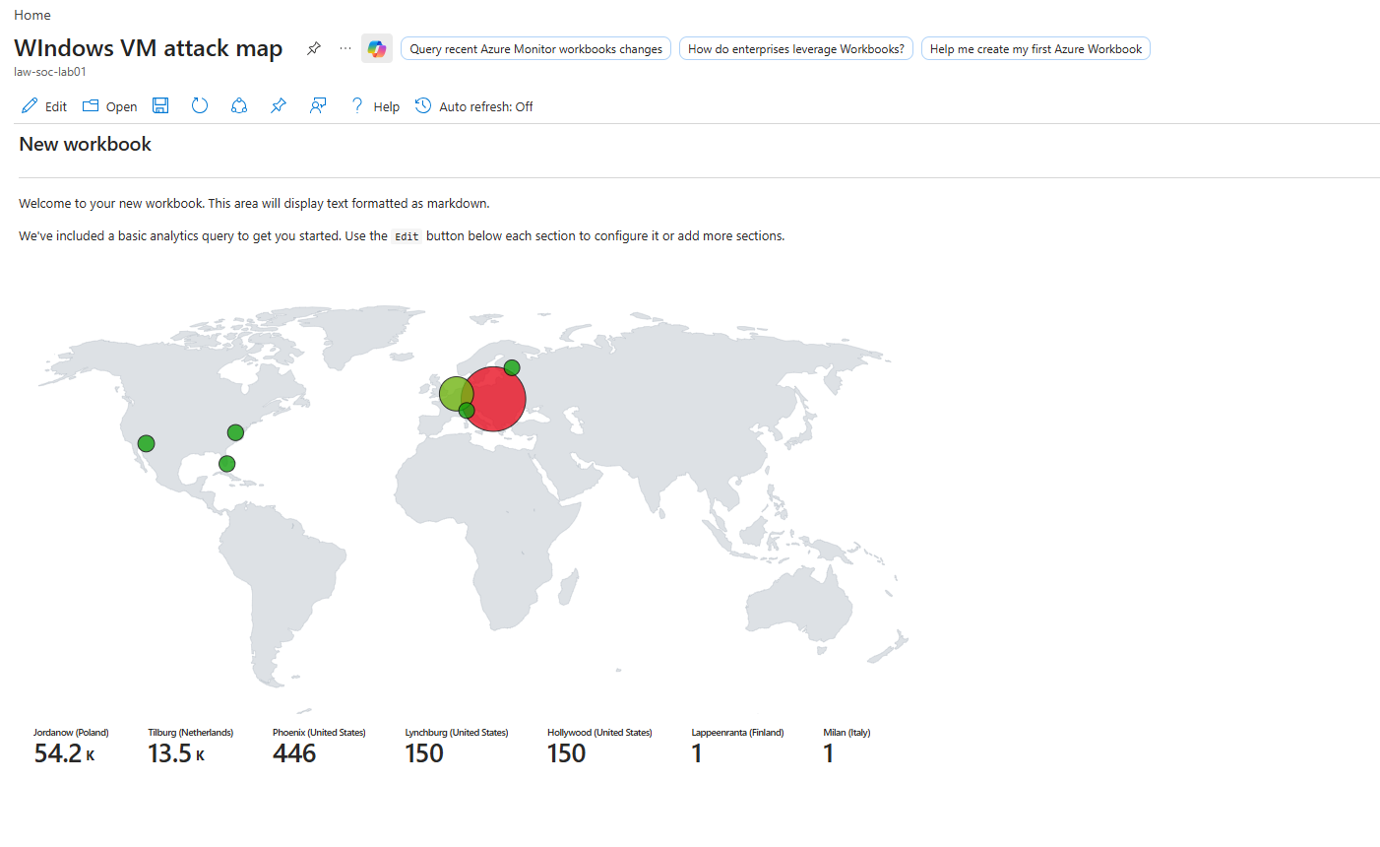

Final Architecture
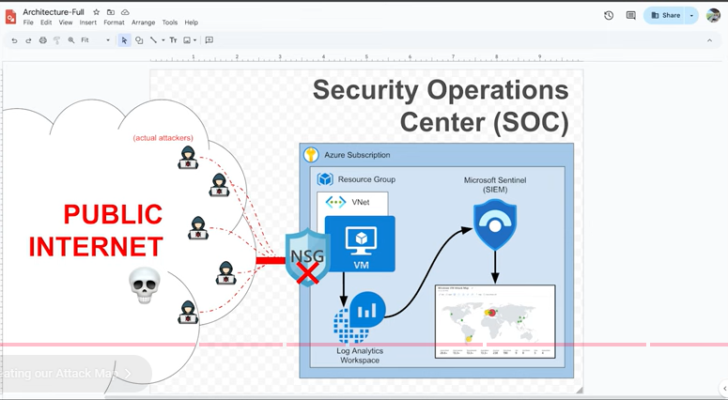

This lab demonstrates not only the Red Team technique of how to use KQL query for log search search such as the “4625” failed login , but also the Blue Team incidence response, showcasing:
- SIEM (Sentinel) log analysis
- Cyber attack detection
- Practical reporting skills
Ensure to delete all resources on Azure using the:
az CLI- az group delete -- rg-soc-lab --yes --no-wait
rg in $(az group list --query "[].name" -o tsv); do az group delete --name $rg --yes --no-wait done

Let’s Connect
You can find this project on GitHub and more on my LinkedIn profile (feel free to add your link).

End of Project – Feel free to fork, clone, or reach out with suggestions.

