caBIG™ Standard Templates

UML Model Example

Please Note: This is an example document, not a template document. There is not standard “template”; however, this document walks the user through the creation of and format of an UML in the caBIG™ program.

TABLE OF CONTENTS

EA Project Table of Contents 3
UML Overview 4
UML Deliverables in caBIG™ 4
Submitting UML Deliverables for Review 4
Example 4

EA Project Table of Contents

Please include a Table of Contents snapshot of the EA file submitted to briefly describe and identify what models are included. Please see the below sample for reference:

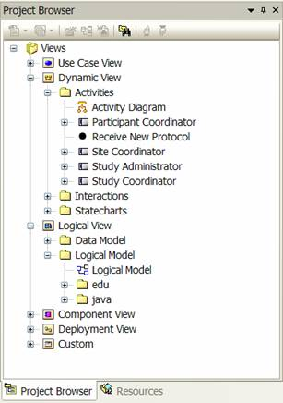

Refer to the Activities > Activity Diagram and Logical Model > Logical Model.

UML Overview

The Unified Modeling Language (UML) (http://www.uml.org) is an object modeling and specification language standardized by the Object Management Group (http://www.omg.org/) . For the purposes of the caBIG™ Program, UML data models refer to the structure diagrams defined in UML 2.0 (primarily Class and Object models). Structure Diagrams describe objects in computer systems in graphical terms that allow for conceptual review of a proposed architecture.

UML Deliverables in caBIG™

There is no standard “template” for the submission of UML models in caBIG™. What is required is a UML model compliant with the caBIG™ semantic loader and a visual representation preferably in PDF form. The caBIG™ program prefers the use of Enterprise Architect (EA) (http://www.sparxsystems.com.au/) for generating UML diagrams. For use in caBIG™, the UML model must be a logical model and follow a number of constraints so the UML model can be used as a substrate for the semantic integration process and code generation. For more information on these constraints please visit http://ncicb.nci.nih.gov/infrastructure/cacore_overview/cacoresdk

As stated above, the UML model serves as the source for the semantic integration process (annotating the model with controlled vocabularies and subsequent generation of common data elements) and for the generation of an object-oriented API. At a very high level the software development methodology in caBIG™ is:

UML Model→Fully annotated XMI File→ISO11179 compliant metadata and API

Submitting UML Deliverables for Review

To submit a UML diagram for review in caBIG™ both the source file (for EA the .EA file) and a graphical representation should be submitted to CVS for immediate review. Additionally, the UML model should be included in the compatibility review submissions package.

Example

The following example is from the caBIO and describes their model for Agent-Anomaly. In a typical model this would be one of many models relating to an entire model.
