Date Time Format Unifier Tool Specification 1.0 Requirements Specification

This document outlines the Application Scope and Requirements for
Date Time Format Unifier Tool Specification 1.0.

PRESENTED TO:  <Client Names> | <CLIENT LOGO>
PRESENTED BY:  <TopCoder Names> | 

Revision History
Author | Revision Number | Date

Application Requirements Specification 4
1. Scope 4
1.1 Overview 4
1.2 Objectives 5
1.3 Limitations & Assumptions 6
2. Logic Requirements 7
2.1 Format Date/Time 8
2.2 Convert Date/Time 10
2.3 Localize Date/Time 12
2.4 List all Available Date/Time Formats 14
2.5 List all Available Date/Time Systems 16
2.6 List all Available Locales 18
2.7 List all Available Time Zones 19
2.8 Obtain Current System Time 20
2.9 Manage Date/Time Systems 21
2.10 Manage Date/Time Formats 23
2.11 Configure Logging 26
2.12 Get API Documentation [External] 28
2.13 Perform Logging 28
3. General Requirements 30
3.1 Graphical User Interface Requirements 30
3.2 Performance Constraints 30
3.3 Security 31
4. Required Documentation 31
4.1 Specification Documentation 31
5. Help / User Documentation 31
6. Notes 31
7. Future Enhancements 32
8. Glossary 33
8.1 Definitions 33
8.2 Acronyms 33

Application Requirements Specification

Scope

Overview
The client wants to develop a set of APIs (i.e. callable functions) that would help to unify the utilization of date and time formats across applications and date systems as well as across locales.
Please note that the terms “API”, “functions”, and “tool” will be used interchangeably and will refer to the same thing here: a collection of date/time management functions.

The goal of such a tool is three-fold:
- Unification and standardization of date/time formats within applications including locale based format information (for example dates in France are different formats than in United States.)
- Creation of easy to use functions for conversion/formatting of date and time data from one date system to another. (For example from Gregorian to Arabic, or from Coptic to Gregorian.)
- Provision of time zone based conversion, which would allow the conversion from one time zone to another.

Such a set of APIs would be quite important for developers, testers, and any technical persons who need to work with date and time data. As an example consider a simple standalone invoicing application. Such an application would need to make sure that all the dates are written out properly and with the right locale. By standardizing the API, such an application could simply do the following equivalent:

- The caller inputs the “Feb-15-73” as a full date, which the function accepts with a desired output format.
- The function would then output for example something like “Wed-15-02-1973”

The API would be used to read, write, and convert date and time data as well as manage actual formats (for example what is the date format for North America as compared to Europe?) used for such date/time data display and storage.

As such this is not a tool that would have any User Interface associated with it. It is simply a collection of useful functions that can be used to manipulate date/time data.

The API must be easy to use and well documented and should not require any complex input from the callers.

The client is envisioning this tool as a set of well-documented APIs, which can be used programmatically as a set of simple service based functions. For example a caller should be able to provide a date/time datum and for example get a string back, which would format this date/time in some specific way.

The client is also envisioning for those APIs to be platform independent (i.e. the component should be able to used and call by developed programs by JAVA, VB 6 and VC++.)

The Problem
The client currently is not using any unified APIs for the purpose of managing date/time data.

Application opportunity
The main opportunity is to create a standard and simple to use date/time based API, which would enable technical users including users such as developers, or testers to get all the relevant date/time functionality for use within their applications.

The client is envisioning being able for those APIs to be platform independent (i.e. the component should be able to used and called by programs developed in JAVA, VB 6 and VC++.)
So there is a great opportunity to create a fully reusable set of API that could be called from anywhere and by any client caller.

The additional opportunity is for the client to have an easy to maintain, and well-designed set of functions with good documentation of the implementation (i.e. the code that actually is the API) as well as good documentation for developers (i.e. documentation on how to use the API.) Part of the maintenance would be a flexible approach that would enable developers to create new System Date formats (for example being able to add “Arabic” Date system) to the tool.

Finally, there is an opportunity to create a tool which will able to log the output, input and the errors in a configurable path file for the execution of the API.

Objectives
The objectives of this application are:
Nonnegotiable:

- To provide a tool that will standardize the date/time data management functionality for date/time formatting and date/time conversion as follows:
  - The API will be able to convert date/time data from one date system to another.
  - The API will be able to format date/time data into different formats as chosen by the caller.
  - The API will be able to work with date/time data for different between locales.
  - The API will be able to work with different timezones and convert date/time data between different timezones.
- To provide a tool which will have an API that is callable by programs developed with JAVA, VB 6 and VC++.
- To provide a tool which will accept as input data such as:
  - Current date and time.
  - Passed in date/time input.
- To provide a tool which will have the ability to log all errors, exceptions, warnings, and debug information during the tool utilization to a configured file.
- To provide an API development documentation.

Nice to have:
- The ability to use the API through a network.
- Including API function help document built into the API.

Project Return on Investment (ROI Metrics):
- The application will allow the standardization of the date/time management functionality to be used within other applications and systems through the use of well-documented and efficient API, which will give all the technical users including developers and testers a common, easily to use platform for such management.

General Capacity Metrics:
- N/A

Limitations & Assumptions
The limitations of the application are listed below:
- There is no authorization/authentication process for the application. The callers will not need to log in or logout.
- There will be no GUI interface for this tool.
- There will be no user accounts for this application.
- The tool will not produce any reports.
- No standard user auditing will be needed, since there is no user identity in the system.
- The application will be utilized in English only. This means that documentation, and any messages (information, error, logging messages) for this tool, will be in English only.
- The system will not utilize any extra/special peripheral devices.
- The system will not be sending nor receiving any emails.
- The API must be created without the utilization of any frameworks that already provide date/time functionality.

Assumptions critical to the success of this application are listed below:
- There is no authentication or authorization used for this application.
- The system will not be sending nor receiving any emails.
- The system will not utilize any extra/special peripheral devices.
- The tool will be utilized in English.
- It will be utilized from different time zones.
- All the users of this tool or the API are professional developers.
- The API will support at least the Gregorian, Arabic, and Coptic date systems.
- The main users of this tool will be other systems that will be calling the API.

Technical assumptions from the client:
- The tool will be developed any of those:
  - MS VC++ 2008 with MFC (as per client request: “NO FRAMEWORKS CAN BE USED”) MS Visual C++ redistribution package 2008 can be used only.
  - Sun JAVA, Oracle JAVA or IBM JRE can be used too.
  - The component should work under Windows XP, Vista, and Windows 7 (for both 32 and 64 platforms.)

Logic Requirements
The following is the Use case diagram for the application:

The use case diagram uses the color schema defined in the following table to distinguish different types of use cases.

Use case color | Description
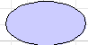 | The blue use case is normal use case
 | The pink use case is aggregate/abstract use case.

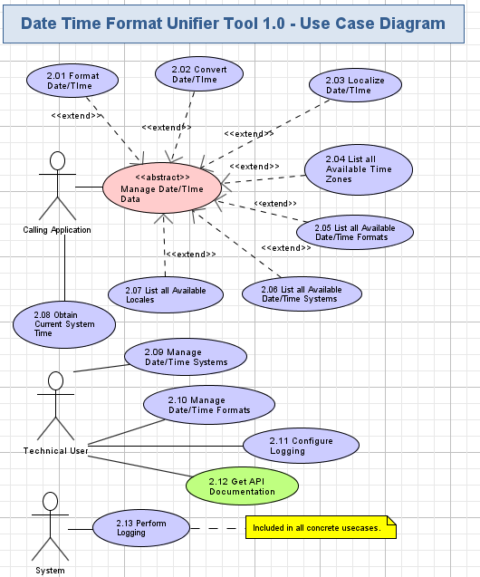

Format Date/Time
The application will allow the caller to take any date/time and format it.
Conceptualization Reference: 4.4.1 Format Date/Time
- Pre-conditions: the caller invoked the system to format date/time. The application was started.
- Post-conditions: the caller formatted date/time successfully.

Format Date/Time Activity
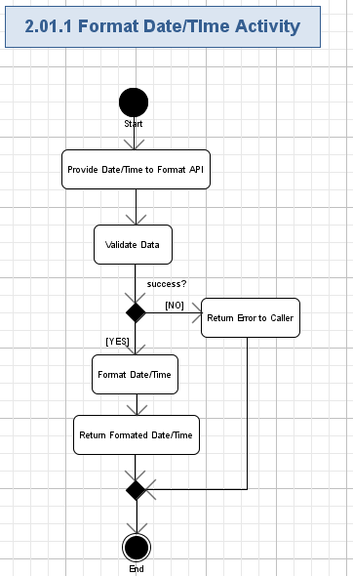

Provide Date/Time to Format API
- The application will provide the API where the user can provide the data to.
- The format of the data is like following:
Data Element | Description | Format | R?
Date/Time | The date/time to localize. | String, max 1024 chars, non empty. | Y
Date/Time Template | The name of the date/time template. | String, max 1024 chars, non empty. | Y

Validate Data
- The application will automatically validate the provided data according to table 2.1.1.1.

Return Error to Caller
- If the validation failed, then the error will be returned to the caller to indicate that the provided data is invalid.

Format Date/Time
- The API will provide the ability to take any date/time and format it according to some specific format, which could be input as well. Please note that the system will be configured to work with a default format, which could be changed as well so that users would not have to input any format for the utilization of the formatting API (see 2.10)
- For example the caller could format the date to be 24-hour date/time without the “AM/PM” designation or vice versa. They would also use a day name instead of day-number etc… The following possibilities are currently envisioned:
  - Formatting of date/time based on specific tokens designating pieces of the date/time. For example “Day” could be used as a token designating the portion of the date as the day. Then the format for “Day” could be “AAA” which would mean that three letters would be used for the formatting. So an example of a day would be “FRI” or “MON”
  - The actual format could involve:
    - Letters and numbers formatting as in the example above.
    - Capitalization formatting (for example “Aaa” which would give us “Fri” instead of “FRI”
    - Template characters, which would simply fill the format string with additional static data such as positioning or esthetical elements such as when the application will start it, should have some sort of splash screen telling the user of its version and name with a short description of what the application does. For example would be such a formatting of the day token as “{AAA}” which for a day would be formatted as “{FRI}” which you will note has the characters “[“ and “}” simply embedded as part of the formatting.
    - See 2.10 for additional details.

Return Formatted Date/Time
- The formatted date/time will be returned to the caller.

Convert Date/Time
The application will allow the caller to take any date/time and convert it.
Conceptualization Reference: 4.4.2 Convert Date/Time
- Pre-conditions: the caller invoked the system to convert date/time. The application was started.
- Post-conditions: the caller converted date/time successfully.

Convert Date/Time Activity
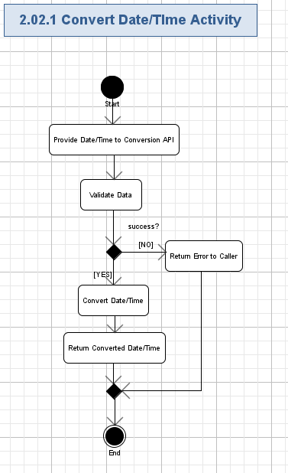

Provide Date/Time to Conversion API
- The application will provide the API where the user can provide the data to.
- The format of the data is like following:
Data Element | Description | Format | R?
Date/Time | The date/time to localize. | String, max 1024 chars, non empty. | Y
Date/Time System | The name of the date/time system. | String, max 1024 chars, non empty. | Y

Validate Data
- The application will automatically validate the provided data according to table 2.2.1.1.

Return Error to Caller
- If the validation failed, then the error will be returned to the caller to indicate that the provided data is invalid.

Convert Date/Time
- The API will provide the ability to take any date/time and convert it according some specific conversion rule (which could also include some formatting rule – note that the format could be a default format for the given context.)
- The conversion here would as follows:
  - From one Date System to another such as from Coptic to Arabic.
    - The input would be the date/time data along with the information about the source and destination date system. If there is no format input then the default format for the given system will be used.
    - The current conversion will be between the following systems:
      - Julian, Coptic, Gregorian, and Arabic inter-conversion. This means that users will be able to convert dates between Julian to/from Coptic, Gregorian to/from Arabic, etc.
The way it will work is that the conversion will allow for conversion from a date in one system to a date in the other system. For example the “1st of January 2013” in Julian System will be the “6th of May 1781” in the Coptic System.
  - From one time zone to another such as from “GTM” to for example “Us/Eastern”
    - The input will be a date/time in one time zone and the output will be the same date in another time zone. A simple zone converter is here as an example: http://www.timezoneconverter.com/cgi-bin/tzc.tzc
    - All the time zones should be in scope. Here is a list of the time zones: http://en.wikipedia.org/wiki/List_of_time_zones_by_country

Return Converted Date/Time
- The converted date/time will be returned to the caller.

Localize Date/Time
The application will allow the caller to take any date/time and localize it.
Conceptualization Reference: 4.4.3 Localize Date/Time
- Pre-conditions: the caller invoked the system to localize date/time. The application was started.
- Post-conditions: the caller localized date/time successfully.

Localize Date/Time Activity
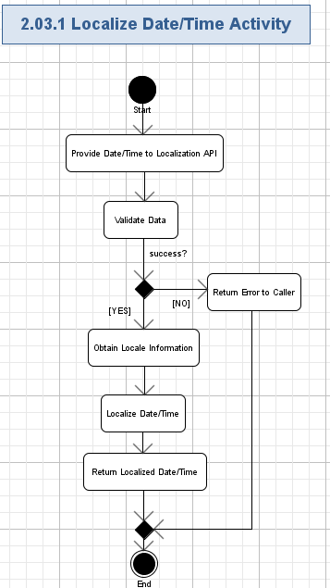

Provide Date/Time to Localization API
- The application will provide the API where the user can provide the data to.
- The format of the data is like following:
Data Element | Description | Format | R?
Date/Time | The date/time to localize. | String, max 1024 chars, non empty. | Y

Validate Data
- The application will automatically validate the provided data according to table 2.3.1.1.

Return Error to Caller
- If the validation failed, then the error will be returned to the caller to indicate that the provided data is invalid.

Obtain Locale Information
- The locale information will be obtained from the underlying middle layer.

Localize Date/Time
- Localization would be nothing more than conversion from one locale to another. For example we could convert the Date from French locale to British Locale.
- Note that such conversion would possibly change the language of the date if the date is using any language based representation such as “Monday” which when converted to French locale would be “Dimanche”.

Return Localized Date/Time
- The localized date/time will be returned to the caller.

List all Available Date/Time Formats
The application will allow the caller to get a list of all the available Date/Time Formats.
Conceptualization Reference: 4.4.4 List all Available Date/Time Formats
- Pre-conditions: the caller invoked the system to obtain all available Date/Time Formats. The application was started.
- Post-conditions: the caller obtained all available Date/Time Formats successfully.

List all Available Date/Time Formats Activity
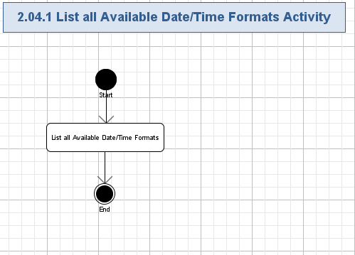

List all Available Date/Time Formats
- The application will provide the API where the caller can get all available Date/Time Formats:
Data Element | Description | Format | R?
List of Templates
Name | The name of the template. | String, max 1024 chars, non empty.  If the name is “Default”, then it will be used as the default template. | Y
List of Tokens under Template
Token | The tokens of the date/time data. | String, max 50 chars, non empty.  The tokens will include:  Day  Month  Year  Hour  Minute(s)  Seconds(s)  Millisecond(s)  Era (i.e. “AD” or “BC”)  12 or 24 hour clock (i.e. “AM” or “PM”) | Y
Formatting | The formatting of the token. | String, max 50 chars, non empty.  The possible values are:  NN;  AAA;  Etc – up to architects.  For example Day could be as “NN” where N is a number (for example 23), which would be the 23rd, or it could be for example “AAA” where “A” is a letter such as “FRI” for Friday | Y
Full Date/Time Formatting | The formatting of the full date/time. | String, max 200 chars, non empty.  For example we could have the following simple format: [Day:NN] /[Month:AAA] /[Year:NNNN]  An example of such a formatted date would be “23/JUN/2013” | Y
Locales | The names of the Locales that support this format. | List of Strings, each is max 1024 chars, non empty. | Y
Timezones | The names of the timezones that support this format. | List of Strings, each is max 1024 chars, non empty. | Y

List all Available Date/Time Systems
The application will allow the caller to get a list of all the available Date/Time Systems. For each system the caller should be able to also obtain the different formats and conversion rules.
Conceptualization Reference: 4.4.5 List all Available Date/Time Systems
- Pre-conditions: the caller invoked the system to obtain all available Date/Time Systems. The application was started.
- Post-conditions: the caller obtained all available Date/Time Systems successfully.

List all Available Date/Time Systems Activity
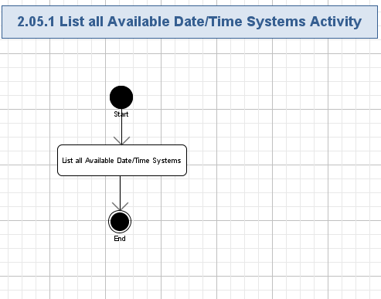

List all Available Date/Time Systems
- The application will provide the API where the caller can get all available Date/Time Systems:
Data Element | Description | Format | R?
List of Date/Time System
Name | The name of the system. | String, max 1024 chars, non empty.  The API will support at least the Julian, Coptic, Gregorian, Arabic inter-conversion date systems. | Y
Date/Time Format Template Name | The name of the template. | String, max 1024 chars, non empty. | Y
Conversion Rule | The conversion rule of the date/time system. | String, max 1024 chars, non empty. | Y

List all Available Locales
The application will allow the caller to get a list of all the available locales. For each locale the caller should be able to also obtain the different formats.
Conceptualization Reference: 4.4.6 List all Available Locales
- Pre-conditions: the caller invoked the system to obtain all available locales. The application was started.
- Post-conditions: the caller obtained all available locales successfully.

List all Available Locales Activity
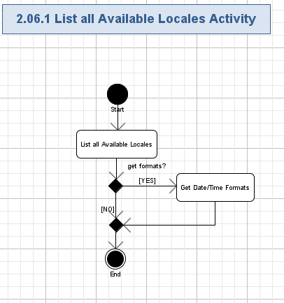

List all Available Locales
- The application will provide the API where the caller can get all available Locales:
Data Element | Description | Format | R?
Locale | The name of the Locales. | String, max 1024 chars, non empty.  All locales should be supported. | Y
- The locale information will be obtained from the underlying middle layer

Get Date/Time Formats
- For each locale the caller should be able to also obtain the different formats, please see 2.10 for details on date/time formats.

List all Available Time Zones
The application will allow the caller to get a list of all the available time zones. For each time zone the caller should be able to also obtain the different formats.
Conceptualization Reference: 4.4.7 List all Available Time Zones
- Pre-conditions: the caller invoked the system to obtain all available time zones. The application was started.
- Post-conditions: the caller obtained all available time zone successfully.

List all Available Time Zones Activity

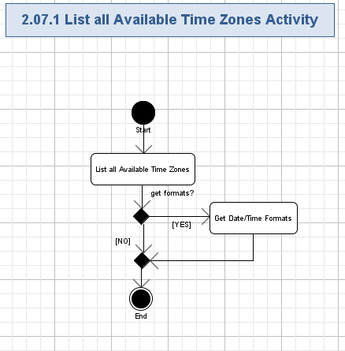

List all Available Time Zones
- The application will provide the API where the caller can get all available Time Zones:
Data Element | Description | Format | R?
Timezones | The name of the time zone. | String, max 1024 chars, non empty.  All the timezones should be supported:  http://en.wikipedia.org/wiki/List_of_time_zones_by_country | Y

Get Date/Time Formats
- For each time zone the caller should be able to also obtain the different formats, please see 2.10 for details on date/time formats.

Obtain Current System Time
The application will allow the caller to get the current time without having to go to a different set of APIs.
Conceptualization Reference: 4.4.8 Obtain Current System Time
- Pre-conditions: the caller invoked the system to obtain current system time. The application was started.
- Post-conditions: the caller obtained current system time successfully.

Obtain Current System Time Activity
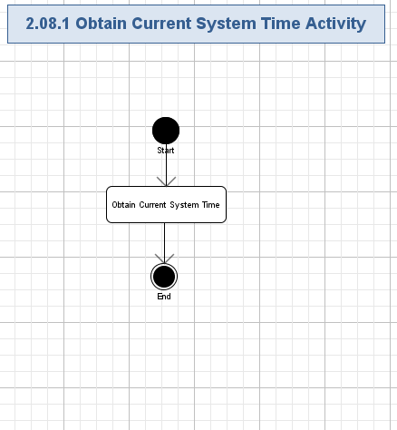

Obtain Current System Time
- The application will provide the API where the caller can get current system time in the default format:
Data Element | Description | Format | R?
Current System Time | The time of the current system in default format. | String, max 1024 chars, non empty. | Y

Manage Date/Time Systems
The application will allow the user to configure the date systems that are available to the API that is to make the tool flexible and easy to use. The user can manage the date/time systems via both programmatic way and configuration file way. The validation will be performed if the user configures the logging via programmatic way.
Conceptualization Reference: 4.4.9 Manage Date/Time Systems
- Pre-conditions: the user provided date/time systems data to the date/time format management API. The application was started.
- Post-conditions: the date/time systems were configured successfully.

Manage Date/Time Systems Activity
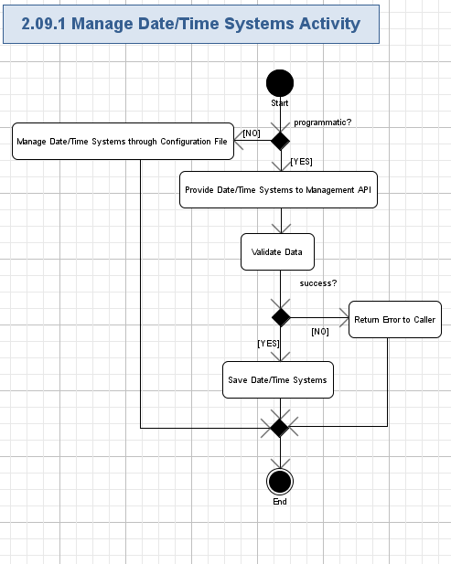

Provide Date/Time System to Management API
- The application will provide the API where the user can provide the data to.
- The formats of the data are like following:
Data Element | Description | Format | R?
List of Date/Time System
Name | The name of the system. | String, max 1024 chars, non empty.  The API will support at least the Julian, Gregorian, Arabic, and Coptic date systems. | Y
Date/Time Format Template Name | The name of the template. | String, max 1024 chars, non empty. | Y
Conversion Rule | The conversion rule of the date/time system. | String, max 1024 chars, non empty. | Y

Validate Data
- The application will automatically validate the provided data according to table 2.11.1.1.

Return Error to Caller
- If the validation failed, then the error will be returned to the caller to indicate that the provided data is invalid.

Save Date/Time Systems
- The application will save the provided date/time systems.

Manage Date/Time Systems through Configuration File
- The user can manage date/time systems directly in the configuration file.
- It is assumed that the entered values will follow the rules specified in 2.9.1.1.

Manage Date/Time Formats
The application will allow the user to configure the formats that are available to the API that is to make the tool flexible and easy to use. Additionally, the user can also configure default formats so that user would not have to provide a format each time they use the formatting API. The user can manage the formats via both programmatic way and configuration file way. The validation will be performed if the user configures the logging via programmatic way.

Conceptualization Reference: 4.4.10 Manage Date/Time Formats
- Pre-conditions: the user provided date/time formats data to the date/time format management API. The application was started.
- Post-conditions: the date/time formats were configured successfully.

Manage Date/Time Formats Activity
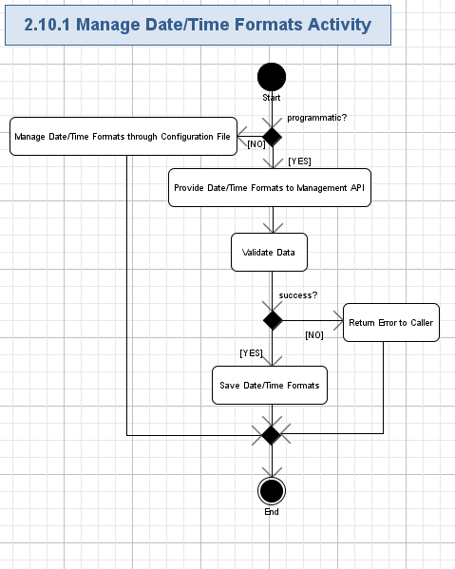

Provide Date/Time Formats to Management API
- The application will provide the API where the user can provide the data to.
- The formats of the data are like following:
Data Element | Description | Format | R?
List of Templates
Name | The name of the template. | String, max 1024 chars, non empty.  If the name is “Default”, then it will be used as the default template. | Y
List of Tokens under Template
Token | The tokens of the date/time data. | String, max 50 chars, non empty.  The tokens will include:  Day  Month  Year  Hour  Minute(s)  Seconds(s)  Millisecond(s)  Era (i.e. “AD” or “BC”)  12 or 24 hour clock (i.e. “AM” or “PM”) | Y
Formatting | The formatting of the token. | String, max 50 chars, non empty.  The possible values are:  NN;  AAA;  Etc – up to architects.  For example Day could be as “NN” where N is a number (for example 23), which would be the 23rd, or it could be for example “AAA” where “A” is a letter such as “FRI” for Friday | Y
Full Date/Time Formatting | The formatting of the full date/time. | String, max 200 chars, non empty.  For example we could have the following simple format: [Day:NN] /[Month:AAA] /[Year:NNNN]  An example of such a formatted date would be “23/JUN/2013” | Y
Locales | The names of the Locales that support this format. | List of Strings, each is max 1024 chars, non empty. | Y
Timezones | The names of the timezones that support this format. | List of Strings, each is max 1024 chars, non empty. | Y

Validate Data
- The application will automatically validate the provided data according to table 2.10.1.1.

Return Error to Caller
- If the validation failed, then the error will be returned to the caller to indicate that the provided data is invalid.

Save Date/Time Formats
- The application will save the provided date/time formats.

Manage Date/Time Formats through Configuration File
- The user can manage date/time formats directly in the configuration file.
- It is assumed that the entered values will follow the rules specified in 2.10.1.1.

Configure Logging
The application will allow the user to configure where the logging is being done for the specific session. The user can set the full path of the logging file (including location and file name). The user can configure the logging via both programmatic way and configuration file way. The validation will be performed if the user configures the logging via programmatic way.
Conceptualization Reference: 4.4.11 Configure Logging
- Pre-conditions: the user provided logging configuration data to the configuration API. The application was started.
- Post-conditions: the path to the logging file was configured successfully.

Configure Logging Activity
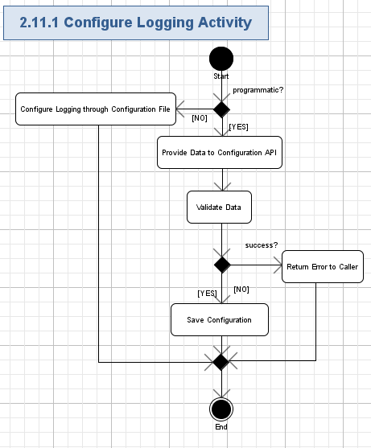

Provide Data to Configuration API
- The application will provide the API where the user can provide the data to.
- The format of the path is like following:
Data Element | Description | Format | R?
Path | The full file path to the logging file (including location and file name).  It should be a valid file. | String, max 1024 chars, non empty. | Y

Validate Data
- The application will automatically validate the provided data according to table 2.11.1.1.

Return Error to Caller
- If the validation failed, then the error will be returned to the caller to indicate that the provided data is invalid.

Save Configuration
- The application will save full path of the logging file that will be used to store the logging entries.

Configure Logging through Configuration File
- The user can configure the path directly in the configuration.
- It is assumed that the entered file path will follow the rules specified in 2.11.1.1.

Get API Documentation [External]
The users will be able to peruse and view documentation for any API within the tool. Such information as “purpose”, “parameter documentation”, and optionally “usage examples” would be part of this documentation.
Conceptualization Reference: 4.4.12 Get API Documentation
- Pre-conditions: the user requested to get API document from the application.
- Post-conditions: the user got the API document successfully.

Perform Logging
The system will automatically log errors, exceptions, warnings and debug information during its execution. Logging information will be stored to some logging system (like files on the server side). This use case is included by all other use cases.
Conceptualization Reference: 4.4.13 Perform Logging
- Pre-conditions: the application was started and it will constantly log all problems during its execution.
- Post-conditions: all errors, exceptions, warnings and debug information were logged to logging system (like log files).

Perform Logging Activity
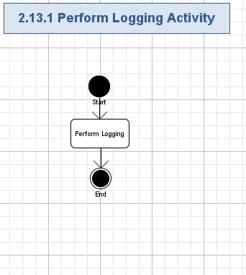

Perform Logging
- The system will log all the errors, exceptions, and warning and debug information during the application execution (together with date/timestamps of occurred problems’ moments).
- The following data will be logged:
  - Method name (String, max 100 chars, non empty),
  - Description of problem (String, max 1024 chars, non empty),
  - Input arguments (if any, String, max 4096 chars, can be empty),
  - Output results (if any, String, max 4096 chars, can be empty),
  - Date and timestamp (String, full date/time format, max 30 chars, non empty),
  - Etc. – up-to Architect.
- It is needed for further maintenance, support and improvement of the application.
- Some sort of the logging system (like just files) is needed for storing this logging information.
- The file, which will hold the log entries, will be stored in a configurable path.

General Requirements

Graphical User Interface Requirements

Main GUI Goal
This application will be a standalone application and does not have any GUI.

Resolution
N/A

Supported Browsers

N/A

Performance Constraints
User Metrics Requirements:
- There could be up to 15 users using the tool concurrently.
- In is assumed that a total of 15 users will be utilizing the application.

Security

Security Roles

Permissions
The application will not be secured through authentication/authorization. There will be no user identity in the system.

Roles
There is two user roles (Technical User and Calling application ) for the whole application. The System user role was added for clarity.

 | Calling Application | Technical User | System
2.1 Format Date/Time | X
2.2 Convert Date/Time | X
2.3 Localize Date/Time | X
2.4 List all Available Date/Time Formats | X
2.5 List all Available Date/Time Systems | X
2.6 List all Available Locales | X
2.7 List all Available Time Zones | X
2.8 Obtain Current System Time | X
2.9 Manage Date/Time Systems |  | X
2.10 Manage Date/Time Formats |  | X
2.11 Configure Logging |  | X
2.12 Get API Documentation [External] |  | X
2.13 Perform Logging |  |  | X

Required Documentation

Specification Documentation
- Requirements Specification (this document)
- High Level Use Case Diagrams
- Activity Diagrams
- Logical data model (as needed)
- Quality Assurance Plan (out of scope for this competition)

Help / User Documentation
None at this time.

Notes
None at this time.

Future Enhancements
None at this time.

Glossary

Definitions

Definition | Description
Date System | This is basically a calendar system. An example would be Coptic, Arabic, Gregorian, or Julian calendars.
VB6 | http://en.wikipedia.org/wiki/VB6
VC++ | http://en.wikipedia.org/wiki/VC%2B%2B
Locale | http://en.wikipedia.org/wiki/Locale
JAVA | http://en.wikipedia.org/wiki/Java_%28programming_language%29
Time Zone | http://en.wikipedia.org/wiki/Time_zone
Technical User | This is the user who will use the tool. In fact this is an aggregate user who will include developers, testers, and other technical users. This has been aggregated into a single user to simplify the diagram.
Calling Application | This is the actual caller of the API. This could be an external system as well as a simple testing program.
BC | Before Common Era  Years are designated as before the Christ's birth.
AD | Years are designated as after the Christ's birth.
AM | Before noon
PM | After noon

Acronyms

Definition | Description
API | Application Programming Interface: http://en.wikipedia.org/wiki/API
GUI | Graphical User Interface.
JVM | Java Virtual Machine

