NAME: EZEOGU CHUKWUEMEKA DANIEL
TITLE: DOCKER PRACTICAL ASSIGNMENT, BUILDING, RUNNING AND DEPLOYING A CONTAINERIZED WEB APPLICATION
DATE: 22-01-2026
1. Introduction
This project demonstrates the installation and use of Docker to build a custom Docker image for a simple static web application. The project covers building and running a container, creating a Docker Compose file to run multiple services, pushing the image to Docker Hub, and pulling and running the image on a new server.
2. Tools and Technologies used
Bullet points:
Amazon EC2(Amazon Linux2)
Docker
Docker Hub
SSH
3. Building a Custom Docker Image
Creating the Web Application:
A simple static HTML file was created to serve as the web application. The file displays a basic message to confirm the container is running successfully.
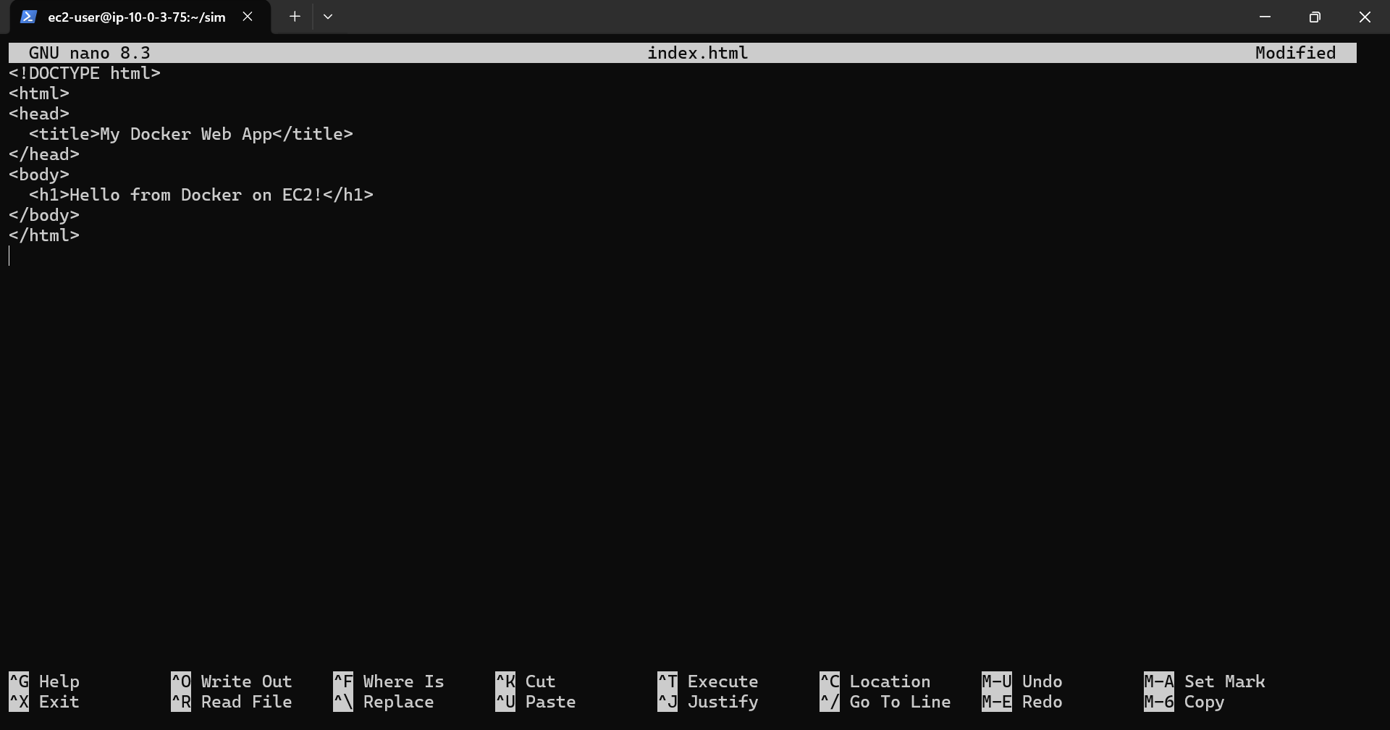
Docker File:
This Dockerfile uses the Nginx base image and copies the static HTML file into the Nginx web directory. Port 80 is exposed to allow HTTP access.
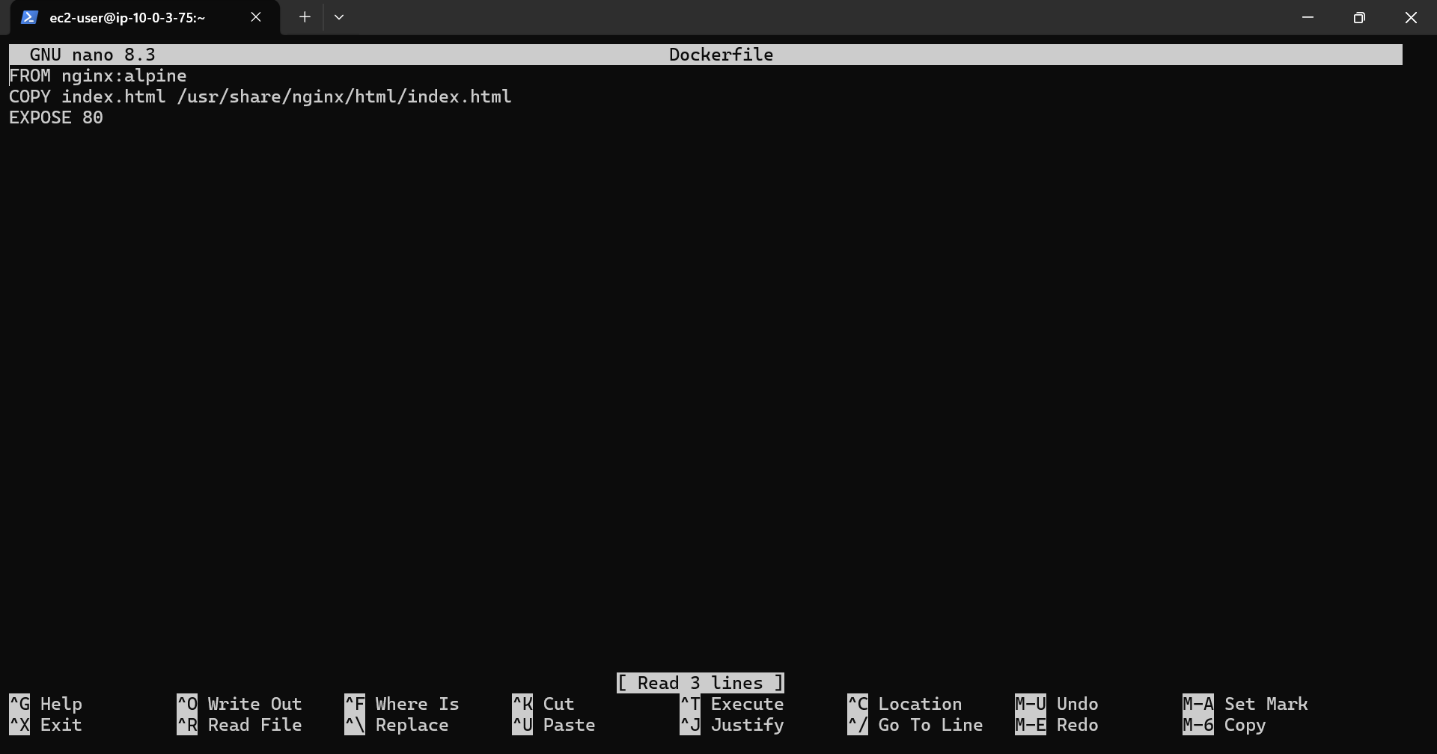
4. Build and Run on EC2
docker build -t simple-web-app .
docker run -d -p 80:80 simple-web-app
