RAPID FORMATIVE UX EVALUATION
Tablé Usability Tests and User Interviews
Four-participant evaluation of the diner mobile experience and merchant web dashboard
Participants: P01 (internal Product/UX tester) and P02-P04 (external peer testers)
Evaluation dates: 24-26 July 2026
Surfaces: Responsive mobile interface and local merchant web dashboard
Purpose: Identify actionable usability issues in the end-to-end diner and merchant workflows

Executive Summary
Four participants evaluated Tablé across the diner-facing mobile interface and the merchant web dashboard. P01 acted as the internal Product/UX tester, while P02, P03, and P04 represented external peer testers. All four completed the principal workflow from restaurant discovery to booking and from merchant campaign creation to offer acceptance.
Most important result: The end-to-end value proposition worked, but the mobile experience was undermined by severe readability failures and unclear product positioning. All four participants found that the registration screen did not explain the restaurant-booking purpose and that transparent surfaces caused overlapping or unreadable text. The three external testers then identified different secondary concerns around immediate-booking semantics, cross-screen feedback, and information reliability.

- Functional strengths: restaurant search, booking, cancellation, inventory restoration, Flash Deal creation, offer acceptance, and merchant-side tracking formed a coherent cross-platform loop.
- Shared mobile issue (4/4): transparent overlays, overlapping layers, and dark text on dark imagery made content difficult or impossible to read, especially in Dark Mode.
- Shared first-use issue (4/4): the registration experience did not clearly communicate that Tablé helps diners find immediately available restaurant tables.
- External-test pattern: P02 focused on immediate-departure and future-time planning; P03 focused on navigation continuity and action confirmation; P04 focused on preference clarity and merchant-state reliability.
- Merchant strength: the dashboard was considered clear and operationally useful; Predicted Busyness and RevPASH were understood.
- Merchant issue: live campaign metrics updated while Campaign History remained stale until a full refresh.

1. Evaluation Scope and Method
The evaluation used a rapid, outcome-focused format. Participants were asked to complete realistic tasks while describing their expectations, points of hesitation, and interpretation of system feedback. The report preserves the original task structure but consolidates repetitive observations into evidence-backed findings.

1.1 Included evidence
- First-use comprehension, navigation, search, filtering, restaurant comparison, booking, cancellation, preferences, bookings, Inbox offers, merchant campaigns, reservations, and settings.
- Participant comments, observed behaviour, cross-platform state changes, and screenshots demonstrating key strengths or usability problems.
Uncollected ratings or demographic details are marked as not recorded.

2. Participant P01 - Internal Test and Interview

2.1 Basic Information
Participant ID: P01
Role: Internal tester; Product and UX Lead
Test date: 24-26 July 2026
Available devices: iPhone 16 (iOS 18.5) and MacBook Air M3
Mobile evaluation surface: Responsive mobile viewport in Google Chrome 149
Web evaluation surface: Local merchant dashboard in Google Chrome 149

2.2 Mobile Test

M1. Product Purpose and Navigation
P01 could identify the sign-in page and bottom navigation. However, the brand name Tablé and the phrase "Find your table" did not immediately establish a restaurant-booking context for a non-native English speaker. The word "table" could refer to furniture, a dining table, or a data table. P01 recommended adding a direct value statement such as "Discover restaurants with tables available now."
Finding: The first screen needs to communicate restaurant discovery and immediate table availability without relying on cultural or linguistic inference.

M2. Location, Discovery, Search, and Comparison
Restaurant cards in Discover clearly presented restaurant name, cuisine, free-table count, and Quiet/Busy status. Search and filters made a specific restaurant easy to locate. P01 nevertheless found that Map and Discover could present different location contexts, weakening trust in whether the restaurant list represented the visible map area.
- Positive: restaurant cards supported fast scanning and comparison.
- Issue: the selected restaurant shown under the map could not be opened directly, forcing a manual return to Restaurants to continue the booking journey.
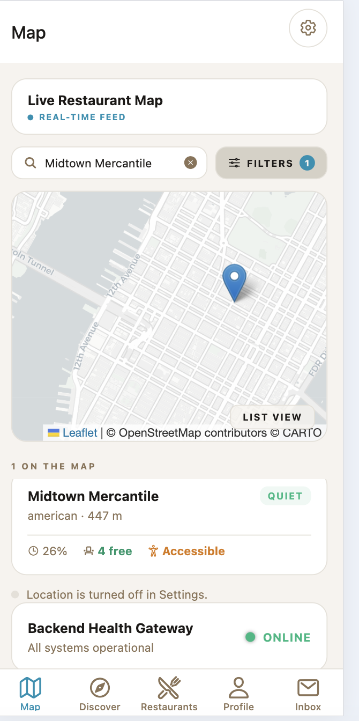
Figure 1. The selected Midtown Mercantile result is visible below the map, but the user could not open it to resume booking.

M3. Restaurant Details and Booking
P01 immediately recognised the restaurant detail page and found the Book Table entry point. Distance, accessibility, available tables, and Quiet status were considered useful decision information. The booking flow displayed Walking, Driving, Transit, and Bicycling options together with ETA and a 15-minute hold window.
- Positive: the core restaurant and travel information was understandable.
- Issue: booking and settings overlays were visually transparent, causing modal text and controls to overlap the restaurant card and underlying navigation.
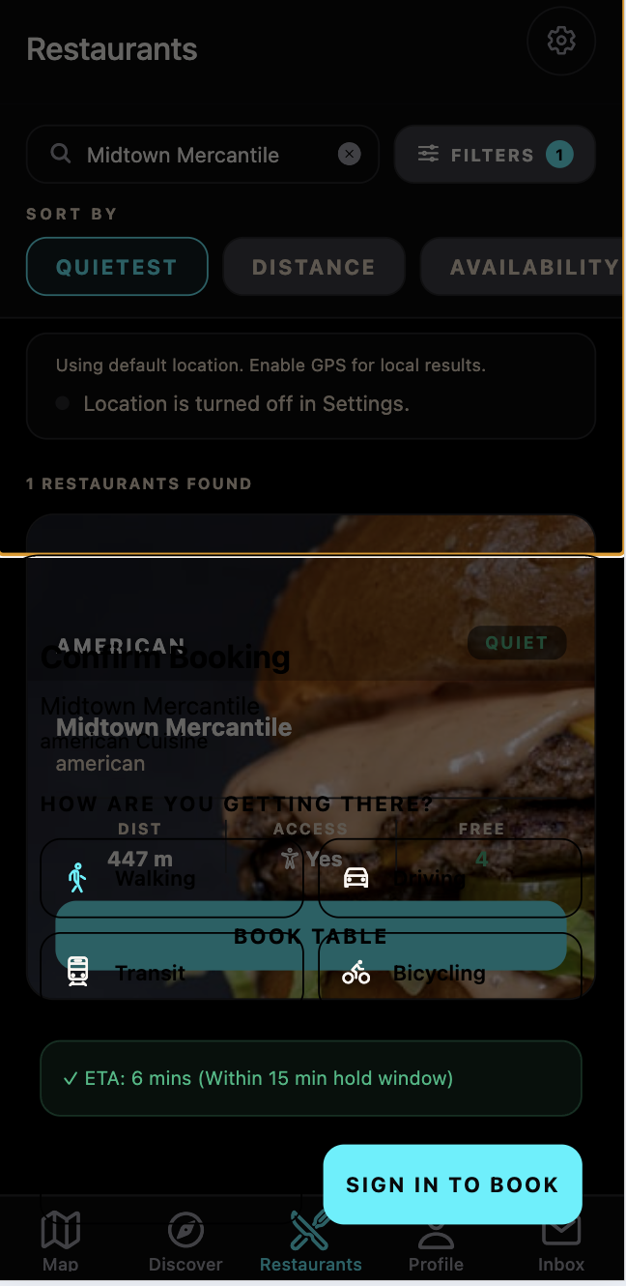
Figure 2. The booking overlay blends with the restaurant image and underlying text, making labels and controls difficult to distinguish.
The same layering problem became substantially worse in Dark Mode. Settings content overlapped the profile page and was nearly unreadable. This was treated as one repeated visual defect rather than several separate findings.
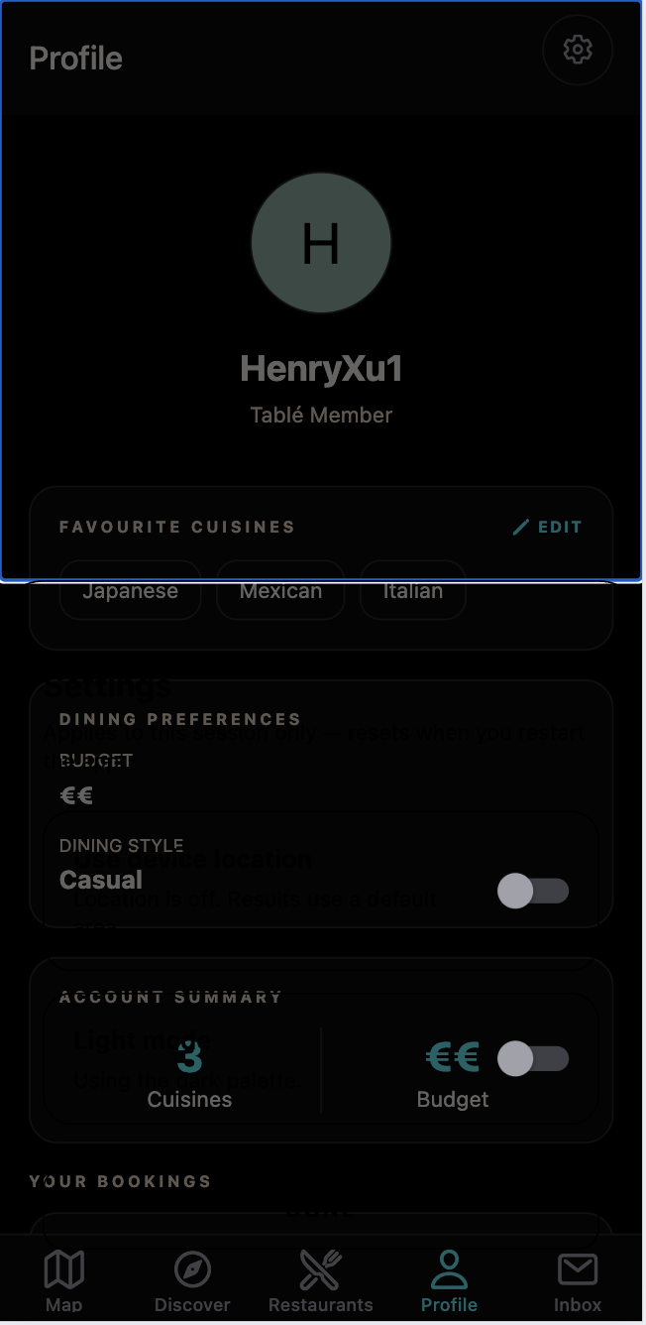
Figure 3. Dark Mode magnifies the overlay problem: settings text and controls merge with the profile content underneath.

M4. Booking Confirmation, Profile, and Cancellation
After booking Midtown Mercantile, the available-table count decreased from four to three. Profile then displayed a confirmed booking with restaurant, time, Walking, ETA, and a cancellation control. Once cancellation was confirmed, Profile immediately showed Cancelled and the restaurant inventory returned from three to four.
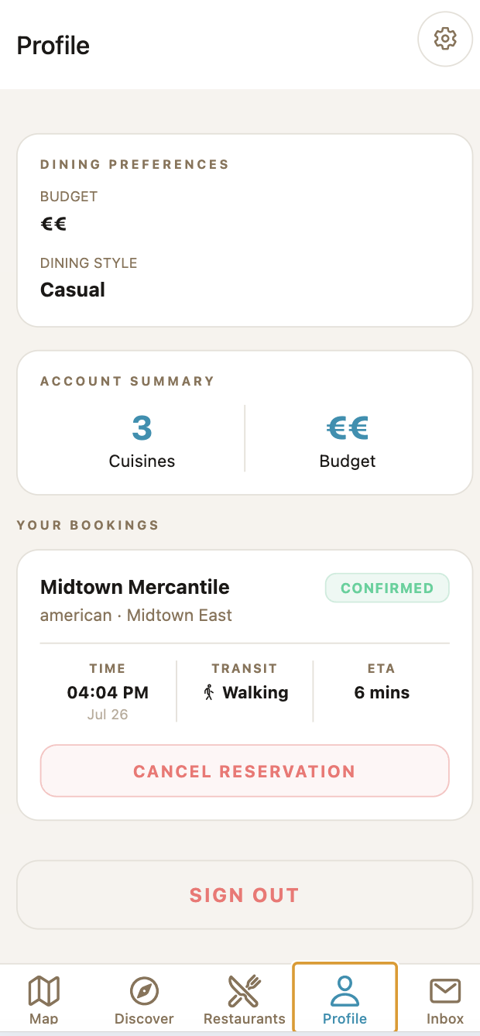
Figure 4. Profile provides a complete confirmed-booking record, including time, transport mode, ETA, and cancellation action.
Positive result: Booking, booking visibility, cancellation, and inventory restoration formed a successful and understandable operational loop.

M5. Preferences and Inbox
Cuisine preferences were easy to add and persisted after refresh. Dining Style options were understandable. The price preference used only euro-symbol counts; P01 correctly inferred that more symbols meant a higher price, but the design required an unnecessary guess. Text labels such as Affordable, Moderate, and Premium or explicit price ranges would reduce ambiguity.
Inbox correctly explained that personalised Flash Deals appear when nearby restaurant promotions match the user's preferences. When an offer was available, the card clearly showed the restaurant, discount, expiry countdown, and Claim Offer action.
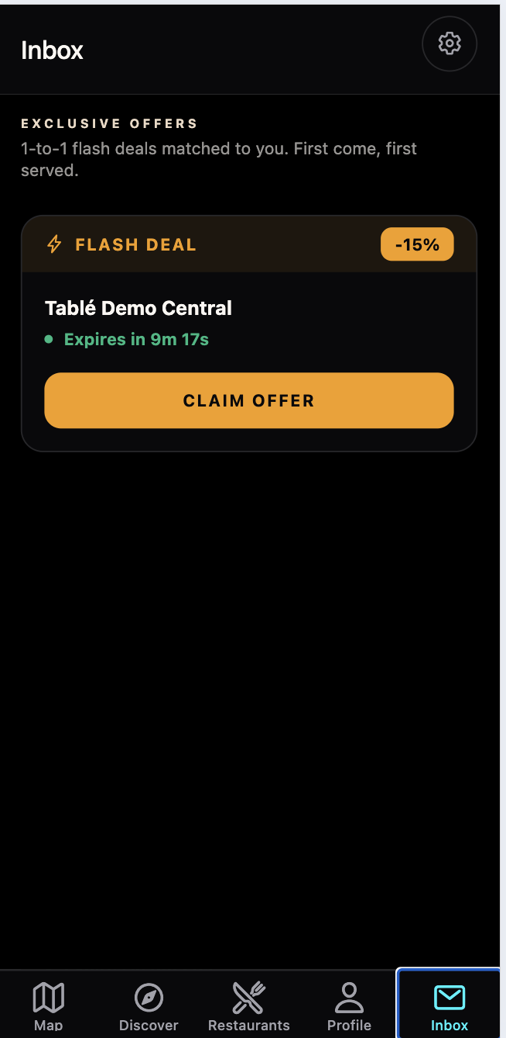
Figure 5. A personalised 15% Flash Deal is visually prominent and includes a clear expiry countdown.
P01 expected Claim Offer to save or obtain the discount for later use. Instead, the action immediately created a confirmed booking and selected Walking by default. The offer disappeared from Inbox without a persistent in-page confirmation; the participant discovered the booking only after opening Profile.
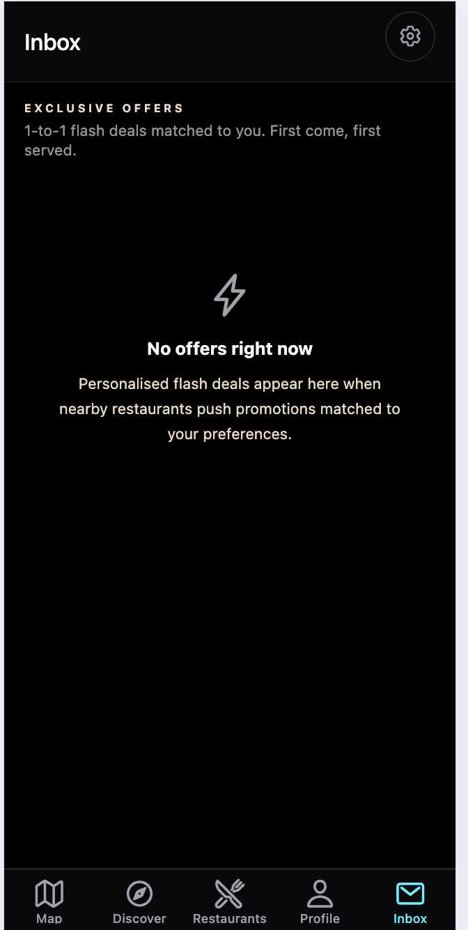
Figure 6. Immediately after claiming, Inbox returns to the empty state without explaining that a booking was created.
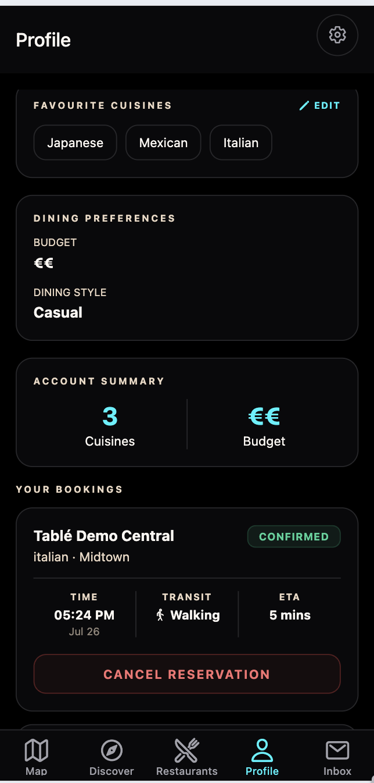
Figure 7. Profile reveals that claiming the offer created a confirmed booking with Walking and a five-minute ETA.
Finding: Claim Offer does more than its label implies. The interface should disclose that the action will book immediately, show the travel mode and hold window, and provide a persistent success state with View Booking and Cancel options.

2.3 Mobile Interview Findings
Most valuable feature: A restaurant can send a targeted Flash Deal, and a matched diner can accept it within a limited period to secure a discounted table.
Most uncomfortable aspect: Overlapping and low-contrast text, particularly in transparent overlays and Dark Mode.
Least trusted information: ETA accuracy was uncertain; the test confirmed comprehension of the ETA presentation, not real-world route accuracy.
Top fix: Resolve readability and overlay layering before other refinements.
Overall satisfaction: 4/5
Likelihood to recommend: 7-8/10 (recorded midpoint: 7.5)

2.4 Merchant Web Test

W1. Overview and Metric Comprehension
P01 could immediately identify the restaurant, Predicted Busyness, and RevPASH. Predicted Busyness was understood as a forecast of future demand, while RevPASH was correctly understood as revenue per available seat-hour. The missing element was a clear forecast time window and last-updated context for Predicted Busyness.
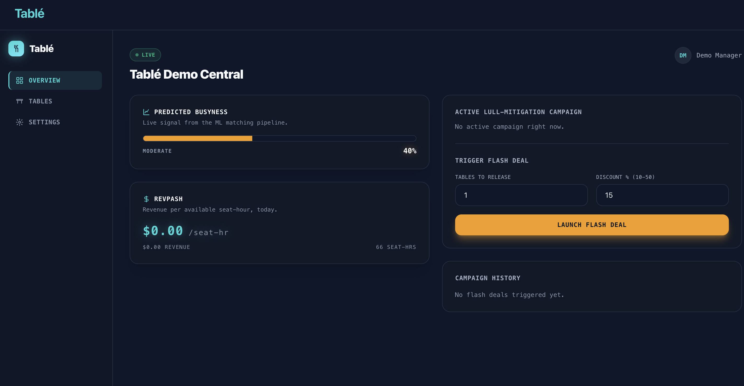
Figure 8. The merchant Overview presents Predicted Busyness, RevPASH, campaign creation, and history in a clear operational layout.

W2. Flash Deal Creation and Live Tracking
P01 understood that Tables to Release and Discount would be used to fill otherwise empty capacity. Before launch, the interface did not explain which customers would receive the offer or provide an estimated audience. After launch, Active Campaign and Live Offer Tracker clearly showed recipient-level status.
- Positive: recipient names and Pending/Accepted states made the campaign operationally transparent.
- Issue: the countdown lacked a label such as Expires in, so a value such as 14:39 was interpreted as waiting time.
- Issue: Active Campaign and Live Offer Tracker updated automatically, but Campaign History remained at 0/2 claimed until a full refresh, contradicting the current 1/2 and Accepted states.
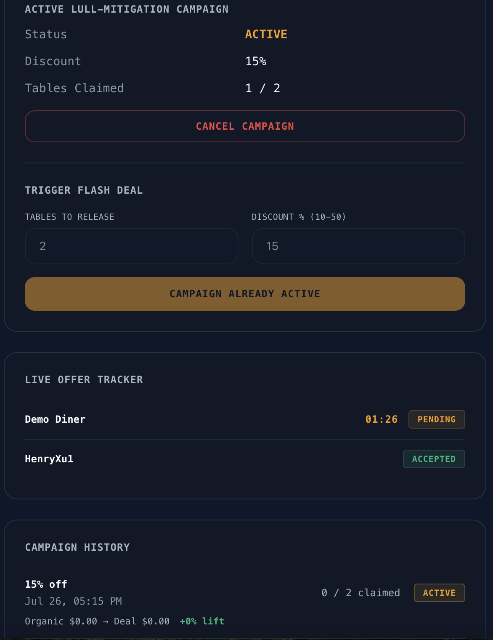
Figure 9. Active Campaign and Live Offer Tracker show 1/2 claimed and Accepted, while Campaign History still reports 0/2 claimed.
Finding: Conflicting values on one screen reduce trust in campaign reporting. Campaign History should refresh with the active campaign and tracker.

W3. Tables, Reservations, and Settings
The Tables page was easy to understand. It showed current occupancy, the diner name, Flash Deal origin, ETA, status, and operational actions in one place. The reservation created by the C-side claim was visible without manual reconciliation.
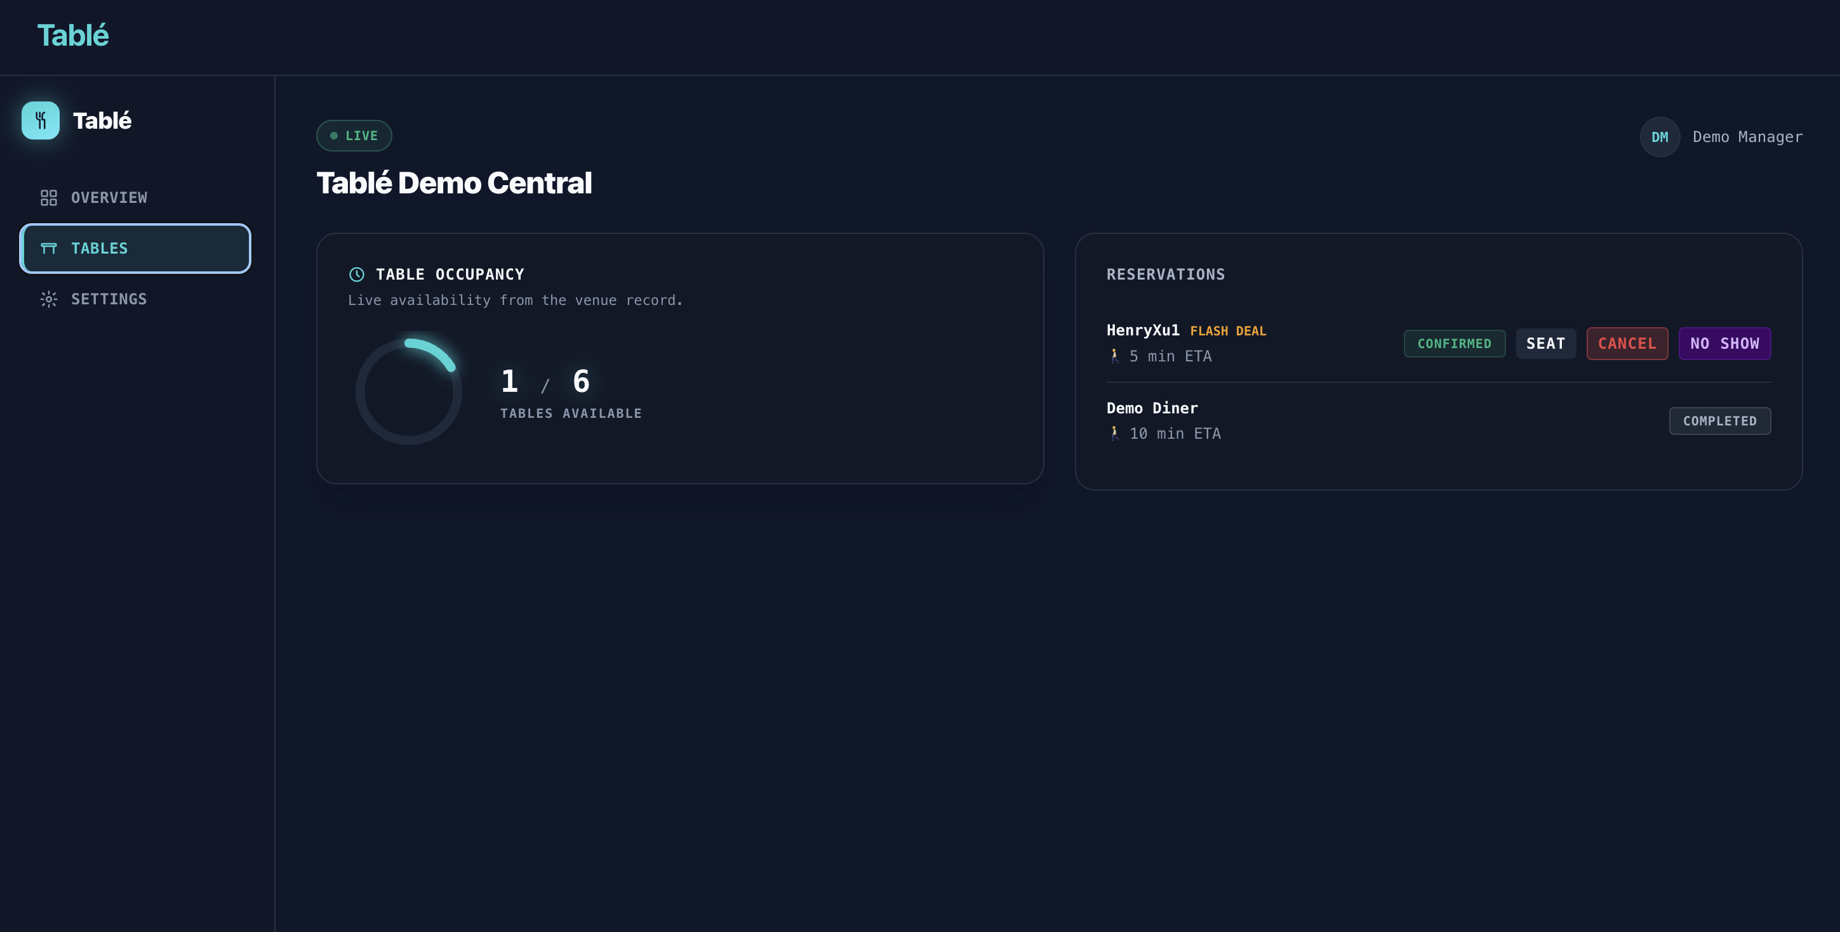
Figure 10. The Tables page clearly connects availability with the accepted Flash Deal reservation and operational actions.
Accessibility settings were understandable. Save Changes was disabled before modification and enabled after a change; the saved value persisted after refresh. The remaining issue was the absence of a success confirmation after saving. Cancel Campaign also executed immediately without confirmation, creating avoidable risk for an irreversible campaign action.

2.5 P01 Summary
- The complete cross-platform workflow was functionally successful.
- Mobile readability was the dominant usability failure and affected core tasks.
- Booking and Claim semantics should state whether the user is making an immediate reservation and should leave now.
- Merchant information architecture was strong, but live and historical campaign states must remain synchronised.

3. Participant P02 - External Test and Interview

3.1 Basic Information
Participant ID: P02
Role: External peer tester; student
Test date: 26 July 2026
Mobile evaluation surface: Responsive mobile viewport in Chrome on Mac
Web evaluation surface: Local merchant dashboard in Chrome on Mac
Restaurant-app usage frequency: Not recorded
Quantitative ratings: Not collected; qualitative responses are reported without inferred scores

3.2 Mobile Test

M1. Shared First-Use and Readability Findings
P02 did not understand the app's purpose from the registration screen and initially interpreted it as a furniture application for finding a suitable table. The participant also encountered transparent panels that allowed page content to remain visible underneath, producing overlapping labels and poor contrast. Dark Mode made the problem substantially worse.
Participant statement: "I did not know what the app was for. I thought it was a furniture app for finding a suitable table."

M2. Discovery and Visual Tone
P02 completed restaurant browsing and comparison, but found dark restaurant-name text placed directly over dark imagery. Beyond legibility, the participant felt that both the diner and merchant experiences used a dark, technology-oriented style that appeared more corporate than hospitality-focused. The participant preferred a lighter, more relaxed dining tone while retaining the existing information hierarchy.
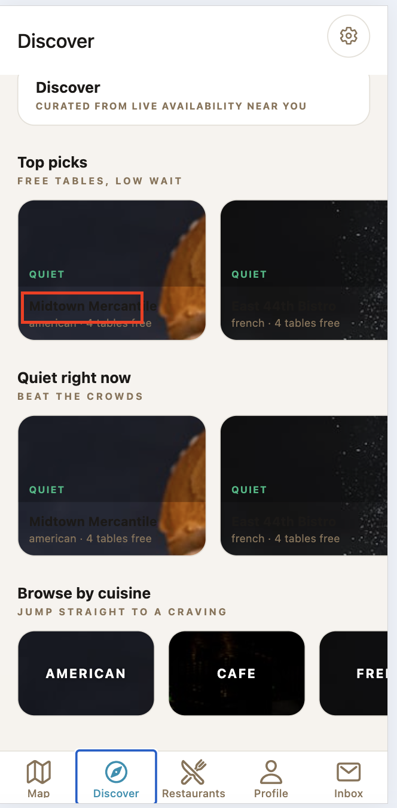
Figure 11. P02 identified dark restaurant-name text over a dark image, producing insufficient contrast even outside a modal.
Participant statement: "Dark text plus a dark background makes the text impossible to see. In Dark Mode, the transparent pages are even worse."

M3. Booking and ETA Semantics
P02 understood the current booking flow but questioned whether pressing Book meant they were expected to depart immediately. The participant also described a realistic planning scenario: when browsing for a meal later in the day, a current ETA does not help evaluate the future dining decision.
Participant statement: "When I booked a table, I was unsure whether I had to leave immediately. If I want to look at restaurants for later, the current ETA is not useful."

- Current MVP issue: the interface must clearly label immediate booking, hold-window timing, and departure expectation.
- Future product opportunity: support scheduled discovery or future-time availability, while keeping it separate from the immediate-booking MVP.

M4. Profile, Bookings, and Inbox
P02 completed the end-to-end diner flow and could find confirmed reservations in Profile. No additional navigation blocker was recorded. The principal hesitation remained whether Book or Claim Offer created an immediate reservation and whether the diner should leave at once.

3.3 Mobile Interview Findings
Problem understood after use: Helping diners find available restaurant tables and helping restaurants fill quiet capacity.
Information concern: Current ETA does not support a later dining plan.
Main hesitation: Whether Book requires immediate departure.
Priority improvement: Fix display readability and clarify product and action semantics.
Qualitative satisfaction: Overall use was acceptable.
Qualitative adoption intent: Willing to use the product as a diner after display and semantic improvements.

3.4 Merchant Web Test

W1. Dashboard and Metrics
P02 considered the merchant dashboard simple and clear. The participant could understand Busyness and RevPASH and did not report a task blocker in Overview, Tables, Reservations, or Settings.
Participant statement: "The B-side dashboard is generally well designed, simple, and clear. I can understand Busyness and RevPASH."

W2. Flash Deal and Operational Flow
P02 completed the Flash Deal workflow and understood its value: restaurants can release discounted capacity and matched diners can accept a limited-time offer. The participant's main criticism was not the dashboard structure but its visual tone and the lack of a clearer hospitality identity.
- Positive: the business logic and dashboard information were understandable.
- Design feedback: the dark, technology-oriented visual language felt more corporate than dining-focused.
- Recommendation: introduce a lighter, more relaxed hospitality tone while preserving the dashboard's clear information hierarchy.

3.5 P02 Summary
- Would use the diner product after display and semantic improvements.
- Ranked readability as the largest usability problem.
- Expected clearer restaurant positioning on the registration screen.
- Needed stronger wording around immediate booking and departure.
- Considered the merchant dashboard clear, but visually too technological and business-like for a dining product.

4. Participant P03 - External Test and Interview

4.1 Basic Information
Participant ID: P03
Role: External peer tester; student
Test date: 26 July 2026
Mobile evaluation surface: Responsive mobile viewport in Chrome on Mac
Web evaluation surface: Local merchant dashboard in Chrome on Mac
Restaurant-app usage frequency: Not recorded
Quantitative ratings: Not collected; qualitative responses are reported without inferred scores

4.2 Mobile Test

M1. Shared First-Use and Readability Findings
P03 could operate the registration controls but could not identify the product category from the first screen. The wording around Table and Find Your Table was interpreted without a clear restaurant context. During later tasks, transparent booking and settings surfaces caused foreground text to overlap restaurant cards and navigation labels, reducing confidence in which controls belonged to the active layer.
Shared finding: The registration screen needs a direct restaurant-booking value proposition, and modal surfaces need an opaque background with reliable theme contrast.

M2. Navigation Continuity and Map Results
P03 found restaurant search and filters easy to use. The participant expected a restaurant result shown beneath the map to open the corresponding detail or booking view. Because the result was not actionable, the participant had to switch manually to Restaurants and repeat part of the selection process.

Figure 12. P03 expected the restaurant result beneath the map to continue directly to details or booking.
Finding: Search results should behave consistently across Map, Discover, and Restaurants, with the restaurant card opening one shared detail and booking route.

M3. Offer Claim and Completion Feedback
P03 understood the Flash Deal card and expiry countdown. After selecting Claim Offer, however, the offer disappeared and Inbox returned to its empty state without explaining that a confirmed reservation had been created. The participant had to inspect Profile to discover the outcome.

Figure 13. After Claim Offer, the empty Inbox provides no success message, booking summary, or route to the new reservation.
The completed state was functionally correct in Profile, but the cross-screen transition was not self-explanatory. P03 expected an explicit success state containing restaurant, discount, time, travel mode, hold window, and View Booking action.

Figure 14. Profile confirms that the claim created a booking, but this result was not communicated on the preceding screen.

4.3 Mobile Interview Findings
Problem understood after use: Finding live restaurant availability and converting matched Flash Deals into reservations.
Main navigation concern: A restaurant selected on Map could not be opened directly.
Main feedback concern: Claim Offer completed a booking without a persistent confirmation on Inbox.
Priority improvement: Connect restaurant cards to one detail route and add explicit completion feedback after consequential actions.
Qualitative adoption intent: Would use the workflow if the interface made state transitions clearer.

4.4 Merchant Web Test

W1. Live Campaign Tracking
P03 understood Tables to Release, Discount, Active Campaign, and recipient-level Pending or Accepted states. The Live Offer Tracker made it possible to verify that the diner-side claim had reached the merchant side. The unlabeled countdown remained ambiguous and was initially read as elapsed or waiting time rather than time remaining.
- Positive: live recipient status supported operational monitoring without a manual refresh.
- Improvement: prefix the timer with Expires in and show the offer expiry timestamp.

W2. Reservations and Table Operations
The Tables page was considered straightforward because occupancy, diner identity, Flash Deal origin, ETA, reservation status, and service actions appeared together. P03 could connect the mobile claim to the merchant reservation without additional explanation.

Figure 15. P03 found the merchant Tables view clear because reservation status and operational actions were consolidated.

4.5 P03 Summary
- Shared the first-use product-purpose and transparent-overlay problems.
- Focused on broken continuity between Map results and the booking route.
- Expected a persistent success state after Claim Offer created a reservation.
- Considered live merchant tracking and reservation operations understandable.

5. Participant P04 - External Test and Interview

5.1 Basic Information
Participant ID: P04
Role: External peer tester; student
Test date: 26 July 2026
Mobile evaluation surface: Responsive mobile viewport in Chrome on Mac
Web evaluation surface: Local merchant dashboard in Chrome on Mac
Restaurant-app usage frequency: Not recorded
Quantitative ratings: Not collected; qualitative responses are reported without inferred scores

5.2 Mobile Test

M1. Shared First-Use and Readability Findings
P04 did not know from registration whether Tablé was a restaurant product, a furniture service, or another kind of table-related application. The participant also encountered the shared overlay defect: transparent edit and settings panels exposed the Profile content underneath, causing headings, choices, and account information to overlap.
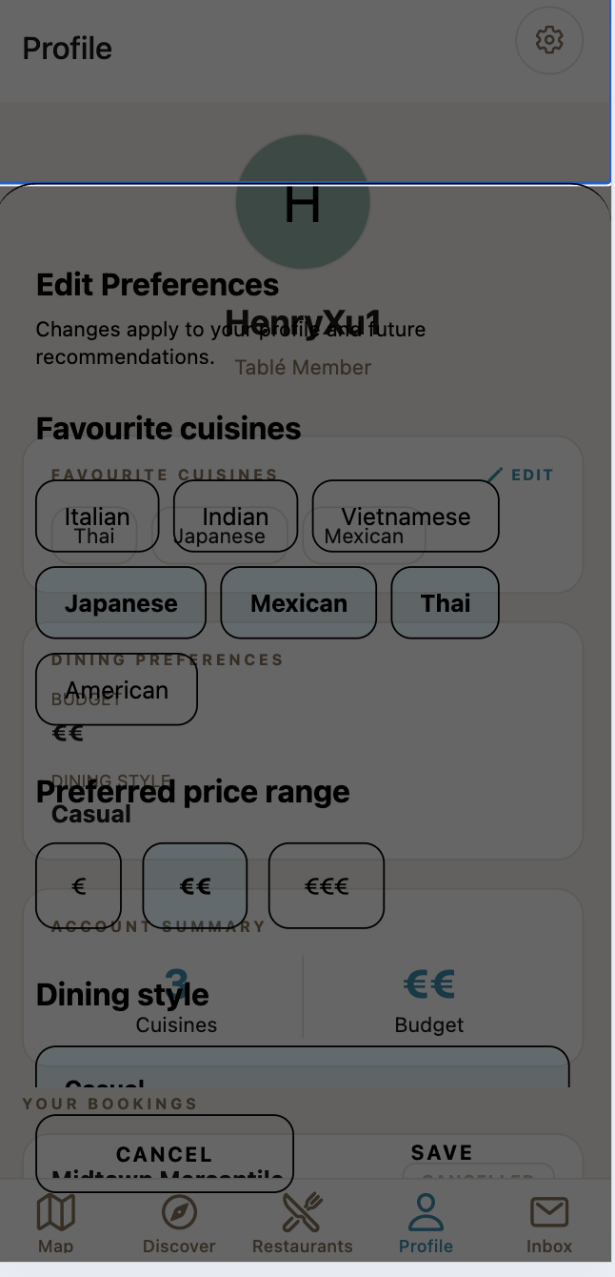
Figure 16. P04's preference-editing task demonstrates the shared transparent-layer defect and overlapping text.
Shared finding: The active modal must visually separate itself from the page beneath it in both Light and Dark modes.

M2. Preferences and Information Clarity
P04 found cuisine selection and Dining Style easy to understand, and saved preferences remained after refresh. The budget control used only one, two, or three euro symbols. The participant inferred that additional symbols meant a higher price, but wanted labels or ranges to remove the need to guess.
- Positive: selected cuisines and Dining Style were easy to review and edit.
- Improvement: pair euro symbols with Affordable, Moderate, and Premium or representative price ranges.

M3. Booking, Cancellation, and Inbox State
P04 could verify a successful booking in Profile and understood the cancellation confirmation. After cancellation, the status changed to Cancelled and restaurant availability returned immediately. The participant therefore trusted the underlying state change, but still wanted clearer success feedback when preferences were saved or an offer was claimed.
- Positive: booking and cancellation states were visible and inventory was restored.
- Issue: successful saves and offer claims did not consistently acknowledge what changed or where to go next.

5.3 Mobile Interview Findings
Problem understood after use: Matching diners with available restaurant capacity and time-limited offers.
Most useful information: Quiet or Busy status, free tables, distance, accessibility, and booking status.
Main information concern: Symbol-only budget levels and inconsistent success feedback.
Priority improvement: Make overlays readable and replace inferred meanings with explicit labels and confirmation states.
Qualitative adoption intent: Positive toward the concept once the product purpose and information labels are clearer.

5.4 Merchant Web Test

W1. Metric and Campaign Comprehension
P04 understood Predicted Busyness as future demand and RevPASH as revenue per available seat-hour. The campaign controls were also understandable, but the participant wanted a forecast time window, last-updated time, and an estimated recipient audience before launch.
- Positive: the Overview hierarchy and principal metrics were easy to scan.
- Improvement: explain the prediction horizon and likely offer audience before the merchant commits.

W2. Data Consistency and Action Feedback
P04 focused on confidence in merchant-side state. Active Campaign and Live Offer Tracker updated to 1/2 claimed and Accepted, while Campaign History still showed 0/2 claimed until a full refresh. The participant also noted that Settings saved successfully without a success message and that Cancel Campaign executed without a confirmation step.

Figure 17. P04 identified conflicting live and historical campaign values on the same dashboard.
Finding: Merchant trust depends on synchronised campaign data and explicit confirmation for saves and destructive actions.

5.5 P04 Summary
- Shared the first-use product-purpose and transparent-overlay problems.
- Focused on preference labels, successful-state feedback, and information confidence.
- Considered the mobile booking and cancellation state model functionally reliable.
- Expected live and historical campaign values to remain synchronised.

6. Cross-Participant Synthesis
The four evaluations produced a consistent pattern. The product's functional loop and merchant logic were understandable, but the mobile visual system and product language created avoidable uncertainty at the moments that mattered most. All participants encountered the same first-use positioning and overlay-readability failures; the three external testers then exposed different secondary weaknesses in booking semantics, navigation continuity, completion feedback, preference labels, and campaign-state confidence. Because the sample size was four, the findings remain directional and should guide iteration rather than be treated as statistically generalisable evidence.

6.1 Shared Strengths
- All four participants completed the principal diner and merchant workflows.
- Restaurant status, free-table information, Flash Deal value, and merchant operational controls were generally understandable.
- The merchant dashboard's information hierarchy was considered clear.
- The booking, cancellation, inventory, offer, and reservation states could be verified across the two product surfaces.

6.2 Prioritised Findings
Rank | Finding | Evidence | Recommended action
1 | Transparent overlays, overlapping text, and dark text on dark imagery make mobile content unreadable, especially in Dark Mode. | P01-P04 (4/4) | Use opaque theme surfaces, correct modal layering, stronger image scrims, and WCAG AA contrast regression tests.
2 | The registration screen does not clearly establish a restaurant and immediate-table context; Table can be interpreted as furniture. | P01-P04 (4/4) | Add a direct restaurant value proposition and restaurant imagery or availability content on the first screen.
3 | Book and Claim Offer do not clearly disclose immediate reservation, default travel mode, hold window, or departure expectation. | P01-P03 (3/4) | Use Claim & Book Now, show the commitment summary before confirmation, and provide a persistent success state.
4 | Restaurant results and completion states do not always provide a clear next step across Map, Inbox, and Profile. | P01 + P03 | Open one shared restaurant-detail route and show persistent success feedback with a direct next action.
5 | Campaign History can contradict the live campaign and tracker until a full refresh. | P01 + P04 | Refresh or invalidate Campaign History whenever active campaign or recipient state changes.
6 | High-consequence actions and saves do not always provide sufficient confirmation. | P01 + P03 + P04 | Confirm campaign cancellation and show success feedback after settings saves and offer claims.

6.3 Product Opportunities
- Clarify the MVP promise: available restaurant tables for dining now, with an explicit hold window and travel expectation.
- Explore a separate future-time browsing or scheduled-reservation mode for diners who are not ready to leave immediately.
- Retain the merchant dashboard's clarity while softening the visual language toward hospitality and dining.
- Label Predicted Busyness with its forecast window and last-updated time, and label offer countdowns as time remaining.

7. Conclusion
Tablé demonstrated a viable end-to-end proposition: restaurants can act on quiet capacity, matched diners can receive a time-limited incentive, and the resulting reservation is visible on both sides. All four participants understood and responded positively to this core value after completing the workflow. Release readiness, however, depends first on making the restaurant-booking purpose explicit and resolving the mobile overlay and contrast failures. Clearer commitment language, navigation continuity, and synchronised feedback would then remove the remaining barriers to comprehension and confidence without changing the underlying product logic.
Release recommendation: Fix mobile contrast and overlay layering first; clarify restaurant positioning and immediate-booking copy second; synchronise campaign history third; then add confirmation and save feedback.

