January 27, 2021

## Tailwind Labs

Kitchener, ON, Canada

To Tailwind Labs,

I often go by “Chuck”. I’m extremely excited to have found this job posting while navigating the documentation on Tailwind CSS and I’m thrilled to be applying for the lead designer position in your company. After reviewing the job description and requirements, I can clearly see that the opportunities that you provide in that position are things that I am looking to engage in professionally. I believe that I’m a perfect candidate to help push your company up to the next level while improving my ability for designing amazing products for people to use.

I started working in web development about 6 years ago and it was due to a goal to benefit the lives of others in an impactful way. I originally went to school to become a doctor, so I have a lot of medical training and although that path has changed, my passions about being on the cutting edge and making things that positively impact the lives of others haven't changed one bit. I really enjoy learning and creating new things which is why I love wearing multiple hats in a company. it allows me to learn from multiple facets and I pride myself in identifying inefficiencies in systems and coming up with creative solutions to mitigate those inefficiencies.

I was an art major in high school and continued to study art deep into university and worked on various projects (personal and professional) like typography videos, 3D animations, video game art, tattoo design, graphic design, creating more short youtube skits than you shake a stick at, playing 7 instruments and speaking 3 languages. And throughout all those ventures I’ve come to understand how the design of things impact the people who use them.

In my years in the field, I found that a big part of why technology tends to be horrible for people to use isn’t usually due to bad functionality but rather because of bad communication of that functionality, or UI/UX. So the past 4 years of my web development energy has been spent on not only helping manage the company I worked for become more efficient but also in offering new, exciting, creative and aesthetically pleasing solutions to our clients with a big emphasis on design oriented development because I believed it would be a major proponent to our success and it has proved to be so! The CEO of the Company entrusted me with building and managing a small design/development team so that the company could offer new products: reusable and modular web apps and mobile apps. The goal was to produce visually appealing products for our clients and as well as to revamp the products we already offer with refreshing and invigorating UI/UX. And now it stands as a major part of the company’s revenue. I spent a lot of time finding ways to push the company to the next level and organizing meetings with the CTO and CEO to accomplish them.

At Boru, Inc. I quickly moved into becoming the company's PHP Developer to Product Manager to Principal Designer and Solutions Architect, responsible for managing the company's internal products and solutions and client facing projects. And I loved every step of it. But there was still a part of me that loved to design so I started teaching, and have taught for 2 years, Web Development with an emphasis on UI/UX design which I do for free in my spare time about 3 times a week for up to 3 students a year. And it's been wildly successful, as I’ve helped people into the field of tech and design and they’ve gone on to do amazing things.

I enjoy the work I do and being able to make the impact that I’ve made and I am glad that it opened up the opportunities it did for me however I want to keep pushing myself to grow as a designer because I believe I’m quite adept at the back end part of my job as a developer/solutions architect but I really want to push my eye for design further and be on the cutting edge of web design so I am looking for jobs that facilitate a focus on design and I’m using Tailwind CSS for my current project and I just happened to notice that you guys were hiring a lead designer so I think I have a lot to offer to the company as a designer while still bringing forth enough initiative to help push the company into newer heights.

Thank you for your time and consideration. I hope we can talk soon about the opportunity!

**Chukwuma “Chuck” Okere**

Some of the awesome things I’ve created below:

* Messaging App
  + An app/web client that was created for Complete Ortho (<https://www.cortho.org/>), a doctors office that uses telephony services to contact and interact with their customers. I created this software for them to manage their communications with customers. It integrates with Twilio to support calling, SMS/MMS and sending emails to their contacts. This one uses Tailwind CSS actually! I coded this as a solo project after hours and sold it to the client to manage their SMS conversations and added functionality to call the contact and email the contact from the UI.

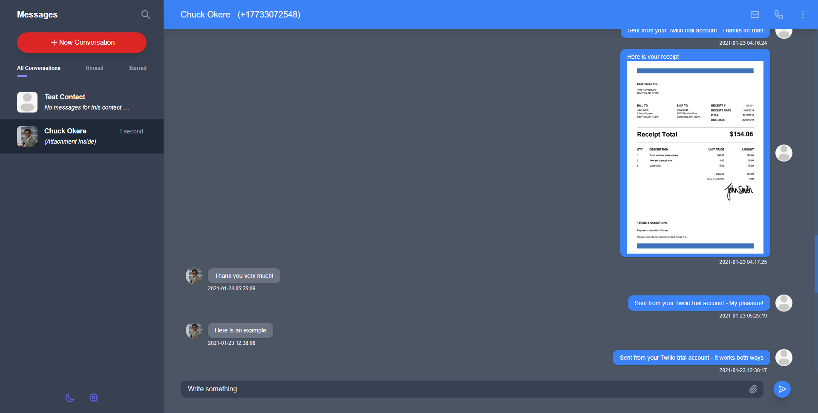

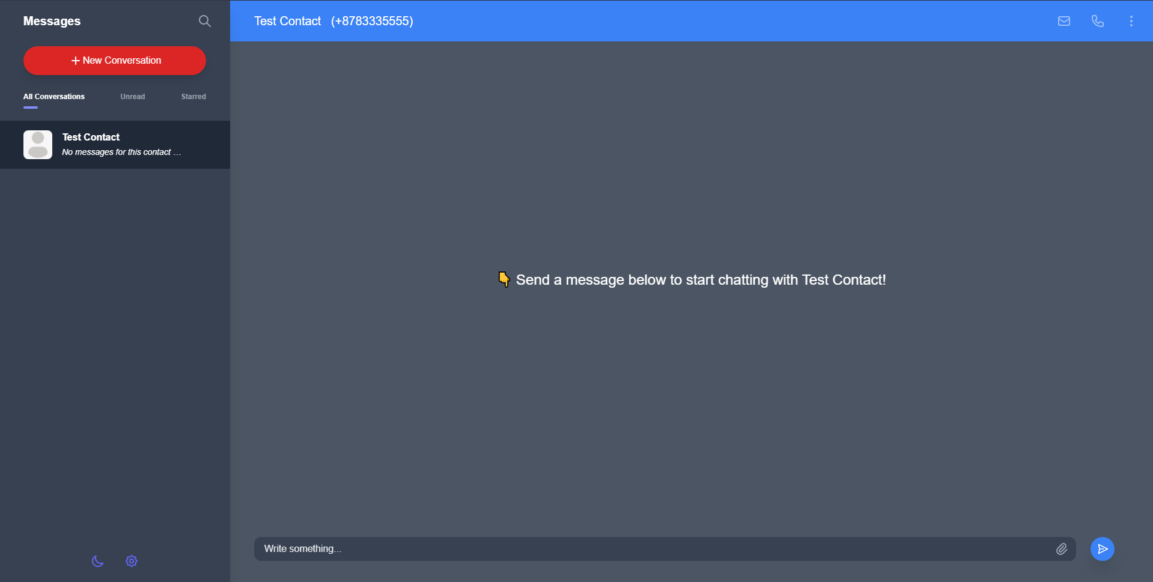

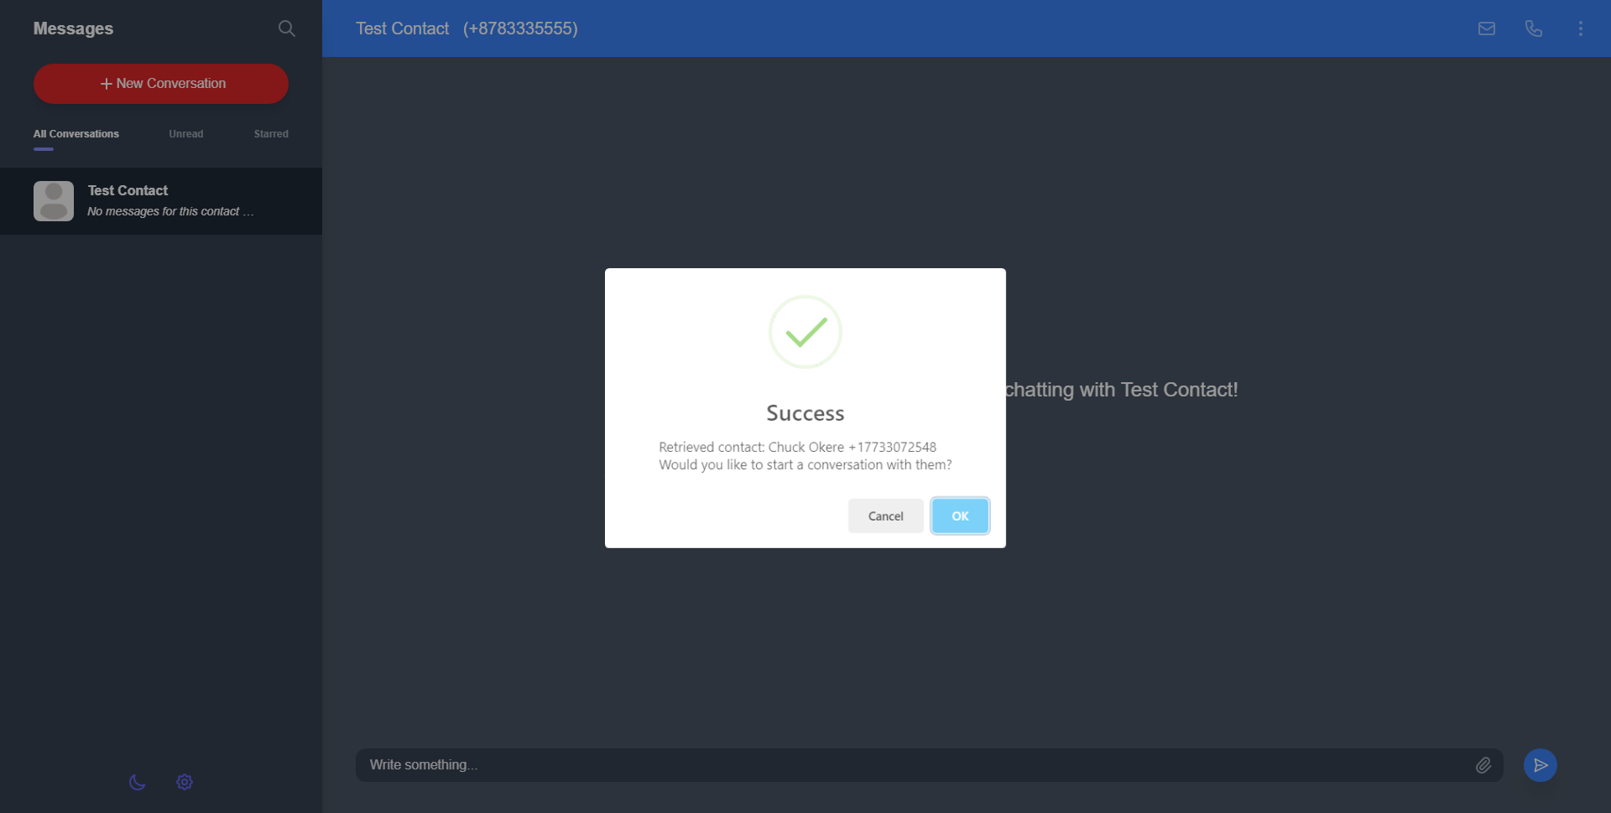

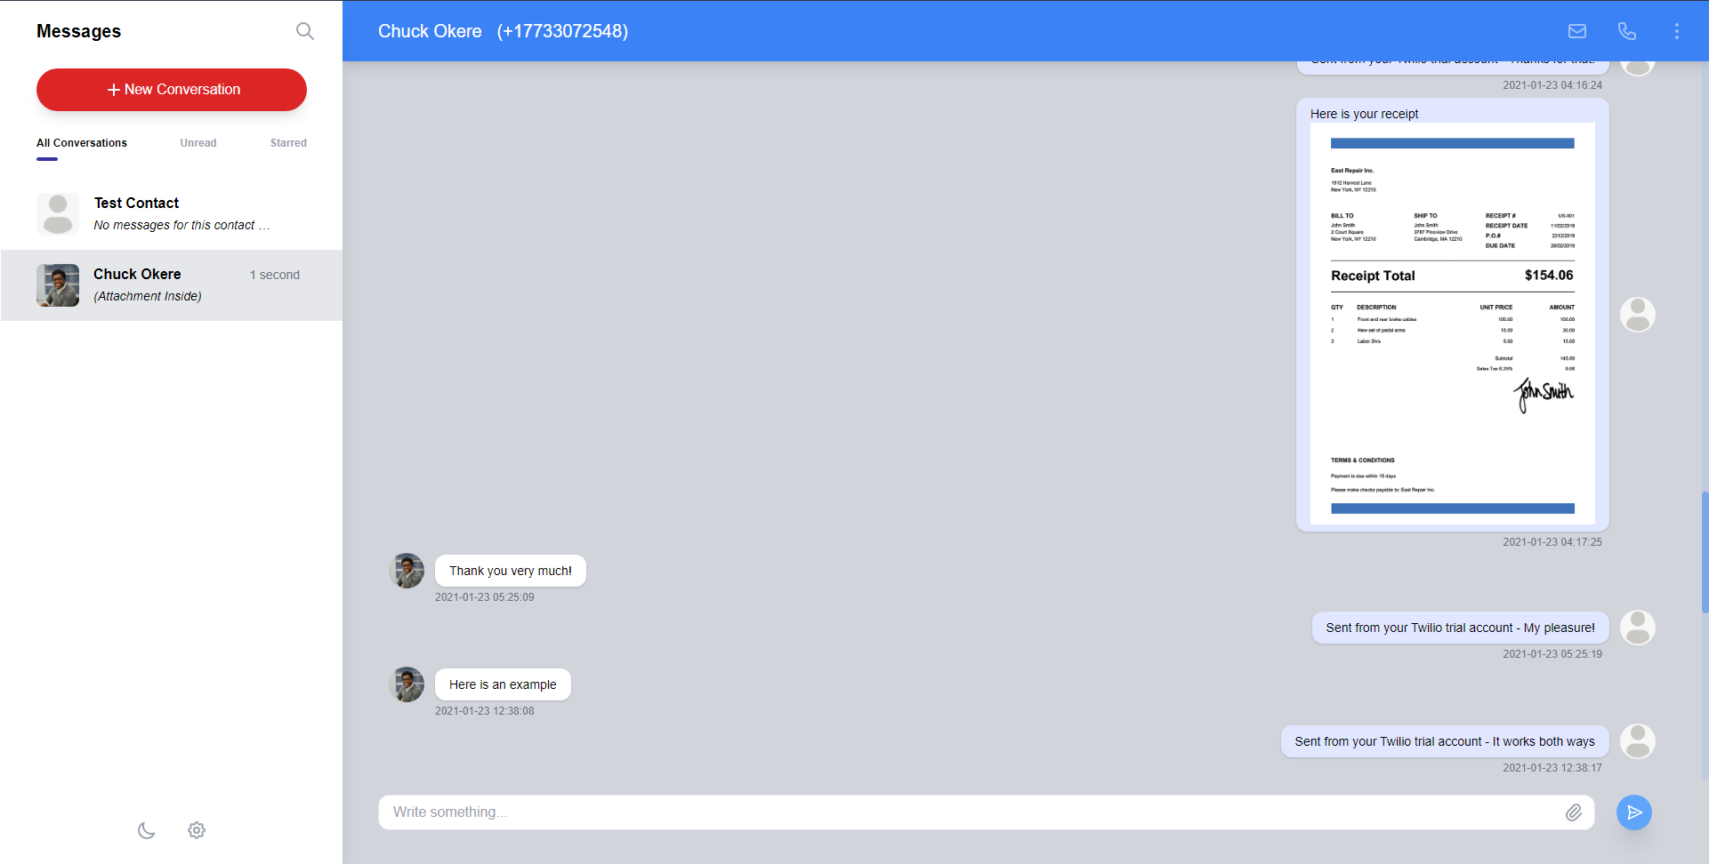

* Redstone dark mode
  + Redstone Capital (<https://www.redstone-capital.com/>) is a client that uses Vtiger but they wanted us to revamp it to suit their business specifically. So I redesigned the UI and they I pitched them these 2 darkmode option (midnight blue and slate grey)which they ended up buying from us and loving. They eventually want to sell access to this platform to other financial institutions

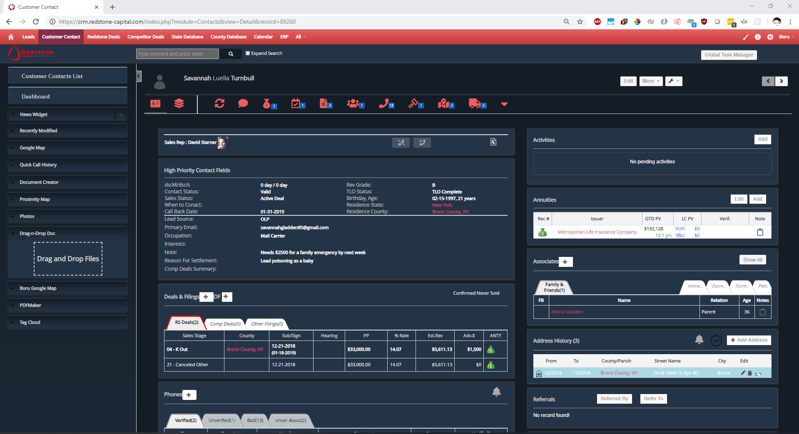

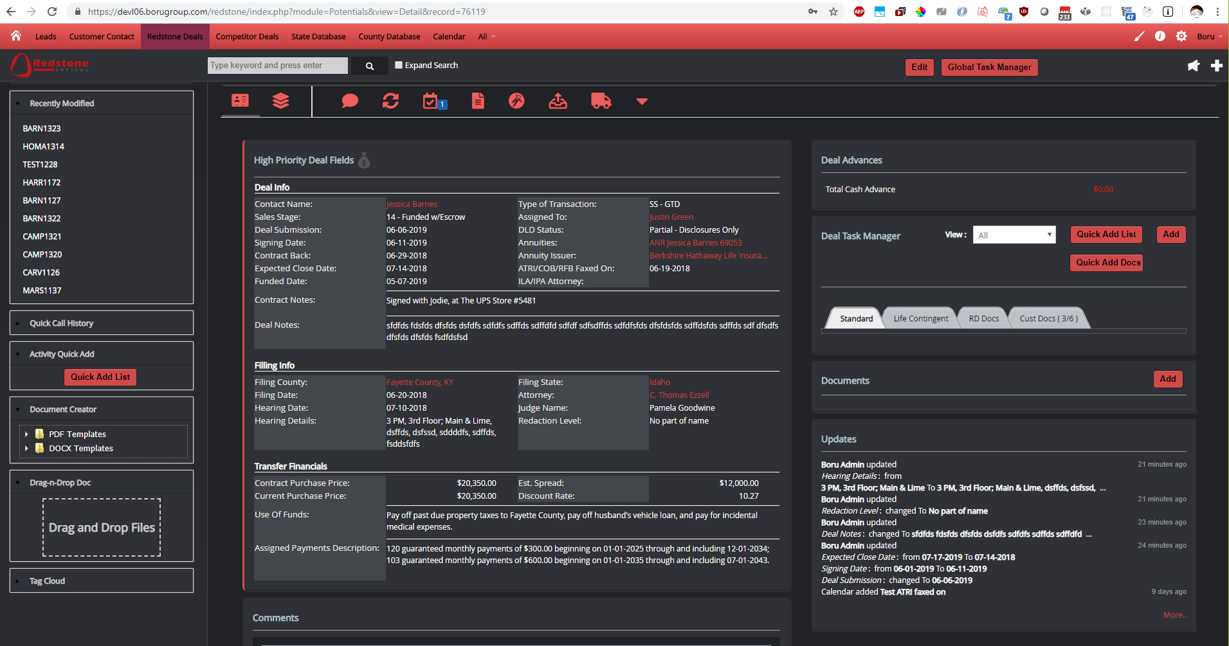

* Mortgage Lead
  + This mobile and web app was created for MortgageLead.com to enable their business to sell mortgage leads they've acquired and have in a database. The app is for the mortgage brokers to buy leads from MortgageLead to conduct their business. I created each page after design and mockup sessions with the <https://mortgagelead.com> team through Zeplin (collaborative platform)

