Homepage: Confirmation message about successful subscription is not styled

**Steps to reproduce:**

1. Go to the homepage.

2. Scroll the page down to the footer.

3. Enter a valid email.

4. Pay attention to the confirmation message styling at the top of the page.

5. Scroll the page down to the footer again.

6. Enter the same email.

7. Pay attention to the validation message at the top of the page.

**Actual result**: The messages are not styled.

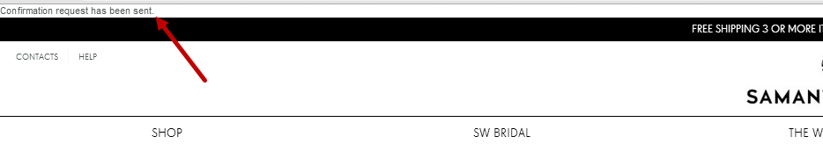

**Expected result:** The messages should be styled according to the style guide.



FF: IE9: IE10: IE11: Homepage: Footer: The letter icon is not aligned with the text

**Steps to reproduce:**

1. Go to the home page using FF31 (latest), IE9, IE10 or IE11.

2. Scroll the page down to the footer.

3. Pay attention to the letter icon on the Sign up button.

**Actual result:** the icon is shifted up in IE and it is shifted down in FF.

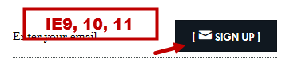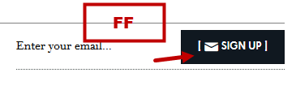

**Expected result:** please align the icon in one line with the text.

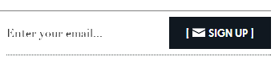

[Mobile] Homepage: Shopping bag is not closed on tapping the homepage on the left

**Steps to reproduce:**

1. Go to Homepage.  
2. Tap the Shopping bag button icon to open the shopping bag  
3. Tap the homepage on the left.

**Actual result:** shopping bag is not closed on tapping the homepage on the left.

<https://www.dropbox.com/s/4ggrdl6xupy0bis/closing_cart.MOV>

**Expected result:** shopping bag should close on tapping the homepage on the left.

Product listing pages are not shown in USD store view even though they were assigned to this store view

**Steps to reproduce:**  
1. Open a homepage   
2. Change the store view to USD. ( the link now is index.php/usd/?___from_store=default)  
3. Hover the mouse over the Shop item of the top navigation.  
Choose Shop by collection - Bridal. ( the link is index.php/usd/test-qa-collection, 404 page )   
Or choose Shop by Style - Bohemian luxe. ( the link is index.php/usd/testbohemianluxe, 404 page)  
4. Go to backend and make sure the mentioned collection and style were set to be shown on each store view.

**Actual result:**the page is not found if the link has usd/ part instead of default/ part.

<https://www.dropbox.com/s/8xdot6ki7txyebo/12-08-2014%209-45-19.mp4>

**Expected result:** the product listing pages should be displayed if the collection or style was assigned to the corresponding store view.

Product listing: The counter of the visible products as well as the number of products in the dropdown are not updated after changing the qty of shown products

**Steps to reproduce:**  
1. Go to the product listing page.

2. Pay attention to the counter of the visible products. Pay attention to the dropdown with qty of the products to display. (E.g. 1-12 of 18 and View 12)  
3. Change the qty of the displayed products per page.  
4. Pay attention to the counter of the visible products. Pay attention to the dropdown with qty of the products to display.

**Actual result:** the visible products are updated via AJAX and the counter is only updated after the page refresh.

<https://www.dropbox.com/s/0s01fdoqdn7kr5y/12-08-2014%2016-37-07.mp4>

**Expected result:**user should see the actual number of displayed products shown by the counter of visible products. User should be able to see the currently viewed number of the products in the dropdown.