小学五年级英语上册期中调研 (2019.11)

听力部分（30分）

**一、 听录音，选出你所听到句子中含有的单词或词组，听一遍。 (共10小题，共10分)**

（ ） 1、A、thirty B、thirsty C、three D、hurry

（ ）2、A、play football B、play basketball C、play well D、play tennis

（ ）3、A、swim B、win C、wing D、wings

（ ）4、A、computer room B、classroom C、music room D、art room

（ ）5、A、China B、Australia C、polar bears D、bald eagles

（ ）6、A、beside B、betwwen C、behind D、before

（ ）7、A、fit B、feet C、foot D、food

（ ）8、A、happy B、hobby C、Bobby D、hungry

（ ）9、A、hear B、hill C、here D、hair

（ ）10、A、on the chair B、on the ice C、in the ice D、under the ice

**二、 根据你所听到的内容给下列图片标上序号，听两遍。 (共1小题，共5分)**

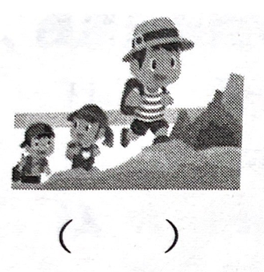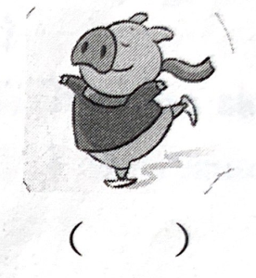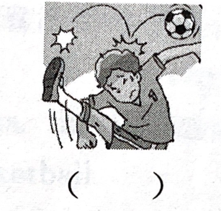I

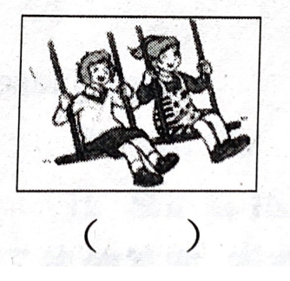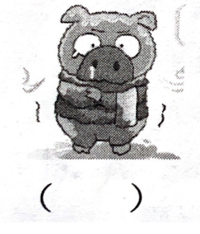

**三、 听录音，选择正确的应答，听两遍。 (共5小题，共5分)**

（ ） 1、A、Yes, it is. B、Yes，there is.

C、No, there aren’t. D、No, there isn’t.

（ ） 2、A、I can sing B、I like singing.

C、I usually sing at school D、Yes, I do.

（ ） 3、A、He likes drawing. B、He reads books at home.

C、She likes drawing. D、He often goes the bookshop.

（ ） 4、A、It’s on the floor. B、It’s on the first floor.

C、Yes,it’s on the second floor. D、They’re on the first floor.

（ ）5、A、Yes, he is. B、No, he doesn’t.

C、Yes, she does. D、No, she doesn’t..

**四、 听对话，选择最佳答案，听两遍。 (共5小题，共5分)**

（ ） 1、1Q: What’s in the house?

A、A house. B、Three bears. C、A river. D、A girl.

（ ） 2、Q:What is Lily’s animal friend?

A、A bird B、A duck C、A parrot D、A horse

（ ）3、Q:How many classrooms are there??

A、22 B、23 C、45 D、21

（ ） 4、Q:Who likes singing?

A、Ben. B、Mike. C、Sam. D、Mike and Sam

（ ） 5、Q:Where is Tim’s classroom?

A、On the first floor. B、On the second floor.

C、On the third floor. D、On the forth floor.

**五、 听录音，完成下列句子，听三遍。 (共1小题，共5分)**

Nancy Black is a new student. Mr Smith_________Yang Ling to_________her around. There are twenty-four classrooms in their school and their classroom is on the_________floor. There are two _________rooms. They are on the second floor. What’s on the fourth floor? There is a_________on it.

笔试部分（70分）

**六、 判断下列单词发音是否相符，相同的打“√”，不相同的打“×” (共5小题，共5分)**

1、（ ）I have a yellow bird. It can fly.

2、（ ）My cousin often goes to the cinema at Sundays.

3、（ ）It’s cold. I need some warm water.

4、（ ）My dog always sleeps in my soft bed.

5、（ ）Don’t jump up. You’ll get juice on my jacket.

**七、 词汇。 (共3小题，共20分)**

[题组题]A、读句子，选出与句子描述相符的图片，将其序号填在横线上，有一幅图片为多余的.

1. When we finish the homework, we can do that and have a rest for a moment.

2. It is lovely. It has a long tail. It can run and jump. It lives in the forest.

3.I don’t like it. Because I am afraid of water.

4.It is a place and we shouldn’t talk in it.

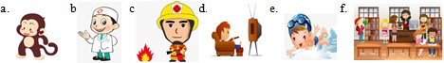 5.A hero in red and orange, always helps people in danger, but his job is dangerous.

[题组题]B、 用括号内所给单词的适当形式填空。

1. Let ______ (we) go and have a look.

2. -How many _____ (book) are there on the wall? -There _____ (be) one.

3. The girl ______ (help) us with English on Sundays.

4. Do you like ______ (run)? No, I like ____________ (swim).

5. There is a river between the_____________(hill).

[题组题]C、在方框内选择合适的词，并用其正确的形式填空，每个词只使用一次，其中有一词为多余项，每空一词。

|  |
| --- |
| do twin dance be peach have |

1.What he like doing?

2.There are many trees in the park.

3.You are not good at **.**

4.Ittwo legs and two wings.

5. Su Hai and Su Yang are .

**八、 选择正确的答案，将其序号填入括号内。 (共10小题，共10分)**

（ ）1、There are two apples. Is green, is red.

A、One;one B、One;other C、One; the other D、One;another

（ ）2、Joe and Jane are twins. They like sports.

A、all B、both C、either D、are

（ ）3、The boy can’t play piano, but he can play ____ football.

A、the; a B、 the; / C、 a; the D、 /；the

（ ）4、In the US, we can see . In China, we can see .

A、bald eagles; pandas B、pandas; polar bears

C、pandas; polar bears D、kangaroos; pandas

（ ）5、—What Lily like? —She likes .

A、do; dancing B、does; dance C、does; dancing D、do; dance

（ ）6、_______ is popular in China.

A、Coffee B、Tea C、Milk D、 Juice

（ ）7、---- Sam good at ? Of course!

A、Does; swim B、Does; swimming C、Is; swimming D、Is; swim

（ ）8、Mike likes________ table tennis. He can ________well.

A、 playing; play B、 playing; playing

C、 play; playing D、 play; play

（ ）9、 There is ___umbrella behind the door. _____ umbrella is nice.

A、an; The B、an; An C、 a; The D、the; An

（ ）10、Are there music rooms in it?

A、a B、some C、any D、/

**九、 阅读下面的对话，从方框中选出能填入空白处的最佳选项，将序号填写在横线上，选项中有一项多余项。 (共1小题，共5分)**

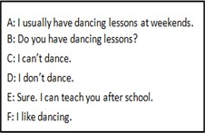

Helen:I like playing the piano. What about you?

Nancy: 1 It’s interesting.

Helen: 2

Nancy:Yes, I do. 3

Helen: That’s good. So you are good at dancing. Right?

Nancy:En, I think so.

Helen: 4 Can you teach me?

Nancy: 5

Helen:Great. Thank you,Nancy.

Nancy:You’re welcome, my friend.

**十、 按要求完成句子。 (共5小题，共10分)**

1、I like playing the piano at home.（对划线部分提问）

do you like at home?

2、 I usually go to school at seven. （用she改写句子。）

She usually to school at seven.

3、She has a lot of books.( 改为一般疑问句,并作否定回答）

she a lot of books? No, .

4、three, in, there, is, forest, a, bears, the, house, and (连词成句)

.

5、dog, Mike’s, big, ears ,has, a, short, and,tail (,) (连词成句)

.

**十一、 阅读理解。 (共15小题，共15分)**

[题组题]

1. 判断句子与图片内容是否相符。正确的√，错误的打×

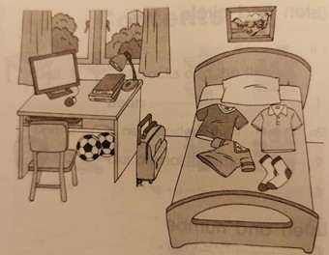

1、This is a girl’s bedroom.（ ）

2、There is a computer, a lamp, two footballs and some books on the desk.（ ）

3、There is a schoolbag between the desk and the bed.（ ）

4、There is a chair in front of the desk and a clock on the wall.（ ）

5、The owner（拥有者） of the room likes sports.（ ）

B、阅读短文，根据短文内容，选择正确的答案。

Dinosaurs in Ice Age III（冰河世纪三）

[题组题] Do you remember ‘Ice Age III’? It is a very funny film for children. It has many dinosaurs in this film. Dinosaur T is a mother dinosaur. She has three baby dinosaurs. She loves her babies very much. She eats meat. She is nice and friendly. Dinosaur X can fly. He eats fish and lives near lakes. He is not very big but he always helps others（他人）. Dinosaur R is very bad. He is very big. He has sharp teeth. His claws are sharp, too. He likes eating meat. He can run very fast, but he can not fly or swim.

（ ）1、Dinosaur T is a ________ dinosaur.

A、 father B、mother C、baby

（ ）2、 Dinosaur T has ________ baby dinosaurs.

A、one B、 two C、 three

（ ）3、What does Dinosaur X eat?

A、 He eats fish. B、 He eats meat. C、 He eats fruits.

（ ）4、 In ‘Ice Age III’, which dinosaur is bad?

A、Dinosaur T B、 Dinosaur X C、Dinosaur R

（ ）5、 What does ‘claws’ mean?

A、爪子 B、 头 C、 尾巴

[题组题]**C、阅读短文，根据短文内容回答问题。**

There are forty-three students in our class. There are two American boys. They are Jack and Mike. They often go to school by bike. And I often go to school on foot. They are our good friends. They are good at playing football. So they like playing it with boys in our class, it’s funny. All of them are happy. But they don’t like playing basketball. There is one English girl in our class. Her name is Lucy. She likes playing basketball and she also like swimming. She usually does her homework in the evening. She often watches TV on Saturday afternoon. She is my good friend. We always have a good time.

1、How many foreigners are there in our class?

2、 What does Jack and Mike like doing?

3、Does Jack and Mike go to school on foot?

4、What does Lucy usually do at weekends?

5、Do foreigner students like our school life?

**十二、 写作。 (共1小题，共5分)**

**请以“My animal friend”为题，不少于5句话。**