**苏州市平直实验小学校2019-2020学年第一学期英语**

**二年级阶段性绿色调研卷 2019.11**

一、听力。

1. [解答题] (10分) 听录音回答。

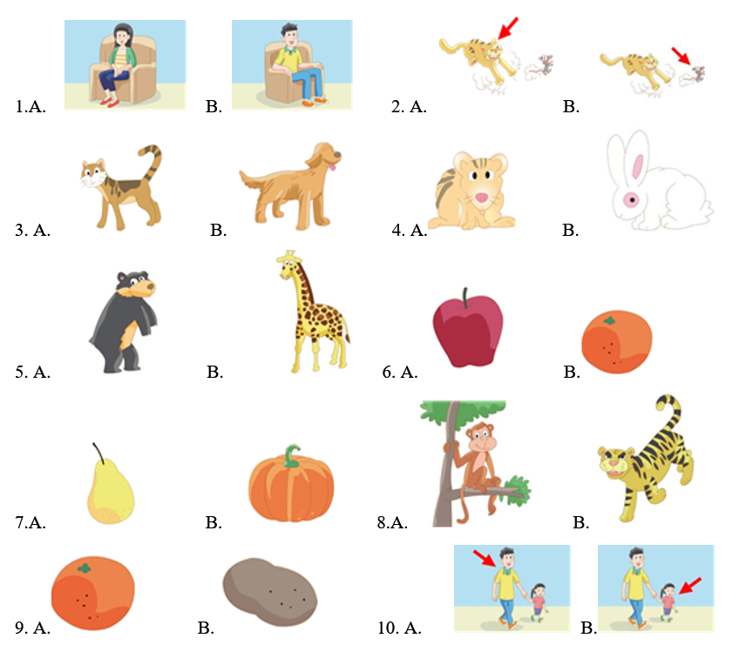

[答案]1.A; 2.B; 3.A; 4.A; 5.A; 6.B; 7.B; 8.A; 9.B; 10.B

[解析]略

2.[解答题](5分)听录音，判断下列图片与所听内容是否相符，相符的打“√”，不相符的打“×”。听两遍。

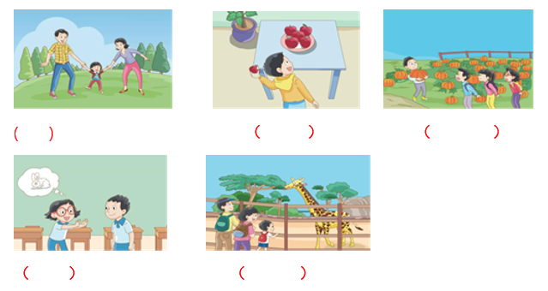

[答案] √√××√

[解析]略

3. [单选题](1分)

A. rubber

B. rabbit

C. run

[答案]B

[解析]略

4. [单选题](1分)

A. bear

B. pear

C. pea

[答案]A

[解析]略

5. [单选题](1分)

A. uncle

B. my

C. mum

[答案]C

[解析]略

6. [单选题](1分)

A.dog

B.dad

C.pig

[答案]B

[解析]略

7.[单选题](1分)

A. have

B. has

C.so

[答案]C

[解析]略

8.[单选题](1分)

A. this

B. they’re

C. they

[答案]A

[解析]略

9.[单选题](1分)

A. what

B. round

C. sweet

[答案]C

[解析]略

10. [单选题](1分)

A. in

B. on

C. at

[答案]B

[解析]略

11.[单选题](1分)

A. look

B. book

C. good

[答案]A

[解析]略

12.[单选题](1分)

A. mat

B. fat

C. that

[答案]A

[解析]略

13. [解答题] (10分)听录音，按你听到的顺序给下列图片或单词排顺序。听两遍

A组

aunt short tail rabbit tiger

（ ） （ ） （ ） （ ） （ ）

B组

a big hamster a short tail a long neck my mum your dad

（ ） （ ） （ ） （ ） （ ）

[答案]3.2.1 .5 .4; 4.1.2.3.5

[解析]略

14.[解答题](5分)听录音，根据所听内容，选择合适的应答。听两遍。

( ) 1. A. She is my cousin. B. Is she your cousin?

( ) 2. A. It’s cute . B. It’s red.

( ) 3. A. It has a short tail. B. It has a long neck.

( ) 4. A. They are oranges. B. Those are pumpkins.

( ) 5. A. Hello, Mrs Li. B. Hello, Mr Wang.

[答案] AABAB

[解析]略

15.[解答题](5分) 听录音，完成对话。听两遍

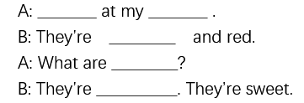

[答案] Look; apples; small; these; pears

[解析]略

二、笔试部分

16.[解答题](5分)圈出不同类的单词。

( ) 1. A. mum B. dad C. uncle D. he

( ) 2.A. orange B. apple C. potato D. pear

( ) 3. A. tiger B.monkey C. zoo D. giraffe

( ) 4. A. big B. red C. yellow D. brown

( ) 5. A. long B. tail C. short D. big

[答案]DCCAB

[解析]略

17. [单选题](1分) This is _____ cousin.

A. I B. my C. me

[答案]B

[解析]略

18. [单选题](1分) Is this _____ aunt?

A. you B. I C. your

[答案]C

[解析]略

19. [单选题](1分) I _______ an uncle and an aunt.

A. have B. has C. is

[答案]A

[解析]略

20. [单选题](1分) Look! It ____ a short tail.

A. have B. has C. are

[答案]B

[解析]略

21. [单选题](1分) Look at the tree. Those are _______.

A. apple B. orange C. pears

[答案]C

[解析]略

22. [单选题](1分) This is my uncle. __________________.

A. He’s tall. B. She’s tall. C. It’s tall.

[答案]A

[解析]略

23. [单选题](1分) Look at ______ bear. ---Oh, it has a short tail.

A. a B.the C.不填

[答案]B

[解析]略

24. [单选题](1分) What are those? ______ oranges.

A. they B. They’re C. It’s

[答案]B

[解析]略

25. [单选题](1分) It’s autumn. It’s _______.

A.fat B.cute C.cool

[答案]C

[解析]略

26. [单选题](1分) The ___ is juicy and sweet.

A. cherry B.pepper C.banana

[答案]A

[解析]略

三、情景选择

27. [单选题](1分)你想告诉别人这是你表妹，你说：

A. This is my cousin. B. This is my aunt.

[答案]A

[解析]略

28. [单选题](1分)你想知道远处那些是什么，你问：

A. What are these? B. What are those?

[答案]B

[解析]略

29. [单选题](1分)你想告诉别人你有一只仓鼠，你说：

A. I have a hamster. B. I have a dog.

[答案]A

[解析]略

30. [单选题](1分) 你想告诉别人那些是南瓜，你说：

A. Those are pumpkins. B. Those are potatoes.

[答案]B

[解析]略

31. [单选题](1分)你想说猴子有一条长尾巴，你说：

A. The monkey has a long tail. B. The bear has a short tail.

[答案]A

[解析]略

四、根据上下文及中文提示，补全对话

32.[解答题] (5分) A组（中文翻译）

A:It’s ..(凉爽) B:Yes. It’s autumn.

A:What are . (这些)? B:They are .（桔子）.

A:What are . (那些)? B:They are black ..(狗）

A:They are cute.

[答案]cool these oranges those dogs

[解析]略

33.[解答题] (5分) B组（划线的英文翻译成中文）

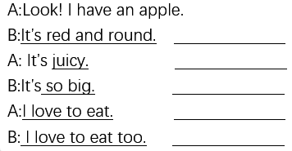

[答案] 它是又红又圆 多汁的 那么大 我爱吃 我也爱吃

[解析]略

五、在B栏中找出A栏的答句，填写在前面括号内。

34.[解答题] (5分)

A B

( ) 1. What’s this? A. Yes, she is.

( ) 2. Is this your mum? B. It’s a lady bird.

( ) 3. Look at the bear. C. Wow, it’s black.

( ) 4. This is my aunt. D. Hello, Mrs Liu.

( ) 5. Those are pears. E. Wow, they’re yellow.

[答案]BACDE

[解析]略

六、连词成句，把句子写在横线上，注意句首大写，句末标点。

35.[解答题] (5分)

(1) my, uncle, This, is (.)



(2) Is , your, aunt , this (?)



(3) have, a, cute, I , dog (.)



(4) too, It’s, white (.)



(5) has, a , neck, long , It (.)



[答案] 1 This is my uncle.;2 Is this your aunt.;3 I have a cute dog.;4 It’s white too.

;5 It has a long neck.

[解析]略

七、阅读短文，完成连线。

36.[解答题] (5分)

It’s autumn. We are on the farm(在农场). Liu Tao has a pumpkin. Yang Ling has two oranges. Su Hai has four peppers. Wang Bing has three potatoes. Look, what are those? They are pears. Miss Li has four.

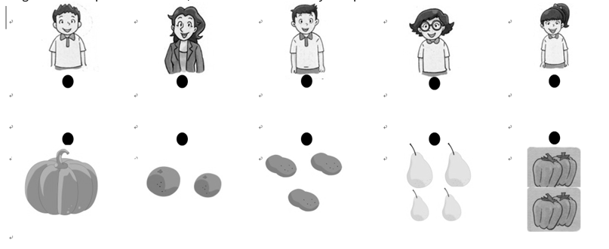

[答案]

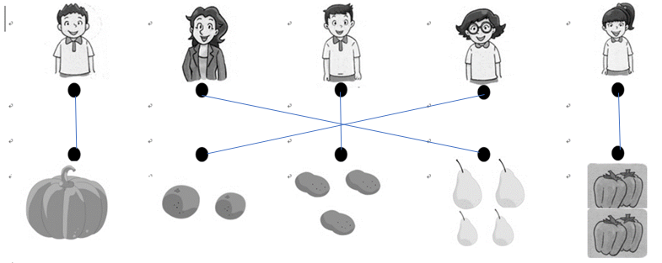

[解析]略