Final Exam: HTML/CSS/BOOTSRAP

**WEP2020**

**{2h30}**

23 DEC 2020

|  |  |  |  |
| --- | --- | --- | --- |
| THEORY |  | 20 | 30 minutes |
| PROJECT 1 |  | 60 | 2 hours |
| PROJECT 2 |  | 20 | 30 minutes |
| **TOTAL** |  | **100** | **3 hours** |

**Instructions**

* **All document and internet ALLOWED**
* You are not allowed to talk or discuss each other during exam.
* If you are found **cheating** or **attempting** to cheat, you will get a 0 score to this exam

**Q1 – 3 PTS**

Complete the code to display result below

|  |  |
| --- | --- |
| **HTML and CSS** | **Display** |
| HTML  ………………………………………………………………………  ………………………………………………………………………  ………………………………………………………………………  ………………………………………………………………………  ………………………………………………………………………  ………………………………………………………………………  CSS  <style>          ol {list-style-type: decimal-leading-zero;}  ………………………………………………………………………  ………………………………………………………………………  </style> |  |

**Q2 – 3 PTS**

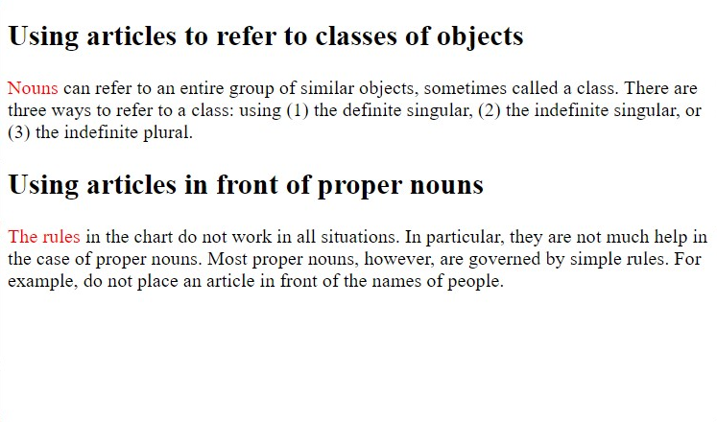

What is the correct structure for above HTML page?

1. <article><h2></h2><p><span>

</span></p></article>

1. <article><p></p><span>

<h2></h2></span></article>

1. <article><p><span></span></p>

</article><h2></h2>

1. <p></p><span><h1></h2></span>

<article></article>

**Q3 – 3 PTS**

We have the following hierarchy of files:

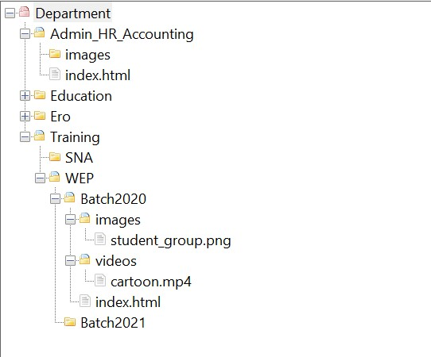

1. Link from index of Batch2020 to cartoon.mp4

<a href="……………………………………………………………………………………………………">

1. Link from index of Batch2020 to index in Admin_HR_Accounting

<a href"……………………………………………………………………………………………………">

1. Link from index of Education to pnc.jpg of Ero

<img src="……………………………………………………………………………………………………">

**Q4 – 2 PTS**

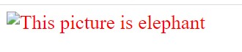

What is the correct code to display above image?

1. img[src]{color:red; font-size:24px;}
2. img[href]{color:red; font-size:24px;}
3. img{color:red; font-size:24px;}
4. img[alt]{color:red; font-size:24px;}

**Q5 – 3 PTS**

Look at the below code:

<body style= “font-size:2 em; color:red”>

<h2>Final exam</h2>

<p style=”color:black; font-size:50%”>Here is the exam to evaluate student ‘s ability on

<span style=”color:blue; font-size:50%”>html

</span>

</p>

</body>

Note:

* 1 EM = 16 PX

What will be the correct answer?

1. span has font-size in pixel: 8 px and color:black
2. span has font-size in pixel: 16 px and color:blue
3. span has font-size in pixel: 16 px and color:red
4. span has font-size in pixel:8px and color:blue

**Q6 – 3 PTS**

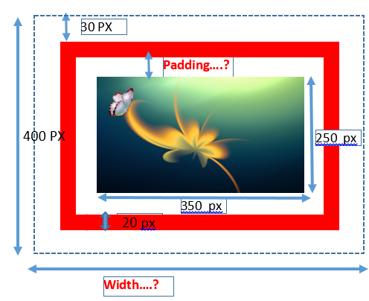

Note:

* All paddings (top, left, right, south) are equal
* All margins (top, left, right, south) are equal

1. What shall be the padding (in PX)?

………………………………………………………………………………………

1. What shall be the total width (in PX)?

………………………………………………………………………………………

**Q7 – 3 PTS**

Look at the HTML page and the HTML code:

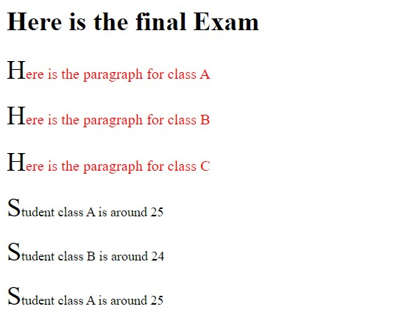

<body>

<div>

<h1>Here is the final Exam</h1>

<p>Here is the paragraph for class A</p>

<p>Here is the paragraph for class B</p>

<p>Here is the paragraph for class C</p>

</div>

<article>

<p>Student class A is around 25</p>

<p>Student class B is around 24</p>

<p>Student class A is around 25</p>

</article>

</body>

What should be the appropriate CSS rules?

div > p {

color:red;

font-size:large;

}

p::first-letter {

font-size:32px;

color:black;

}

p > div {

color:red;

font-size:large

}

p:first-letter {

font-size:32px;

color:black

}

article > p {

color:red;

font-size:large

}

p:first-letter{

font-size:32px;

color:black

}

p>article {

color:red;

font-size:large

}

p::first-letter {

font-size:32px;

color:black

}

**Practice 1 – 60 points**

Reproduce the website below.

* Use the code in the folder “project1”.
* Don’t use Bootstrap
* Separate CSS and HTML
* Use media-query to make the page responsive as shown in second image

Large screen version

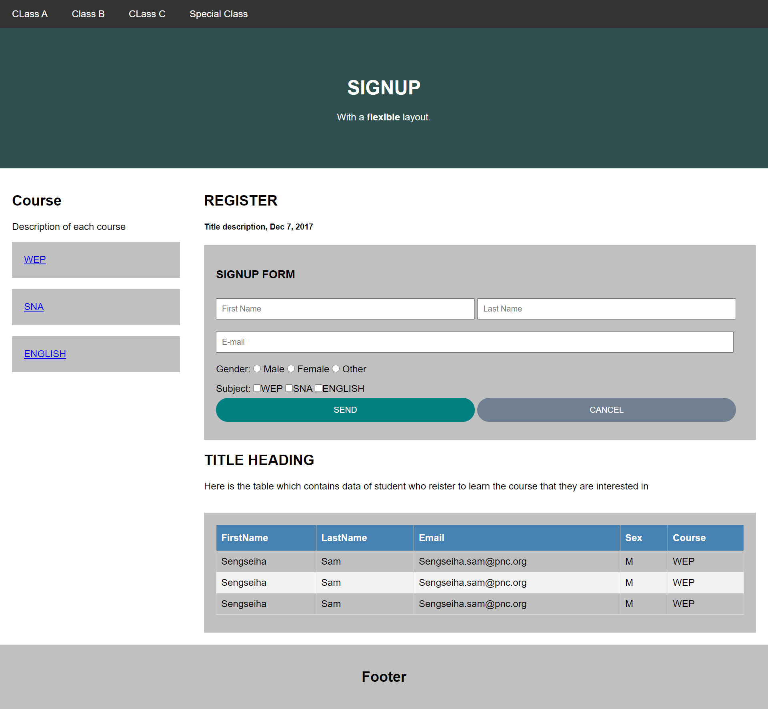

Small screen version

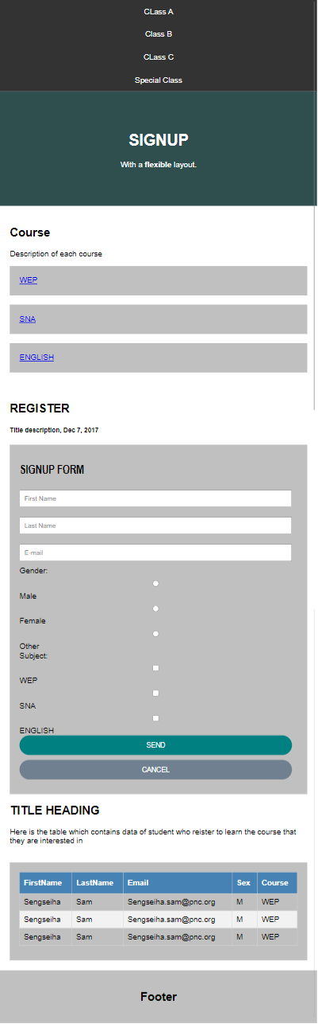

**Practice 2 – 20 points**

* Use the code in the folder “project2”.
* Complete the HTML to reproduce the website below.
* Use only bootstrap classes

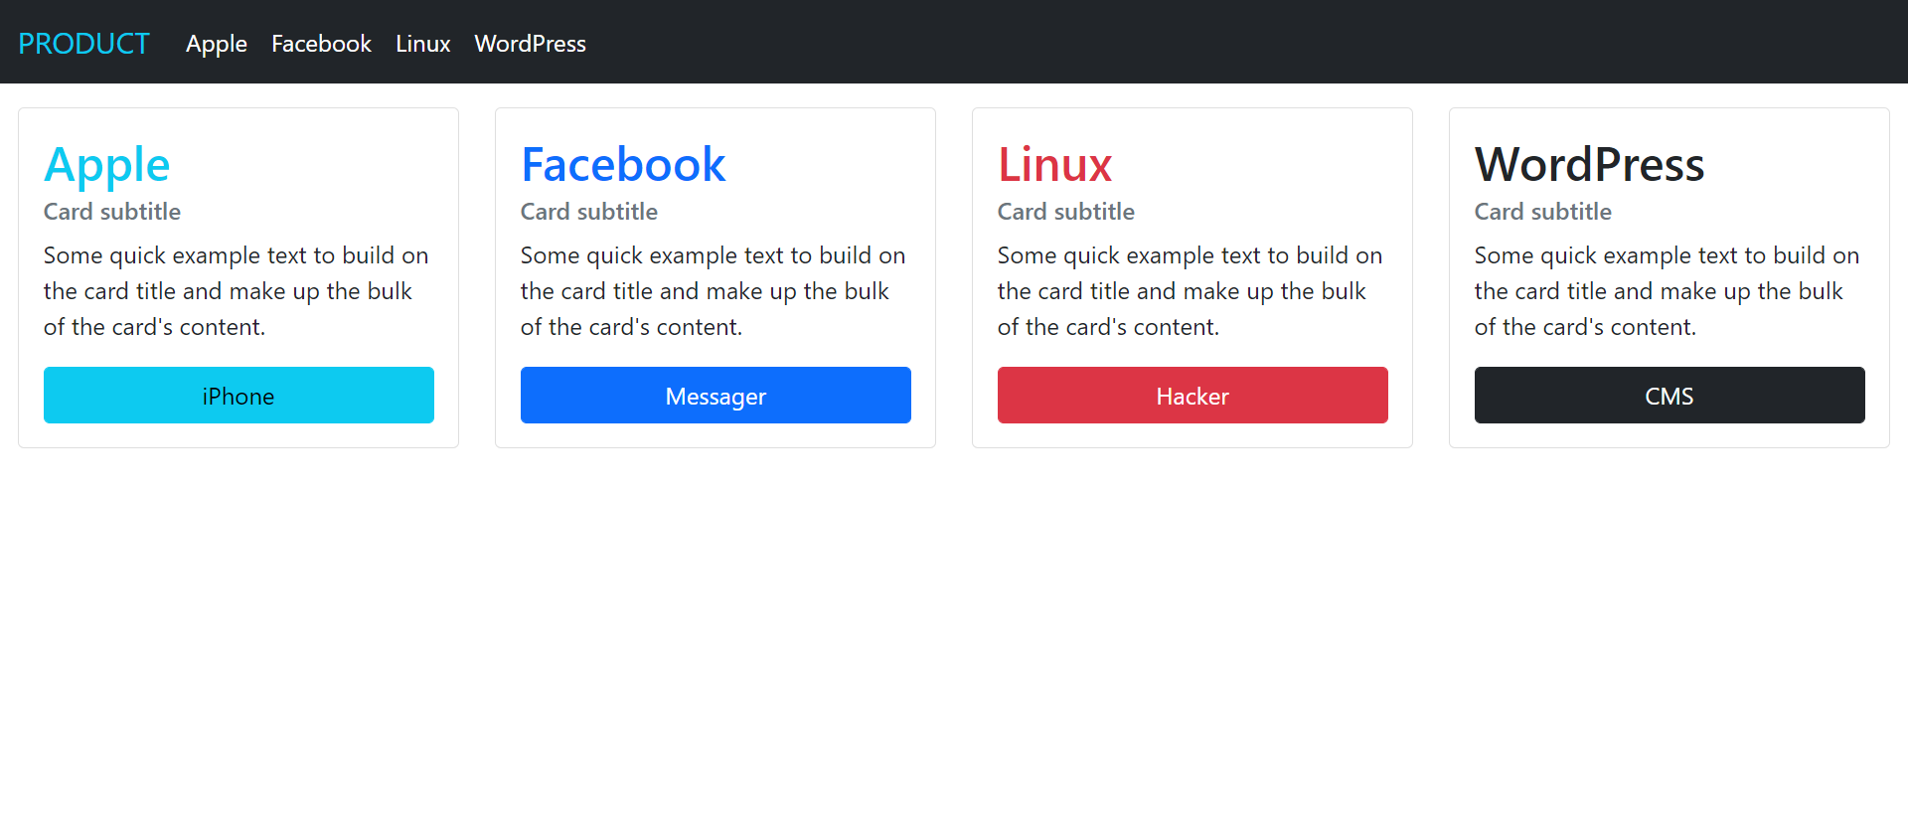

Large screen version

Medium screen version

Small screen version

