CO -OPERATIVE AUDIT AND SUPERVISION CORPORATION

(COASCO)

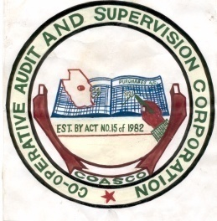

Co-operative Audit and Supervision Corporation
(COASCO)
Hatibu Avenue
P.O.Box 761
Telephone:
General line (026) 2323265, 2321485
Fax (026) 2321486
E-mail: info@coasco.go.tz
Website:www.coasco.go.tz

NEWS COMING SOON

