GSN Community Setup Pack: Community Setup Story Bank (2026-09-14)
Authenticity mark: GSN Original Community Setup Material | Source-controlled in gmfn_mvp/docs | Document date: 2026-09-14
Document date: 2026-09-14
Pack: GSN Community Setup Pack
Authenticity mark: GSN original community setup material, source-controlled in `gmfn_mvp/docs`.
Use these short stories when sending the setup pack to a client. They are framing stories, not proof that a specific client has already completed the setup.

Church or Faith Group
A church has announcements in WhatsApp, attendance in notebooks, welfare requests in private messages, and business posts scattered across different groups. When leaders change, people ask who approved what and where the latest instruction lives.
GSN gives the church a cleaner Community Domain path: official notices, joining, meeting records, member response, support requests and selected public-safe evidence can sit in one governed place. Members can still hear about things through WhatsApp, but the action record is not trapped inside one phone.
Boundary: GSN supports evidence and continuity. It does not replace pastoral judgement, safeguarding policy, legal registration or church leadership decisions.

School or Youth Organisation
A school or youth group needs to announce programmes, register attendance, collect responses, and keep evidence of what was offered to students or parents. WhatsApp is fast, but it is weak for long-term handover and audit.
GSN helps create a governed setup where programmes, notices, attendance, documents and response paths can be organised. Leaders can give members a clearer way to know where to go, what to do next and how to recover if they miss a message.
Boundary: GSN is not a child-safeguarding substitute, education regulator, payment guarantee or parental approval engine.

NGO, Charity or Community Organisation
An NGO runs programmes, collects needs, asks for evidence and reports to funders. The work can become hard to prove when records sit in personal chats and scattered spreadsheets.
GSN gives the organisation a structured setup pack: community identity, notices, meeting memory, evidence paths, DemandBox-style needs, support records and public-safe reporting language. It helps the organisation separate real activity from claims.
Boundary: GSN can support evidence discipline, but funders, trustees and regulators still decide what counts as formal proof.

Cooperative, Market or Business Network
A cooperative or market group has sellers, buyers, rotating opportunities, trust concerns and repeated informal promises. People need visibility, but they also need boundaries so a public post is not mistaken for verification or payment proof.
GSN helps set up shops, product/service blocks, Spotlight, DemandBox and owner analytics. The group can see attention, contact taps and public interest, then connect serious trade to stronger evidence where needed.
Boundary: views, shares, calls and WhatsApp openings are attention signals, not sales, buyer proof or product quality proof.

Family, Diaspora or Association
A family or diaspora association may coordinate welfare, meetings, dues, announcements, member records and local support across countries and phones. The problem is not only communication; it is continuity.
GSN gives the association a way to preserve structure: identity, joining, notices, documents, support actions, finance evidence boundaries and handover memory. People can still talk in WhatsApp, but the important action path can be kept in GSN.
Boundary: GSN does not decide family authority, legal inheritance, immigration status, or private identity claims by itself.

How To Use A Story
Pick one story that matches the client. Add only the setup steps relevant to their first deployment. Do not flood a first conversation with the expanded 56-entry master bank; the original 44 modules are preserved there, with Strategic Application Lenses kept for deeper setup conversations.

Scan to download this GSN article
Community Setup Story Bank
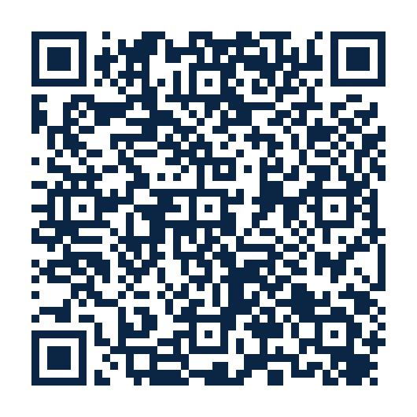
For: Sales, onboarding and community champions
https://raw.githubusercontent.com/chumanwafor216-svg/gmfn-mvp/main/docs/community-
setup-pack/GSN_COMMUNITY_SETUP_STORY_BANK_2026-09-14.pdf
QR access depends on the file being publicly reachable or shared through an approved public mirror.

