Failed test

**Failed test**

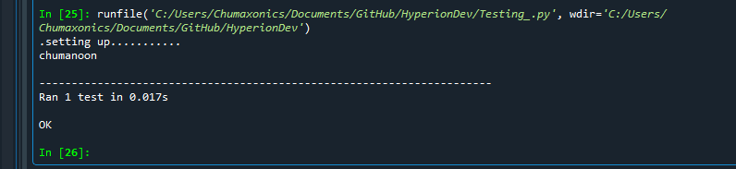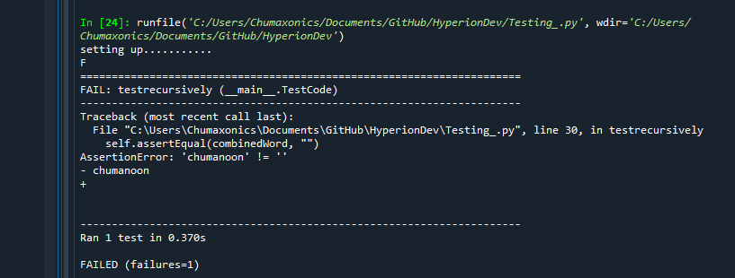

**Passed test**