面談日程ツール Ver.3.1（マクロ版） マクロの貼り付け方
いっしょに届いた「面談日程ツール_Ver3.1.xlsx」に、このWordのマクロを貼り付けて、マクロ有効ブック（.xlsm）にします。学校のパソコンで1回だけ行います（10分ほど）。
手順
① 「面談日程ツール_Ver3.1.xlsx」を開いて、キーボードの Alt ＋ F11 を押します。マクロを書く画面（VBA）が開きます。
② 左の一覧の「ThisWorkbook」をダブルクリックします。右に白い画面が出ます。
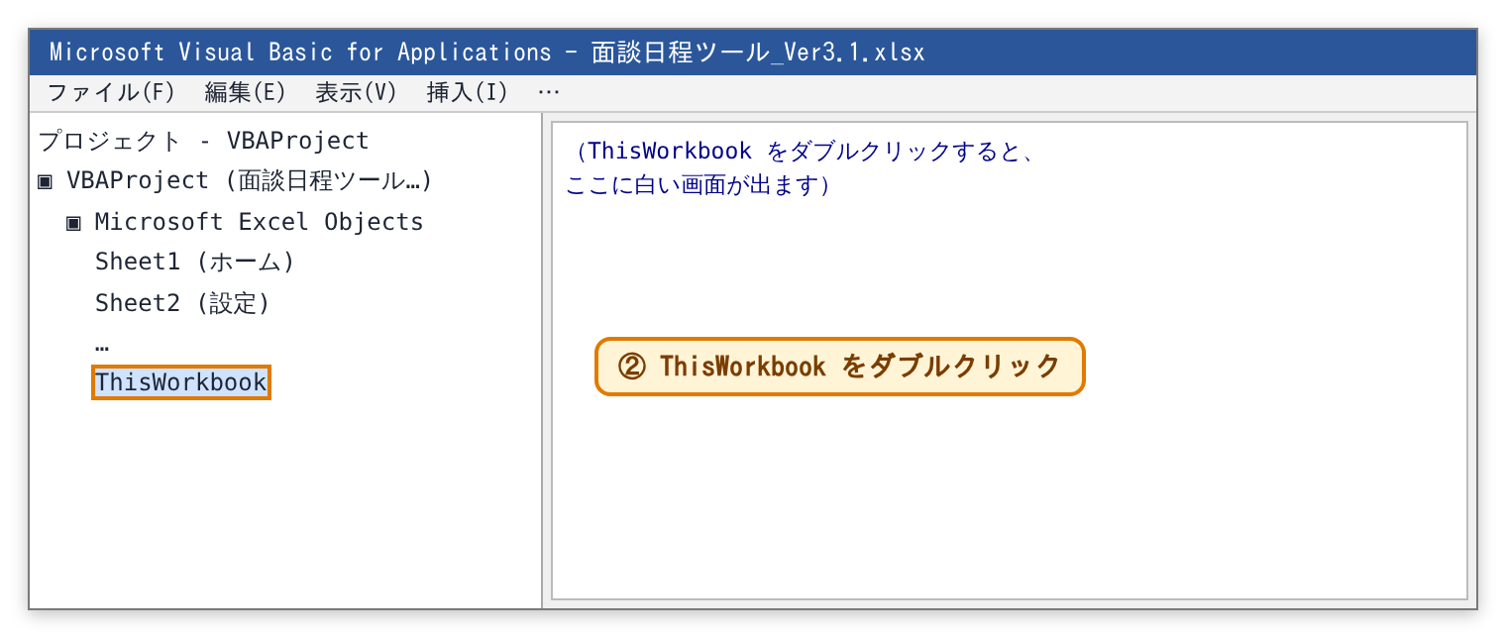
③ このWordの最後の「ここから」の下から「ここまで」の上までを、マウスでなぞって全部選び、Ctrl ＋ C でコピーします。VBAの白い画面をクリックして Ctrl ＋ V で貼り付け、右上の×で閉じます。
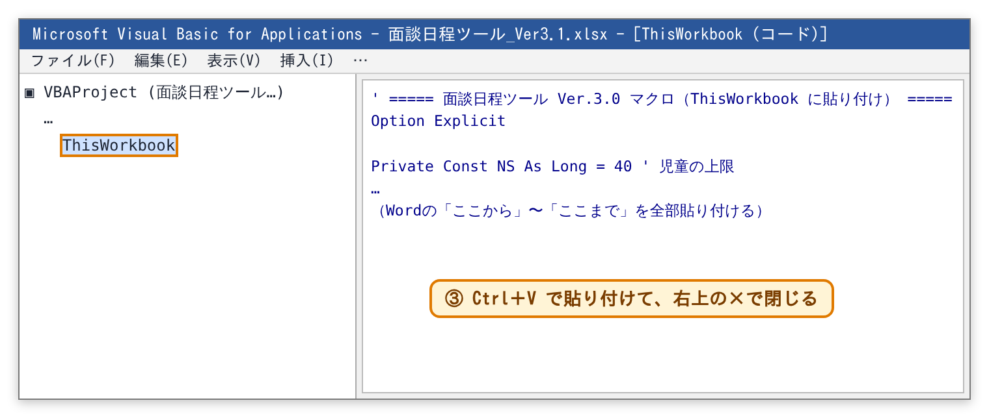
④ Excelの［ファイル］→［名前を付けて保存］で、ファイルの種類を「Excel マクロ有効ブック (*.xlsm)」にして保存します。ふつうの .xlsx で保存するとマクロが消えるので、気をつけてください。
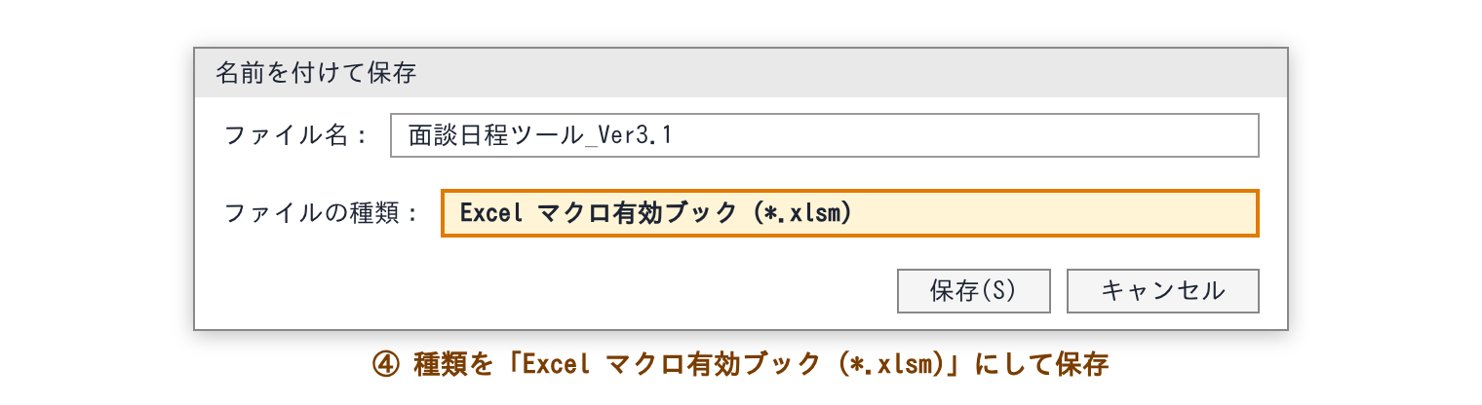
⑤ いったん閉じて、保存した .xlsm を開き直します。黄色い帯が出たら［コンテンツの有効化］を押します。これで使えます。
⑥ ほかの先生には、できた .xlsm を校内で配ります。開いて［コンテンツの有効化］を押せば使えます（①〜④は要りません）。
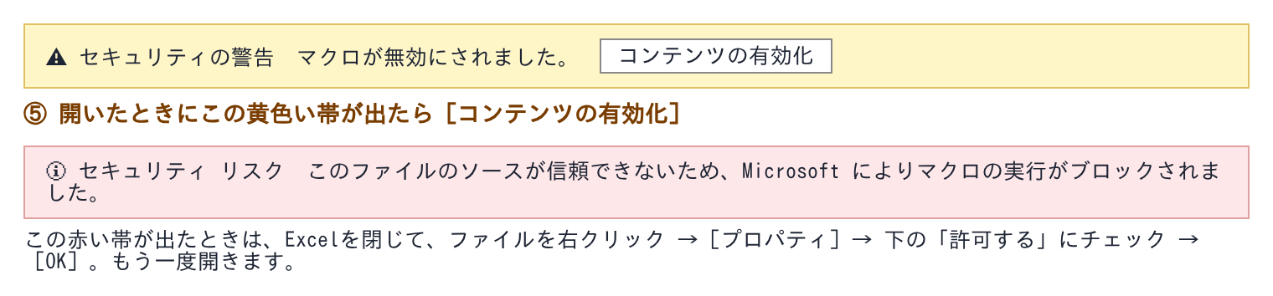
うまく動かないとき
・青いボタンを押しても何も起きない → マクロが有効になっていません。開き直して［コンテンツの有効化］を押してください。.xlsx のまま保存していないかも確かめてください（ファイル名の最後が .xlsm）。
・赤い帯「マクロの実行がブロックされました」が出る → Excelを閉じて、ファイルを右クリック →［プロパティ］→ 下の「許可する」にチェック →［OK］。
・貼り付けたあと「コンパイル エラー」が出る → 貼り付けがとちゅうで切れているかもしれません。白い画面を Ctrl ＋ A で全部選んで消し、もう一度「ここから」〜「ここまで」を全部コピーして貼り付けてください。
・ThisWorkbook 以外（標準モジュールなど）に貼ると、ボタンやダブルクリックが動きません。かならず ThisWorkbook に貼ってください。
・マクロでした操作は Ctrl ＋ Z で戻せません。「調整・決定」は［ひとつ前に戻す］を使ってください。
マクロでできること
・自動案A：［自動案を作る（A・B両方）］［この案を「調整・決定」へ写す］ 自動案B：［この案を「調整・決定」へ写す］
・×入力：マスをダブルクリックで×が付く／消える。「児童を選ぶ」で名前を選ぶとその子の表へ。［次の未入力の子へ］
・調整・決定：名前をクリック→入れられる枠に色。ダブルクリック2回で入れ替え（空いたマスなら移動）。［ひとつ前に戻す］（10回まで）
・設定：時間帯・1枠の長さを変えると、×入力とお手紙の使わない行が自動で合う
・名簿：兄弟が〇の子がいると、兄弟①〜③の列が自動で開く
・兄弟確認用・お手紙：［印刷プレビュー］［PDFで保存］（お手紙は1日の枠が13以上なら夏、12以下なら秋の形）
・開いたとき、Excelの計算方法が「手動」になっていたら「自動」に直す

▼▼▼ ここから（この下の行から、「ここまで」の上の行までを全部コピー） ▼▼▼
' ===== 面談日程ツール Ver.3.1 マクロ（ThisWorkbook に貼り付け） =====
' 自動案（A：詰める／B：散らす）を作る・調整・決定へ写す・×のダブルクリック入力・入れ替え・ひとつ前に戻す・印刷・PDF
Option Explicit

Private Const NS As Long = 40 ' 児童の上限
Private Const ND As Long = 6 ' 日数の上限
Private Const NT As Long = 24 ' 1日の枠の上限
Private Const NN As Long = 144 ' 枠の総数（ND×NT）
Private Const BIGV As Double = 1000000000#
Private Const BLK As Long = 28 ' ×入力の1人分の行数
Private Const HIST As Long = 10 ' 「ひとつ前に戻す」でとっておく数

Private mBusy As Boolean ' マクロが書いているあいだは、変更の合図を無視する
Public gNoRepair As Boolean ' 確かめ用（入れ替えでなおさない）

' ---- 計算Aから読むもの ----
Private rDay() As Double, rTime() As Double, rAvoid() As Double, rOcc0() As Double, rNext() As Double
Private rNB() As Double, rNoGap() As Double, rPrio() As Double, rOcc() As Double
Private okM() As Double, xM() As Double
Private sElig() As Double, sGap() As Double, sHope() As Double, sSibFlag() As Double, sNoGap() As Double, sSibT() As Double
Private sS() As Double, sD() As Double, sT() As Double, sPre() As Double, sPost() As Double, sPref() As Double
Private nAM As Double, nPM As Double

' ---- 結果 ----
Private outB() As Long, outC() As Long, outG() As Long

' =====================================================================
' Excel の出来事
' =====================================================================
Private Sub Workbook_Open()
On Error Resume Next
If Application.Calculation <> xlCalculationAutomatic Then Application.Calculation = xlCalculationAutomatic
mBusy = True
Me.Worksheets("calcA").Range("A5:B5").ClearContents ' 入れ替えで選んでいたマス
mBusy = False
SaveShadow
AdjustRows
SiblingColumns
End Sub

Private Sub Workbook_SheetChange(ByVal Sh As Object, ByVal Target As Range)
If mBusy Then Exit Sub
On Error GoTo Done
Select Case Sh.Name
Case "設定"
If Not Intersect(Target, Sh.Range("B3:D5")) Is Nothing Then AdjustRows
Case "名簿"
If Not Intersect(Target, Sh.Range("E5:E44")) Is Nothing Then SiblingColumns
Case "×入力"
If Not Intersect(Target, Sh.Range("D3")) Is Nothing Then JumpToChild
Case "調整・決定"
If Not Intersect(Target, Sh.Range("C6:H29")) Is Nothing Then PushHistoryFromShadow: SaveShadow
End Select
Done:
End Sub

Private Sub Workbook_SheetSelectionChange(ByVal Sh As Object, ByVal Target As Range)
If mBusy Then Exit Sub
On Error GoTo Done
If Sh.Name = "調整・決定" Then
If Target.CountLarge = 1 Then
If Not Intersect(Target, Sh.Range("C6:H29")) Is Nothing Then
If CStr(Target.Value) <> "" And CStr(Target.Value) <> CStr(Sh.Range("J5").Value) Then
mBusy = True
Sh.Range("J5").Value = Target.Value ' 「児童を選ぶ」に入れる → 入れられる枠に色がつく
mBusy = False
End If
End If
End If
End If
Done:
mBusy = False
End Sub

Private Sub Workbook_SheetBeforeDoubleClick(ByVal Sh As Object, ByVal Target As Range, Cancel As Boolean)
If mBusy Then Exit Sub
On Error GoTo Done
Select Case Sh.Name
Case "×入力": ToggleX Sh, Target, Cancel
Case "名簿": ToggleSib Sh, Target, Cancel
Case "調整・決定": SwapPick Sh, Target, Cancel
End Select
Done:
mBusy = False
End Sub

Private Sub Workbook_SheetFollowHyperlink(ByVal Sh As Object, ByVal Target As Hyperlink)
Dim a As String
On Error GoTo Done
a = Sh.Name & "!" & Target.Range.Cells(1, 1).Address(False, False)
Select Case a
Case "自動案A!J3", "自動案B!J3": MakePlans
Case "自動案A!K3": CopyPlan "自動案A"
Case "自動案B!K3": CopyPlan "自動案B"
Case "×入力!G3": NextUnentered
Case "名簿!F3": ToggleSibCols
Case "調整・決定!J3": UndoGrid
Case "兄弟確認用!J3": Preview "兄弟確認用"
Case "兄弟確認用!K3": SavePDF "兄弟確認用"
Case "お手紙（秋）!M4", "お手紙（夏）!J4": Preview LetterSheet()
Case "お手紙（秋）!M6", "お手紙（夏）!J6": SavePDF LetterSheet()
End Select
Exit Sub
Done:
mBusy = False
Application.ScreenUpdating = True
MsgBox "うまく動きませんでした（" & Err.Description & "）", vbExclamation
End Sub

' =====================================================================
' 設定・名簿・×入力
' =====================================================================
Public Sub AdjustRows()
' 設定の枠の数に合わせて、×入力・お手紙の「使わない時刻の行」を隠す／出す（フィルターをかけ直す）
Dim nm As Variant, ws As Worksheet
On Error Resume Next
Application.Calculate
For Each nm In Array("×入力", "お手紙（夏）", "お手紙（秋）")
Set ws = Me.Worksheets(CStr(nm))
If ws.AutoFilterMode Then ws.AutoFilter.ApplyFilter
Next
End Sub

Public Sub SiblingColumns()
' 兄弟が〇の子がいれば、兄弟①〜③の日時の欄（G〜O列）を出す。いなければしまう
Dim ws As Worksheet, n As Long
On Error Resume Next
Set ws = Me.Worksheets("名簿")
n = Application.WorksheetFunction.CountIf(ws.Range("E5:E44"), "?*")
ws.Range("G:O").EntireColumn.Hidden = (n = 0)
End Sub

Private Sub ToggleSibCols()
' ボタン：兄弟の日時の欄を出す／しまう
Dim ws As Worksheet
Set ws = Me.Worksheets("名簿")
ws.Range("G:O").EntireColumn.Hidden = Not ws.Range("G1").EntireColumn.Hidden
End Sub

Private Sub ToggleSib(ByVal ws As Worksheet, ByVal Target As Range, Cancel As Boolean)
' 名簿の「兄弟」の欄をダブルクリック → 〇が付く／消える。付けたら兄弟クラスの欄へ
If Target.Cells.Count <> 1 Then Exit Sub
If Intersect(Target, ws.Range("E5:E44")) Is Nothing Then Exit Sub
Cancel = True
mBusy = True
If Trim(CStr(Target.Value)) = "" Then Target.Value = "〇" Else Target.ClearContents
mBusy = False
SiblingColumns
If CStr(Target.Value) <> "" Then Target.Offset(0, 1).Select
End Sub

Private Sub ToggleX(ByVal ws As Worksheet, ByVal Target As Range, Cancel As Boolean)
' ×入力：表のマス・「この日全部」・「この時間全部」をダブルクリックすると、×が付く／消える
Dim r As Long, c As Long, off As Long, hit As Boolean
If Target.Cells.Count <> 1 Then Exit Sub
r = Target.Row: c = Target.Column
If r < 5 Then Exit Sub
off = (r - 5) Mod BLK
If c >= 3 And c <= 2 + ND And ((off >= 3 And off <= 2 + NT) Or off = 1) Then hit = True
If c = 1 And off >= 3 And off <= 2 + NT Then hit = True
If Not hit Then Exit Sub
Cancel = True
mBusy = True
If Trim(CStr(Target.Value)) = "" Then Target.Value = "×" Else Target.ClearContents
mBusy = False
End Sub

Private Sub JumpToChild()
Dim ws As Worksheet, nm As String, i As Long
Set ws = Me.Worksheets("×入力")
nm = CStr(ws.Range("D3").Value)
If nm = "" Then Exit Sub
i = ChildIndex(nm)
If i > 0 Then Application.Goto ws.Range("A" & (5 + (i - 1) * BLK)), True
End Sub

Private Function ChildIndex(ByVal nm As String) As Long
Dim ros As Worksheet, i As Long
Set ros = Me.Worksheets("名簿")
For i = 1 To NS
If CStr(ros.Cells(4 + i, 16).Value) = nm Then ChildIndex = i: Exit Function
Next
End Function

Private Sub NextUnentered()
' 今いる子の次から、×が「未入力」の子をさがして、その子の表へ
Dim ws As Worksheet, ros As Worksheet, cur As Long, k As Long, i As Long
Set ws = Me.Worksheets("×入力"): Set ros = Me.Worksheets("名簿")
cur = 0
If ActiveSheet.Name = "×入力" Then
If ActiveCell.Row >= 5 Then cur = (ActiveCell.Row - 5) \ BLK + 1
End If
For k = 1 To NS
i = ((cur + k - 1) Mod NS) + 1
If CStr(ros.Cells(4 + i, 17).Value) = "未入力" Then
mBusy = True
ws.Range("D3").Value = ros.Cells(4 + i, 16).Value
mBusy = False
Application.Goto ws.Range("A" & (5 + (i - 1) * BLK)), True
Exit Sub
End If
Next
MsgBox "×が未入力の子はいません。", vbInformation
End Sub

' =====================================================================
' 自動案
' =====================================================================
Public Sub MakePlans()
Dim nfA As Long, nfB As Long, ca As Worksheet
Application.ScreenUpdating = False
Application.Calculate
Set ca = Me.Worksheets("calcA")
LoadData
nfA = RunPlan(False): WritePlan Me.Worksheets("calcB")
nfB = RunPlan(True): WritePlan Me.Worksheets("calcC")
mBusy = True
With Me.Worksheets("calcB")
.Range("B1").Value = 1
.Range("C1").Value = ca.Range("A7").Value ' 作ったときの「入力の合計」（あとで変わったら知らせる）
.Range("D1").Value = Now
End With
mBusy = False
Application.Calculate
Application.ScreenUpdating = True
If nfA + nfB = 0 Then
MsgBox "自動案A・Bを作りました。", vbInformation
Else
MsgBox "自動案A・Bを作りました。" & vbLf & "入る枠がない子：A " & nfA & "人、B " & nfB & "人" & vbLf & "（右の「入る枠がない」に名前が出ています）", vbInformation
End If
End Sub

Private Sub Rng1(ByVal ws As Worksheet, ByVal r As Long, a() As Double)
' 計算Aの r 行目の D〜EQ（枠1〜144）を 1〜144 の配列に
Dim v As Variant, j As Long
v = ws.Range(ws.Cells(r, 4), ws.Cells(r, 3 + NN)).Value
ReDim a(1 To NN)
For j = 1 To NN: a(j) = Val0(v(1, j)): Next
End Sub

Private Function Val0(ByVal x As Variant) As Double
If IsNumeric(x) And Not IsEmpty(x) Then Val0 = CDbl(x) Else Val0 = 0
End Function

Private Sub LoadData()
Dim ca As Worksheet, v As Variant, i As Long, j As Long, k As Long, p As Long
Set ca = Me.Worksheets("calcA")
Rng1 ca, 2, rDay: Rng1 ca, 3, rTime: Rng1 ca, 5, rAvoid: Rng1 ca, 7, rOcc0
Rng1 ca, 106, rNext: Rng1 ca, 109, rOcc: Rng1 ca, 117, rNB: Rng1 ca, 118, rNoGap
ReDim rPrio(0 To 4, 1 To NN)
For k = 0 To 4
v = ca.Range(ca.Cells(110 + k, 4), ca.Cells(110 + k, 3 + NN)).Value
For j = 1 To NN: rPrio(k, j) = Val0(v(1, j)): Next
Next
ReDim okM(1 To NS, 1 To NN): ReDim xM(1 To NS, 1 To NN)
v = ca.Range(ca.Cells(60, 4), ca.Cells(59 + NS, 3 + NN)).Value
For i = 1 To NS: For j = 1 To NN: okM(i, j) = Val0(v(i, j)): Next: Next
v = ca.Range(ca.Cells(10, 4), ca.Cells(9 + NS, 3 + NN)).Value
For i = 1 To NS: For j = 1 To NN: xM(i, j) = Val0(v(i, j)): Next: Next
ReDim sElig(1 To NS): ReDim sGap(1 To NS): ReDim sHope(1 To NS): ReDim sSibFlag(1 To NS)
ReDim sNoGap(1 To NS): ReDim sSibT(1 To NS)
ReDim sS(1 To NS, 1 To 3): ReDim sD(1 To NS, 1 To 3): ReDim sT(1 To NS, 1 To 3)
ReDim sPre(1 To NS, 1 To 3): ReDim sPost(1 To NS, 1 To 3): ReDim sPref(1 To NS, 1 To 3)
For i = 1 To NS
p = 9 + i
sElig(i) = Val0(ca.Range("C" & p).Value)
sGap(i) = Val0(ca.Range("IQ" & p).Value)
sHope(i) = Val0(ca.Range("IP" & p).Value)
sSibFlag(i) = Val0(ca.Range("IW" & p).Value)
sNoGap(i) = Val0(ca.Range("IX" & p).Value)
sSibT(i) = Val0(ca.Range("JF" & p).Value)
For k = 1 To 3
sS(i, k) = Val0(ca.Cells(p, 209 + 3 * (k - 1)).Value) ' HA HD HG
sD(i, k) = Val0(ca.Cells(p, 210 + 3 * (k - 1)).Value) ' HB HE HH
sT(i, k) = Val0(ca.Cells(p, 211 + 3 * (k - 1)).Value) ' HC HF HI
sPre(i, k) = Val0(ca.Cells(p, 218 + 2 * (k - 1)).Value) ' HJ HL HN
sPost(i, k) = Val0(ca.Cells(p, 219 + 2 * (k - 1)).Value) ' HK HM HO
sPref(i, k) = Val0(ca.Cells(p, 263 + (k - 1)).Value) ' JC JD JE
Next
Next
nAM = Val0(ca.Range("A3").Value): nPM = Val0(ca.Range("A4").Value)
End Sub

Private Function RunPlan(ByVal spread As Boolean) As Long
' 入れられる枠が少ない子から1人ずつ決める（Ver.2.5 の式と同じ決め方）＋ 入れ替えでなおす
Dim pr() As Boolean, fr() As Double, sf() As Double, na() As Double, ld() As Double, nx() As Double, xs() As Double
Dim stp As Long, i As Long, j As Long, best As Double, bi As Long, bj As Long, sc As Double, x As Double
Dim p1 As Double, p2 As Double, E As Long, F As Long, desp As Boolean, avail As Double, nxt As Double
Dim gapOf() As Long, slotOf() As Long, rowOf() As Long, nfail As Long, fails() As Long
ReDim pr(1 To NS): ReDim fr(1 To NN): ReDim sf(1 To NN): ReDim na(1 To NN): ReDim ld(1 To ND)
ReDim nx(1 To NN): ReDim xs(1 To NN)
ReDim outB(1 To NS): ReDim outC(1 To NS): ReDim outG(1 To NS)
ReDim gapOf(1 To NS): ReDim slotOf(1 To NS): ReDim rowOf(1 To NS): ReDim fails(1 To NS)
For i = 1 To NS: pr(i) = (sElig(i) <> 1): Next
For j = 1 To NN
fr(j) = 1 - rOcc0(j): na(j) = rNoGap(j)
If rOcc(j) = 1 And rDay(j) >= 1 And rDay(j) <= ND Then ld(rDay(j)) = ld(rDay(j)) + 1
Next
For stp = 1 To NS
For j = 1 To NN
nx(j) = 1: xs(j) = 1
If j < NN Then
If rNext(j) = 1 Then nx(j) = fr(j + 1): xs(j) = fr(j + 1) + sf(j + 1)
End If
Next
' --- だれを決めるか ---
best = BIGV: bi = 0
For i = 1 To NS
If Not pr(i) Then
p1 = 0: p2 = 0
For j = 1 To NN
If okM(i, j) = 1 Then
If sGap(i) = 2 Then
p1 = p1 + fr(j) * nx(j): p2 = p2 + (fr(j) + sf(j)) * xs(j)
Else
p1 = p1 + fr(j): p2 = p2 + fr(j) + sf(j)
End If
End If
Next
sc = IIf(sSibT(i) = 1, 0, 100000000#) + (p1 * 1000 + p2) * 100 + i
If sc < best Then best = sc: bi = i
End If
Next
If bi = 0 Then Exit For
i = bi: pr(i) = True: E = sGap(i): F = sHope(i)
outB(stp) = i: rowOf(i) = stp
p1 = 0
For j = 1 To NN
If okM(i, j) = 1 Then
If E = 2 Then
p1 = p1 + fr(j) * nx(j)
Else
p1 = p1 + fr(j)
End If
End If
Next
desp = (p1 = 0)
' --- どの枠にするか ---
best = BIGV: bj = 0
For j = 1 To NN
If desp Then
avail = fr(j) + sf(j): nxt = xs(j)
Else
avail = fr(j): nxt = nx(j)
End If
If okM(i, j) * avail = 1 Then
If Not (E = 2 And nxt = 0) Then
x = SlotScore(i, j, spread, fr, nx, na, ld)
If x < best Then best = x: bj = j
End If
End If
Next
outC(stp) = bj
If bj = 0 Then
nfail = nfail + 1: fails(nfail) = i
Else
slotOf(i) = bj
If E > 0 And rNext(bj) = 1 And nx(bj) = 1 Then outG(stp) = bj + 1: gapOf(i) = bj + 1
fr(bj) = 0: sf(bj) = 0
If outG(stp) > 0 Then
fr(outG(stp)) = 0
If E = 1 Then sf(outG(stp)) = sf(outG(stp)) + 1
End If
If sNoGap(i) = 1 Then na(bj) = na(bj) + 1
If rDay(bj) >= 1 And rDay(bj) <= ND Then ld(rDay(bj)) = ld(rDay(bj)) + 1
End If
Next
If Not gNoRepair Then RepairPlan fr, sf, gapOf, slotOf, rowOf, fails, nfail
RunPlan = nfail
End Function

Private Function SlotScore(ByVal i As Long, ByVal j As Long, ByVal spread As Boolean, fr() As Double, nx() As Double, na() As Double, ld() As Double) As Double
Dim d As Long, t As Long, E As Long, F As Long, s As Double, adj As Double, w As Double, nb As Double
d = (j - 1) \ NT + 1: t = ((j - 1) Mod NT) + 1: E = sGap(i): F = sHope(i)
If sSibT(i) = 1 Then
s = SibCost(i, j, d, t)
If E = 1 And nx(j) = 0 Then s = s + 25
SlotScore = s: Exit Function
End If
If spread And F = 0 Then
adj = 0
If t > 1 Then
If rNext(j - 1) = 1 Then adj = adj + 1 - fr(j - 1)
End If
If t < NT Then
If rNext(j) = 1 Then adj = adj + 1 - fr(j + 1)
End If
s = IIf(ld(d) < 20, ld(d), 20) * 400 + adj * 150 + t * 10 + d + rAvoid(j) * 100000
If E = 1 And nx(j) = 0 Then s = s + 50000
Else
s = rPrio(F, j)
If E = 1 And nx(j) = 0 Then s = s + 1000
End If
If sSibFlag(i) = 1 Then
nb = 0
If t > 1 Then
If rNB(j - 1) = 1 Then nb = nb + xM(i, j - 1)
End If
If t < NT Then
If rNB(j) = 1 Then nb = nb + xM(i, j + 1)
End If
s = s + nb * IIf(spread, 4000, 500)
End If
w = IIf(spread, 2000, 300)
If t > 1 Then
If rNB(j - 1) = 1 And na(j - 1) > 0 Then s = s - w
End If
If t < NT Then
If sNoGap(i) = 1 And rNB(j) = 1 And fr(j + 1) = 0 Then s = s - w
End If
SlotScore = s
End Function

Private Function SibCost(ByVal i As Long, ByVal j As Long, ByVal d As Long, ByVal t As Long) As Double
' 兄弟の時間がある子：兄弟のすぐ前・すぐ後 → 同じ日の近い時間 → ほかの日
Dim k As Long, c As Double, m As Double, nadj As Long
m = 999999
For k = 1 To 3
If sS(i, k) > 0 Then
If j = sS(i, k) Then SibCost = 200000 + rAvoid(j) * 50: Exit Function
If d = sD(i, k) Then
If j = sPre(i, k) Then
c = IIf(sPref(i, k) = 2, 30, 0)
ElseIf j = sPost(i, k) Then
c = IIf(sPref(i, k) = 1, 30, 0)
Else
c = Abs(t - sT(i, k)) * 100
End If
Else
c = 100000 + Abs(d - sD(i, k)) * 1000 + t * 10
End If
If c < m Then m = c
End If
If j = sPre(i, k) Then nadj = nadj + 1
If j = sPost(i, k) Then nadj = nadj + 1
Next
If nadj >= 2 Then m = m - 50
SibCost = m + rAvoid(j) * 50
End Function

Private Function IsAdj(ByVal i As Long, ByVal j As Long) As Boolean
Dim k As Long
For k = 1 To 3
If j > 0 And (j = sPre(i, k) Or j = sPost(i, k)) Then IsAdj = True
Next
End Function

Private Sub RepairPlan(fr() As Double, sf() As Double, gapOf() As Long, slotOf() As Long, rowOf() As Long, fails() As Long, nfail As Long)
' 1) 入る枠がない子：入っている子（後ろを空けない・兄弟の時間なし）を別の空き枠へ動かして、その枠に入れる
' 2) 兄弟の前後に入らなかった子：兄弟のすぐ前・すぐ後の枠が空いていれば移す。ほかの子がいれば入れ替える
Dim f As Long, u As Long, j As Long, j2 As Long, p As Long, done As Boolean, occ() As Long, i As Long, k As Long, tj As Long, cur As Long
ReDim occ(1 To NN)
For i = 1 To NS
If slotOf(i) > 0 Then occ(slotOf(i)) = i
Next
f = 1
Do While f <= nfail
u = fails(f): done = False
For j = 1 To NN ' そのまま入れる枠（空けておいた枠も）
If okM(u, j) = 1 And occ(j) = 0 And (fr(j) + sf(j)) >= 1 Then
If NextOk(u, j, fr, sf) Then Place u, j, fr, sf, gapOf, slotOf, rowOf, occ: done = True: Exit For
End If
Next
If Not done Then
For j = 1 To NN ' 1人動かして入れる
p = occ(j)
If p > 0 And okM(u, j) = 1 Then
If sSibT(p) = 0 And sGap(p) = 0 And NextOk(u, j, fr, sf) Then
For j2 = 1 To NN
If j2 <> j And okM(p, j2) = 1 And occ(j2) = 0 And (fr(j2) + sf(j2)) >= 1 Then
Unplace p, fr, sf, gapOf, slotOf, occ
Place p, j2, fr, sf, gapOf, slotOf, rowOf, occ
Place u, j, fr, sf, gapOf, slotOf, rowOf, occ
done = True: Exit For
End If
Next
End If
End If
If done Then Exit For
Next
End If
If done Then
For k = f To nfail - 1: fails(k) = fails(k + 1): Next
nfail = nfail - 1
Else
f = f + 1
End If
Loop
For i = 1 To NS ' 2) 兄弟の前後
cur = slotOf(i)
If cur > 0 And sSibT(i) = 1 And rowOf(i) > 0 Then
If Not IsAdj(i, cur) Then
For k = 1 To 6
If k Mod 2 = 1 Then tj = sPre(i, (k + 1) \ 2) Else tj = sPost(i, k \ 2)
If tj > 0 Then
If okM(i, tj) = 1 Then
If occ(tj) = 0 And (fr(tj) + sf(tj)) >= 1 Then
Unplace i, fr, sf, gapOf, slotOf, occ
If NextOk(i, tj, fr, sf) Then
Place i, tj, fr, sf, gapOf, slotOf, rowOf, occ: Exit For
Else
Place i, cur, fr, sf, gapOf, slotOf, rowOf, occ
End If
ElseIf occ(tj) > 0 And sGap(i) = 0 Then
p = occ(tj)
If sSibT(p) = 0 And sGap(p) = 0 And okM(p, cur) = 1 And rowOf(p) > 0 Then
Unplace i, fr, sf, gapOf, slotOf, occ
Unplace p, fr, sf, gapOf, slotOf, occ
Place p, cur, fr, sf, gapOf, slotOf, rowOf, occ
Place i, tj, fr, sf, gapOf, slotOf, rowOf, occ
Exit For
End If
End If
End If
End If
Next
End If
End If
Next
End Sub

Private Function NextOk(ByVal i As Long, ByVal j As Long, fr() As Double, sf() As Double) As Boolean
' 「必ず空けたい」の子は、すぐ後の枠が空いている（または空けておいた枠）ときだけ
NextOk = True
If sGap(i) = 2 And j < NN Then
If rNext(j) = 1 And fr(j + 1) + sf(j + 1) < 1 Then NextOk = False
End If
End Function

Private Sub Place(ByVal i As Long, ByVal j As Long, fr() As Double, sf() As Double, gapOf() As Long, slotOf() As Long, rowOf() As Long, occ() As Long)
fr(j) = 0: sf(j) = 0: occ(j) = i: slotOf(i) = j: gapOf(i) = 0
If sGap(i) > 0 And j < NN Then
If rNext(j) = 1 And occ(j + 1) = 0 And fr(j + 1) + sf(j + 1) >= 1 Then
gapOf(i) = j + 1: fr(j + 1) = 0
If sGap(i) = 1 Then sf(j + 1) = 1 Else sf(j + 1) = 0
End If
End If
If rowOf(i) > 0 Then outC(rowOf(i)) = j: outG(rowOf(i)) = gapOf(i)
End Sub

Private Sub Unplace(ByVal i As Long, fr() As Double, sf() As Double, gapOf() As Long, slotOf() As Long, occ() As Long)
Dim j As Long
j = slotOf(i)
If j > 0 Then occ(j) = 0: fr(j) = 1: sf(j) = 0
If gapOf(i) > 0 Then fr(gapOf(i)) = 1: sf(gapOf(i)) = 0: gapOf(i) = 0
slotOf(i) = 0
End Sub

Private Sub WritePlan(ByVal ws As Worksheet)
Dim v() As Variant, k As Long
ReDim v(1 To NS, 1 To 7)
For k = 1 To NS
v(k, 1) = k: v(k, 2) = outB(k): v(k, 3) = outC(k)
If outC(k) > 0 Then v(k, 4) = rAvoid(outC(k)) Else v(k, 4) = 0
v(k, 5) = 0: v(k, 6) = 0: v(k, 7) = outG(k)
Next
mBusy = True
ws.Range("A3").Resize(NS, 7).Value = v
mBusy = False
End Sub

Private Sub CopyPlan(ByVal sh As String)
Dim src As Worksheet, dst As Worksheet, st As Long, msg As String
Set src = Me.Worksheets(sh): Set dst = Me.Worksheets("調整・決定")
st = Val0(Me.Worksheets("calcA").Range("A6").Value)
If st = 0 Then MsgBox "まだ自動案を作っていません。先に［自動案を作る］を押してください。", vbExclamation: Exit Sub
msg = sh & "を「調整・決定」の表に写します。" & vbLf & "いま「調整・決定」に入っている名前は、そのまま残ります（自動案にも入っています）。"
If st = 2 Then msg = msg & vbLf & vbLf & "※ 自動案を作ったあとに、×・名簿・設定・調整・決定が変わっています。先に［自動案を作る］を押すのがおすすめです。"
If MsgBox(msg & vbLf & vbLf & "写しますか？", vbYesNo + vbQuestion) <> vbYes Then Exit Sub
PushHistory
mBusy = True
SetBlock dst.Range("C6:H29"), src.Range("C6:H29").Value
If st = 1 Then ' 写した表は自動案と同じなので、「変わった」とは知らせない
Application.Calculate
Me.Worksheets("calcB").Range("C1").Value = Me.Worksheets("calcA").Range("A7").Value
End If
mBusy = False
SaveShadow
Application.Goto dst.Range("A1"), True
End Sub

' =====================================================================
' 調整・決定：入れ替え・ひとつ前に戻す
' =====================================================================
Private Sub SwapPick(ByVal ws As Worksheet, ByVal Target As Range, Cancel As Boolean)
Dim ca As Worksheet, a As String, first As Range, tmp As Variant
If Target.Cells.Count <> 1 Then Exit Sub
If Intersect(Target, ws.Range("C6:H29")) Is Nothing Then Exit Sub
Cancel = True
Set ca = Me.Worksheets("calcA")
a = CStr(ca.Range("A5").Value)
mBusy = True
If a = "" Then
If CStr(Target.Value) <> "" Then ca.Range("A5").Value = Target.Address: ca.Range("B5").Value = Target.Value
ElseIf a = Target.Address Then
ca.Range("A5:B5").ClearContents ' 同じマスをもう一度 → やめる
Else
mBusy = False
PushHistory
mBusy = True
Set first = ws.Range(a)
tmp = first.Value
SetCell first, Target.Value
SetCell Target, tmp
ca.Range("A5:B5").ClearContents
End If
mBusy = False
SaveShadow
End Sub

Private Sub SetCell(ByVal c As Range, ByVal v As Variant)
' 空なら消す（空を代入しても消えないことがあるため）
If IsEmpty(v) Then
c.ClearContents
ElseIf CStr(v) = "" Then
c.ClearContents
Else
c.Value = v
End If
End Sub

Private Sub SetBlock(ByVal dst As Range, ByVal v As Variant)
' 表をまとめて写す：先に消してから、空でないマスだけ入れる
Dim r As Long, c As Long
dst.ClearContents
For r = 1 To dst.Rows.Count
For c = 1 To dst.Columns.Count
If Not IsEmpty(v(r, c)) Then
If CStr(v(r, c)) <> "" Then dst.Cells(r, c).Value = v(r, c)
End If
Next
Next
End Sub

Private Sub SaveShadow()
' いまの「調整・決定」の表を、変更前の形としてとっておく
Dim ca As Worksheet
Set ca = Me.Worksheets("calcA")
mBusy = True
SetBlock ca.Range("D300:I323"), Me.Worksheets("調整・決定").Range("C6:H29").Value
mBusy = False
End Sub

Private Sub PushHistoryFromShadow()
PushArray Me.Worksheets("calcA").Range("D300:I323").Value
End Sub

Private Sub PushHistory()
PushArray Me.Worksheets("調整・決定").Range("C6:H29").Value
End Sub

Private Sub PushArray(ByVal v As Variant)
Dim ca As Worksheet, n As Long, k As Long
Set ca = Me.Worksheets("calcA")
n = Val0(ca.Range("A299").Value)
mBusy = True
If n >= HIST Then
For k = 1 To HIST - 1 ' いちばん古いものをすてる
SetBlock ca.Range("D" & (330 + (k - 1) * 25)).Resize(24, 6), ca.Range("D" & (330 + k * 25)).Resize(24, 6).Value
Next
n = HIST - 1
End If
SetBlock ca.Range("D" & (330 + n * 25)).Resize(24, 6), v
ca.Range("A299").Value = n + 1
mBusy = False
End Sub

Private Sub UndoGrid()
Dim ca As Worksheet, n As Long
Set ca = Me.Worksheets("calcA")
n = Val0(ca.Range("A299").Value)
If n <= 0 Then MsgBox "戻せる操作がありません。", vbInformation: Exit Sub
mBusy = True
SetBlock Me.Worksheets("調整・決定").Range("C6:H29"), ca.Range("D" & (330 + (n - 1) * 25)).Resize(24, 6).Value
ca.Range("D" & (330 + (n - 1) * 25)).Resize(24, 6).ClearContents
ca.Range("A299").Value = n - 1
ca.Range("A5:B5").ClearContents
mBusy = False
SaveShadow
End Sub

' =====================================================================
' 印刷・PDF
' =====================================================================
Private Function LetterSheet() As String
' 1日の枠が13以上なら夏の形、12以下なら秋の形
If Val0(Me.Worksheets("設定").Range("B6").Value) >= 13 Then LetterSheet = "お手紙（夏）" Else LetterSheet = "お手紙（秋）"
End Function

Private Sub Preview(ByVal sh As String)
AdjustRows
Me.Worksheets(sh).PrintPreview
End Sub

Private Sub SavePDF(ByVal sh As String)
Dim f As String, gr As String, ttl As String, p As Long
If Me.Path = "" Then MsgBox "先にこのファイルを保存してください（PDFは、このファイルと同じ場所に保存します）。", vbExclamation: Exit Sub
AdjustRows
gr = CStr(Me.Worksheets("お手紙（秋）").Range("C5").Value) ' 例：6年1組 保護者様
p = InStr(gr, " ")
If p > 0 Then gr = Left(gr, p - 1)
If sh = "兄弟確認用" Then
ttl = gr & "_面談日程（兄弟確認用）"
Else
ttl = gr & "_" & CStr(Me.Worksheets(sh).Range(IIf(sh = "お手紙（夏）", "B8", "C8")).Value)
End If
ttl = Replace(Replace(Replace(Replace(Replace(Replace(Replace(Replace(Replace(ttl, "\", ""), "/", ""), ":", ""), "*", ""), "?", ""), """", ""), "<", ""), ">", ""), "|", "")
f = Me.Path & Application.PathSeparator & ttl & ".pdf"
Me.Worksheets(sh).ExportAsFixedFormat Type:=xlTypePDF, Filename:=f, IgnorePrintAreas:=False, OpenAfterPublish:=True
MsgBox "PDFを保存しました：" & vbLf & f, vbInformation
End Sub
▲▲▲ ここまで ▲▲▲

