* [Problem - Skyline!](http://oj.interviewkickstart.com/view_test_problem/290/21/)

This is a very popular problem. Make sure you nail it. Here is the problem definition:

You are given a set of n rectangles in no particular order. They have varying widths and heights, but their bottom edges are collinear, so that they look like buildings on a skyline. For each rectangle, you’re given the x position of the left edge, the x position of the right edge, and the height. Your task is to draw an outline around the set of rectangles so that you can see what the skyline would look like when silhouetted at night.

Each building is represented by triplet (left, ht, right)

‘left': is x coordinated of left side (or wall).

‘right': is x coordinate of right side

‘ht': is height of building.

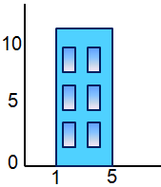

For example, the building above, is represented as (1, 11, 5).

A skyline is a collection of rectangular strips. A rectangular strip is represented as a pair (left, ht) where left is x coordinate of left side of strip and ht is height of strip.

Examples:

Input: Array of buildings

{ (1,11,5), (2,6,7), (3,13,9), (12,7,16), (14,3,25),

(19,18,22), (23,13,29), (24,4,28) }

Output: Skyline (an array of rectangular strips)

A strip has x coordinate of left side and height

(1, 11), (3, 13), (9, 0), (12, 7), (16, 3), (19, 18),

(22, 3), (23, 13), (29, 0)

The below figure demonstrates input and output.

The left side shows buildings and right side shows skyline.

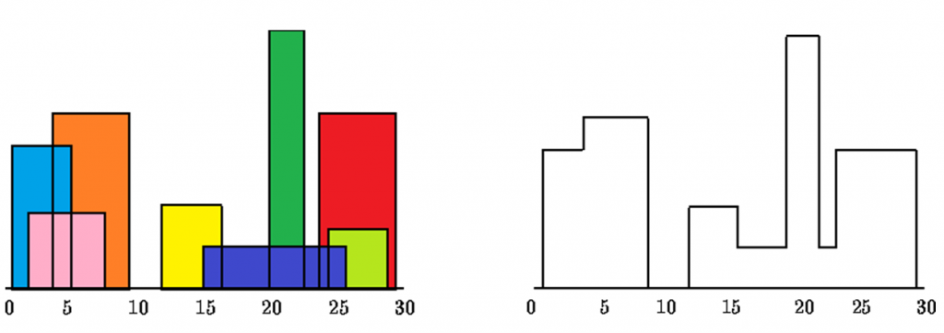

Consider following as another example when there is only one

building

Input: {(1, 11, 5)}

Output: (1, 11), (5, 0)

**Note:**

This problem is under development according to IK standards. If you'd like to contribute, then please feel free to email [soham@interviewkickstart.com](mailto:soham@interviewkickstart.com)

Till we finish developing this problem, you can look at:

Good explanation with visuals: <https://briangordon.github.io/2014/08/the-skyline-problem.html>

Succinct explanation: <http://www.geeksforgeeks.org/divide-and-conquer-set-7-the-skyline-problem/>

More granular problem definition: <https://leetcode.com/problems/the-skyline-problem/>