UDS COMMUNICATION OVER CAN NETWORK

Project Report

Contents
Requirement 3
Abstract. 4
Project Overview: 5
TESTER Node: 5
ECU Node: 5
Frame format: 6
System Background: 7
Algorithm 8
Block Diagram 9
TESTER (Client Side) Code 10
ECU (Server Side) Code 14
Results 17
Future Enhancement 19

Requirement
Implementing ECU and tester using LPC1768 and sending UDS request through can protocol

Abstract.
This project implements communication between 2 devices one acting as a Tester and another acting as Electronic Control Unit (ECU) communicating between two LPC1768 microcontroller through the Controller Area Network (CAN) protocol. The objective is to establish reliable data exchange between two nodes using Unified Diagnostic Services (UDS) messages. The system is designed such that the Tester sends two diagnostic requests to the ECU — one triggered by a timer and another triggered by an external interrupt. When the timer event occurs, the Tester sends a request for the Vehicle Identification Number (VIN), and the ECU responds by transmitting the VIN back through the CAN network. Similarly, when an external interrupt is activated, the Tester sends another UDS request asking for the ECU Hardware Number, and the ECU responds accordingly. The received data from both requests are displayed on a computer screen via UART for verification. The implementation demonstrates effective use of CAN communication, UART interfacing, timer control, and interrupt handling in automotive diagnostics, ensuring accurate message transfer and safe termination of communication between the two systems.

Project Overview:
This project builds a mini diagnostic communication system between two LPC1768 boards — one acting as a Tester and the other as an ECU. They talk via the CAN Bus, using UDS messages to exchange important information like VIN and Hardware Number. All actions are time-triggered or button-triggered, and results are shown on the PC terminal through UART.
It’s a hands-on demonstration of how real cars diagnose and communicate internally, combining embedded systems, communication protocols, and automotive technology in one project.

TESTER Node:
- Timer (3s): Automatically triggers a UDS request for VIN (F190).
- GPIO Interrupt (P2.13): On button press, triggers a UDS request for ECU HW No. (F113).
- Send requests to CAN Bus with ID 0x7DF.

ECU Node:
- Listens for requests on the CAN Bus.
- Processes UDS Requests: Decodes the Data Identifier (DID).
- Sends Responses back to the CAN Bus with ID 0x7E8.
- UART: Both nodes use UART to print status and data to a serial terminal on a PC.

Frame format:
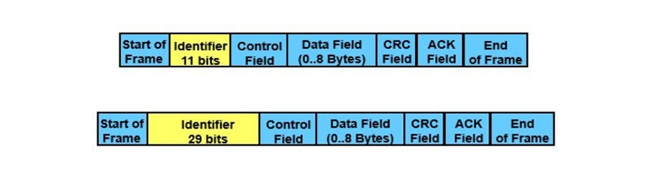

UDS request message consists of 8 bytes, formatted as follows:
Byte 0: Protocol Control Information (PCI) – indicates data length (e.g., 0x03).
Byte 1: Service Identifier (SID) – 0x22 for “Read Data by Identifier.”
Byte 2: Data Identifier High Byte (DID High) – 0xF1.
Byte 3: Data Identifier Low Byte (DID Low) – 0x90 for VIN or 0x13 for Hardware Number.
Bytes 4–7: Padding bytes (unused, filled with 0x00).

For Eg:
The ECU receives the VIN request, identifies the Data Identifier (DID = F190), processes the request, and prepares an 8-byte response in the following format:
Byte 0: Protocol Control Information (PCI) – indicates data length (e.g., 0x06).
Byte 1: Positive Response SID – original SID + 0x40 (e.g., 0x62).
Byte 2: Data Identifier High Byte (DID High) – 0xF1.
Byte 3: Data Identifier Low Byte (DID Low) – 0x90 for VIN or 0x13 for Hardware Number.
Bytes 4–7: Data bytes containing ASCII values of the response (e.g., 'E' 'C' 'U' or 'A' 'B' '1' '2').

System Background:
- In this project, we implement the UDS ReadDataByIdentifier (Service 0x22) over CAN. This service enables the tester to request specific ECU data items using their corresponding Data Identifiers (DIDs).
- Project Requirement Includes Implementation of sending UDS messages both Periodic Messages and message Send on External Interrupt:
- Periodic Message: The tester cyclically sends a ReadDataByIdentifier request for the Vehicle Identification Number (VIN), which is assigned DID F190.
- External Interrupt Trigger: Upon an external interrupt event, the tester sends a ReadDataByIdentifier request for the ECU Hardware Number, which corresponds to DID F113.

Algorithm
- Begin.
- Power ON both the Tester and ECU boards.
- Establish the CAN connection between the Tester and ECU.
- Connect both boards to the PC via UART to display communication logs.
- Flash ad initialize firmware on both boards to configure CAN, UART, Timer, and External Interrupt.
- Keep the Tester ready to send UDS diagnostic requests through the CAN bus.
- Keep the ECU in continuous receiving mode to process incoming CAN messages.
- The Tester periodically triggers a UDS ReadDataByIdentifier request for the Vehicle Identification Number (DID F190).
- The Tester sends the UDS request as an 8-byte CAN frame, and the ECU prints the received request on its UART terminal.
- The ECU identifies the incoming DID as F190 (VIN), processes the request, prepares the UDS Positive Response, and sends it back to the Tester.
The ECU prints a confirmation message indicating that the VIN response was sent.
- The Tester receives the VIN response and displays the decoded value on its UART terminal.
- When an external interrupt (button press) occurs on the Tester, it sends a UDS request for the ECU Hardware Number (DID F113).
- The ECU receives the Hardware Number request, prints the received frame on UART, processes it, generates the corresponding UDS response, and sends it to the Tester.
The ECU prints a confirmation message indicating that the Hardware Number response was sent.
- The Tester receives the Hardware Number response and prints the value on the UART terminal.
- Verify that both VIN and Hardware Number values appear correctly on the Tester’s UART terminal.
- Stop.

Block Diagram

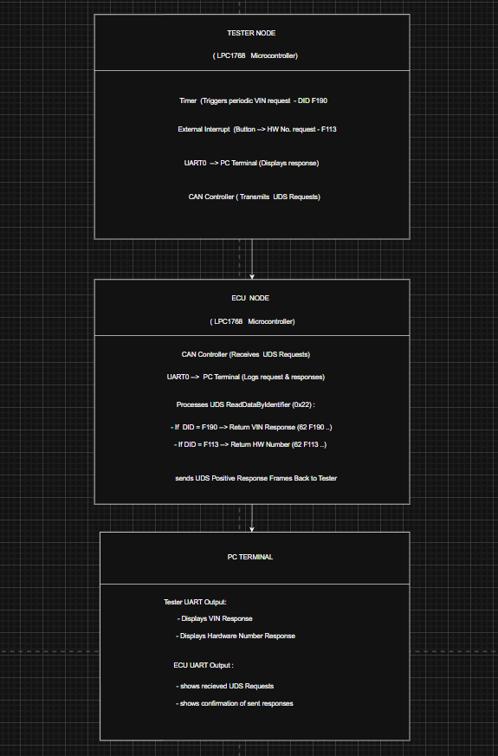

TESTER (Client Side) Code
#include "LPC17xx.h"
#include <stdint.h>
#include <stdio.h>
#define THRE (1 << 5)
#define DLAB (1 << 7)

typedef struct {
uint32_t id;
uint8_t len;
uint8_t data[8];
} CAN_msg;

volatile int sendPeriodicFlag = 0;

// Function Prototypes
void UART0_Init(void);
void UART0_Write(char c);
void UART0_WriteStr(const char *s);
void CAN_Init(void);
void CAN1_Send(CAN_msg *msg);
void setup_timer(void);
void setup_GPIO_interrupt(void);

// UDS CAN Messages
CAN_msg udsReqPeriodic;
CAN_msg udsReqKey;

// TIMER0 Interrupt (Every 3s)
void TIMER0_IRQHandler(void) {
LPC_TIM0->IR = 1;
sendPeriodicFlag = 1;
}

// GPIO Interrupt (Button P2.13)
void EINT3_IRQHandler(void) {
if (LPC_GPIOINT->IO2IntStatF & (1 << 13)) {
LPC_GPIOINT->IO2IntClr = (1 << 13);

CAN1_Send(&udsReqKey);
UART0_WriteStr("Button P2.13: ECU HW Number request sent\r\n");
}
}

int main(void) {
SystemInit();
UART0_Init();
CAN_Init();

UART0_WriteStr("UDS Tester Ready\r\n");

// Prepare VIN request (F190)
udsReqPeriodic.id = 0x7DF;
udsReqPeriodic.len = 8;
udsReqPeriodic.data[0] = 0x03;
udsReqPeriodic.data[1] = 0x22;
udsReqPeriodic.data[2] = 0xF1;
udsReqPeriodic.data[3] = 0x90;
for (int i = 4; i < 8; i++) udsReqPeriodic.data[i] = 0x00;

// Prepare ECU Hardware Number request (F113)
udsReqKey.id = 0x7DF;
udsReqKey.len = 8;
udsReqKey.data[0] = 0x03;
udsReqKey.data[1] = 0x22;
udsReqKey.data[2] = 0xF1;
udsReqKey.data[3] = 0x13;
for (int i = 4; i < 8; i++) udsReqKey.data[i] = 0x00;

setup_timer();
setup_GPIO_interrupt();

while (1) {
if (sendPeriodicFlag) {
sendPeriodicFlag = 0;
CAN1_Send(&udsReqPeriodic);
UART0_WriteStr("Periodic VIN request sent\r\n");
}
__WFI();
}
}

// UART Functions
void UART0_Init(void) {
LPC_PINCON->PINSEL0 |= (1 << 4) | (1 << 6);
LPC_UART0->LCR = 0x83;
LPC_UART0->DLL = 162;
LPC_UART0->DLM = 0;
LPC_UART0->LCR = 0x03;
}

void UART0_Write(char c) {
while (!(LPC_UART0->LSR & THRE));
LPC_UART0->THR = c;
}
void UART0_WriteStr(const char *s) {
while (*s) UART0_Write(*s++);
}
// Timer Setup (3s)
void setup_timer(void) {
LPC_SC->PCONP |= (1 << 1);
LPC_SC->PCLKSEL0 &= ~(3 << 2);
LPC_SC->PCLKSEL0 |= (1 << 2);

LPC_TIM0->PR = 25000 - 1;
LPC_TIM0->MR0 = 3000 - 1;
LPC_TIM0->MCR = 3;
LPC_TIM0->TCR = 1;
NVIC_EnableIRQ(TIMER0_IRQn);
}
// GPIO Interrupt Setup (P2.13)
void setup_GPIO_interrupt(void) {
LPC_PINCON->PINSEL4 &= ~(3 << 26);
LPC_GPIO2->FIODIR &= ~(1 << 13);
LPC_GPIOINT->IO2IntEnF |= (1 << 13);
LPC_GPIOINT->IO2IntClr = (1 << 13);
NVIC_EnableIRQ(EINT3_IRQn);
}
// CAN Init + Send
void CAN_Init(void) {
LPC_SC->PCONP |= (1 << 13) | (1 << 14);
LPC_SC->PCLKSEL0 &= ~((3 << 26) | (3 << 28));

LPC_PINCON->PINSEL0 &= ~0x0000000F;
LPC_PINCON->PINSEL0 |= 0x00000005;

LPC_CANAF->AFMR = 0x02;
LPC_CAN1->MOD = LPC_CAN2->MOD = 1;
LPC_CAN1->BTR = (0 << 23) | (0 << 22) | (5 << 20) | (6 << 16) | (2);
LPC_CAN2->BTR = LPC_CAN1->BTR;
LPC_CAN1->MOD = LPC_CAN2->MOD = 0;
}
void CAN1_Send(CAN_msg *msg) {
while (!(LPC_CAN1->SR & (1 << 2)));
LPC_CAN1->TFI1 = (msg->len & 0x0F) << 16;
LPC_CAN1->TID1 = msg->id & 0x7FF;
LPC_CAN1->TDA1 = (msg->data[3] << 24) | (msg->data[2] << 16) |
(msg->data[1] << 8) | (msg->data[0]);
LPC_CAN1->TDB1 = (msg->data[7] << 24) | (msg->data[6] << 16) |
(msg->data[5] << 8) | (msg->data[4]);
LPC_CAN1->CMR = 0x21;
}

ECU (Server Side) Code
#include "LPC17xx.h"
#include <stdint.h>
#include <stdio.h>
#define THRE (1 << 5)
#define DLAB (1 << 7)

typedef struct {
uint32_t id;
uint8_t len;
uint8_t data[8];
} CAN_msg;

void UART0_Init(void);
void UART0_Write(char c);
void UART0_WriteStr(const char *s);
void CAN_Init(void);
int CAN2_Receive(CAN_msg *msg);
void CAN2_Send(CAN_msg *msg);

int main(void) {
SystemInit();
UART0_Init();
CAN_Init();

UART0_WriteStr("UDS ECU Ready\r\n");

CAN_msg rx, tx;

while (1) {
if (CAN2_Receive(&rx)) {
UART0_WriteStr("UDS Req: ");
for (int i = 0; i < rx.len; i++) {
char buf[5];
sprintf(buf, "%02X ", rx.data[i]);
UART0_WriteStr(buf);
}
UART0_WriteStr("\r\n");

// VIN Request F190
if (rx.data[1] == 0x22 && rx.data[2] == 0xF1 && rx.data[3] == 0x90) {
tx.id = 0x7E8;
tx.len = 8;
tx.data[0] = 0x06;
tx.data[1] = 0x62;
tx.data[2] = 0xF1;
tx.data[3] = 0x90;
tx.data[4] = 'E';
tx.data[5] = 'C';
tx.data[6] = 'U';
tx.data[7] = 0x00;
CAN2_Send(&tx);
UART0_WriteStr("UDS Resp Sent: 62 F190 ECU\r\n");

// ECU HW Number F113
} else if (rx.data[1] == 0x22 && rx.data[2] == 0xF1 && rx.data[3] == 0x13) {
tx.id = 0x7E8;
tx.len = 8;
tx.data[0] = 0x06;
tx.data[1] = 0x62;
tx.data[2] = 0xF1;
tx.data[3] = 0x13;
tx.data[4] = 'A';
tx.data[5] = 'B';
tx.data[6] = '1';
tx.data[7] = '2';
CAN2_Send(&tx);
UART0_WriteStr("UDS Resp Sent: 62 F113 AB12\r\n");
}
}
}
}

void UART0_Init(void) {
LPC_PINCON->PINSEL0 |= (1 << 4) | (1 << 6);
LPC_UART0->LCR = 0x83;
LPC_UART0->DLL = 162;
LPC_UART0->DLM = 0;
LPC_UART0->LCR = 0x03;
}

void UART0_Write(char c) {
while (!(LPC_UART0->LSR & THRE));
LPC_UART0->THR = c;
}

void UART0_WriteStr(const char *s) {
while (*s) UART0_Write(*s++);
}

void CAN_Init(void) {
LPC_SC->PCONP |= (1 << 13) | (1 << 14);
LPC_SC->PCLKSEL0 &= ~((3 << 26) | (3 << 28));

LPC_PINCON->PINSEL4 &= ~0x0003C000;
LPC_PINCON->PINSEL4 |= 0x00014000;

LPC_CANAF->AFMR = 0x02;
LPC_CAN1->MOD = LPC_CAN2->MOD = 1;
LPC_CAN1->BTR = (0 << 23) | (0 << 22) | (5 << 20) | (6 << 16) | (2);
LPC_CAN2->BTR = LPC_CAN1->BTR;
LPC_CAN1->MOD = LPC_CAN2->MOD = 0;
}

int CAN2_Receive(CAN_msg *msg) {
if (LPC_CAN2->GSR & 1) {
msg->id = LPC_CAN2->RID;
msg->len = (LPC_CAN2->RFS >> 16) & 0x0F;

uint32_t A = LPC_CAN2->RDA, B = LPC_CAN2->RDB;
msg->data[0] = A & 0xFF;
msg->data[1] = (A >> 8) & 0xFF;
msg->data[2] = (A >> 16) & 0xFF;
msg->data[3] = (A >> 24) & 0xFF;
msg->data[4] = B & 0xFF;
msg->data[5] = (B >> 8) & 0xFF;
msg->data[6] = (B >> 16) & 0xFF;
msg->data[7] = (B >> 24) & 0xFF;

LPC_CAN2->CMR = (1 << 2);
return 1;
}
return 0;
}

void CAN2_Send(CAN_msg *msg) {
while (!(LPC_CAN2->SR & (1 << 2)));
LPC_CAN2->TFI1 = (msg->len & 0x0F) << 16;
LPC_CAN2->TID1 = msg->id & 0x7FF;
LPC_CAN2->TDA1 = (msg->data[3] << 24) | (msg->data[2] << 16) |
(msg->data[1] << 8) | (msg->data[0]);
LPC_CAN2->TDB1 = (msg->data[7] << 24) | (msg->data[6] << 16) |
(msg->data[5] << 8) | (msg->data[4]);
LPC_CAN2->CMR = 0x21;
}

Results

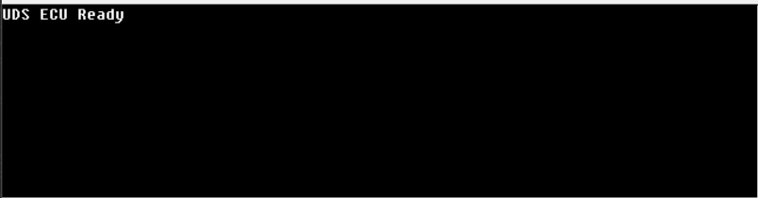
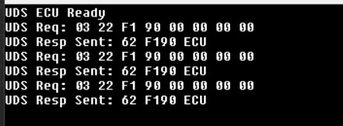
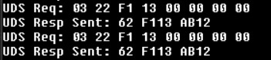
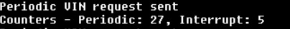
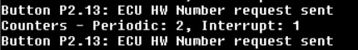
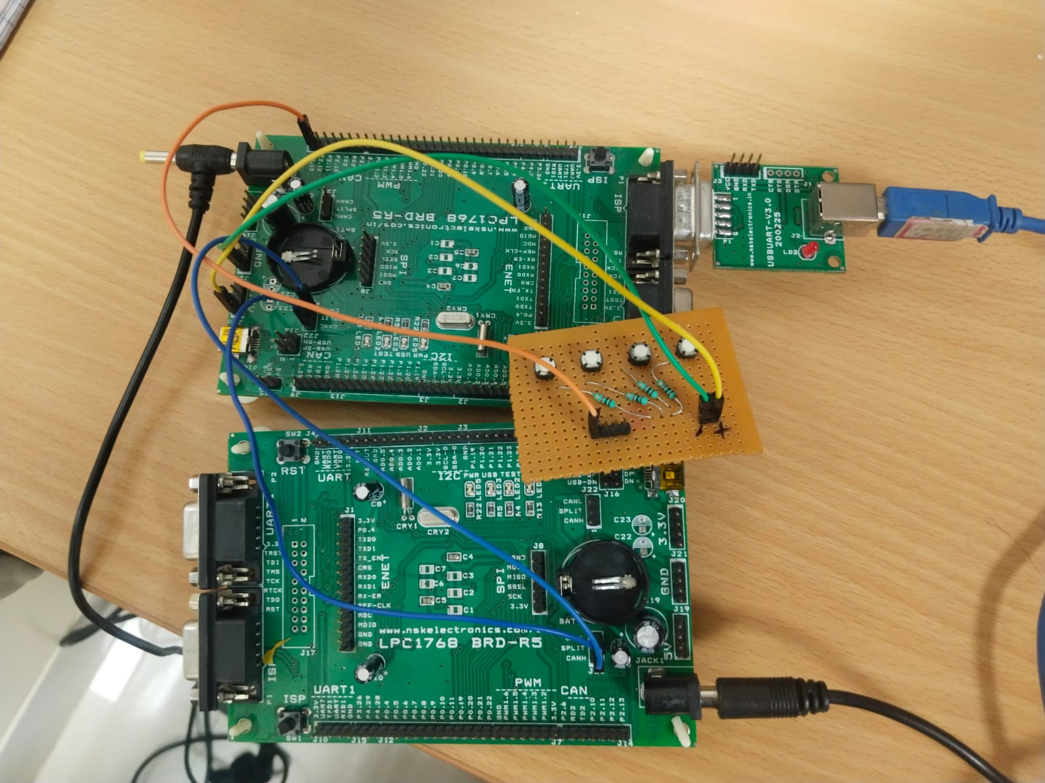

Future Enhancement
1) Add security access service (0x27) with seed-key authentication

2) Implement multiple ECU support with functional addressing

3) Add diagnostic trouble code management (services 0x19, 0x14)

