National Taipei University of Technology
Object-Oriented Analysis and Design
Homework #7
arch-checker
A Fluent Architectural Style Compliance Tool for Java

Team Member:
113598009 資工碩二 李俊威

Table of Contents
1. Requirement Document 3
1.1 Change History 3
1.2 Problem Statement 3
1.3 Summary of System Features 4
1.4 Use Case Diagram 4
1.5 Use Cases 5
1.6 Non-Functional Requirements and Constraints 10
1.7 Glossary 10
1.8 Software Environments 11
2. Domain Model 11
2.1 Domain Class Diagram (Concepts) 11
2.2 Associations 13
2.3 Attributes 14
3. Revision Based on TA Comments, Midterm Review, and Findings 1
4. Measurement 51

1. Requirement Document

1.1 Change History
Version | Date | Author | Description
1.0 | 2026-03-03 | 李俊威 | Initial submission (HW1) — Problem Statement
2.0 | 2026-03-12 |  | Add System Features, Use Cases, NFR, Glossary (HW2)
3.0 | 2026-04-01 |  | Add Domain Model; revise HW2: condense Problem Statement, rename SF-XX to FEA-XX, remove CLI commands from Use Cases, generalize error messages, remove implementation details
4.0 | 2026-04-17 |  | Add Design (Logical Architecture, Use-Case Realizations with GRASP, Design Class Model); revise HW3: remove non-system-state items from UC-02/UC-03 preconditions, reformat Domain Model descriptions as tables
5.0 | 2026-04-22 |  | Revise HW4: compact UC-01/UC-04 Sequence Diagrams, redraw Design Class Diagram, add Class Specifications table
6.0 | 2026-04-29 |  | 新增 Implementation Class Model、Programming、Unit Testing 三章節（HW5）；系統以 Maven 專案交付，使用 JavaParser、SnakeYAML、picocli、JUnit 5。
7.0 | 2026-05-05 |  | 重新命名介面與類別以更精確反映職責：ProfileRepository→ProfileLoader、SuppressionRepository→SuppressionStore、ArchitectureConstraint→ComplianceRule（套件 domain.constraint→domain.rule）；同步更新 Implementation Class Diagram、Sequence Diagrams 與內文敘述。
8.0 | 2026-05-26 |  | Iteration II：選定 UC-02 Define Style Profile 與 UC-03 Check with Interactive Fix Suggestions 為本迭代要實作之 use cases；於 Domain Model 新增 Violation.suggestion [0..1] 屬性以支援 UC-03 顯示修正建議；依 HW6 規定移除 Design／Implementation／Programming／Unit Testing 四章節，留待 HW7 提交。
9.0 | 2026-06-14 | FrankLi | Iteration II implementation: UC-02 (Define Style Profile) and UC-03 (Check with Interactive Fix Suggestions). Add Design, Implementation Class Model, Programming, and Unit Testing sections. 7 new classes, 6 modified classes, 28 JUnit 5 tests all pass.

1.2 Problem Statement
隨著軟體系統規模擴大與 AI 輔助程式碼生成的普及，人工驗證架構風格合規性日益困難，成為開發週期的瓶頸。現有工具（如 ArchUnit）雖可將架構限制寫成測試規則，但使用門檻較高，開發者需熟悉底層 API 並撰寫大量樣板程式碼，缺乏以風格為中心的高階抽象。arch-checker 是一套專為 Java 開發者設計的命令列工具，用於自動驗證 Java 專案的架構風格合規性。使用者可透過宣告式 API 以 YAML 定義架構風格設定檔（Style Profile），將命名、依賴、繼承等規則封裝為可重複使用的風格單元。系統透過 Java 原始碼的 AST 解析，精確偵測結構性違規，並產出含檔案路徑、行號與錯誤描述的完整報告，適用於本地開發、程式碼審查與持續整合情境。

1.3 Summary of System Features
ID | Feature Name | Priority | Description
FEA-01 | Architecture Compliance Checking | High | 掃描 Java 專案目錄，依使用者定義的 Style Profile 偵測違規
FEA-02 | Style Profile Definition via YAML | High | 使用者以 YAML 格式定義任意架構風格規則（DependencyRule、NamingRule、SupertypeRule、PackageRule）；工具不預設任何內建風格
FEA-03 | Violation Report Generation | High | 輸出含檔案路徑、行號、規則 ID、說明的違規報告
FEA-04 | Multiple Report Formats | Low | 支援 Console 與 JSON 兩種輸出格式
FEA-05 | Violation Suppression | Medium | 標記特定違規為「已知且接受」，下次不再回報

1.4 Use Case Diagram
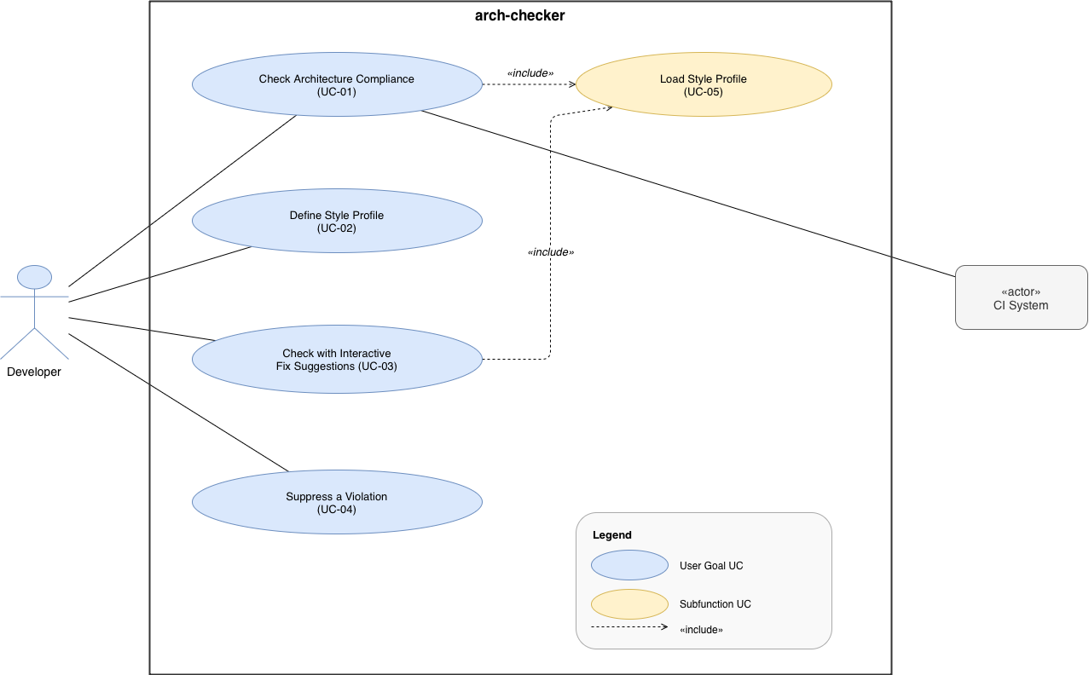
Actors:
Developer (Primary)：使用工具定義架構規則並檢查 Java 專案的開發者
CI System (Secondary)：在 CI/CD pipeline 中自動觸發合規檢查，依賴 exit code 判斷結果
UC | Name | Level | Format | Triggered by
UC-01 | Check Architecture Compliance | User Goal | Fully Dressed | Developer / CI System
UC-02 | Define Style Profile | User Goal | Fully Dressed | Developer
UC-03 | Check with Interactive Fix Suggestions | User Goal | Fully Dressed | Developer
UC-04 | Suppress a Violation | User Goal | Brief | Developer
UC-05 | Load Style Profile | Subfunction | Brief | UC-01 / UC-03 (include)

1.5 Use Cases
UC-01: Check Architecture Compliance (Fully Dressed)
Use Case | UC-01
Use Case Name | Check Architecture Compliance
Scope | arch-checker CLI
Level | User Goal
Primary Actor | Developer
Stakeholders and Interests | Developer：想要取得準確且詳細的違規報告，包含檔案路徑與行號，以便快速找出不符合規範的類別，避免費時的人工審查。  Team Lead / Architect：想確保整個程式碼庫符合團隊定義的架構規則，零違規代表架構一致性獲得維護。  CI System（次要）：想要可靠的 POSIX exit code（0/1/2）來判斷 pipeline 是否通過，不需要解讀報告內文。
Preconditions | 1. arch-checker 已安裝並可在系統中存取  2. 目標 Java 專案目錄存在且可讀取  3. Style Profile YAML 檔案存在且語法正確
Success Guarantee | 系統產生完整的 ViolationReport，包含：已檢查檔案數、違規清單、suppressedCount；並回傳 POSIX exit code（0 = pass，1 = violations found）
Main Success Scenario | 1. Developer 發出對指定專案目錄進行架構合規檢查的要求，並指定要使用的 Style Profile  2. 系統確認專案目錄存在  3. 系統讀取並解析指定的 Style Profile YAML 檔案  4. 系統遞迴掃描專案目錄下所有 .java 檔案  5. 系統以 JavaParser 將每個 .java 檔解析為 AST（CompilationUnit）  6. 系統對每個 CompilationUnit 套用 Profile 中所有 ComplianceRule 規則  7. 系統收集所有 Violation，每筆包含：檔案路徑、行號、規則 ID、說明文字  8. 系統過濾已被 suppress 的 Violation  9. 系統以 Console 格式輸出 ViolationReport（含違規清單與 summary）  10. 系統回傳 exit code：無違規則 0，有違規則 1
Extensions | 2a. 專案目錄不存在：系統輸出錯誤訊息，exit code 2，終止  3a. Style Profile 檔案不存在：系統輸出錯誤訊息，exit code 2，終止  3b. YAML 語法錯誤：系統輸出 YAML 解析錯誤與行號，exit code 2，終止  3c. YAML 語法正確但規則定義無效（如未知的 rule type）：系統輸出 validation 錯誤清單，exit code 2，終止  4a. 專案目錄下無 .java 檔：系統輸出警告訊息，exit code 0，終止  5a. 某 .java 檔語法錯誤無法解析：系統記錄警告訊息，跳過該檔案，繼續處理其餘檔案  8a. 所有 Violation 皆已被 suppress：報告顯示全部通過（含已抑制數量），exit code 0
Special Requirements | NFR-01（Performance）：掃描 1,000 個 .java 檔案必須在 10 秒內完成（一般開發機）  NFR-02（Usability）：所有錯誤訊息必須包含：錯誤原因、位置（檔案/行號）、建議修正動作  NFR-05（CI Compatibility）：exit code 遵循 POSIX 標準，可直接整合 GitHub Actions / Jenkins
Technology and Data Variations List | *a. Style Profile 接受任意 YAML 檔案路徑，不支援內建名稱  *b. 輸出格式可切換為 JSON，預設為 Console 文字格式  4a. Java 檔案掃描採遞迴深度優先走訪
Frequency of Occurrence | CI 環境：每次 push 觸發，每日可達數十次；本地開發：每小時數次
Miscellaneous | 是否需支援 multi-module Maven 專案（多個 src/main/java 子目錄）？  大型專案（>10,000 個 .java 檔）是否需要增量掃描機制？

UC-02: Define Style Profile (Fully Dressed) ← Iteration II（本迭代實作）
Use Case | UC-02
Use Case Name | Define Style Profile
Scope | arch-checker CLI
Level | User Goal
Primary Actor | Developer
Stakeholders and Interests | Developer：想用最少工夫定義出可重複使用的架構規則，希望工具提供模板降低手寫 YAML 的門檻，並在儲存前即時得知格式是否正確。  Team Lead：想要團隊共享一份統一的 Profile 並版本控制於 Git，確保規則描述清楚且長期可維護。
Preconditions | arch-checker 已安裝並可在系統中存取
Success Guarantee | 一個語法正確、至少含 1 條規則的 .yaml Profile 檔案存在於磁碟，且可被 UC-01 成功載入使用
Main Success Scenario | 1. Developer 發出建立新 Style Profile 模板的要求，並指定輸出位置  2. 系統產生含預設結構與欄位說明註解的空白 YAML 模板，寫入指定位置  3. Developer 完成 YAML 編輯後，發出驗證 Style Profile 的要求  4. 系統讀取並解析 YAML 檔  5. 系統驗證每條規則的 type（NamingRule / DependencyRule / SupertypeRule / PackageRule）與所有必填欄位  6. 系統驗證每個 package pattern 的語法（只允許英數字、*、.）  7. 系統輸出驗證成功訊息，顯示載入的規則數量  8. Developer 在執行 UC-01 時指定此 Profile
Extensions | 3a. Developer 跳過模板建立步驟，直接對已存在的 YAML 發出驗證要求：從 Step 4 開始，正常執行  4a. 指定檔案不存在：系統輸出錯誤訊息，終止  5a. YAML 頂層結構錯誤（不是合法的 YAML mapping）：系統輸出錯誤訊息與錯誤行號，終止  5b. 遇到未知的 rule type：系統輸出錯誤訊息，列出允許的規則類型，終止  6a. package pattern 含非法字元：系統輸出錯誤訊息，終止  7a. YAML 格式正確但 rules 清單為空：系統輸出警告訊息，表示 Profile 有效但不會產生違規，exit code 0
Special Requirements | NFR-02（Usability）：所有 validation 錯誤訊息必須清楚指出 YAML 錯誤行號，並提供修正建議  NFR-04（Extensibility）：擴充新的規則類型不應影響現有規則的合規檢查行為
Technology and Data Variations List | *a. Profile 格式為 YAML（以 SnakeYAML 解析），採 UTF-8 編碼  *b. Developer 可使用任意文字編輯器（VS Code、IntelliJ、Vim 等），不需 IDE plugin  2a. 若輸出目錄不存在，系統自動建立
Frequency of Occurrence | 每個新專案通常執行一次；規則有異動時重複執行 validate；相對低頻，以週或月為單位
Miscellaneous | 是否提供 JSON Schema 供 IntelliJ / VS Code 在編輯 Profile YAML 時自動補全？  Profile 是否支援繼承（extends: <other-yaml-path>）以在既有規則上擴充？

UC-03: Check Architecture Compliance with Interactive Fix Suggestions (Fully Dressed) ← Iteration II（本迭代實作）
Use Case | UC-03
Use Case Name | Check Architecture Compliance with Interactive Fix Suggestions
Scope | arch-checker CLI
Level | User Goal
Primary Actor | Developer
Stakeholders and Interests | Developer：想逐條審視每個 Violation 並當場決定是否 suppress，希望系統提供可操作的修復建議，而不只是列出錯誤清單。  Team Lead：想知道哪些 Violation 是「已知且接受」的技術債，並有持久化且可稽核的 suppression 紀錄，而非無聲地被略過。
Preconditions | 1. 同 UC-01 的前置條件  2. Terminal 支援互動式輸入（非 pipe 重定向的 non-TTY 模式）
Success Guarantee | 對每條 Violation，三種結果之一成立：(a) Suppression 記錄寫入 .arch-checker-suppress.yaml，(b) Violation 保留在報告中，(c) 流程中止；最終 ComplianceReport 反映所有決策結果
Main Success Scenario | 1. Developer 發出以互動模式對指定專案進行架構合規檢查的要求，並指定 Style Profile  2. 系統完成掃描流程（同 UC-01 Step 2–7）：走訪檔案、解析 AST、套用規則、收集所有 Violation  3. 系統展示第一條 Violation，顯示：檔案路徑與行號、違反的 ComplianceRule ID 與說明、RefactoringSuggestion（若存在）  4. 系統提示是否接受 suppression?  5. Developer 輸入 y：系統將此 Violation 的 rule ID 與時間戳記寫入 .arch-checker-suppress.yaml  6. 系統展示下一條 Violation（回到 Step 3）  7. 所有 Violation 處理完畢後，系統輸出最終 ComplianceReport（已扣除接受的 suppression）  8. 系統回傳 exit code（0 = 無未接受 Violation，1 = 有未接受 Violation）
Extensions | 3a. 此 Violation 有 RefactoringSuggestion：系統在顯示 [y/n/q] 提示前，額外顯示建議操作  3b. 掃描後無 Violation：系統直接輸出全部通過訊息，不進入互動迴圈，exit code 0  5a. Developer 輸入 n：此 Violation 保留在最終報告中，系統繼續下一條（Step 6）  5b. Developer 輸入 q：系統中止互動迴圈，輸出已處理部分的 partial report，exit code 1  5c. Developer 輸入非法值（非 y/n/q）：系統輸出 Invalid input. Please enter y, n, or q:，重新等待輸入  8a. 所有 Violation 均被 suppress（全部輸入 y）：報告顯示全部通過（含已抑制數量），exit code 0
Special Requirements | NFR-02（Usability）：互動提示須清晰易懂，Developer 無需查閱文件即能理解 [y/n/q] 各選項的含義  NFR-06（Testability）：互動流程的合規性檢查邏輯必須可透過 unit test 獨立驗證，不依賴完整的 CLI 環境
Technology and Data Variations List | *a. Suppression 記錄寫入 .arch-checker-suppress.yaml，包含：rule ID、reason（預設為 suppressed interactively）、timestamp  4a. [y/n/q] 輸入大小寫不敏感（Y、Yes 均視為接受）  *b. 若 stdout 被 pipe 重定向（non-TTY），系統自動降級為非互動批次模式並輸出警告
Frequency of Occurrence | 本地開發初次建立 suppression 清單時使用，通常每個新專案執行一次；後續違規出現時按需使用，整體低頻
Miscellaneous | 是否需要提供 --accept-all 選項，一次 suppress 所有 Violation？  Suppression 是否應設有效期限，避免長期堆積技術債？

UC-04: Suppress a Violation (Brief)
Developer 發出抑制特定違規的要求，並提供 rule ID 與原因說明。系統將 suppression 記錄（rule ID、reason、timestamp）寫入 .arch-checker-suppress.yaml。下次執行 UC-01 時，於 Step 8 過濾生效。

UC-05: Load Style Profile (Brief — Subfunction)
UC-01 與 UC-03 的 <<include>> 子流程。系統讀取使用者指定的 Style Profile YAML 檔，解析並驗證規則定義。成功後將 Profile 載入記憶體，供各 rule checker 使用。

1.6 Non-Functional Requirements and Constraints
ID | Category | Requirement
NFR-01 | Performance | 完整的 compliance check（UC-01）掃描 1,000 個 .java 檔案必須在 10 秒內完成（一般開發機）
NFR-02 | Usability | 所有錯誤訊息必須包含：錯誤原因、位置（檔案路徑 / 行號）、建議修正動作
NFR-03 | Portability | 工具需在 JDK 17+ 環境（Windows / macOS / Linux）上運行，不依賴特定 IDE
NFR-04 | Extensibility | 系統應支援在不修改既有合規檢查流程的前提下，擴充對新架構規則類型的支援
NFR-05 | CI Compatibility | exit code 遵循 POSIX 標準（0 = success，非 0 = failure），可直接整合 GitHub Actions 與 Jenkins
NFR-06 | Testability | 每個架構規則的合規性檢查邏輯必須可透過 unit test 獨立驗證，不依賴完整的 CLI 環境

1.7 Glossary
Term | Definition
Style Profile | 使用者以 YAML 格式定義的架構規則集合，描述特定專案的架構約束；工具本身不提供任何內建 Profile
ComplianceRule | Style Profile 中的單條約束規則，為 NamingRule、DependencyRule、SupertypeRule、PackageRule 的抽象父類別
SupertypeRule | 一種 ComplianceRule，要求特定 package 內的 class 必須 implement 指定 interface 或 extend 指定 class；以 simple name 比對，不進行 fully qualified name resolution
Violation | 一筆架構違規記錄，包含：檔案路徑、行號、規則 ID、說明文字
ViolationReport | 單次 check 執行的完整輸出，彙整所有 Violation 與 summary
AST (Abstract Syntax Tree) | Java 原始碼的抽象語法樹表示，由 JavaParser 解析產生，供各 ConstraintChecker 進行分析
CompilationUnit | JavaParser 解析單一 .java 檔案後產生的根節點物件
Suppression | 開發者明確標記「此 Violation 已知且接受」的機制，使其在後續報告中不再出現
exit code | CLI 程式結束時回傳給 shell 的整數碼（0 = pass，1 = violations found，2 = error）
Package Pattern | 規則定義中用來比對 Java package 名稱的萬用字元字串（如 *.ui.*）；只允許英數字、*、.
suggestion | 針對單筆 Violation 的修正建議文字，於互動模式（UC-03）顯示給開發者；為 Violation 的可選屬性（[0..1]），非獨立概念類別。對應 NFR-02 之「建議修正動作」。

1.8 Software Environments
Item | Choice | Rationale
Development Language | Java 17 (JDK 17+) | LTS 版本穩定
AST Parser | JavaParser 3.x | 純 Java，API 直覺，無需 JDK tools
CLI Framework | picocli | 輕量，annotation-driven，與 Java 17 相容
Profile Format | YAML (SnakeYAML) | 可讀性高，易於編輯
Test Framework | JUnit 5 | unit testing
Build Tool | Maven | 依賴管理方便

2. Domain Model

2.1 Domain Class Diagram (Concepts)
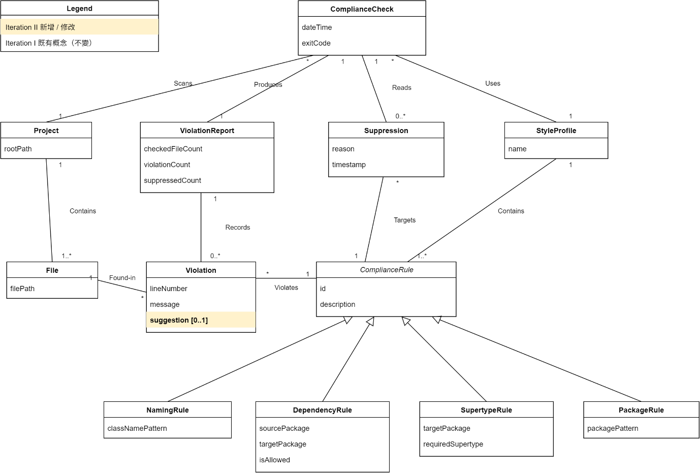
上圖為 arch-checker 的 Domain Class Diagram。識別出的概念類別如下：
已採納的概念類別與理由：
Concept | Rationale for Inclusion
ComplianceCheck | 代表一次完整的架構合規檢查作業，對應 UC-01/UC-03 中 Developer 對專案發出檢查要求的動作。系統需記錄每次檢查的時間與結果。
StyleProfile | 使用者以 YAML 定義的架構規則集合，包含多條 ComplianceRule。系統在 UC-01 載入 Profile 後，於 UC-02 逐條驗證其中的約束規則。
ComplianceRule | StyleProfile 中的單條約束規則（抽象概念），為 Profile 的組成元素。設為抽象類別，因其具有四個具體子類型，各自對應不同的架構約束面向。
NamingRule / DependencyRule / SupertypeRule / PackageRule | ComplianceRule 的四種具體子類型，分別檢查類別命名慣例、套件間依賴方向、繼承關係要求與套件結構規範。UC-02 驗證流程中依規則類型分派不同的檢查邏輯。
Project | 被檢查的目標 Java 專案，UC-01 中 Developer 指定的掃描對象。系統需知道專案路徑以定位其中的 File。
File | 專案中的 .java 原始碼檔案，為 Project 的組成元素。每個 Violation 需關聯到特定的 File 以定位違規位置。
ViolationReport | 單次檢查的完整報告，為 ComplianceCheck 的產出物。彙整所有 Violation 並提供統計摘要，供 Developer 或 CI 系統判讀結果。
Violation | 單筆架構違規記錄，記載哪個 File 違反了哪條 ComplianceRule。為 ViolationReport 的明細項目。
Suppression | 開發者標記「已知且接受」的違規抑制記錄，對應 UC-04 的功能。讓團隊可以在不修改程式碼的情況下，將特定違規排除於報告之外。
排除的候選概念與理由：
Excluded Candidate | Reason for Exclusion
CompilationUnit / AST | 這是 JavaParser 函式庫的軟體產物（software artifact），屬於實作層面的概念，不應出現在 Domain Model 中。
ProfileLoader / ProfileValidator | 這些是軟體類別（software classes），負責解析與驗證 Profile 的內部行為，非領域中的真實概念。
ConsoleReport / JSONReport | Console 與 JSON 是 ViolationReport 的輸出格式（SF-04），屬於呈現方式而非領域概念，不需獨立建模。
Developer / CISystem | 這些是外部 Actor，不屬於系統內部的領域概念。
ExitCode | exit code 是數值型態，適合作為 ComplianceCheck 的屬性而非獨立的概念類別。
ProfileTemplate | UC-02 產生的 YAML 模板是 StyleProfile 的輸出／呈現形式（與被排除的 ConsoleReport／JSONReport 同類），屬實作層產物，非領域概念。
ValidationResult / ValidationError | UC-02 驗證流程的產出。iteration I 已將負責解析與驗證 Profile 的 ProfileValidator 列為軟體類別，其產出同屬實作層，不需建模為領域概念。
Suggestion（升級為類別） | UC-03 的修正建議在本領域僅為一段文字，無自身結構、身份與關聯。依「純資料型別值即屬性」原則，應為 Violation 的屬性 suggestion [0..1]；升級為獨立類別屬過度建模（over-modeling）。
InteractiveSession / FixDecision | UC-03 的 [y/n/q] 逐條互動為控制流程，非「需要記憶的事物」；其結果（寫入 Suppression 或保留 Violation）已由既有概念建模，無須另立會話類別。

2.2 Associations
關聯的建立依據「需要記憶的關係」原則（need-to-remember associations）。下表列出各關聯的名稱、對應數量與建立理由：
Association | Cardinality | Rationale
ComplianceCheck Uses StyleProfile | * — 1 | 每次檢查使用一份 Profile；同一份 Profile 可被多次檢查使用。
ComplianceCheck Scans Project | * — 1 | 每次檢查掃描一個專案；同一專案可被多次檢查。
ComplianceCheck Produces ViolationReport | 1 — 1 | 每次檢查產出一份報告，一對一關係。
ComplianceCheck Reads Suppression | 1 — 0..* | 檢查時讀取已存在的 Suppression 記錄來過濾結果。
StyleProfile Contains ComplianceRule | 1 — 1..* | 一份 Profile 至少包含一條規則，為組合關係。
Project Contains File | 1 — 1..* | 專案包含一至多個 Java 檔案，為組合關係。
ViolationReport Records Violation | 1 — 0..* | 報告記錄零至多筆違規，為報告的明細項目。
Violation Violates ComplianceRule | * — 1 | 每筆違規對應一條被違反的規則。
Violation Found-in File | * — 1 | 每筆違規發生在特定的 Java 檔案中。
Suppression Targets ComplianceRule | * — 1 | 每筆抑制記錄對應一條特定規則。
此外，NamingRule、DependencyRule、SupertypeRule、PackageRule 為 ComplianceRule 的泛化（generalization）子類型，以空心三角形箭頭表示繼承關係。

2.3 Attributes
屬性的選擇遵循「在 Domain Model 中聚焦於資料型別屬性」的原則，避免將複雜概念當作屬性、避免以外鍵（foreign key）代替關聯。各概念類別之屬性整理如下：
Class | Attributes
ComplianceCheck | dateTime（檢查執行時間）、exitCode（結果碼：0=pass, 1=violations, 2=error）
StyleProfile | name（Profile 名稱，用於識別）
ComplianceRule | id（規則識別碼）、description（規則說明文字）
NamingRule | classNamePattern（類別命名的正規表達式 pattern）
DependencyRule | sourcePackage（來源套件 pattern）、targetPackage（目標套件 pattern）、isAllowed（是否允許此依賴方向）
SupertypeRule | targetPackage（適用的套件 pattern）、requiredSupertype（要求繼承或實作的型別名稱）
PackageRule | packagePattern（套件結構的萬用字元 pattern）
Project | rootPath（專案根目錄路徑）
File | filePath（檔案路徑）
ViolationReport | checkedFileCount（已檢查檔案數）、violationCount（違規總數）、suppressedCount（已抑制數量）
Violation | lineNumber（發生行號）、message（違規說明）、suggestion（針對該筆違規的修正建議，可選 [0..1]）
Suppression | filePath（被抑制違規所在檔案路徑）、lineNumber（被抑制違規所在行號）、reason（抑制原因）、timestamp（抑制時間戳記）

}
}
return p;
Files.writeString(p, body);
Path p = dir.resolve(name + ".java");
private static Path writeJava(Path dir, String name, String body) throws IOException {

}
assertTrue(result.isEmpty());

List<Violation> result = rule.validate(List.of(new File(src, "com.bar")));

"com.foo.domain", "com.foo.infra", false);
"domain must not depend on infra",
DependencyRule rule = new DependencyRule("R-DEP-01",
"package com.bar;\nimport com.foo.infra.X;\nclass C {}\n");
Path src = writeJava(tmp, "C",
void filesOutsideSourcePackageAreSkipped(@TempDir Path tmp) throws IOException {
@Test

}
assertTrue(result.isEmpty(), "expected no violation but got " + result);

List<Violation> result = rule.validate(List.of(new File(src, "com.foo.app")));

"com.foo.app", "com.foo.domain", true);
"app must depend on domain",
DependencyRule rule = new DependencyRule("R-DEP-02",
"package com.foo.app;\nimport com.foo.domain.Y;\nclass C {}\n");
Path src = writeJava(tmp, "C",
void allowedImportsAreIgnored(@TempDir Path tmp) throws IOException {
@Test

}
assertTrue(result.get(0).getMessage().contains("must not depend on"));
assertEquals(1, result.size());

List<Violation> result = rule.validate(List.of(new File(src, "com.foo.domain")));

"com.foo.domain", "com.foo.infra", false);
"domain must not depend on infra",
DependencyRule rule = new DependencyRule("R-DEP-01",
"package com.foo.domain;\nimport com.foo.infra.X;\nclass C {}\n");
Path src = writeJava(tmp, "C",
void disallowedImportProducesViolation(@TempDir Path tmp) throws IOException {
@Test

class DependencyRuleTest {

import static org.junit.jupiter.api.Assertions.*;

import java.util.List;
import java.nio.file.Path;
import java.nio.file.Files;
import java.io.IOException;

import org.junit.jupiter.api.io.TempDir;
import org.junit.jupiter.api.Test;
import com.archchecker.domain.compliance.Violation;
import com.archchecker.domain.codebase.File;

package com.archchecker.domain.rule;
— DependencyRuleTest.java — DependencyRule with suggestion

}
}
return p;
Files.writeString(p, body);
Path p = dir.resolve(name + ".java");
private static Path writeJava(Path dir, String name, String body) throws IOException {

}
assertTrue(result.get(0).getMessage().contains("BadName"));
assertEquals(1, result.size());

List<Violation> result = rule.validate(List.of(new File(src, "com.foo")));

NamingRule rule = new NamingRule("R-NAME-01", "Service suffix", ".*Service");
"package com.foo;\nclass GoodService {}\nclass BadName {}\n");
Path src = writeJava(tmp, "Mixed",
void multipleClassesInOneFileAreEachChecked(@TempDir Path tmp) throws IOException {
@Test

}
assertTrue(result.get(0).getMessage().contains("AccountManager"));
assertEquals(2, result.get(0).getLineNumber());
assertEquals(1, result.size());

List<Violation> result = rule.validate(List.of(new File(src, "com.foo")));

NamingRule rule = new NamingRule("R-NAME-01", "Service suffix", ".*Service");
"package com.foo;\nclass AccountManager {}\n");
Path src = writeJava(tmp, "AccountManager",
void nonCompliantClassNameProducesOneViolation(@TempDir Path tmp) throws IOException {
@Test

}
assertTrue(result.isEmpty(), "expected no violation but got " + result);

List<Violation> result = rule.validate(List.of(new File(src, "com.foo")));

NamingRule rule = new NamingRule("R-NAME-01", "Service suffix", ".*Service");
"package com.foo;\nclass AccountService {}\n");
Path src = writeJava(tmp, "AccountService",
void compliantClassNameProducesNoViolation(@TempDir Path tmp) throws IOException {
@Test

class NamingRuleTest {

import static org.junit.jupiter.api.Assertions.*;

import java.util.List;
import java.nio.file.Path;
import java.nio.file.Files;
import java.io.IOException;

import org.junit.jupiter.api.io.TempDir;
import org.junit.jupiter.api.Test;
import com.archchecker.domain.compliance.Violation;
import com.archchecker.domain.codebase.File;

package com.archchecker.domain.rule;
— NamingRuleTest.java — NamingRule with suggestion

}
}
}
return List.of(new Violation(1, "synthetic violation", reportedFile, this));
@Override public List<Violation> validate(List<File> files) {
AlwaysFailRule(File f) { super("FAIL", "always fail"); this.reportedFile = f; }
private final File reportedFile;
private static class AlwaysFailRule extends ComplianceRule {

}
}
return Collections.emptyList();
@Override public List<Violation> validate(List<File> files) {
AlwaysPassRule() { super("PASS", "always pass"); }
private static class AlwaysPassRule extends ComplianceRule {

}
@Override public void save(Path f, List<Suppression> s) { stored.clear(); stored.addAll(s); }
@Override public List<Suppression> loadAll(Path f, StyleProfile p) { return stored; }
FakeSupStore(List<Suppression> s) { this.stored = new ArrayList<>(s); }
private final List<Suppression> stored;
private static class FakeSupStore implements SuppressionStore {

}
@Override public StyleProfile load(Path profilePath) { return profile; }
FakeProfileLoader(StyleProfile p) { this.profile = p; }
private final StyleProfile profile;
private static class FakeProfileLoader implements ProfileLoader {

}
@Override public Project parseProject(Path rootPath) { return project; }
FakeParser(Project p) { this.project = p; }
private final Project project;
private static class FakeParser implements CodeParser {

}
assertEquals(1, r.getReport().getSuppressedCount());
assertEquals(0, r.getReport().getViolationCount());
assertEquals(0, r.getExitCode());

Paths.get("/x"), Paths.get("/p.yaml"), Paths.get("/s.yaml"));
ComplianceCheckService.CheckResult r = service.run(

ComplianceCheckService service = new ComplianceCheckService(parser, profileRepo, supRepo);
FakeSupStore supRepo = new FakeSupStore(List.of(sup));
new StyleProfile("p", List.of(rule)));
FakeProfileLoader profileRepo = new FakeProfileLoader(
Suppression sup = new Suppression(rule, file.getFilePath(), 1, "ack", Instant.now());
AlwaysFailRule rule = new AlwaysFailRule(file);
FakeParser parser = new FakeParser(new Project(Paths.get("/x"), List.of(file)));
File file = new File(Paths.get("/x/A.java"), "com.foo");
void suppressedViolationIsExcludedFromReport() {
@Test

}
assertEquals(1, r.getReport().getViolationCount());
assertEquals(1, r.getExitCode());

Paths.get("/x"), Paths.get("/p.yaml"), Paths.get("/s.yaml"));
ComplianceCheckService.CheckResult r = service.run(

ComplianceCheckService service = new ComplianceCheckService(parser, profileRepo, supRepo);
FakeSupStore supRepo = new FakeSupStore(Collections.emptyList());
new StyleProfile("p", List.of(rule)));
FakeProfileLoader profileRepo = new FakeProfileLoader(
AlwaysFailRule rule = new AlwaysFailRule(file);
FakeParser parser = new FakeParser(new Project(Paths.get("/x"), List.of(file)));
File file = new File(Paths.get("/x/A.java"), "com.foo");
void runReturnsExitOneWhenViolationsFound() {
@Test

}
assertEquals(1, r.getReport().getCheckedFileCount());
assertEquals(0, r.getReport().getViolationCount());
assertEquals(0, r.getExitCode());

Paths.get("/x"), Paths.get("/p.yaml"), Paths.get("/s.yaml"));
ComplianceCheckService.CheckResult r = service.run(

ComplianceCheckService service = new ComplianceCheckService(parser, profileRepo, supRepo);
FakeSupStore supRepo = new FakeSupStore(Collections.emptyList());
new StyleProfile("p", List.of(new AlwaysPassRule())));
FakeProfileLoader profileRepo = new FakeProfileLoader(
List.of(new File(Paths.get("/x/A.java"), "com.foo"))));
FakeParser parser = new FakeParser(new Project(Paths.get("/x"),
void runReturnsExitZeroWhenNoViolations() {
@Test

class ComplianceCheckServiceTest {

import static org.junit.jupiter.api.Assertions.*;

import java.util.List;
import java.util.Collections;
import java.util.ArrayList;
import java.time.Instant;
import java.nio.file.Paths;
import java.nio.file.Path;

import org.junit.jupiter.api.Test;
import com.archchecker.domain.profile.StyleProfile;
import com.archchecker.domain.rule.ComplianceRule;
import com.archchecker.domain.compliance.Violation;
import com.archchecker.domain.compliance.Suppression;
import com.archchecker.domain.codebase.Project;
import com.archchecker.domain.codebase.File;

package com.archchecker.application;
— ComplianceCheckServiceTest.java — core compliance check

}
}
assertEquals(4, profile.getRules().size(), "template must produce 4 rules");
assertNotNull(profile);

com.archchecker.domain.profile.StyleProfile profile = loader.load(output);
new com.archchecker.infrastructure.profile.YamlProfileLoader();
com.archchecker.infrastructure.profile.YamlProfileLoader loader =

new ProfileTemplateService().generateTemplate(output);
Path output = tmp.resolve("arch.yaml");
void generatedTemplateIsLoadableByYamlProfileLoader(@TempDir Path tmp) throws IOException {
@Test

}
assertTrue(content.contains("type: package"), "must include package rule example");
assertTrue(content.contains("type: supertype"), "must include supertype rule example");
assertTrue(content.contains("type: dependency"), "must include dependency rule example");
assertTrue(content.contains("type: naming"), "must include naming rule example");
String content = Files.readString(output);

new ProfileTemplateService().generateTemplate(output);
Path output = tmp.resolve("arch.yaml");
void generatedTemplateContainsAllFourRuleTypes(@TempDir Path tmp) throws IOException {
@Test

}
assertTrue(content.contains("rules:"), "template must include 'rules:' section");
assertTrue(content.contains("name:"), "template must include 'name:' field");
String content = Files.readString(output);
assertTrue(Files.exists(output), "template file should be created");

service.generateTemplate(output);

ProfileTemplateService service = new ProfileTemplateService();
Path output = tmp.resolve("arch.yaml");
void generateTemplateCreatesReadableYamlFile(@TempDir Path tmp) throws IOException {
@Test

class ProfileTemplateServiceTest {

import static org.junit.jupiter.api.Assertions.*;

import java.nio.file.Path;
import java.nio.file.Files;
import java.io.IOException;

import org.junit.jupiter.api.io.TempDir;
import org.junit.jupiter.api.Test;

package com.archchecker.application;
— ProfileTemplateServiceTest.java [new] — UC-02 template generation

}
}
}
saved.clear(); saved.addAll(s);
@Override public void save(Path f, List<Suppression> s) {
@Override public List<Suppression> loadAll(Path f, StyleProfile p) { return saved; }
final List<Suppression> saved = new ArrayList<>();
private static class SpyStore implements SuppressionStore {

}
}
return Collections.emptyList();
@Override public List<Violation> validate(List<File> files) {
StubRule(String id) { super(id, "stub"); }
private static class StubRule extends ComplianceRule {

}
return r;
for (Violation v : violations) r.addViolation(v);
r.setCheckedFileCount(1);
ViolationReport r = new ViolationReport();
private static ViolationReport reportWith(Violation... violations) {

}
new BufferedReader(new StringReader(input)));
return new InteractiveFixer(store, new PrintStream(buf),
ByteArrayOutputStream buf = new ByteArrayOutputStream();
private static InteractiveFixer fixerWithInput(String input, SpyStore store) {

}
"should re-prompt on invalid input");
assertTrue(buf.toString().contains("Invalid input"),

fixer.fix(report, Paths.get("/s.yaml"), new StyleProfile("p", List.of(rule)));
new BufferedReader(new StringReader("maybe\ny\n")));
new PrintStream(buf),
InteractiveFixer fixer = new InteractiveFixer(store,

ByteArrayOutputStream buf = new ByteArrayOutputStream();
SpyStore store = new SpyStore();
ViolationReport report = reportWith(v);
Violation v = new Violation(1, "bad", file, rule);
StubRule rule = new StubRule("R-NAME-01");
File file = new File(Paths.get("/x/A.java"), "com.foo");
void invalidInputPromptsAgainBeforeAccepting() {
@Test

}
assertEquals(0, result.getNewlySuppressed());
assertEquals(2, result.getRemaining().size(), "both violations remain after quit");

fixer.fix(report, Paths.get("/s.yaml"), new StyleProfile("p", List.of(rule)));
InteractiveFixer.FixResult result =
InteractiveFixer fixer = fixerWithInput("q\n", store);

SpyStore store = new SpyStore();
ViolationReport report = reportWith(v1, v2);
Violation v2 = new Violation(2, "v2", file, rule);
Violation v1 = new Violation(1, "v1", file, rule);
StubRule rule = new StubRule("R-NAME-01");
File file = new File(Paths.get("/x/A.java"), "com.foo");
void answerQStopsLoopAndKeepsRemainingViolations() {
@Test

}
assertTrue(store.saved.isEmpty());
assertEquals(0, result.getNewlySuppressed());
assertEquals(1, result.getRemaining().size());
assertEquals(1, result.getExitCode());

fixer.fix(report, Paths.get("/s.yaml"), new StyleProfile("p", List.of(rule)));
InteractiveFixer.FixResult result =
InteractiveFixer fixer = fixerWithInput("n\n", store);

SpyStore store = new SpyStore();
ViolationReport report = reportWith(v);
Violation v = new Violation(1, "bad name", file, rule);
StubRule rule = new StubRule("R-NAME-01");
File file = new File(Paths.get("/x/A.java"), "com.foo");
void answerNKeepsViolationInRemaining() {
@Test

}
assertEquals(1, store.saved.size());
assertTrue(result.getRemaining().isEmpty());
assertEquals(1, result.getNewlySuppressed());
assertEquals(0, result.getExitCode());

InteractiveFixer.FixResult result = fixer.fix(report, Paths.get("/s.yaml"), profile);
InteractiveFixer fixer = fixerWithInput("y\n", store);

StyleProfile profile = new StyleProfile("p", List.of(rule));
SpyStore store = new SpyStore();
ViolationReport report = reportWith(v);
Violation v = new Violation(1, "bad name", file, rule, "Rename it");
StubRule rule = new StubRule("R-NAME-01");
File file = new File(Paths.get("/x/A.java"), "com.foo");
void answerYSuppressesViolationAndReturnsExitZero() {
@Test

class InteractiveFixerTest {

import static org.junit.jupiter.api.Assertions.*;

import java.util.List;
import java.util.Collections;
import java.util.ArrayList;
import java.nio.file.Paths;
import java.nio.file.Path;
import java.io.StringReader;
import java.io.PrintStream;
import java.io.ByteArrayOutputStream;
import java.io.BufferedReader;

import org.junit.jupiter.api.Test;
import com.archchecker.domain.rule.ComplianceRule;
import com.archchecker.domain.profile.StyleProfile;
import com.archchecker.domain.compliance.ViolationReport;
import com.archchecker.domain.compliance.Violation;
import com.archchecker.domain.compliance.Suppression;
import com.archchecker.domain.codebase.File;

package com.archchecker.application;
— InteractiveFixerTest.java [new] — UC-03 interactive fixer
The following test files cover the new Iteration II functionality:

6.2 Unit Testing Code Listing [new]
[INFO] BUILD SUCCESS
[INFO] Tests run: 28, Failures: 0, Errors: 0, Skipped: 0
[INFO] Tests run: 3, Failures: 0, Errors: 0, Skipped: 0 ✓
[INFO] Running com.archchecker.infrastructure.suppression.YamlSuppressionStoreTest
[INFO] Tests run: 3, Failures: 0, Errors: 0, Skipped: 0 ✓
[INFO] Running com.archchecker.infrastructure.profile.YamlProfileLoaderTest
[INFO] Tests run: 2, Failures: 0, Errors: 0, Skipped: 0 ✓
[INFO] Running com.archchecker.domain.rule.SupertypeRuleTest
[INFO] Tests run: 2, Failures: 0, Errors: 0, Skipped: 0 ✓
[INFO] Running com.archchecker.domain.rule.PackageRuleTest
[INFO] Tests run: 3, Failures: 0, Errors: 0, Skipped: 0 ✓
[INFO] Running com.archchecker.domain.rule.NamingRuleTest
[INFO] Tests run: 3, Failures: 0, Errors: 0, Skipped: 0 ✓
[INFO] Running com.archchecker.domain.rule.DependencyRuleTest
[INFO] Tests run: 2, Failures: 0, Errors: 0, Skipped: 0 ✓
[INFO] Running com.archchecker.application.SuppressionServiceTest
[INFO] Tests run: 3, Failures: 0, Errors: 0, Skipped: 0 ✓
[INFO] Running com.archchecker.application.ProfileTemplateServiceTest [new]
[INFO] Tests run: 4, Failures: 0, Errors: 0, Skipped: 0 ✓
[INFO] Running com.archchecker.application.InteractiveFixerTest [new]
[INFO] Tests run: 3, Failures: 0, Errors: 0, Skipped: 0 ✓
[INFO] Running com.archchecker.application.ComplianceCheckServiceTest
$ mvn test

6.1 Snapshots of Testing Result [new]

6. Unit Testing [new]

}
}
}
return 2;
System.err.println("Validation failed: " + e.getMessage());
} catch (Exception e) {
return 0;
}
System.out.println(" - " + desc);
for (String desc : result.getRuleDescriptions()) {
+ "' is valid. Loaded " + result.getRuleCount() + " rule(s):");
System.out.println("Profile '" + result.getProfileName()
ProfileValidateService.ValidateResult result = service.validate(profilePath);
try {
new ProfileValidateService(new YamlProfileLoader());
ProfileValidateService service =
public Integer call() {
@Override

private Path profilePath;
@Parameters(index = "0", description = "Style Profile YAML file to validate.")

public class ProfileValidateCommand implements Callable<Integer> {
description = "Validate a Style Profile YAML and display loaded rules.")
@Command(name = "validate",

import java.util.concurrent.Callable;
import java.nio.file.Path;

import picocli.CommandLine.Parameters;
import picocli.CommandLine.Command;
import com.archchecker.infrastructure.profile.YamlProfileLoader;
import com.archchecker.application.ProfileValidateService;

package com.archchecker.cli;
— ProfileValidateCommand.java [new]

}
}
return 0;
System.out.println("Profile template written to: " + outputPath);
new ProfileTemplateService().generateTemplate(outputPath);
public Integer call() {
@Override

private Path outputPath;
@Parameters(index = "0", description = "Output path for the generated YAML template.")

public class ProfileInitCommand implements Callable<Integer> {
description = "Generate a Style Profile YAML template at the specified path.")
@Command(name = "init",

import java.util.concurrent.Callable;
import java.nio.file.Path;

import picocli.CommandLine.Parameters;
import picocli.CommandLine.Command;
import com.archchecker.application.ProfileTemplateService;

package com.archchecker.cli;
— ProfileInitCommand.java [new]

}
}
return fixResult.getExitCode();
+ " suppressed.");
+ (report.getSuppressedCount() + fixResult.getNewlySuppressed())
+ fixResult.getRemaining().size() + " violation(s) remaining; "
System.out.println("Checked " + report.getCheckedFileCount() + " file(s); "
System.out.println("--");
System.out.println();

fixer.fix(report, suppressionFile, profile);
InteractiveFixer.FixResult fixResult =
new BufferedReader(new InputStreamReader(System.in)));
store, System.out,
InteractiveFixer fixer = new InteractiveFixer(
StyleProfile profile = profileLoader.load(profilePath);

}
return result.getExitCode();
new ConsoleReporter().render(report);
if (report.getViolationCount() == 0) {
ViolationReport report = result.getReport();

checkService.run(projectPath, profilePath, suppressionFile);
ComplianceCheckService.CheckResult result =
new JavaParserAdapter(), profileLoader, store);
ComplianceCheckService checkService = new ComplianceCheckService(

YamlSuppressionStore store = new YamlSuppressionStore();
YamlProfileLoader profileLoader = new YamlProfileLoader();
public Integer call() {
@Override

private Path suppressionFile;
defaultValue = ".arch-checker-suppress.yaml")
description = "Suppression file (default: .arch-checker-suppress.yaml).",
@Option(names = {"-s", "--suppress-file"},

private Path profilePath;
@Parameters(index = "1", description = "Style Profile YAML file.")

private Path projectPath;
@Parameters(index = "0", description = "Java project root directory.")

public class FixCommand implements Callable<Integer> {
description = "Check architecture compliance with interactive fix suggestions.")
@Command(name = "fix",

import java.util.concurrent.Callable;
import java.nio.file.Path;
import java.io.InputStreamReader;
import java.io.BufferedReader;

import picocli.CommandLine.Parameters;
import picocli.CommandLine.Option;
import picocli.CommandLine.Command;
import com.archchecker.infrastructure.suppression.YamlSuppressionStore;
import com.archchecker.infrastructure.report.ConsoleReporter;
import com.archchecker.infrastructure.profile.YamlProfileLoader;
import com.archchecker.infrastructure.parser.JavaParserAdapter;
import com.archchecker.domain.profile.StyleProfile;
import com.archchecker.domain.compliance.ViolationReport;
import com.archchecker.application.InteractiveFixer;
import com.archchecker.application.ComplianceCheckService;

package com.archchecker.cli;
— FixCommand.java [new]

}
}
public List<String> getRuleDescriptions() { return ruleDescriptions; }
public int getRuleCount() { return ruleDescriptions.size(); }
public String getProfileName() { return profileName; }

}
this.ruleDescriptions = ruleDescriptions;
this.profileName = profileName;
public ValidateResult(String profileName, List<String> ruleDescriptions) {

private final List<String> ruleDescriptions;
private final String profileName;
public static class ValidateResult {

}
return new ValidateResult(profile.getName(), ruleIds);
}
ruleIds.add(r.getId() + " (" + r.getClass().getSimpleName() + ")");
for (ComplianceRule r : profile.getRules()) {
List<String> ruleIds = new ArrayList<>();
StyleProfile profile = profileLoader.load(profilePath);
public ValidateResult validate(Path profilePath) {

}
this.profileLoader = profileLoader;
public ProfileValidateService(ProfileLoader profileLoader) {

private final ProfileLoader profileLoader;
public class ProfileValidateService {

import java.util.List;
import java.util.ArrayList;
import java.nio.file.Path;

import com.archchecker.domain.rule.ComplianceRule;
import com.archchecker.domain.profile.StyleProfile;

package com.archchecker.application;
— ProfileValidateService.java [new]

}
}
}
throw new RuntimeException("Failed to write profile template: " + e.getMessage(), e);
} catch (IOException e) {
Files.writeString(outputPath, TEMPLATE, StandardCharsets.UTF_8);
}
Files.createDirectories(outputPath.getParent());
if (outputPath.getParent() != null) {
try {
public void generateTemplate(Path outputPath) {

+ " packagePattern: \"**.domain.**\"\n";
+ " description: \"Domain layer must exist\"\n"
+ " type: package\n"
+ " - id: R-PKG-01\n"
+ " # PackageRule: assert a package pattern exists in the project\n"
+ "\n"
+ " requiredSupertype: \"ComplianceRule\"\n"
+ " targetPackage: \"**.domain.rule\"\n"
+ " description: \"All rule classes must extend ComplianceRule\"\n"
+ " type: supertype\n"
+ " - id: R-SUP-01\n"
+ " # SupertypeRule: require classes in a package to extend/implement a type\n"
+ "\n"
+ " isAllowed: false\n"
+ " targetPackage: \"**.infrastructure.**\"\n"
+ " sourcePackage: \"**.domain.**\"\n"
+ " description: \"Domain must not depend on infrastructure\"\n"
+ " type: dependency\n"
+ " - id: R-DEP-01\n"
+ " # DependencyRule: control allowed/forbidden package dependencies\n"
+ "\n"
+ " classNamePattern: \".*Service\"\n"
+ " description: \"Service classes must end with 'Service'\"\n"
+ " type: naming\n"
+ " - id: R-NAME-01\n"
+ " # NamingRule: enforce a class name regex pattern\n"
+ "rules:\n"
+ "name: my-profile\n"
+ "# See https://github.com/your-org/arch-checker for full documentation.\n"
"# arch-checker Style Profile\n"
private static final String TEMPLATE =

public class ProfileTemplateService {

import java.nio.file.Path;
import java.nio.file.Files;
import java.nio.charset.StandardCharsets;
import java.io.IOException;

package com.archchecker.application;
— ProfileTemplateService.java [new]

}
}
public int getExitCode() { return remaining.isEmpty() ? 0 : 1; }
public List<Violation> getRemaining() { return remaining; }
public int getNewlySuppressed() { return newlySuppressed; }

}
this.remaining = remaining;
this.newlySuppressed = newlySuppressed;
public FixResult(int newlySuppressed, List<Violation> remaining) {

private final List<Violation> remaining;
private final int newlySuppressed;
public static class FixResult {

}
store.save(suppressionFile, all);
v.getLineNumber(), "Suppressed interactively", Instant.now()));
all.add(new Suppression(v.getRule(), v.getFile().getFilePath(),
List<Suppression> all = new ArrayList<>(store.loadAll(suppressionFile, profile));
private void suppress(Violation v, Path suppressionFile, StyleProfile profile) {

}
}
}
return "q";
} catch (IOException e) {
out.print("Invalid input. Please enter y, n, or q: ");
if (trimmed.equals("q") || trimmed.equals("quit")) return "q";
if (trimmed.equals("n") || trimmed.equals("no")) return "n";
if (trimmed.equals("y") || trimmed.equals("yes")) return "y";
String trimmed = line.trim().toLowerCase();
if (line == null) return "q";
String line = in.readLine();
try {
out.print("Suppress? [y/n/q]: ");
while (true) {
private String prompt() {

}
return new FixResult(newlySuppressed, remaining);
}
}
default -> remaining.add(v);
}
quit = true;
remaining.add(v);
case "q" -> {
}
newlySuppressed++;
suppress(v, suppressionFile, profile);
case "y" -> {
switch (answer) {
String answer = prompt();
}
out.println(" Suggestion: " + v.getSuggestion());
if (v.hasSuggestion()) {
out.println(" " + v.describe());
out.println("Violation " + (i + 1) + "/" + violations.size() + ":");
out.println();
}
continue;
remaining.add(v);
if (quit) {
Violation v = violations.get(i);
for (int i = 0; i < violations.size(); i++) {

boolean quit = false;
List<Violation> remaining = new ArrayList<>();
int newlySuppressed = 0;
List<Violation> violations = new ArrayList<>(report.getViolations());
public FixResult fix(ViolationReport report, Path suppressionFile, StyleProfile profile) {

}
this.in = in;
this.out = out;
this.store = store;
public InteractiveFixer(SuppressionStore store, PrintStream out, BufferedReader in) {

private final BufferedReader in;
private final PrintStream out;
private final SuppressionStore store;
public class InteractiveFixer {

import java.util.List;
import java.util.ArrayList;
import java.time.Instant;
import java.nio.file.Path;
import java.io.PrintStream;
import java.io.IOException;
import java.io.BufferedReader;

import com.archchecker.domain.profile.StyleProfile;
import com.archchecker.domain.compliance.ViolationReport;
import com.archchecker.domain.compliance.Violation;
import com.archchecker.domain.compliance.Suppression;

package com.archchecker.application;
— InteractiveFixer.java [new]

}
}
+ " [" + rule.getId() + "] " + message;
return file.getFilePath() + ":" + lineNumber
public String describe() {

public boolean hasSuggestion() { return suggestion != null && !suggestion.isBlank(); }
public String getSuggestion() { return suggestion; }
public ComplianceRule getRule() { return rule; }
public File getFile() { return file; }
public String getMessage() { return message; }
public int getLineNumber() { return lineNumber; }

}
this.suggestion = suggestion;
this.rule = rule;
this.file = file;
this.message = message;
this.lineNumber = lineNumber;
ComplianceRule rule, String suggestion) {
public Violation(int lineNumber, String message, File file,

}
this(lineNumber, message, file, rule, null);
public Violation(int lineNumber, String message, File file, ComplianceRule rule) {

private final String suggestion; // [0..1]
private final ComplianceRule rule;
private final File file;
private final String message;
private final int lineNumber;
public class Violation {

import com.archchecker.domain.rule.ComplianceRule;
import com.archchecker.domain.codebase.File;

package com.archchecker.domain.compliance;
— Violation.java [mod] — suggestion field added
The following listings show the most important source files for Iteration II (new / modified). For the full source, see the project repository.

5.2 Source Code Listing [new]
Checked 33 file(s); 36 violation(s); 0 suppressed.
--
... (36 violations total)
Suggestion: Rename 'CodeParser' to match pattern '.*Service'
Class 'CodeParser' violates naming pattern '.*Service'
src\main\java\com\archchecker\application\CodeParser.java:7 [R-NAME-01]
$ arch-checker check src/main/java target/sample-arch.yaml
UC-01: check compliance (running tool on its own source with the generated template — expected violations because the template uses a strict NamingRule requiring all classes to end with 'Service'):

- R-PKG-01 (PackageRule)
- R-SUP-01 (SupertypeRule)
- R-DEP-01 (DependencyRule)
- R-NAME-01 (NamingRule)
Profile 'my-profile' is valid. Loaded 4 rule(s):
$ arch-checker profile validate target/sample-arch.yaml

Profile template written to: target\sample-arch.yaml
$ arch-checker profile init target/sample-arch.yaml
UC-02: profile init and validate

5.1 Snapshots of System Execution [new]

5. Programming [new]
Table 4.3 — Line of Code per Production Class
No. | Class Name | # Methods | LOC (excl. comments/blanks)
1 | cli.Main | 2 | 20
2 | cli.CheckCommand | 6 | 39
3 | cli.SuppressCommand | 8 | 39
4 | cli.ProfileCommand [new] | 2 | 11
5 | cli.ProfileInitCommand [new] | 3 | 18
6 | cli.ProfileValidateCommand [new] | 3 | 30
7 | cli.FixCommand [new] | 5 | 55
8 | application.ComplianceCheckService | 12 | 41
9 | application.SuppressionService | 6 | 39
10 | application.InteractiveFixer [new] | 15 | 87
11 | application.ProfileTemplateService [new] | 3 | 48
12 | application.ProfileValidateService [new] | 11 | 31
13 | application.CodeParser (interface) | 1 | 6
14 | application.ProfileLoader (interface) | 1 | 6
15 | application.SuppressionStore (interface) | 1 | 9
16 | application.Reporter (interface) | 1 | 5
17 | domain.compliance.ComplianceCheck | 13 | 45
18 | domain.compliance.Violation [mod] | 15 | 31
19 | domain.compliance.ViolationReport | 12 | 29
20 | domain.compliance.Suppression | 13 | 29
21 | domain.codebase.File | 7 | 24
22 | domain.codebase.Project | 6 | 18
23 | domain.profile.StyleProfile | 6 | 18
24 | domain.rule.ComplianceRule | 8 | 27
25 | domain.rule.NamingRule [mod] | 7 | 46
26 | domain.rule.DependencyRule [mod] | 10 | 52
27 | domain.rule.SupertypeRule [mod] | 8 | 44
28 | domain.rule.PackageRule [mod] | 5 | 36
29 | infrastructure.parser.JavaParserAdapter | 4 | 42
30 | infrastructure.profile.YamlProfileLoader | 3 | 69
31 | infrastructure.report.ConsoleReporter | 5 | 22
32 | infrastructure.report.JsonReporter | 6 | 36
33 | infrastructure.suppression.YamlSuppressionStore | 5 | 79
 | Sum | 213 | 1131
The following table counts non-blank, non-comment lines of code for each production class (without test code). Classes new in Iteration II are marked [new]; modified ones are marked [mod].

4.3 Line of Code [new]
Table 4.2.2 — Summary of Implementation Class/Method Changes
 | Added | Removed | Modified (signature change)
Class | 7 | 0 | 6 (Main, Violation, NamingRule, DependencyRule, SupertypeRule, PackageRule)
Method / Attribute | 17 | 0 | 0
Table 4.2.2 summarises the overall count of changes.

Table 4.2.1 — Comparison of Design vs Implementation (Iteration II changes)
Class | Method / Attribute | Design | Imp.
FixCommand [new] | call(): Integer | Yes | Yes
ProfileCommand [new] | run(): void | Yes | Yes
ProfileInitCommand [new] | call(): Integer | Yes | Yes
ProfileValidateCommand [new] | call(): Integer | Yes | Yes
InteractiveFixer [new] | fix(report, file, profile): FixResult | Yes | Yes
InteractiveFixer [new] | prompt(): String | Yes | Yes
InteractiveFixer [new] | suppress(v, file, profile): void | Yes | Yes
InteractiveFixer.FixResult [new] | getExitCode(): int | Yes | Yes
ProfileTemplateService [new] | generateTemplate(outputPath): void | Yes | Yes
ProfileValidateService [new] | validate(profilePath): ValidateResult | Yes | Yes
ProfileValidateService.ValidateResult [new] | getRuleCount(): int | Yes | Yes
Violation [mod] | suggestion: String [0..1] (new attribute) | Yes | Yes
Violation [mod] | getSuggestion(): String (new method) | Yes | Yes
Violation [mod] | hasSuggestion(): boolean (new method) | Yes | Yes
NamingRule [mod] | validate(): now sets suggestion on Violation | Yes | Yes
DependencyRule [mod] | validate(): now sets suggestion on Violation | Yes | Yes
SupertypeRule [mod] | validate(): now sets suggestion on Violation | Yes | Yes
PackageRule [mod] | validate(): now sets suggestion on Violation | Yes | Yes
Main [mod] | subcommands: added ProfileCommand, FixCommand | Yes | Yes
Table 4.2.1 lists all classes and selected methods that were added or changed in Iteration II, comparing the DCD (Design) with the actual code (Implementation). 'Yes' means the class/method exists in that artifact.

4.2 Comparison: Design vs Implementation [new]
Figure 4.1 — Implementation Class Diagram (same structure as DCD; Iteration II additions highlighted in green)
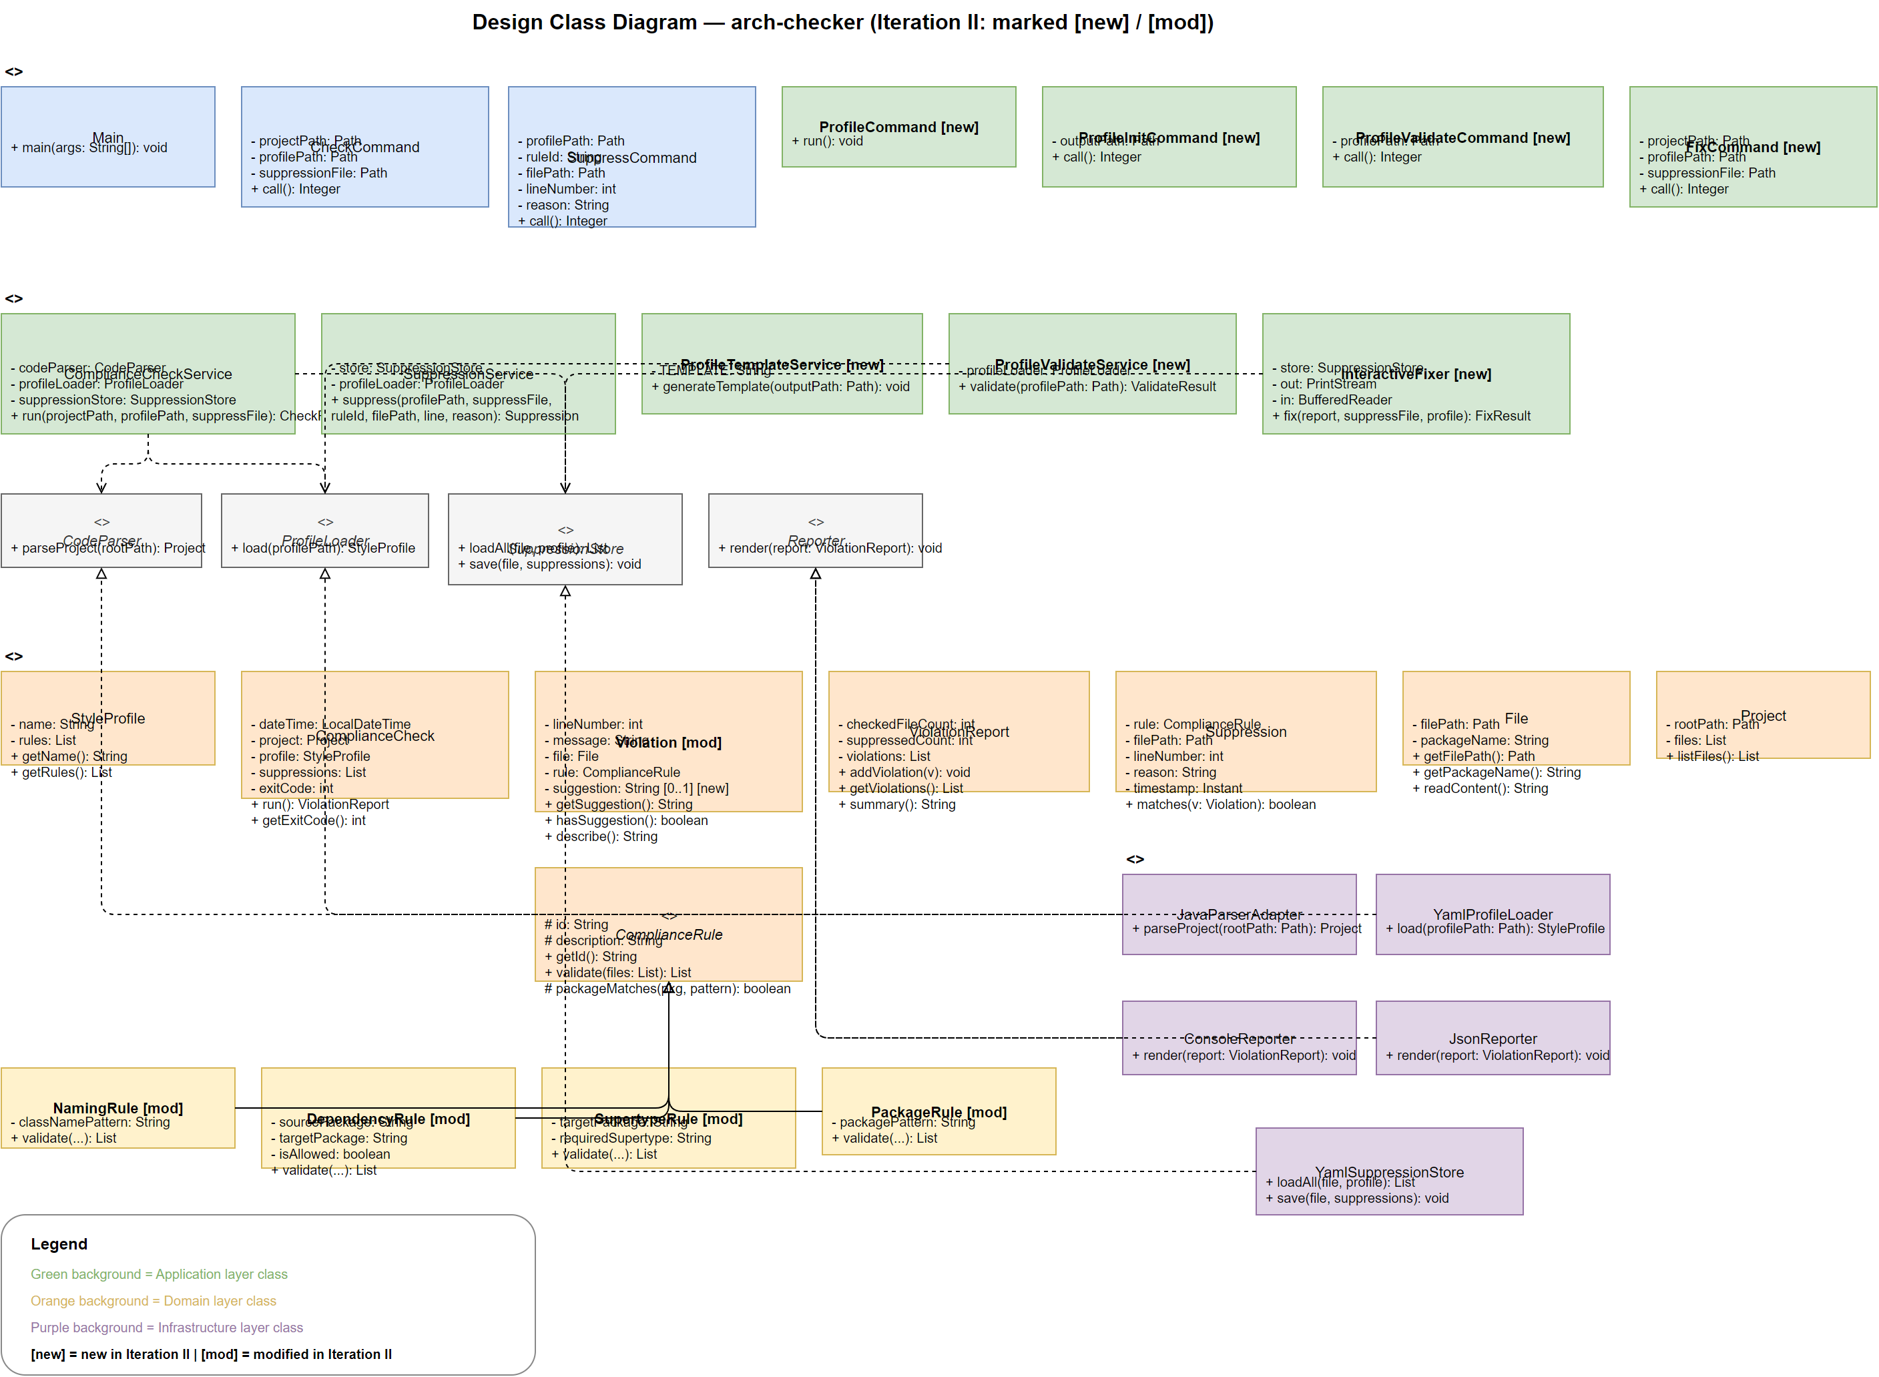
The Implementation Class Diagram (ICD) reflects the actual compiled structure of the system. Because we followed the DCD closely, the ICD is structurally identical to Figure 3.3. The key additions compared to Iteration I are the seven new classes (FixCommand, ProfileCommand, ProfileInitCommand, ProfileValidateCommand, InteractiveFixer, ProfileTemplateService, ProfileValidateService) and the suggestion field on Violation.

4.1 Implementation Class Diagram [new]

4. Implementation Class Model [new]
Figure 3.3 — Design Class Diagram (Iteration II)

The Design Class Diagram (DCD) below shows all classes, attributes, and key methods of the system after Iteration II. Classes marked [new] are new additions; those marked [mod] have been modified. The four ComplianceRule subclasses now include suggestion messages on each Violation they produce, supporting UC-03's interactive display.

3.3 Design Class Model [new]
Figure 3.2.2b — SD for validateProfile() with GRASP labels
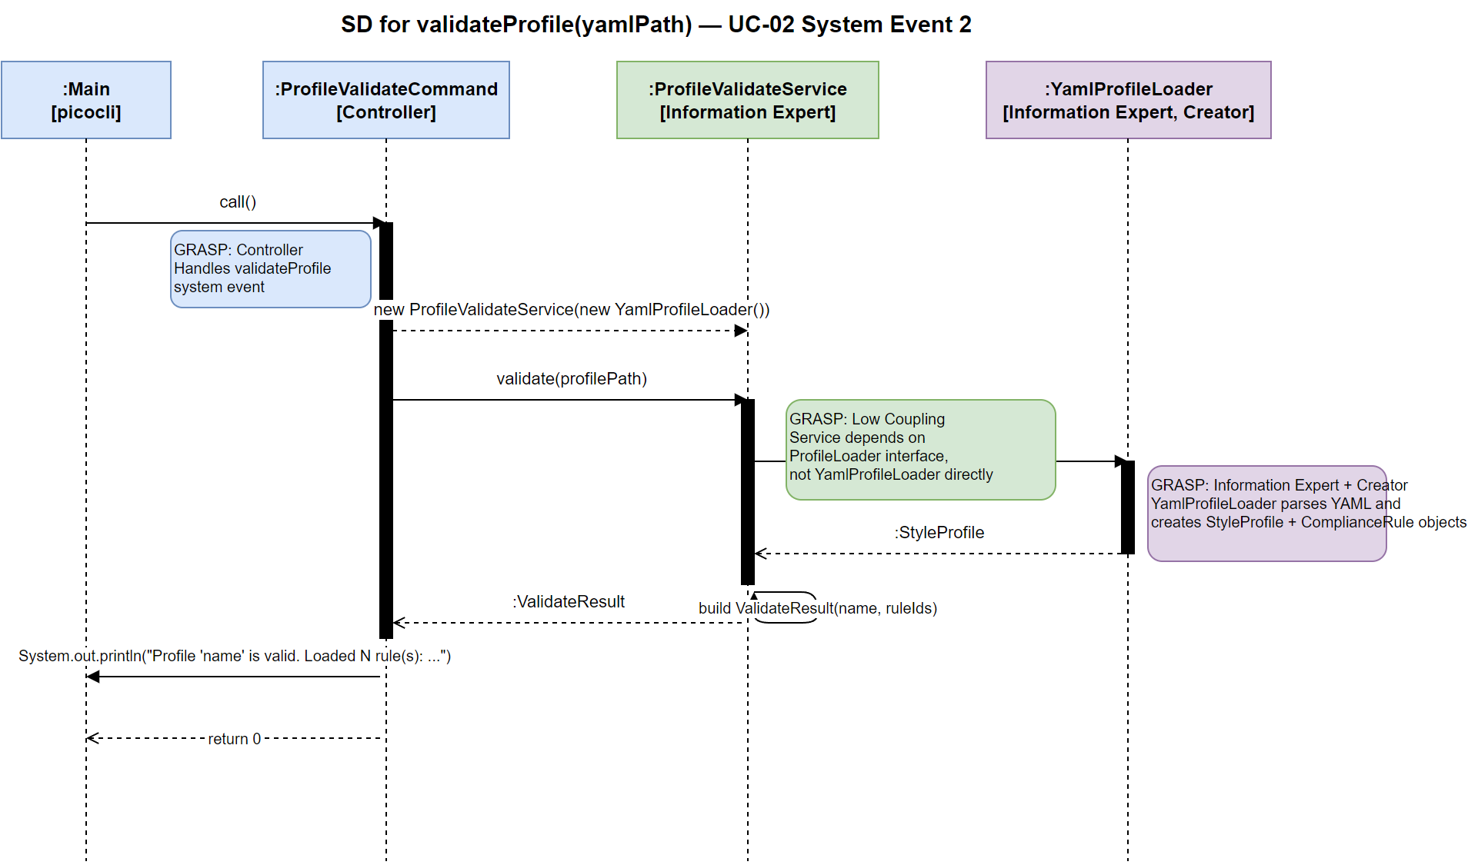
• Low Coupling: ProfileValidateService depends on the ProfileLoader interface, not on YamlProfileLoader directly, enabling easy substitution.
• Creator: YamlProfileLoader creates StyleProfile and ComplianceRule objects since it holds the parsed YAML data.
• Information Expert: ProfileValidateService knows validation orchestration; YamlProfileLoader is the expert on YAML parsing and StyleProfile creation.
• Controller: ProfileValidateCommand handles the validateProfile event.
GRASP patterns applied:
System Event 2: validateProfile(yamlPath)

Figure 3.2.2a — SD for initProfile() with GRASP labels
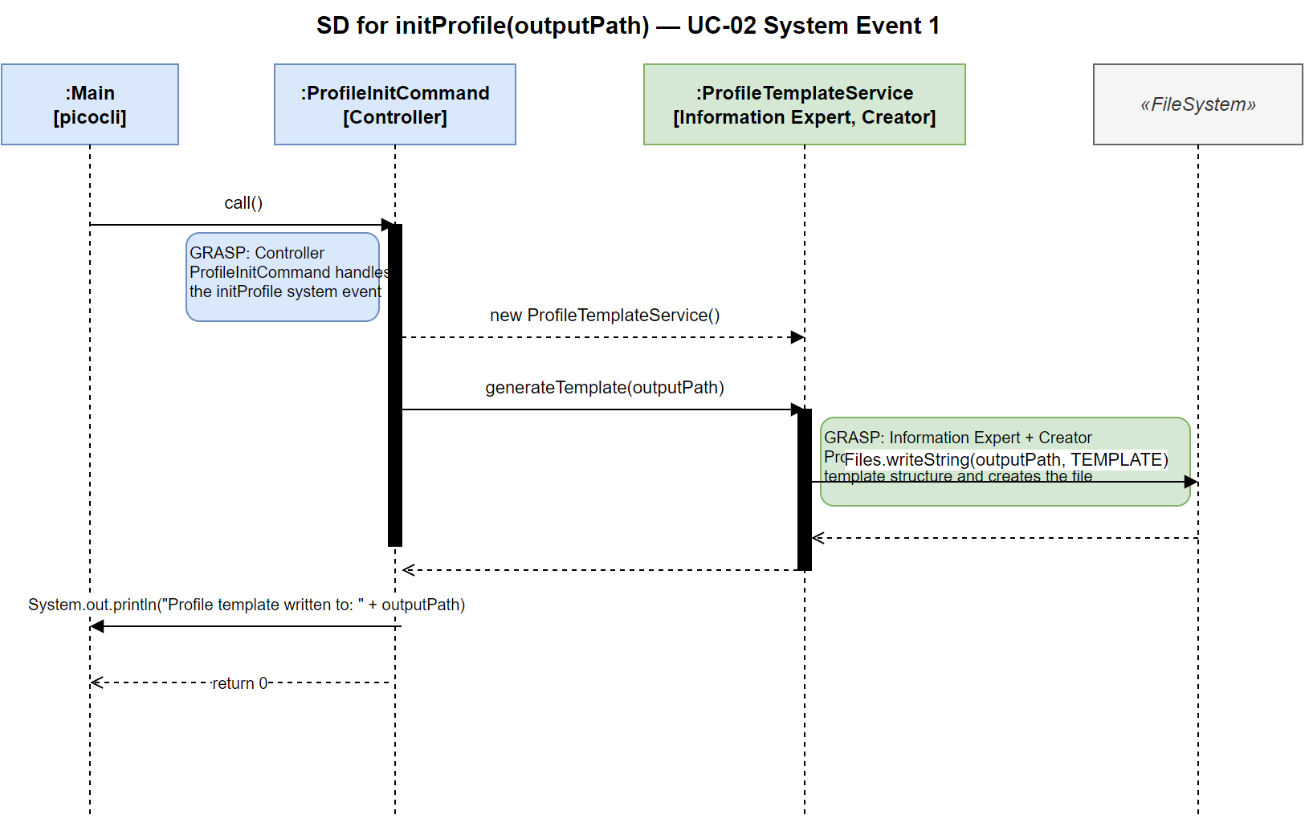
• Low Coupling: ProfileInitCommand creates ProfileTemplateService locally, keeping the CLI independent of file-system details.
• Information Expert + Creator: ProfileTemplateService has full knowledge of the template structure and is responsible for creating and writing the YAML file.
• Controller: ProfileInitCommand handles the initProfile system event as a use-case controller (one controller per use case).
GRASP patterns applied:
System Event 1: initProfile(outputPath)

3.2.2 Sequence Diagrams with GRASP Patterns
Figure 3.2.1 — SSD for UC-02 Define Style Profile
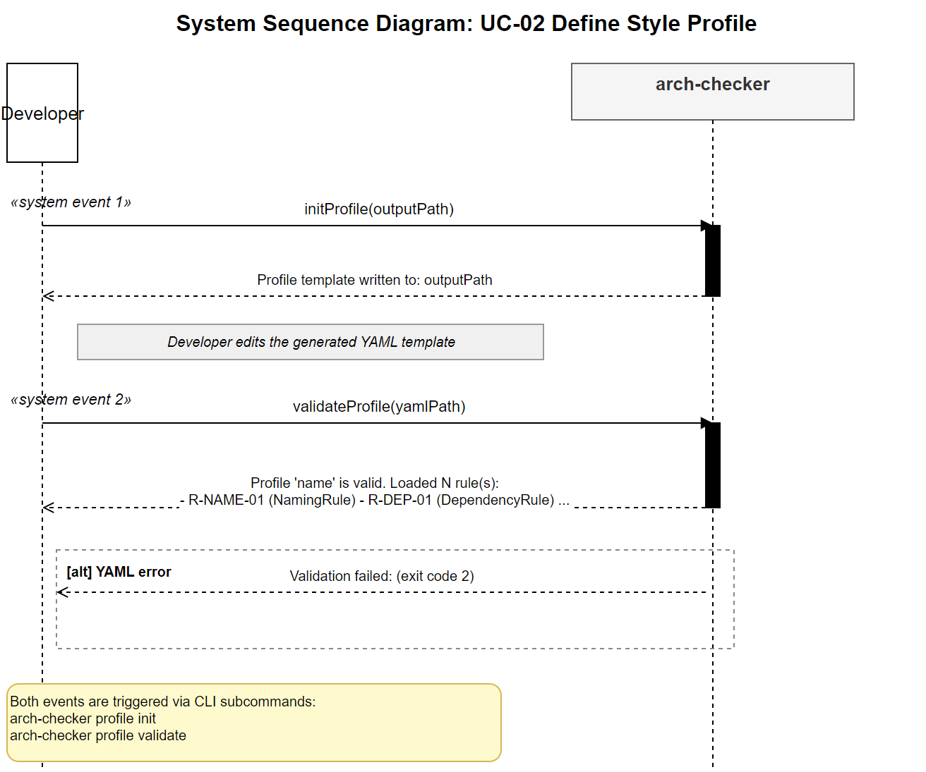
UC-02 is the most significant new use case in Iteration II. It exposes two system events: initProfile(outputPath) generates a YAML template, and validateProfile(yamlPath) validates an edited profile and reports how many rules were loaded.

3.2.1 System Sequence Diagram — UC-02 Define Style Profile

3.2 Use-Case Realizations with GRASP Patterns [new]
Figure 3.1 — Logical Architecture (UML Package Diagram)
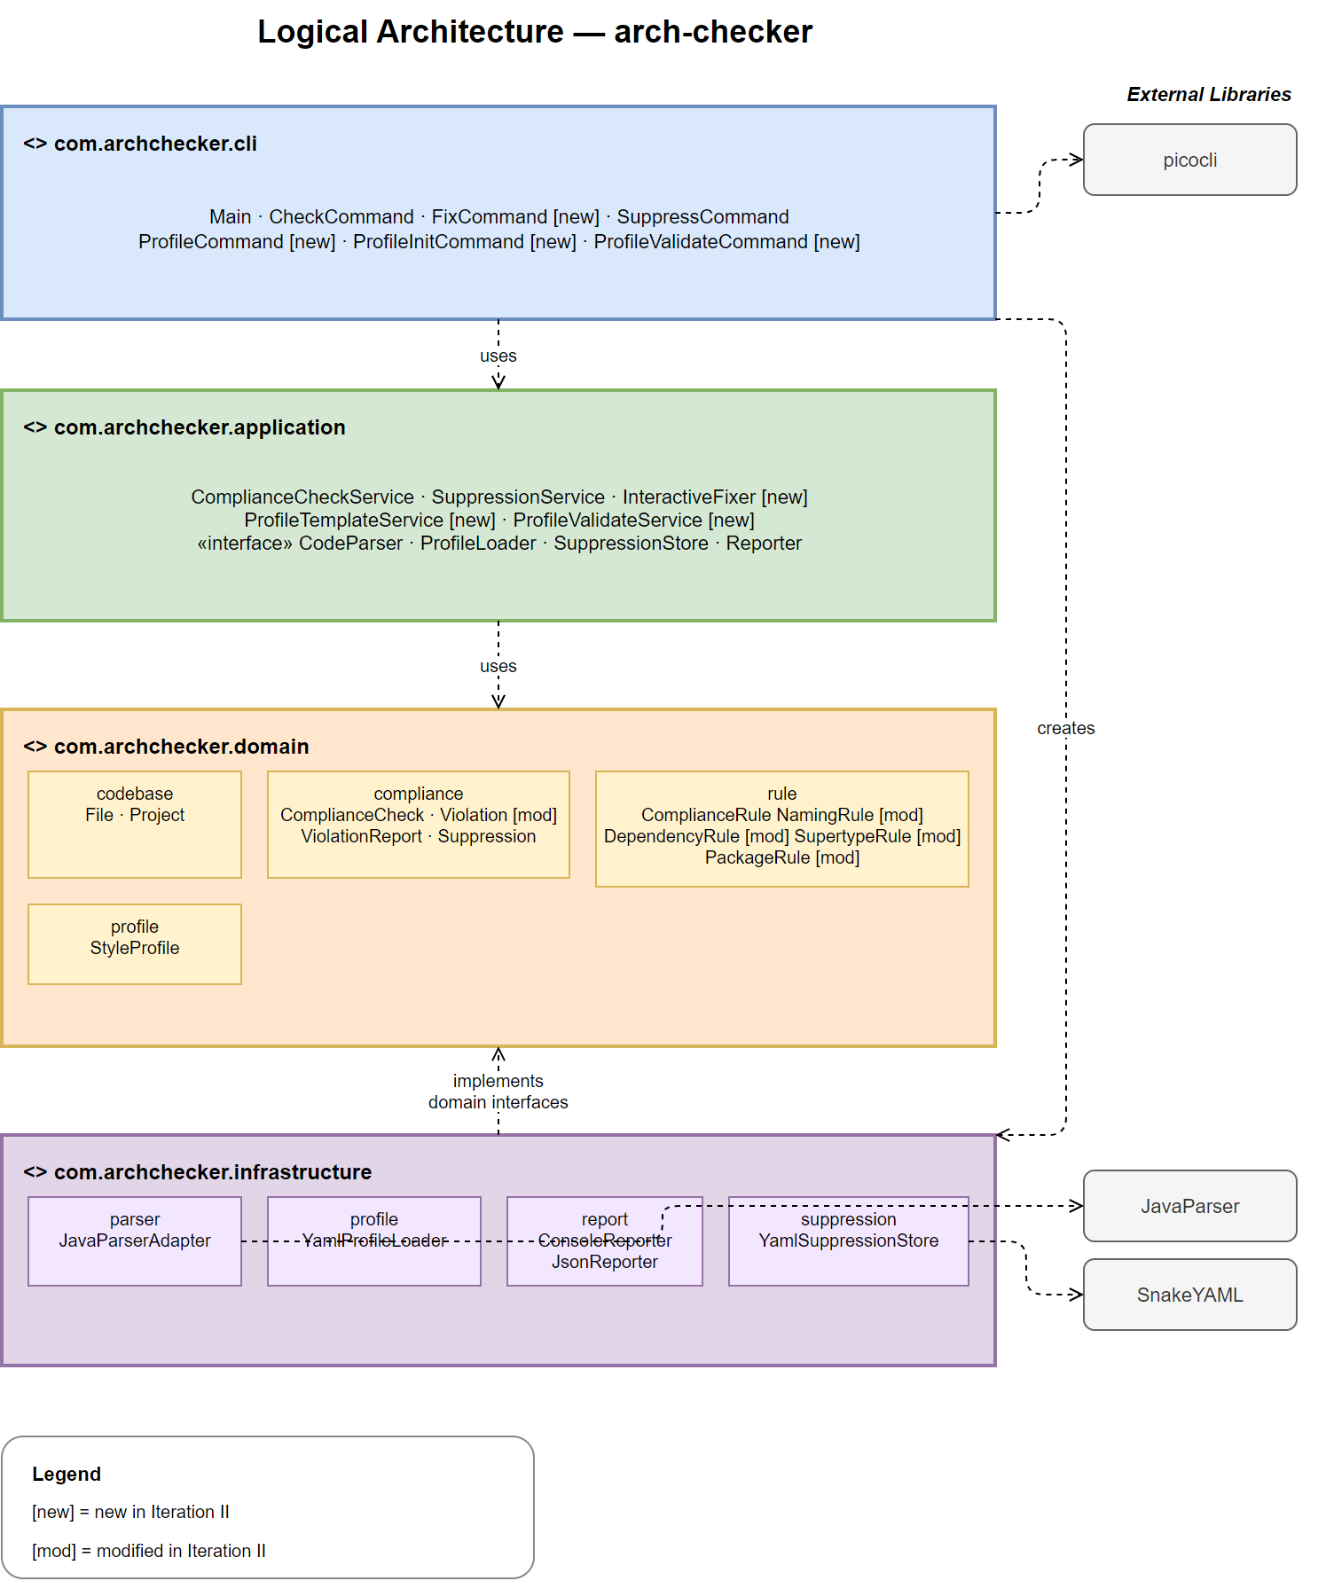
The arch-checker system is organised into four horizontal layers: CLI, Application, Domain, and Infrastructure. The CLI layer depends on the Application layer for business logic and on the Infrastructure layer for concrete adapters; it uses picocli as the CLI framework. The Application layer defines interfaces (CodeParser, ProfileLoader, SuppressionStore, Reporter) that the Infrastructure layer implements, following the Dependency Inversion Principle. The Domain layer contains pure business objects with no outward dependencies. Iteration II adds FixCommand, ProfileCommand, ProfileInitCommand, ProfileValidateCommand (CLI layer) and InteractiveFixer, ProfileTemplateService, ProfileValidateService (Application layer).

3.1 Logical Architecture with UML Package Diagram [new]

3. Design [new]

7. Revision Based on TA Comments, Midterm Review, and Findings
本次作業進入 Iteration II。以下修訂依據期中 review 與自我檢視進行。本文件之新增／修改處皆以黃色 highlight 標示。
1. Use Case 選擇：選定 UC-02（Define Style Profile）與 UC-03（Check with Interactive Fix Suggestions）為 Iteration II 要實作之 use cases——兩者於期中（Iteration I）未 demo、規劃於期末 demo，且自 HW2 起即以 fully dressed 格式定義。其餘 UC-01／UC-04／UC-05 已於 Iteration I 實作。
2. Domain Model：依 UC-03「逐條顯示修正建議」之需求，於 Violation 新增 suggestion [0..1] 屬性。修正建議係針對「單筆違規」而非「規則」，故置於 Violation；且其為純文字值、無自身結構與關聯。message 與 suggestion 語意切分：message 為錯誤原因與位置，suggestion 為可選之修法。
3. Bad Conceptual Classes：經分析，ProfileTemplate（輸出形式）、ValidationResult／ValidationError（軟體產物）、Suggestion（升級為類別，屬過度建模）、InteractiveSession／FixDecision（控制流程）皆不應納入領域模型，已於 §2.1 明列並說明理由。
4. 模型合併（Combine with Iteration I）：Iteration I 之 12 個概念類別、10 條關聯與既有屬性全數保留不變；Iteration II 對領域模型之唯一結構變更為新增 Violation.suggestion 屬性（未新增概念類別與關聯）。§2 之領域類別圖即為兩迭代之合併模型。
5. 文件結構：依 HW6 規定，本次移除 HW5 之 Design、Implementation Class Model、Programming、Unit Testing 四章節，留待 HW7（Iteration II 之設計與實作）重新提交。

8. Measurement
Student ID | Name | HW | Date | Duration
113598009 | 李俊威 | HW#1 | 115/03/03 15:00 ~ 18:00 | 3H
 |  | HW#2 | 115/03/12 15:00 ~ 21:00 | 6H
 |  | HW#3 | 115/04/01 14:00 ~ 20:00 | 6H
 |  | HW#4 | 115/04/17 14:00 ~ 18:00 | 4H
 |  |  | 115/04/22 13:00 ~ 17:00 | 4H
 |  | HW#5 | 115/04/29 19:00 ~ 23:30 | 4.5H
 |  |  | 115/05/05 15:00 ~ 23:00 | 8H
 |  | HW#6 | 115/05/26 20:00 ~ 23:30 | 3.5H
113598009 | FrankLi | HW#7 | 115/06/14 20:00 ~ 23:59 | 4H

