Exercise 3

Team5

113598009 李俊威

113598005 王昱捷

113598037 陳宥錡

114598003 許芷菱

Usecase 1: Plan Route

1)SSD:
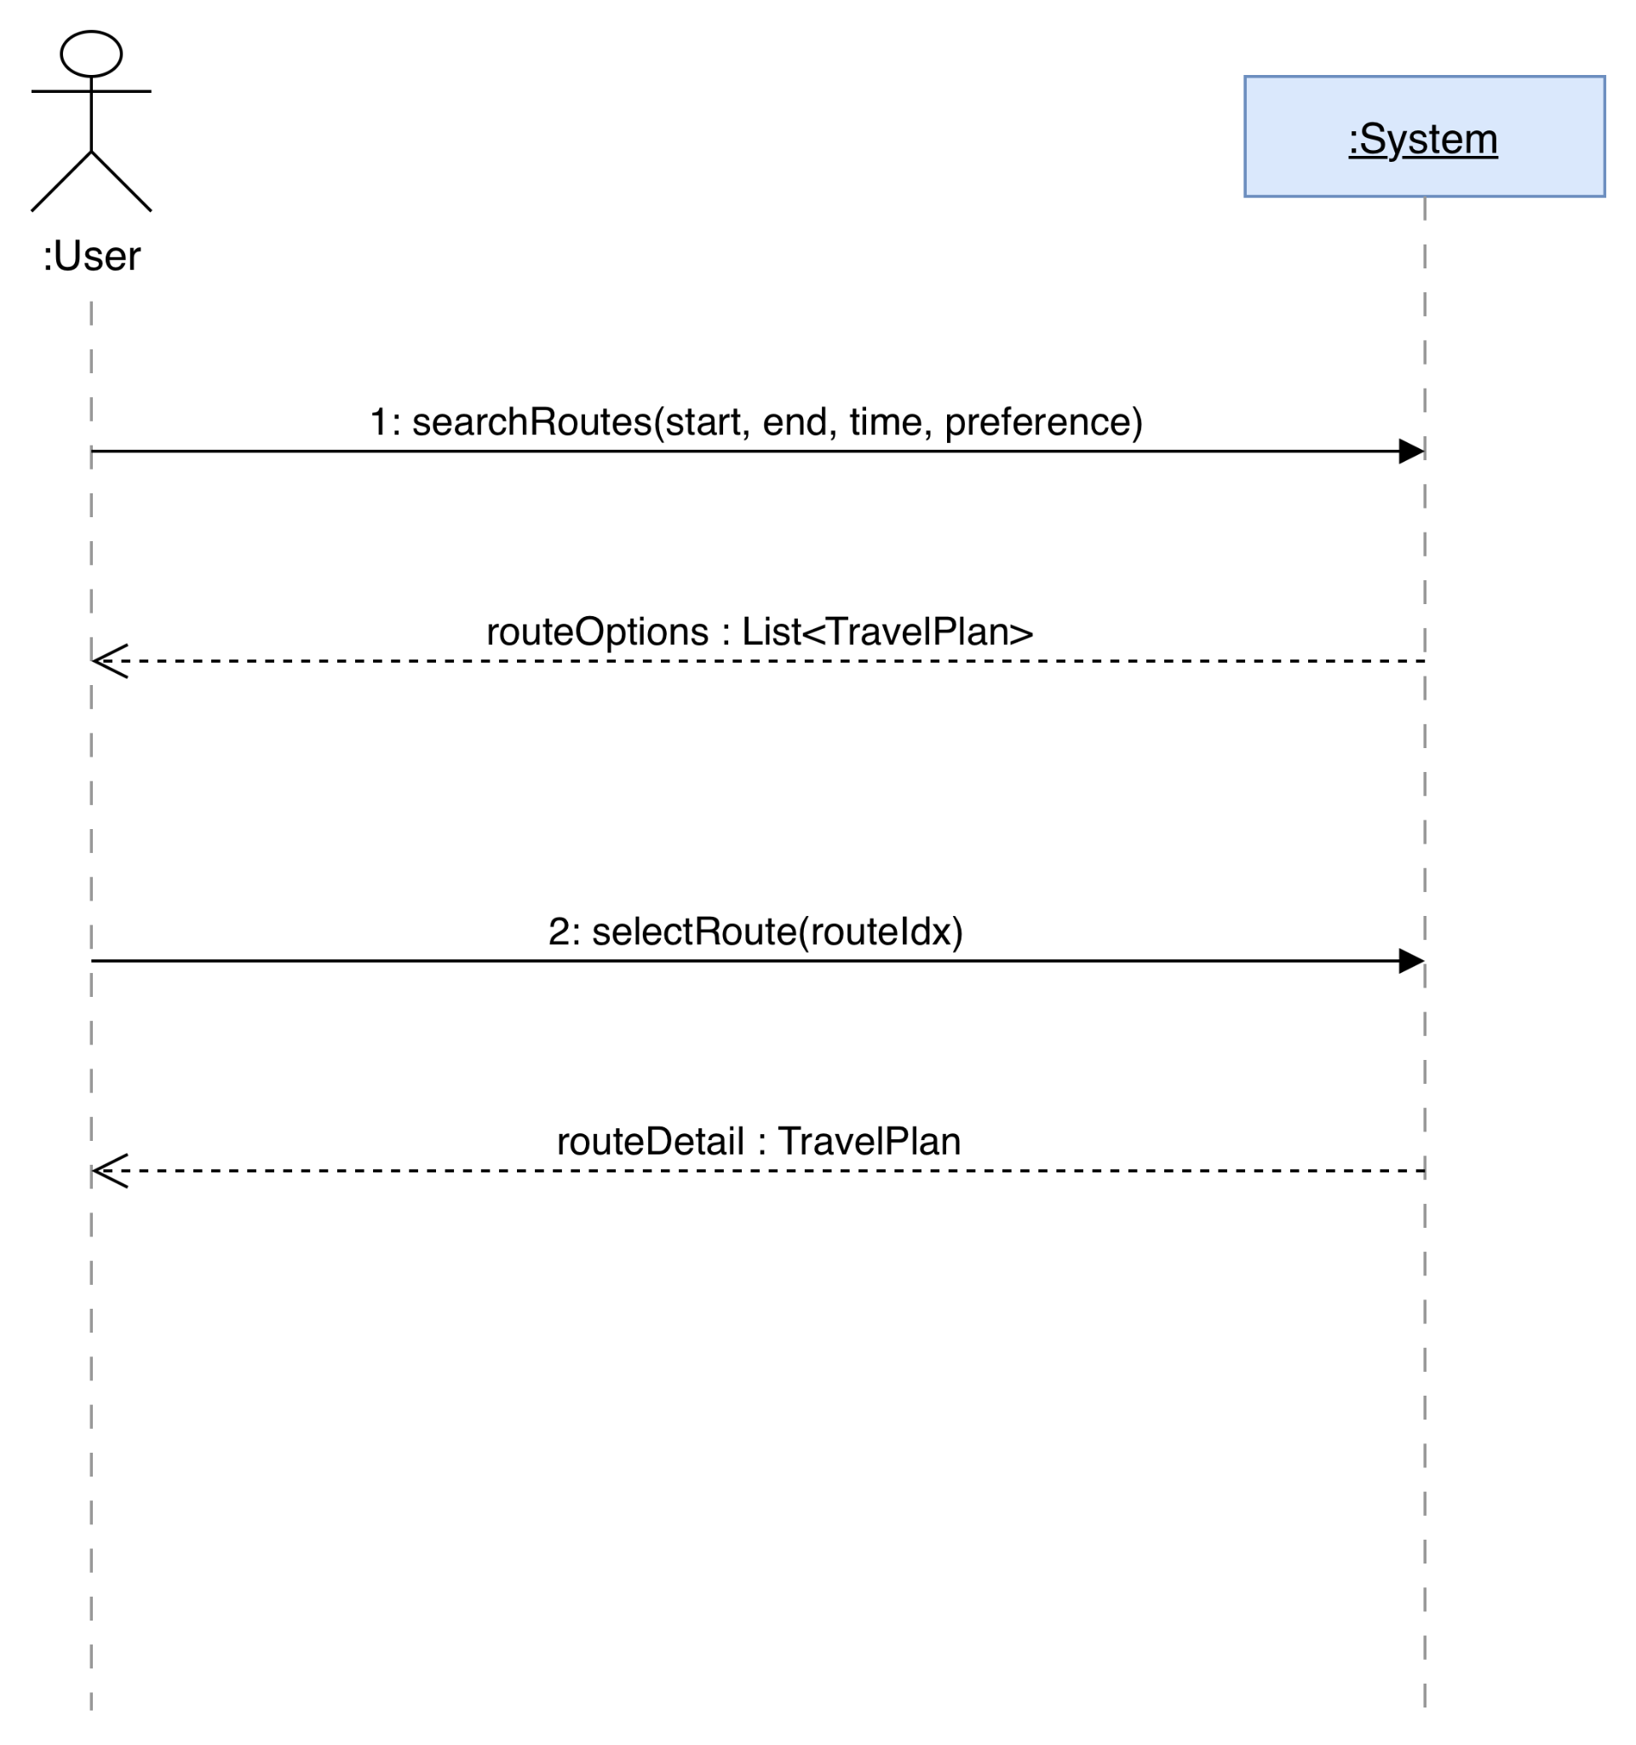

2)Sequence Diagram:

1.searchRoutes

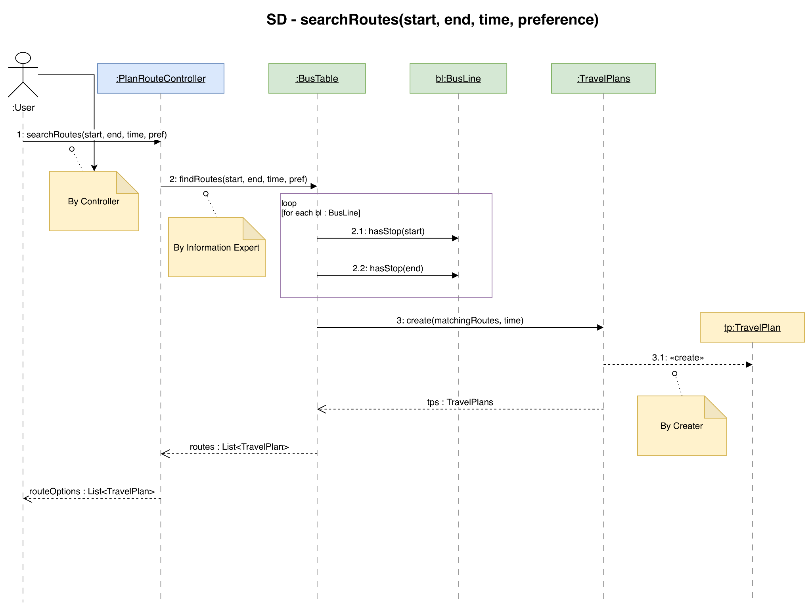

2.selectRoute
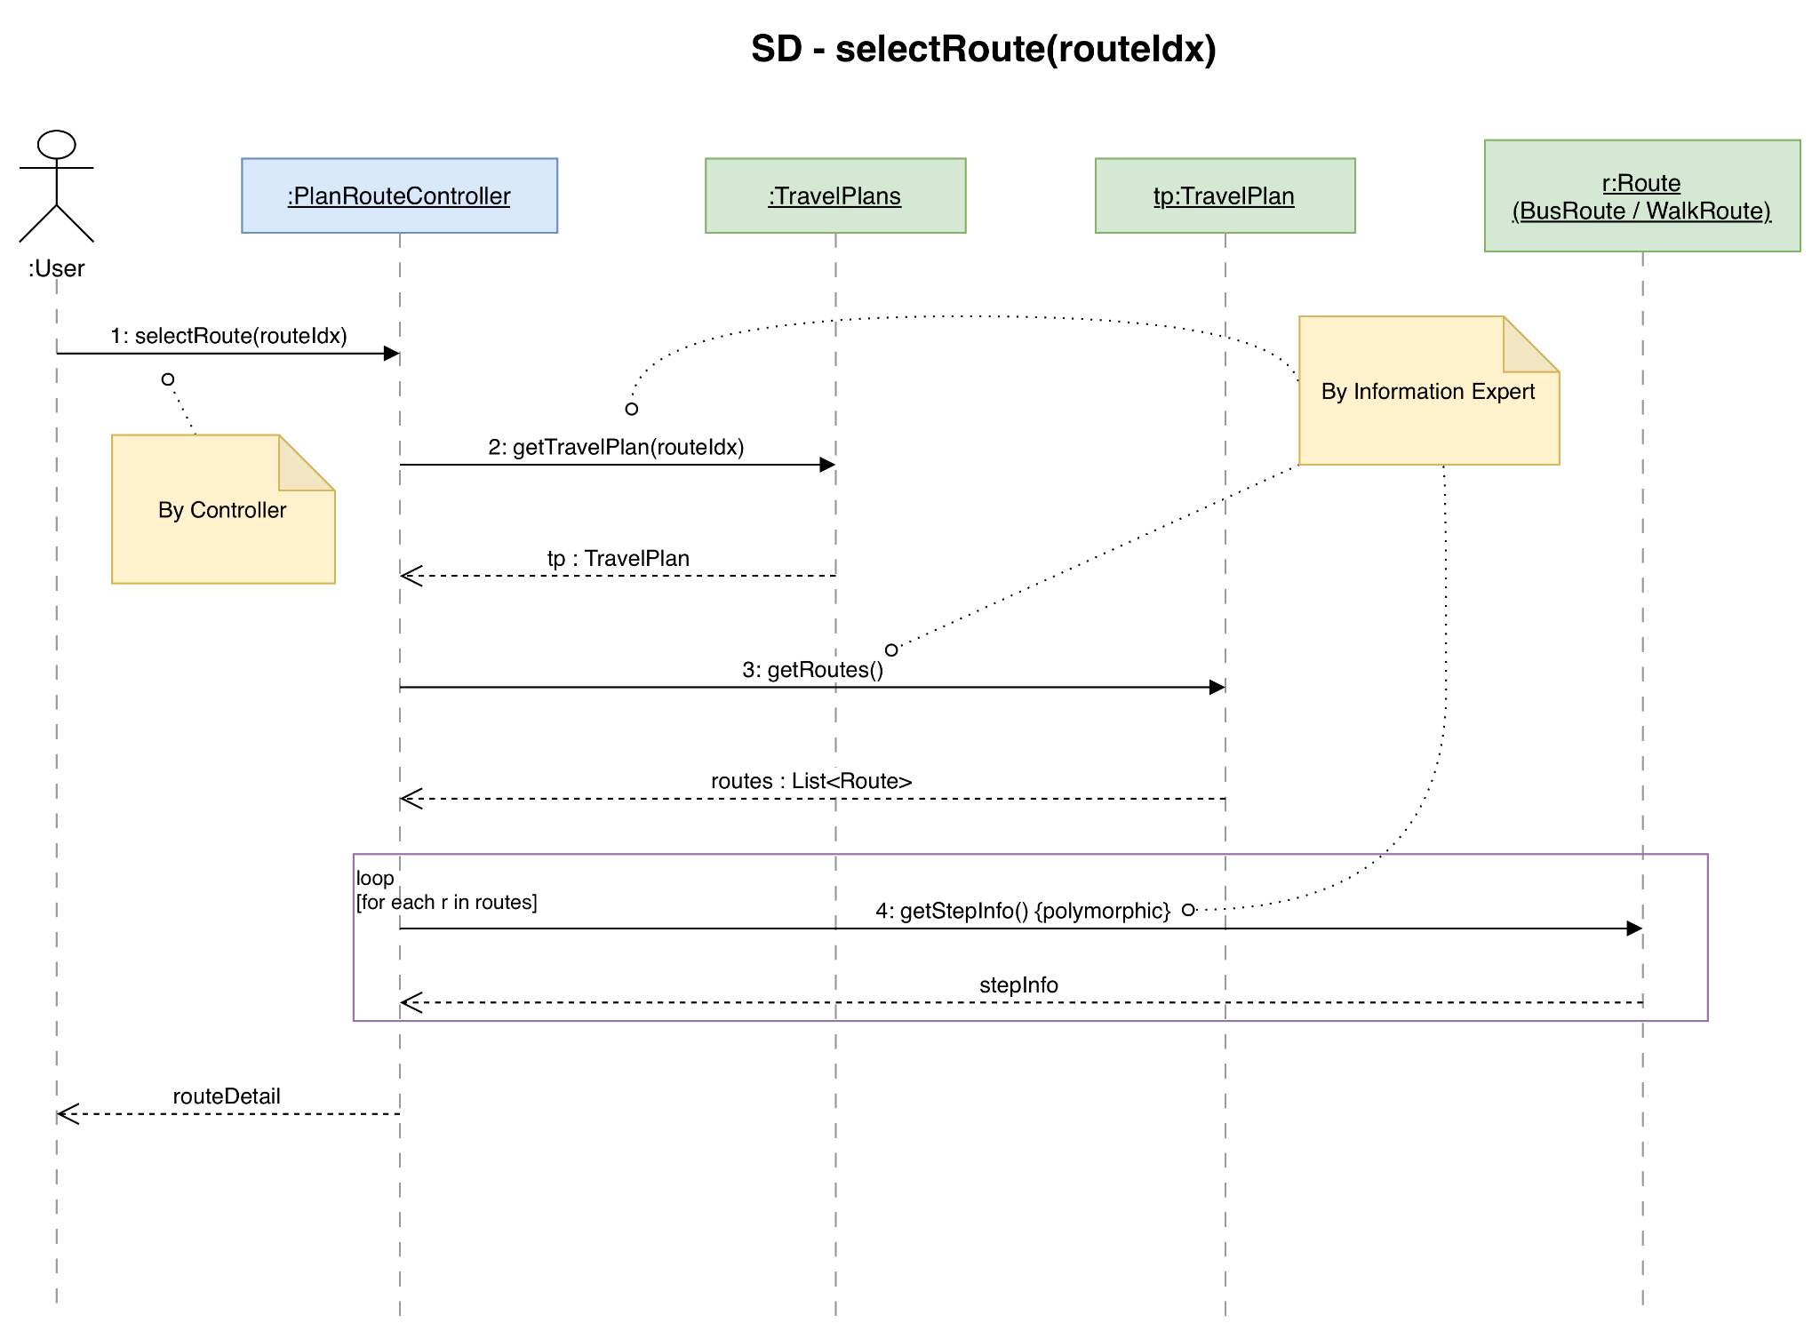

Usecase 2: Add Favorite

1)SSD:
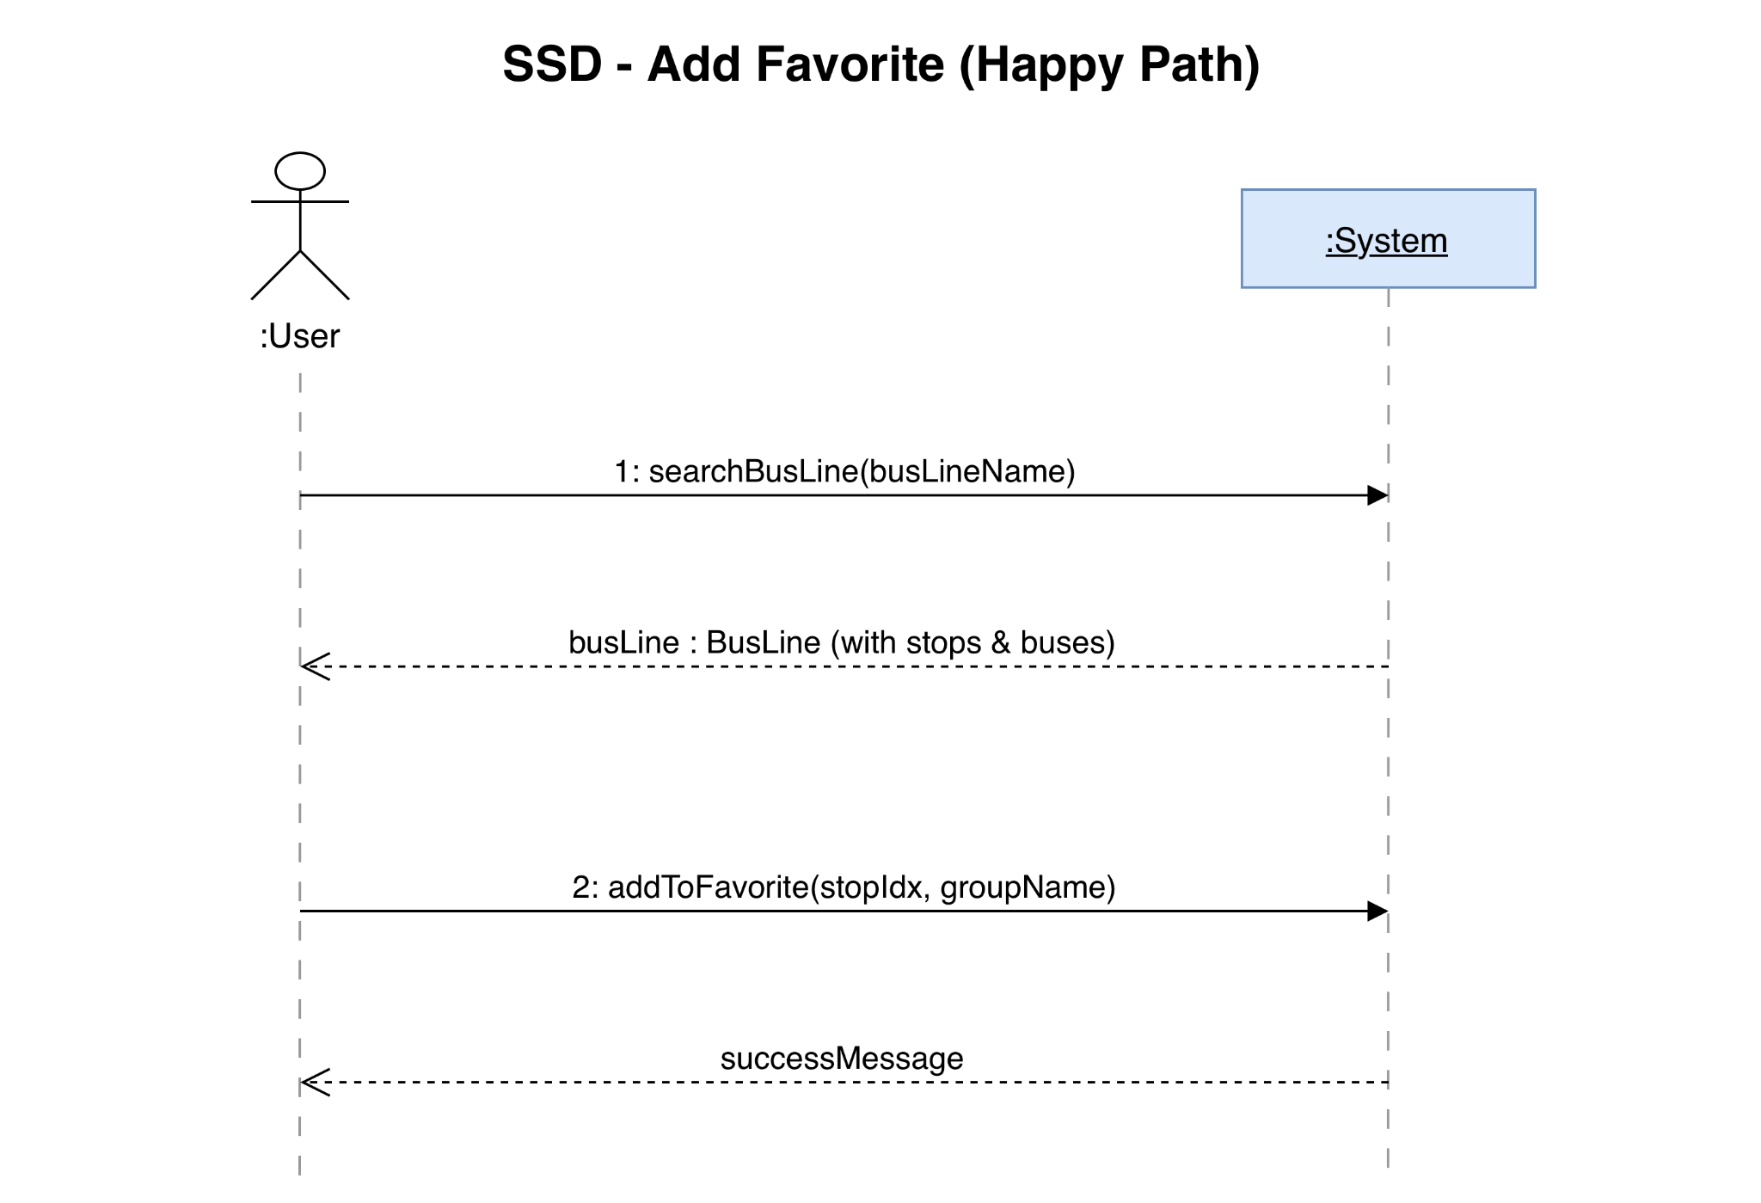

2)Sequence Diagram:

1.searchBusLine
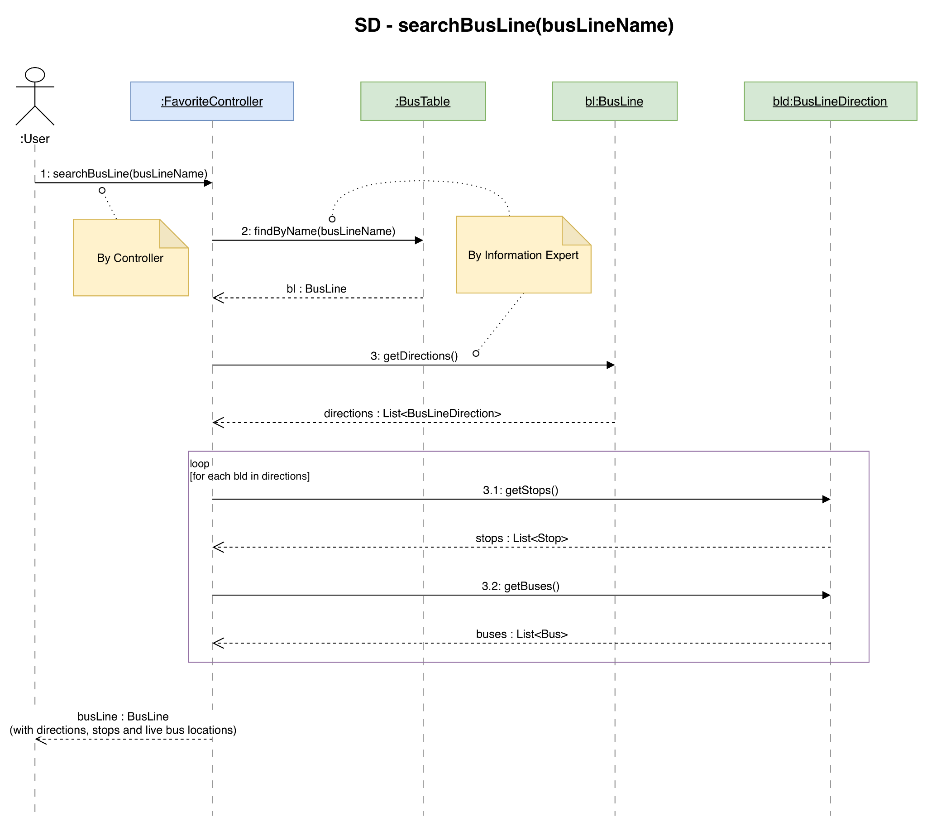

2.addToFavorite
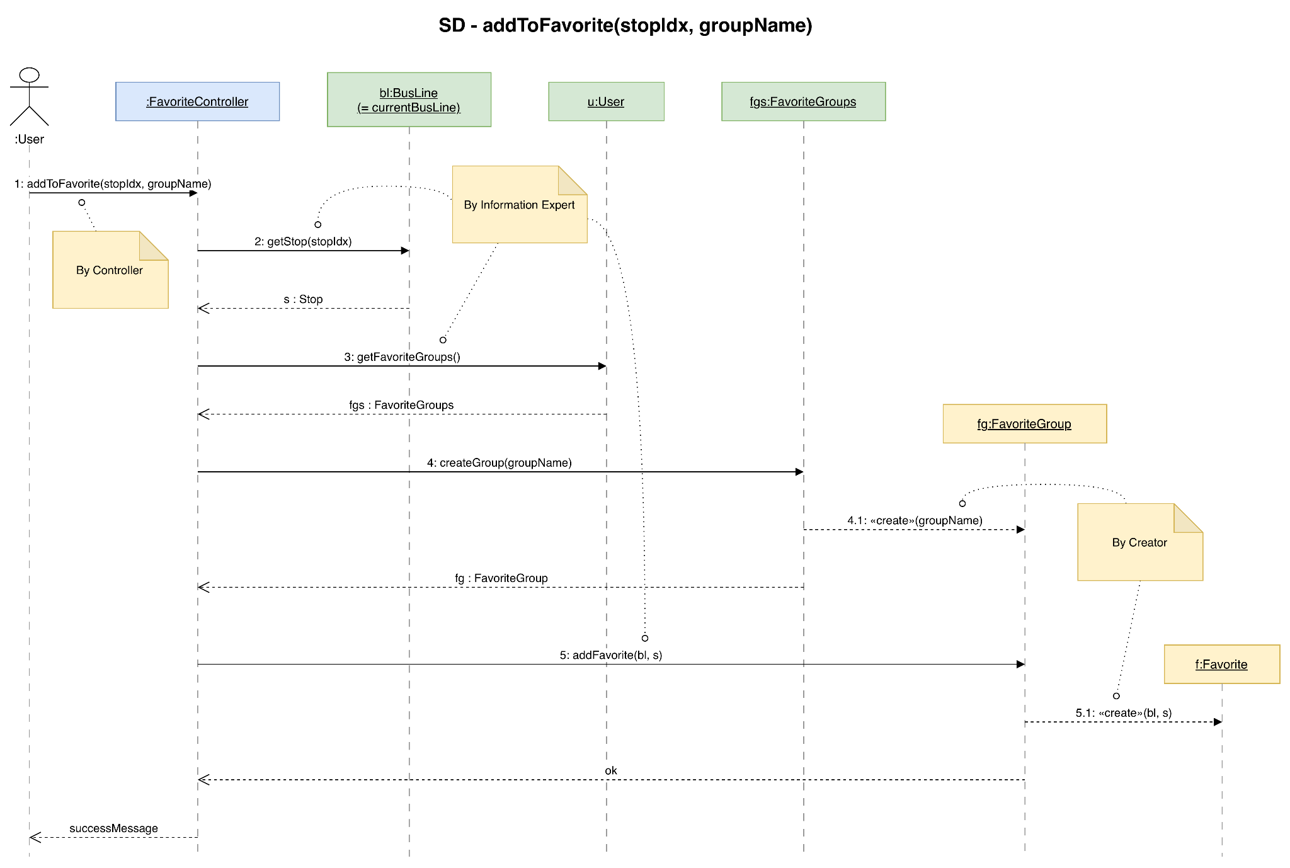

Design Class Diagram
