Build A Mobile App Leveraging Watson Question and Answer Service on Bluemix
Before getting started, we will need:
Bluemix Account
Java Liberty and Watson Question And Answer Service Skill
Android Development Skill
cf cloud foundry command line tool

Code URL:
https://hub.jazz.net/project/chunbintang/travelbuddy/overview

Overall Architecture of "TravelBuddy"
The TravelBuddy app is divided into 3 tiers, the mobile app tie, app server tier, and the Waston service tier. Please refer to the picture below for more details. We will cover how to implement it in details later on.
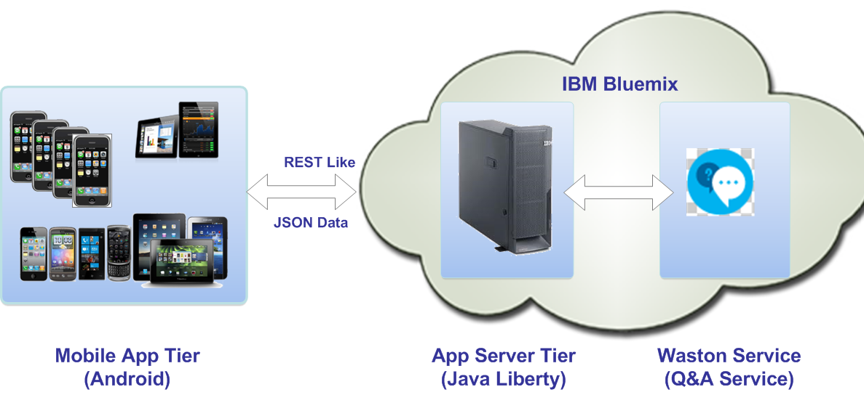

STEP 1: Build TravelBuddy App on Bluemix
a. Java Liberty Runtime
1. Login in Bluemix and Open the Catalog menu.
2. From the Runtimes section, click Liberty for Java.
3. In the App field, specify the name of the app, in this case, it is set to qa002.
4. Click Create.Wait for your application to provision.
b. Watson Question And Answer Service
1. Click the App created in the Dashboard. Open the Catalog menu.
2. Click Add A Service.
3. Choose Question And Answer Service under Watson.
4. Click Create. Click OK if it is prompted to restart the application.

You will get an application on Bluemix similar as follows:

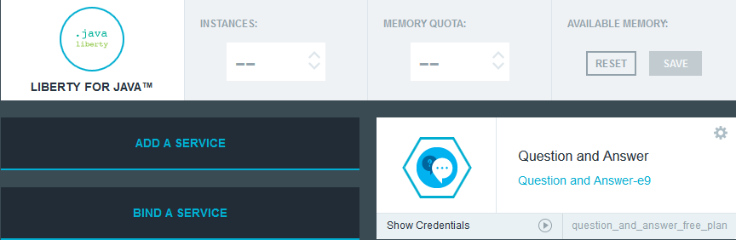

STEP 2: Review Server Side Code
You may find the source code at https://hub.jazz.net/project/chunbintang/travelbuddy/overview. The primary class is com.ibm.mds.MobileServlet.java.

Collect the relevant info from VCAP_SERVICES
The following code snippet shows how to collect relevant info from VCAP_SERVICES to prepare the connection to Waston QA service.

String VCAP_SERVICES = System.getenv("VCAP_SERVICES");
if (VCAP_SERVICES == null) {
return;
}

JSONObject sysEnv = null;

try {
sysEnv = JSONObject.parse(VCAP_SERVICES);
} catch (IOException e) {
e.printStackTrace();
}

System.out.println("Processing VCAP_SERVICES");
if (sysEnv == null)
return;
System.out.println("Looking for: " + serviceName);
if (sysEnv.containsKey(serviceName)) {
JSONArray services = (JSONArray) sysEnv.get(serviceName);
JSONObject service = (JSONObject) services.get(0);
JSONObject credentials = (JSONObject) service.get("credentials");
baseURL = (String) credentials.get("url");
username = (String) credentials.get("username");
password = (String) credentials.get("password");
System.out.println("baseURL = " + baseURL);
System.out.println("username = " + username);
System.out.println("password = " + password);
} else {
System.out.println(serviceName
+ " is not available in VCAP_SERVICES, "
+ "please bind the service to your application");
}

Connecting to Watson QA Service
The following code snippet shows how to connect Watson QA Service and encapsulate the response into JSON format to return to the mobile app tier.

Note the URL is "/v1/question/travel". Currently, Watson QA Service supports two domains, travel and health. In this case, we are using travel domain knowledge to make a TravelBuddy. If we choose "/v1/question/health", then we will get a HealthBuddy.

Executor executor = Executor.newInstance().auth(username, password);
URI serviceURI = new URI(baseURL + "/v1/question/travel").normalize();
String answersJsonStr = executor
.execute(
Request.Post(serviceURI)
.addHeader("Accept", "application/json")
.addHeader("X-SyncTimeout", "30")
.bodyString(postData.toString(),
ContentType.APPLICATION_JSON))
.returnContent().asString();
JSONObject resultObject = new JSONObject();
JSONArray jsonArray = new JSONArray();
JSONArray pipelines = JSONArray.parse(answersJsonStr);
// the response has two pipelines, lets use the first one
JSONObject answersJson = (JSONObject) pipelines.get(0);
JSONArray answers = (JSONArray) ((JSONObject) answersJson
.get("question")).get("evidencelist");
for (int i = 0; i < answers.size(); i++) {
JSONObject answer = (JSONObject) answers.get(i);
double p = Double.parseDouble((String) answer.get("value"));
p = Math.floor(p * 100);
JSONObject obj = new JSONObject();
obj.put("confidence", Double.toString(p) + "%");
obj.put("text", (String) answer.get("text"));
jsonArray.add(obj);
}
resultObject.put("respCode", RESP_SUCCESS);
resultObject.put("body", jsonArray);
doResp(resultObject.toString(), resp);

STEP 3: Build and Deploy Server Side App
1. Build the project using Eclipse and export it as war archive, for example, "travelbuddy.war". You may find a compiled one under MyData/ under source code in case you do not want to compile it by yourself.
2. Use cf tools to deploy app.
cf push <app_name> -p travelbuddy.war
In my case, it is：
cf push qa002 -p travelbuddy.war

STEP 4: Review Mobile App Code
You may find the mobile app source code under TravelBuddyAndroid folder at https://hub.jazz.net/project/chunbintang/travelbuddy/overview.
The primary class to communicate with app server tier is com.ibm.sample.travelbuddy.MainActivity.java. We employ the open source Asynchronous HTTP Library for Android library to perform the HTTP connections. It could be downloaded by https://github.com/loopj/android-async-http. Below is the code snippet.

RequestParams param = new RequestParams();
param.add("questionText", sTxt);
HttpUtil.get(param, new JsonHttpResponseHandler() {
@Override
public void onSuccess(int statusCode, Header[] headers,
JSONObject response) {
Log.i("doSearch", response.toString());
try {
String respCode = response.getString("respCode");
if (respCode.equals(HttpUtil.RESP_SUCCESS)) {
JSONArray bodyArray = response.getJSONArray("body");
itemList.clear();
for (int i = 0; i < bodyArray.length(); i++) {
JSONObject obj = bodyArray.getJSONObject(i);
itemList.add("(" + obj.getString("confidence")
+ ") " + obj.getString("text"));
}
adapter.notifyDataSetChanged();
} else {
Toast.makeText(getApplicationContext(),
response.getString("respText"),
Toast.LENGTH_LONG).show();
}
} catch (JSONException e) {
// TODO Auto-generated catch block
e.printStackTrace();
}
}
});

STEP 5: Build Mobile App
1. Set up the Android IDE using Eclipse.
2. Clone the Android package from /TravelBuddyAndroid at https://hub.jazz.net/project/chunbintang/travelbuddy/overview and import it into Android IDE .
3. Modify com.ibm.sample.travelbuddy.HttpUtil.java to your app name.
private final static String MOBILE_BACKEND_URL = "http://<app_name>.mybluemix.net/MobileServlet";
In my case, ad the app_name is qa002, it is modified to:
private final static String MOBILE_BACKEND_URL = "http://qa002.mybluemix.net/MobileServlet";
4. Build Android app.

STEP 6: Run TravelBuddy
Use Android IDE to run the application in an Android emulator (Click Run > Run As > Android Application).
Input some question in the text field , for example, "where is new york"
Click Search to get the answer to the question.
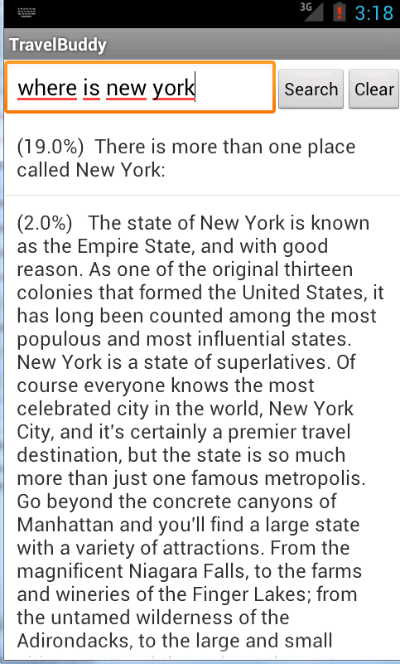

Conclusion
You see how easy to create a mobile app leveraging IBM Watson Question and Answer service on Bluemix, right? Do not hesitate to try it by yourselves.

