Fulfilment System – Architecture & Sequence Diagrams
This document explains the overall architecture, entity relationships, fulfilment concept, and request flows of the Fulfilment / Warehouse Management System. It is written in an interview-review friendly manner.

1. High-Level Architecture
The system follows Clean (Hexagonal) Architecture. Business logic is isolated from infrastructure concerns such as REST APIs and databases. Use cases orchestrate domain rules and interact with persistence via ports.

2. Core Entities & Relationships
• Store: Physical selling location
• Product: Item sold to customers
• Warehouse: Fulfilment unit holding products
• FulfilmentAssignment: Mapping entity connecting Store–Product–Warehouse
Fulfilment represents which warehouse supplies which product to which store.

3. Architecture Flow Diagram
Client → REST API → Use Case → Domain Ports → Adapters → Database
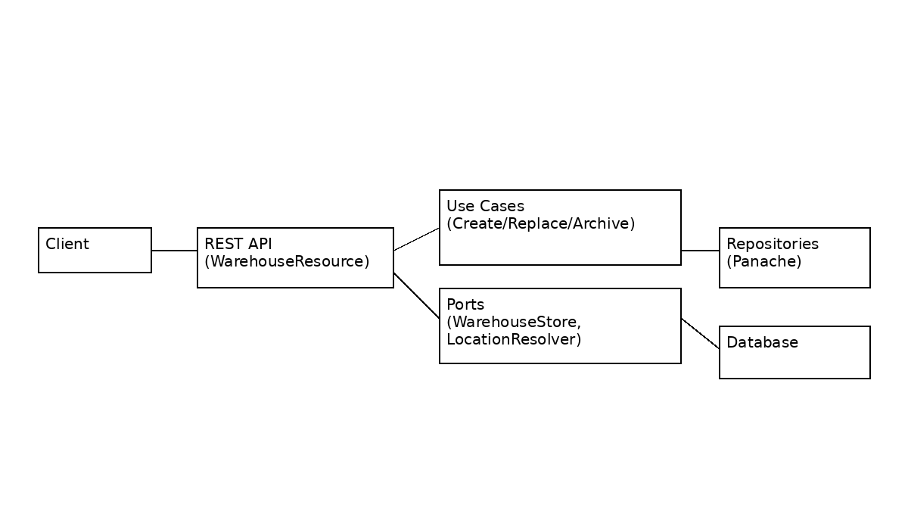

4. Sequence Diagram – Create Warehouse
Client → WarehouseResourceImpl → CreateWarehouseUseCase → LocationGateway & WarehouseStore → Database
Validations:
• Business Unit uniqueness
• Location validity
• Capacity & stock checks

5. Sequence Diagram – Replace Warehouse
Client → WarehouseResourceImpl → ReplaceWarehouseUseCase
→ Archive old warehouse → Create new warehouse with same BU code
Old warehouse is archived to preserve history.

6. Sequence Diagram – Fulfilment Assignment
Client → FulfilmentResource → AssignWarehouseToProductAndStoreUseCase → FulfilmentStore → Database
Constraints enforced:
• Max 3 warehouses per store
• Max 2 warehouses per product per store
• Max 5 products per warehouse

