Warehouse Management System – UML Sequence Diagrams

Architecture:
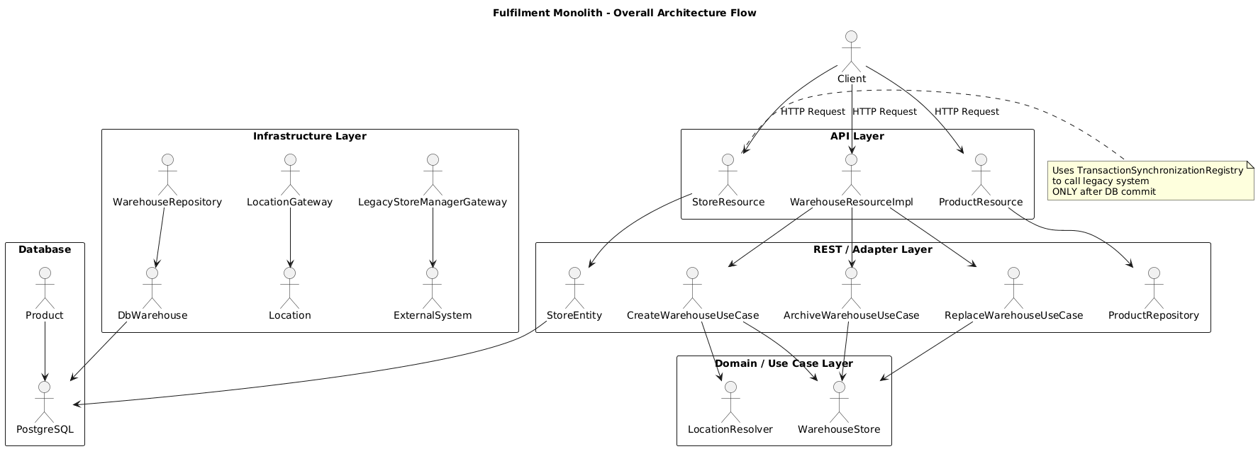

1. Create Warehouse – UML Sequence Diagram
Client
|
| POST /warehouse
v
WarehouseResourceImpl
|
| create(warehouse)
v
CreateWarehouseUseCase
|
|-- validate businessUnitCode uniqueness
|-- validate location via LocationGateway
|-- validate capacity & stock
|
| create(warehouse)
v
WarehouseStore
|
| persist
v
WarehouseRepository
|
| INSERT
v
Database

2. Replace Warehouse – UML Sequence Diagram
Client
|
| PUT /warehouse/{businessUnitCode}
v
WarehouseResourceImpl
|
| replace(warehouse)
v
ReplaceWarehouseUseCase
|
|-- find current warehouse
|-- validate active status
|-- validate stock & capacity
|
| update(oldWarehouse)
v
WarehouseStore
|
| UPDATE (archive)
v
WarehouseRepository
|
| UPDATE
v
Database
|
| create(newWarehouse)
v
WarehouseStore
|
| INSERT
v
WarehouseRepository
|
| INSERT
v
Database

3. Archive Warehouse – UML Sequence Diagram
Client
|
| DELETE /warehouse/{id}
v
WarehouseResourceImpl
|
| archive(warehouse)
v
ArchiveWarehouseUseCase
|
|-- validate not archived
|-- set archivedAt
|
| update(warehouse)
v
WarehouseStore
|
| UPDATE
v
WarehouseRepository
|
| UPDATE
v
Database
Create Warehouse
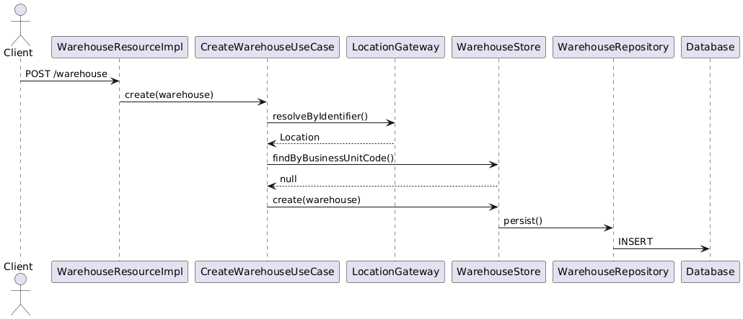

Replace Warehouse:
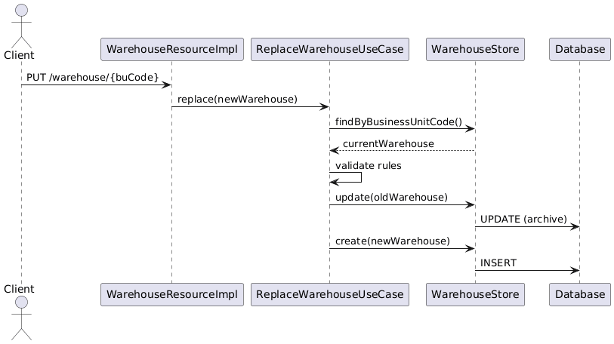
Archive Ware House:
