Chapter 2
Elasticity of Demand
- Desire
- Ability to pay
- willingness to pay
Determining factor of Demand
- Price
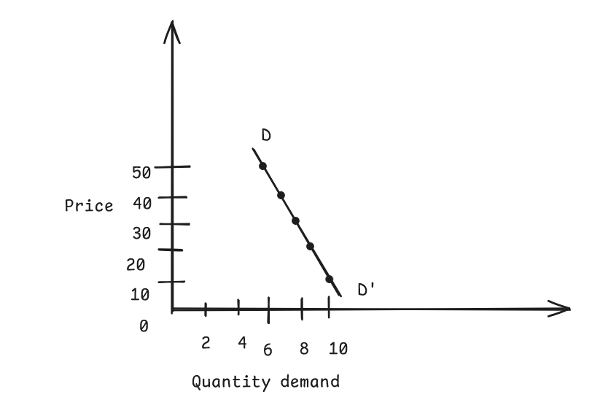
- Income
- Price of related good(price of bike and petrol or pepsi and coke)
- Advertisement
- Climate and Season
- Population size and composition
- Future expectations

Elasticity of Demand:
it is defined as the measurement of percentage change in quantity demand of the commodity due to change in its determinants such as price, income, etc.
- Price Elasticity of Demand: it is defined as the measurement of percentage change in quantity demand of the commodity due to percentage change of the price of that commodity.
(Ep)
Mathematically,
Ep = % change in Q.D / % change in Price
= $\frac{Qf-Qi}{Qi}*100\%=\% change$
= $\frac{DeltaQ}{Qi}*100\%$
Ep = delta(Q) / Delta (P) * p/q

- Suppose price of commodity increases from Rs. 10 to Rs. 15 as a result Quantity Demand decreases from 10 units to 8 units. Calculate price elasticity of demand.
Given:
Initial Price= Pi= 10
Final Price = Pf=15
Initial Demand = Qi = 10
Final Demand = Qf= 8
Now:
Change in price = Pf-Pi = 15-10= 5
Change in Quantity Demand = 8-10=-2
Using The formula:
= delta Q / delta P = -2/5 * 10/10 =-0.4

- If demand function is given by Q = 100-5P and P = Rs10 Calculate Price Elasticity

Given:
Quantity Demand(Q)= 100 – 5P
Price(P)=Rs. 10
Now: Substituting value of P in Q
= 100 – 5*10
= 50
Now using the formula
Ep = dQ/dP * p/q
= -5 * 10/50 = -1

- Suppose the annual fee of MBS program is Rs. 3000, and numbers of student enrolled is 4000. Suppose TU increases its fee to Rs. 4000 and Price elasticity of demand is -0.4 Calculate final number of student.is it wise decision to increase fee.

Given: Initial Price (Pi) = Rs. 3000
Initial Quantity Demand(Di) = 4000
Final Price ( Pf) = Rs. 4000
Final Quantity Demand(Df) = ?
Price Elasticity of Demand (Ep) = -0.4
Now: We have Formula:
Ep= delta(Q) / delta(P) * p/q
-0.4= (x-4000/4000-3000) * (3000/4000)
x = 3467

