OUTPUT:
False Position:
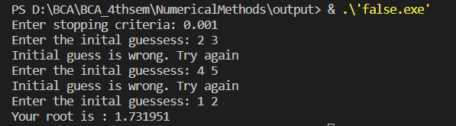

Newton Raphson:
