OUTPUT:
Lagrange interpolation
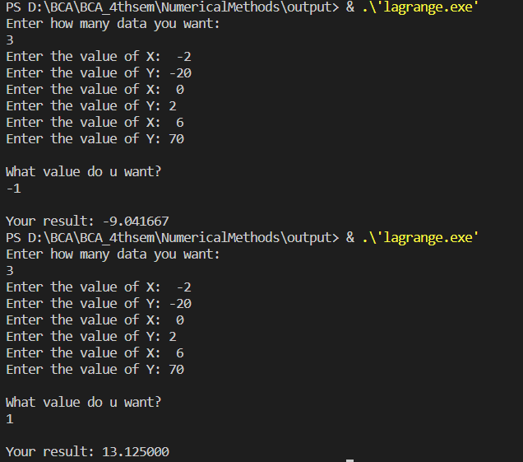

OUTPUT:
Least square method (linear regression y=a+bx)
