**Tribhuvan University**

**Faculty of Humanities and Social Sciences**

**Online Bike Rental System**

**A PROJECT PROPOSAL**

**Submitted to**

**Department of Computer Application**

**DAV College**

#### In partial fulfillment of the requirements for the Bachelors in Computer Application

Submitted by

Md Noorullah Khan

Roll no: 9

BCA 4th Semester

2080

Table of Contents

Contents

1. INTRODUCTION 3

2. PROBLEM STATEMENT 4

3. OBJECTIVE 5

4. METHODOLOGY 6

4.1 Requirement Identification 6

i. Study of Existing System 6

ii. Requirement Collection 6

4.2 Feasibility Study 7

i. Technical Feasibility: 7

ii. Operational Feasibility: 7

iii. Economic Feasibility: 7

4.3 High Level System Design 8

i. Data Flow Diagram 8

# INTRODUCTION

Online Bike Rental System is the service by which users can directly rent a motorcycle and confirm rental services for various purpose over internet. Since technology has advanced, more and more buyers are willing to skip physically visiting the showroom in favor of riding an expensive motorcycle and using a computer and the internet. This is the result of the World Wide Web's development. Businesses have tried to rent out their pricey motorcycles to web surfers. Thus, with the aid of a computer and the internet, people can rent almost anything that meets their needs online.

The main purpose of this project is to develop an online bike rental system that will rent out motorcycles via the internet. Additionally, the system's development has made it dependable, safe, and easy to use. It is the system that maintains number of motorcycles and can book and rent them out for a set amount of time.

The main target audience of this system is bike enthusiasts. Owning a high-end motorcycle is expensive. Most people appreciate the idea of renting a bike and riding it whenever they want. Bicycle rental services are used by people for many purposes, one of which is transportation.

Not just for tourism, but also for personal and work commutes, people are turning to bike rental services. Nepal’s market for two-wheeler rental services is ripe with opportunities, and new rental platforms are igniting a new passion among city dwellers. People can rent a variety of bikes for different periods depending on their needs and preferences.

# PROBLEM STATEMENT

All of us have a fascination for motorcycles. The number of bike lovers is increasing day by day. Since a motorcycle is an expensive product, so it is not possible to purchase for everyone in terms of financial condition. However, it is possible to fulfill their desire to ride bikes through rental services. In this way the customer will be able to rent a bike according to his needs and the other customer will also benefit financially. Although this service is available outside our country, this service has not yet been fully launched in Nepal. However, this business has immense growth potential. So it will become very popular in this country very soon.

Because of the above problems, it is desired to have a Bike Rental System.

# OBJECTIVE

* To produce a web-based system that allow customer to register and reserve bike online.

# METHODOLOGY

## 4.1 Requirement Identification

### Study of Existing System

We have surfed through some of the rental-based websites, and we observed those and compared the features with the system proposed.

* One of them is Maharjan Bikes Rental[1]. The system in that website only had vehicle data and their rates and we could only enter our name and email in their system.
* Another system we came across was of Bangladesh named Chaad Ride[2].

This system offered:

* 1. User register and login
  2. Vehicle gallery
  3. Offers bike for hourly, daily, weekly, or monthly basis in Dhaka & Cox’s Bazar.
* Limitation of Existing system:
  1. Maharjan Bikes Rental did not have any kind of authentication or authorization.
  2. Image of citizenship and passport could not be uploaded in it even though that system had mentioned about citizenship and passport.

### Requirement Collection

1. Function Requirements:

* User Registration and Authentication
* Bike Listing and Details
* Booking and Reservation
* User profile Management
* Admin Dashboard
* Rating and Feedback

1. Non-Functional Requirements

* User friendly UI
* Security

## 4.2 Feasibility Study

### Technical Feasibility:

This project will make use of HTML, CSS, and JavaScript for its front end. MySQL is going to be used for the database, and PHP will be the language used for server-side programming. These are well-known technologies that are used in web application development. For this project, a desktop or laptop that is easily available in the market is needed. It can be concluded that this project is technically feasible.

### Operational Feasibility:

This project has simple UI and modules that are also not complex so, it is user friendly. The online bike rental system fits in well with our existing operational workflows when it comes to the adoption process. Checking the availability of the required resources and making sure it is prepared for the changeover. It evaluates the system's compatibility with our current databases and procedures, giving security and legal compliance the greatest importance. So, this project can be said operationally feasible.

### Economic Feasibility:

This economic feasibility analysis aims to provide a clear understanding of the financial implications and benefits associated with the implementation of the Online Bike Rental System. The organization seeks to make well-informed decisions to ensure the project's success and alignment with its overarching financial goals. So, this system can be said economically feasible.

## 4.3 High Level System Design

### Data Flow Diagram

Fig: Level – 0 Data Flow Diagram

### ii. Methodology

The waterfall model is ideal for developing this project because all the requirements are known and there is not much time left for development. The requirements analysis, system design, implementation, testing, and deployment phases make up the project's five stages.

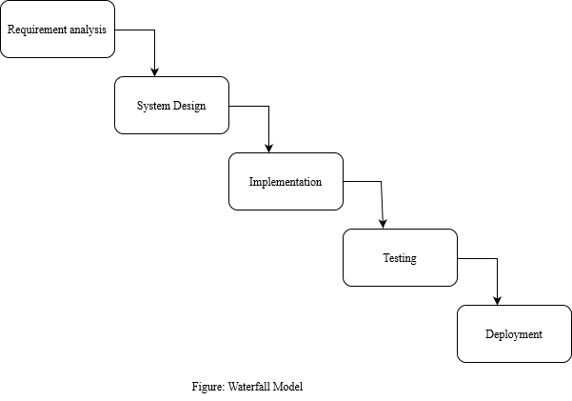

# GANTT CHART

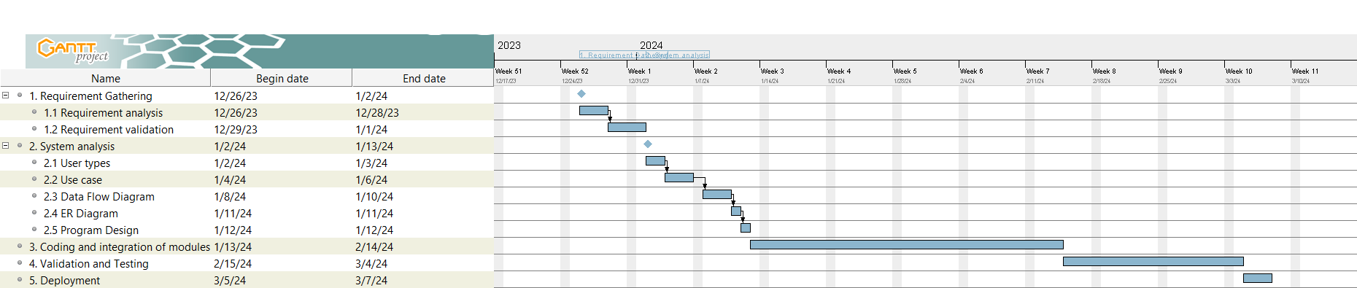

Figure: Online Bike Rental System Gantt Chart