- Factorial of a number:
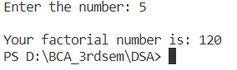

- Sum of n^{th} numbers:
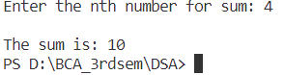

- Fibonacci series:
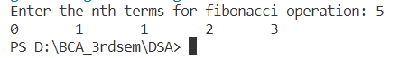

- Tower of Hanoi
