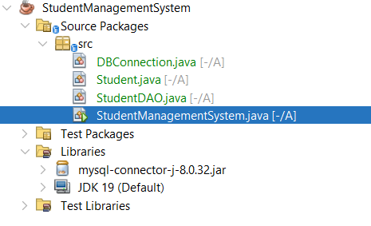
DBConnection.java:
package src;
import javax.swing.*;
import javax.swing.table.DefaultTableModel;
import java.awt.*;
import java.awt.event.*;
import java.util.List;

public class StudentManagementSystem extends JFrame {
private StudentDAO studentDAO;

// Components for "View All" tab
private JTable table;
private DefaultTableModel tableModel;

// Components for "Add Student" tab
private JTextField addNameField, addEmailField, addAgeField, addGradeField;

// Components for "Update Student" tab
private JTextField updateIdField, updateNameField, updateEmailField, updateAgeField, updateGradeField;

// Components for "Delete Student" tab
private JTextField deleteIdField;

// Components for "Search Student" tab
private JTextField searchField;
private JTable searchTable;
private DefaultTableModel searchTableModel;

public StudentManagementSystem() {
studentDAO = new StudentDAO();
initComponents();
}

private void initComponents() {
setTitle("Student Management System");
setDefaultCloseOperation(JFrame.EXIT_ON_CLOSE);
setSize(800, 600);
setLocationRelativeTo(null);
JTabbedPane tabbedPane = new JTabbedPane();
JPanel viewPanel = new JPanel(new BorderLayout());
tableModel = new DefaultTableModel(new String[]{"ID", "Name", "Email", "Age", "Grade"}, 0);
table = new JTable(tableModel);
JScrollPane scrollPane = new JScrollPane(table);
viewPanel.add(scrollPane, BorderLayout.CENTER);
JButton refreshButton = new JButton("Refresh");
refreshButton.addActionListener(e -> loadAllStudents());
viewPanel.add(refreshButton, BorderLayout.SOUTH);
tabbedPane.addTab("View All", viewPanel);

JPanel addPanel = new JPanel(new GridLayout(5, 2, 10, 10));
addPanel.setBorder(BorderFactory.createEmptyBorder(10,10,10,10));
addPanel.add(new JLabel("Name:"));
addNameField = new JTextField();
addPanel.add(addNameField);

addPanel.add(new JLabel("Email:"));
addEmailField = new JTextField();
addPanel.add(addEmailField);

addPanel.add(new JLabel("Age:"));
addAgeField = new JTextField();
addPanel.add(addAgeField);

addPanel.add(new JLabel("Grade:"));
addGradeField = new JTextField();
addPanel.add(addGradeField);

JButton addButton = new JButton("Add Student");
addButton.addActionListener(e -> addStudent());
addPanel.add(addButton);

tabbedPane.addTab("Add Student", addPanel);

JPanel updatePanel = new JPanel(new GridLayout(6, 2, 10, 10));
updatePanel.setBorder(BorderFactory.createEmptyBorder(10,10,10,10));
updatePanel.add(new JLabel("Student ID:"));
updateIdField = new JTextField();
updatePanel.add(updateIdField);

updatePanel.add(new JLabel("New Name:"));
updateNameField = new JTextField();
updatePanel.add(updateNameField);

updatePanel.add(new JLabel("New Email:"));
updateEmailField = new JTextField();
updatePanel.add(updateEmailField);

updatePanel.add(new JLabel("New Age:"));
updateAgeField = new JTextField();
updatePanel.add(updateAgeField);

updatePanel.add(new JLabel("New Grade:"));
updateGradeField = new JTextField();
updatePanel.add(updateGradeField);

JButton updateButton = new JButton("Update Student");
updateButton.addActionListener(e -> updateStudent());
updatePanel.add(updateButton);

tabbedPane.addTab("Update Student", updatePanel);

JPanel deletePanel = new JPanel(new GridLayout(2, 2, 10, 10));
deletePanel.setBorder(BorderFactory.createEmptyBorder(10,10,10,10));
deletePanel.add(new JLabel("Student ID:"));
deleteIdField = new JTextField();
deletePanel.add(deleteIdField);

JButton deleteButton = new JButton("Delete Student");
deleteButton.addActionListener(e -> deleteStudent());
deletePanel.add(deleteButton);

tabbedPane.addTab("Delete Student", deletePanel);

JPanel searchPanel = new JPanel(new BorderLayout());
JPanel searchInputPanel = new JPanel(new FlowLayout());
searchInputPanel.add(new JLabel("Enter ID or Name:"));
searchField = new JTextField(20);
searchInputPanel.add(searchField);
JButton searchButton = new JButton("Search");
searchButton.addActionListener(e -> searchStudent());
searchInputPanel.add(searchButton);
searchPanel.add(searchInputPanel, BorderLayout.NORTH);

searchTableModel = new DefaultTableModel(new String[]{"ID", "Name", "Email", "Age", "Grade"}, 0);
searchTable = new JTable(searchTableModel);
JScrollPane searchScrollPane = new JScrollPane(searchTable);
searchPanel.add(searchScrollPane, BorderLayout.CENTER);
tabbedPane.addTab("Search Student", searchPanel);

add(tabbedPane);

loadAllStudents();
}

private void loadAllStudents() {
tableModel.setRowCount(0);
List<Student> students = studentDAO.getAllStudents();
for (Student student : students) {
tableModel.addRow(new Object[]{
student.getId(),
student.getName(),
student.getEmail(),
student.getAge(),
student.getGrade()
});
}
}

private void addStudent() {
String name = addNameField.getText().trim();
String email = addEmailField.getText().trim();
int age;
String grade = addGradeField.getText().trim();
try {
age = Integer.parseInt(addAgeField.getText().trim());
} catch (NumberFormatException e) {
JOptionPane.showMessageDialog(this, "Invalid age. Please enter a valid number.");
return;
}

Student student = new Student(name, email, age, grade);
boolean success = studentDAO.insertStudent(student);
if (success) {
JOptionPane.showMessageDialog(this, "Student added successfully.");
addNameField.setText("");
addEmailField.setText("");
addAgeField.setText("");
addGradeField.setText("");
loadAllStudents();
} else {
JOptionPane.showMessageDialog(this, "Failed to add student. Check logs for details.");
}
}

private void updateStudent() {
int id;
try {
id = Integer.parseInt(updateIdField.getText().trim());
} catch (NumberFormatException e) {
JOptionPane.showMessageDialog(this, "Invalid ID. Please enter a valid number.");
return;
}
String name = updateNameField.getText().trim();
String email = updateEmailField.getText().trim();
int age;
try {
age = Integer.parseInt(updateAgeField.getText().trim());
} catch (NumberFormatException e) {
JOptionPane.showMessageDialog(this, "Invalid age. Please enter a valid number.");
return;
}
String grade = updateGradeField.getText().trim();

Student student = new Student(id, name, email, age, grade);
boolean success = studentDAO.updateStudent(student);
if (success) {
JOptionPane.showMessageDialog(this, "Student updated successfully.");
updateIdField.setText("");
updateNameField.setText("");
updateEmailField.setText("");
updateAgeField.setText("");
updateGradeField.setText("");
loadAllStudents();
} else {
JOptionPane.showMessageDialog(this, "Failed to update student. Check logs for details.");
}
}

private void deleteStudent() {
int id;
try {
id = Integer.parseInt(deleteIdField.getText().trim());
} catch (NumberFormatException e) {
JOptionPane.showMessageDialog(this, "Invalid ID. Please enter a valid number.");
return;
}
boolean success = studentDAO.deleteStudent(id);
if (success) {
JOptionPane.showMessageDialog(this, "Student deleted successfully.");
deleteIdField.setText("");
loadAllStudents();
} else {
JOptionPane.showMessageDialog(this, "Failed to delete student. Check logs for details.");
}
}

private void searchStudent() {
String keyword = searchField.getText().trim();
List<Student> students = studentDAO.getStudentByIdOrName(keyword);
searchTableModel.setRowCount(0);
for (Student student : students) {
searchTableModel.addRow(new Object[]{
student.getId(),
student.getName(),
student.getEmail(),
student.getAge(),
student.getGrade()
});
}
if (students.isEmpty()) {
JOptionPane.showMessageDialog(this, "No matching student found.");
}
}

public static void main(String[] args) {
SwingUtilities.invokeLater(() -> {
new StudentManagementSystem().setVisible(true);
});
}
}

Student.java:
package src;
public class Student {
private int id;
private String name;
private String email;
private int age;
private String grade;

public Student() {}

public Student(int id, String name, String email, int age, String grade) {
this.id = id;
this.name = name;
this.email = email;
this.age = age;
this.grade = grade;
}
public Student(String name, String email, int age, String grade) {
this.name = name;
this.email = email;
this.age = age;
this.grade = grade;
}

public int getId() { return id; }
public void setId(int id) { this.id = id; }

public String getName() { return name; }
public void setName(String name) { this.name = name; }

public String getEmail() { return email; }
public void setEmail(String email) { this.email = email; }

public int getAge() { return age; }
public void setAge(int age) { this.age = age; }

public String getGrade() { return grade; }
public void setGrade(String grade) { this.grade = grade; }

@Override
public String toString() {
return "Student [ID=" + id + ", Name=" + name + ", Email=" + email
+ ", Age=" + age + ", Grade=" + grade + "]";
}
}
StudentDAO.java
package src;
import java.sql.*;
import java.util.ArrayList;
import java.util.List;

public class StudentDAO {

public boolean insertStudent(Student student) {
String sql = "INSERT INTO students (name, email, age, grade) VALUES (?, ?, ?, ?)";
try (Connection conn = DBConnection.getConnection();
PreparedStatement pstmt = conn.prepareStatement(sql)) {

pstmt.setString(1, student.getName());
pstmt.setString(2, student.getEmail());
pstmt.setInt(3, student.getAge());
pstmt.setString(4, student.getGrade());

int rowsAffected = pstmt.executeUpdate();
return rowsAffected > 0;

} catch (SQLException | ClassNotFoundException e) {
e.printStackTrace();
return false;
}
}

// Retrieve and return all students from the database.
public List<Student> getAllStudents() {
List<Student> students = new ArrayList<>();
String sql = "SELECT * FROM students";

try (Connection conn = DBConnection.getConnection();
PreparedStatement pstmt = conn.prepareStatement(sql);
ResultSet rs = pstmt.executeQuery()) {

while (rs.next()) {
Student student = new Student(
rs.getInt("id"),
rs.getString("name"),
rs.getString("email"),
rs.getInt("age"),
rs.getString("grade")
);
students.add(student);
}

} catch (SQLException | ClassNotFoundException e) {
e.printStackTrace();
}
return students;
}

public boolean updateStudent(Student student) {
String sql = "UPDATE students SET name = ?, email = ?, age = ?, grade = ? WHERE id = ?";
try (Connection conn = DBConnection.getConnection();
PreparedStatement pstmt = conn.prepareStatement(sql)) {

pstmt.setString(1, student.getName());
pstmt.setString(2, student.getEmail());
pstmt.setInt(3, student.getAge());
pstmt.setString(4, student.getGrade());
pstmt.setInt(5, student.getId());

int rowsAffected = pstmt.executeUpdate();
return rowsAffected > 0;

} catch (SQLException | ClassNotFoundException e) {
e.printStackTrace();
return false;
}
}

public boolean deleteStudent(int id) {
String sql = "DELETE FROM students WHERE id = ?";
try (Connection conn = DBConnection.getConnection();
PreparedStatement pstmt = conn.prepareStatement(sql)) {

pstmt.setInt(1, id);
int rowsAffected = pstmt.executeUpdate();
return rowsAffected > 0;

} catch (SQLException | ClassNotFoundException e) {
e.printStackTrace();
return false;
}
}

public List<Student> getStudentByIdOrName(String keyword) {
List<Student> students = new ArrayList<>();
String sql = "SELECT * FROM students WHERE id = ? OR name LIKE ?";
try (Connection conn = DBConnection.getConnection();
PreparedStatement pstmt = conn.prepareStatement(sql)) {

try {
int id = Integer.parseInt(keyword);
pstmt.setInt(1, id);
} catch (NumberFormatException ex) {
pstmt.setInt(1, -1);
}

pstmt.setString(2, "%" + keyword + "%");

try (ResultSet rs = pstmt.executeQuery()) {
while (rs.next()) {
Student student = new Student(
rs.getInt("id"),
rs.getString("name"),
rs.getString("email"),
rs.getInt("age"),
rs.getString("grade")
);
students.add(student);
}
}

} catch (SQLException | ClassNotFoundException e) {
e.printStackTrace();
}
return students;
}
}

StudentManagementSystem.java
package src;
import javax.swing.*;
import javax.swing.table.DefaultTableModel;
import java.awt.*;
import java.awt.event.*;
import java.util.List;

public class StudentManagementSystem extends JFrame {
private StudentDAO studentDAO;

// Components for "View All" tab
private JTable table;
private DefaultTableModel tableModel;

// Components for "Add Student" tab
private JTextField addNameField, addEmailField, addAgeField, addGradeField;

// Components for "Update Student" tab
private JTextField updateIdField, updateNameField, updateEmailField, updateAgeField, updateGradeField;

// Components for "Delete Student" tab
private JTextField deleteIdField;

// Components for "Search Student" tab
private JTextField searchField;
private JTable searchTable;
private DefaultTableModel searchTableModel;

public StudentManagementSystem() {
studentDAO = new StudentDAO();
initComponents();
}

private void initComponents() {
setTitle("Student Management System");
setDefaultCloseOperation(JFrame.EXIT_ON_CLOSE);
setSize(800, 600);
setLocationRelativeTo(null);
JTabbedPane tabbedPane = new JTabbedPane();
JPanel viewPanel = new JPanel(new BorderLayout());
tableModel = new DefaultTableModel(new String[]{"ID", "Name", "Email", "Age", "Grade"}, 0);
table = new JTable(tableModel);
JScrollPane scrollPane = new JScrollPane(table);
viewPanel.add(scrollPane, BorderLayout.CENTER);
JButton refreshButton = new JButton("Refresh");
refreshButton.addActionListener(e -> loadAllStudents());
viewPanel.add(refreshButton, BorderLayout.SOUTH);
tabbedPane.addTab("View All", viewPanel);

JPanel addPanel = new JPanel(new GridLayout(5, 2, 10, 10));
addPanel.setBorder(BorderFactory.createEmptyBorder(10,10,10,10));
addPanel.add(new JLabel("Name:"));
addNameField = new JTextField();
addPanel.add(addNameField);

addPanel.add(new JLabel("Email:"));
addEmailField = new JTextField();
addPanel.add(addEmailField);

addPanel.add(new JLabel("Age:"));
addAgeField = new JTextField();
addPanel.add(addAgeField);

addPanel.add(new JLabel("Grade:"));
addGradeField = new JTextField();
addPanel.add(addGradeField);

JButton addButton = new JButton("Add Student");
addButton.addActionListener(e -> addStudent());
addPanel.add(addButton);

tabbedPane.addTab("Add Student", addPanel);

JPanel updatePanel = new JPanel(new GridLayout(6, 2, 10, 10));
updatePanel.setBorder(BorderFactory.createEmptyBorder(10,10,10,10));
updatePanel.add(new JLabel("Student ID:"));
updateIdField = new JTextField();
updatePanel.add(updateIdField);

updatePanel.add(new JLabel("New Name:"));
updateNameField = new JTextField();
updatePanel.add(updateNameField);

updatePanel.add(new JLabel("New Email:"));
updateEmailField = new JTextField();
updatePanel.add(updateEmailField);

updatePanel.add(new JLabel("New Age:"));
updateAgeField = new JTextField();
updatePanel.add(updateAgeField);

updatePanel.add(new JLabel("New Grade:"));
updateGradeField = new JTextField();
updatePanel.add(updateGradeField);

JButton updateButton = new JButton("Update Student");
updateButton.addActionListener(e -> updateStudent());
updatePanel.add(updateButton);

tabbedPane.addTab("Update Student", updatePanel);

JPanel deletePanel = new JPanel(new GridLayout(2, 2, 10, 10));
deletePanel.setBorder(BorderFactory.createEmptyBorder(10,10,10,10));
deletePanel.add(new JLabel("Student ID:"));
deleteIdField = new JTextField();
deletePanel.add(deleteIdField);

JButton deleteButton = new JButton("Delete Student");
deleteButton.addActionListener(e -> deleteStudent());
deletePanel.add(deleteButton);

tabbedPane.addTab("Delete Student", deletePanel);

JPanel searchPanel = new JPanel(new BorderLayout());
JPanel searchInputPanel = new JPanel(new FlowLayout());
searchInputPanel.add(new JLabel("Enter ID or Name:"));
searchField = new JTextField(20);
searchInputPanel.add(searchField);
JButton searchButton = new JButton("Search");
searchButton.addActionListener(e -> searchStudent());
searchInputPanel.add(searchButton);
searchPanel.add(searchInputPanel, BorderLayout.NORTH);

searchTableModel = new DefaultTableModel(new String[]{"ID", "Name", "Email", "Age", "Grade"}, 0);
searchTable = new JTable(searchTableModel);
JScrollPane searchScrollPane = new JScrollPane(searchTable);
searchPanel.add(searchScrollPane, BorderLayout.CENTER);
tabbedPane.addTab("Search Student", searchPanel);

add(tabbedPane);

loadAllStudents();
}

private void loadAllStudents() {
tableModel.setRowCount(0);
List<Student> students = studentDAO.getAllStudents();
for (Student student : students) {
tableModel.addRow(new Object[]{
student.getId(),
student.getName(),
student.getEmail(),
student.getAge(),
student.getGrade()
});
}
}

private void addStudent() {
String name = addNameField.getText().trim();
String email = addEmailField.getText().trim();
int age;
String grade = addGradeField.getText().trim();
try {
age = Integer.parseInt(addAgeField.getText().trim());
} catch (NumberFormatException e) {
JOptionPane.showMessageDialog(this, "Invalid age. Please enter a valid number.");
return;
}

Student student = new Student(name, email, age, grade);
boolean success = studentDAO.insertStudent(student);
if (success) {
JOptionPane.showMessageDialog(this, "Student added successfully.");
addNameField.setText("");
addEmailField.setText("");
addAgeField.setText("");
addGradeField.setText("");
loadAllStudents();
} else {
JOptionPane.showMessageDialog(this, "Failed to add student. Check logs for details.");
}
}

private void updateStudent() {
int id;
try {
id = Integer.parseInt(updateIdField.getText().trim());
} catch (NumberFormatException e) {
JOptionPane.showMessageDialog(this, "Invalid ID. Please enter a valid number.");
return;
}
String name = updateNameField.getText().trim();
String email = updateEmailField.getText().trim();
int age;
try {
age = Integer.parseInt(updateAgeField.getText().trim());
} catch (NumberFormatException e) {
JOptionPane.showMessageDialog(this, "Invalid age. Please enter a valid number.");
return;
}
String grade = updateGradeField.getText().trim();

Student student = new Student(id, name, email, age, grade);
boolean success = studentDAO.updateStudent(student);
if (success) {
JOptionPane.showMessageDialog(this, "Student updated successfully.");
updateIdField.setText("");
updateNameField.setText("");
updateEmailField.setText("");
updateAgeField.setText("");
updateGradeField.setText("");
loadAllStudents();
} else {
JOptionPane.showMessageDialog(this, "Failed to update student. Check logs for details.");
}
}

private void deleteStudent() {
int id;
try {
id = Integer.parseInt(deleteIdField.getText().trim());
} catch (NumberFormatException e) {
JOptionPane.showMessageDialog(this, "Invalid ID. Please enter a valid number.");
return;
}
boolean success = studentDAO.deleteStudent(id);
if (success) {
JOptionPane.showMessageDialog(this, "Student deleted successfully.");
deleteIdField.setText("");
loadAllStudents();
} else {
JOptionPane.showMessageDialog(this, "Failed to delete student. Check logs for details.");
}
}

private void searchStudent() {
String keyword = searchField.getText().trim();
List<Student> students = studentDAO.getStudentByIdOrName(keyword);
searchTableModel.setRowCount(0);
for (Student student : students) {
searchTableModel.addRow(new Object[]{
student.getId(),
student.getName(),
student.getEmail(),
student.getAge(),
student.getGrade()
});
}
if (students.isEmpty()) {
JOptionPane.showMessageDialog(this, "No matching student found.");
}
}

public static void main(String[] args) {
SwingUtilities.invokeLater(() -> {
new StudentManagementSystem().setVisible(true);
});
}
}

OUTPUT:
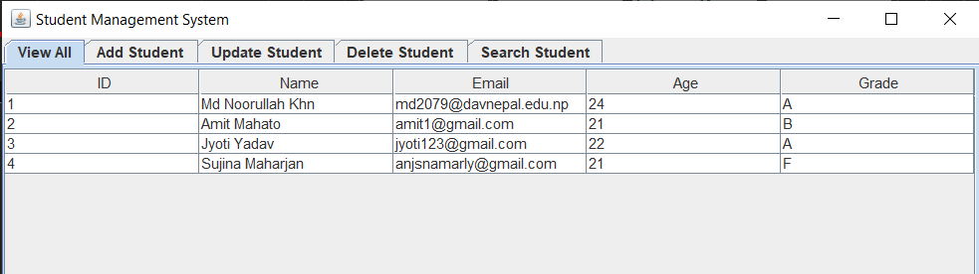
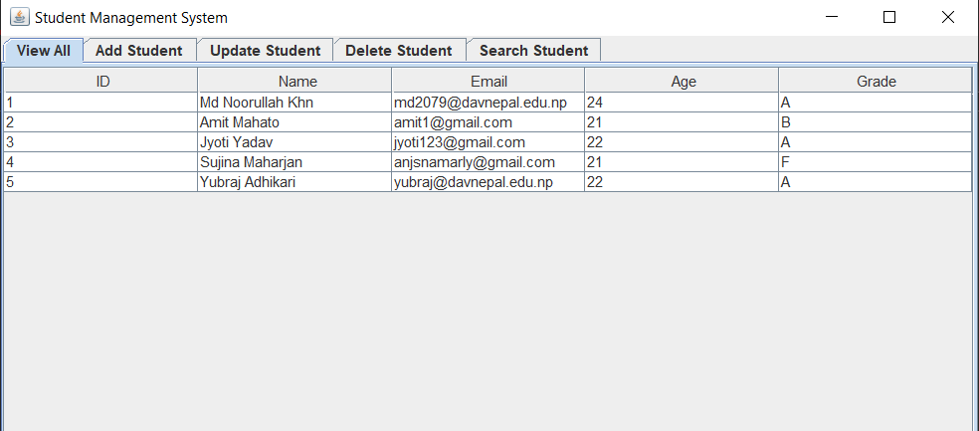
Insert: After Insert:
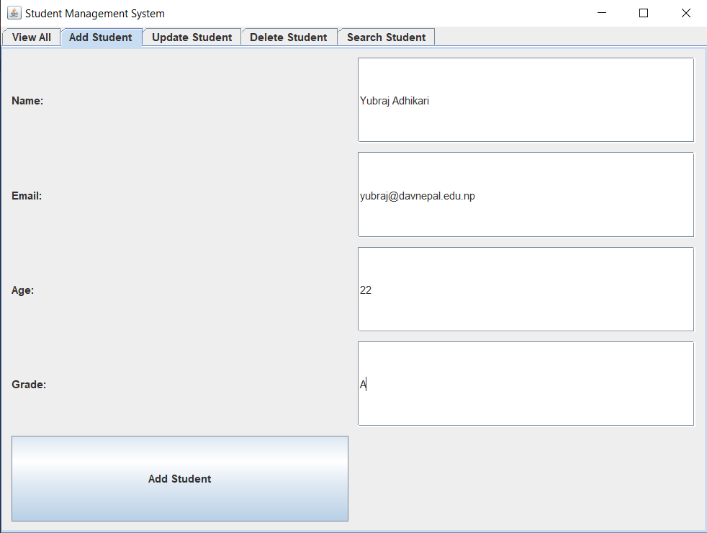

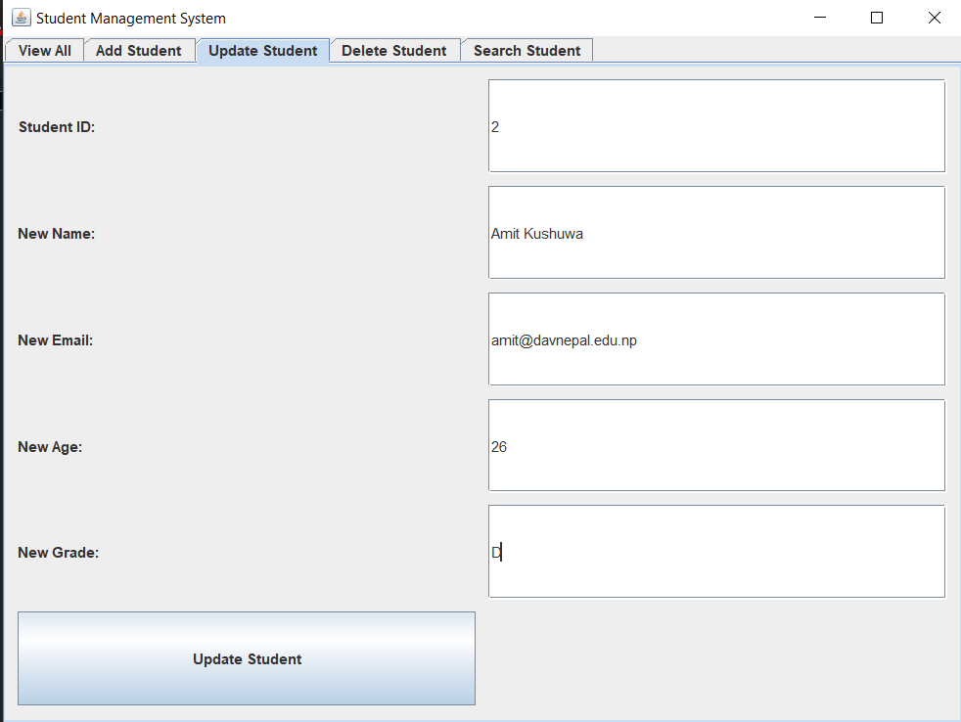
Update:

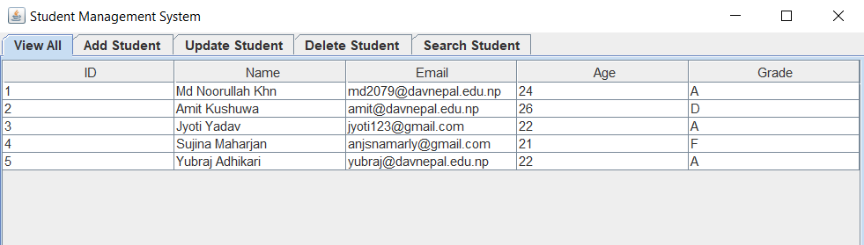
After Update:

Delete:
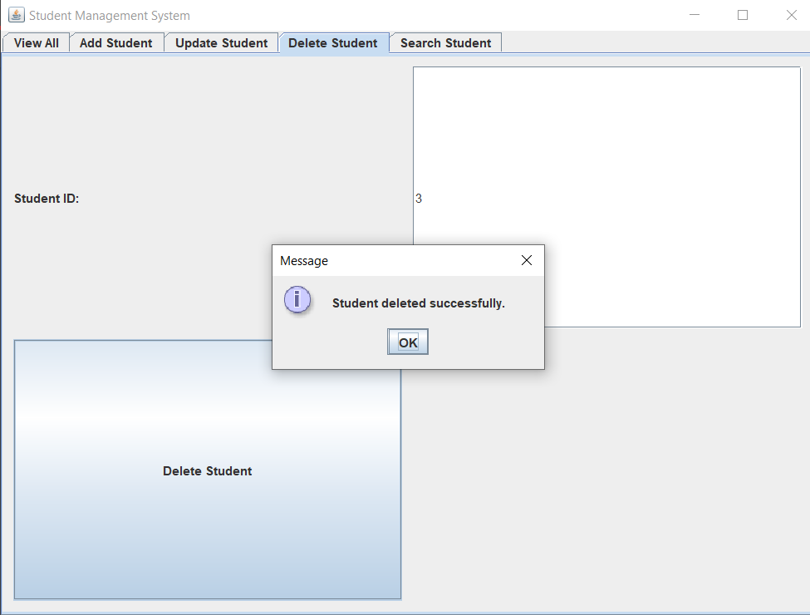

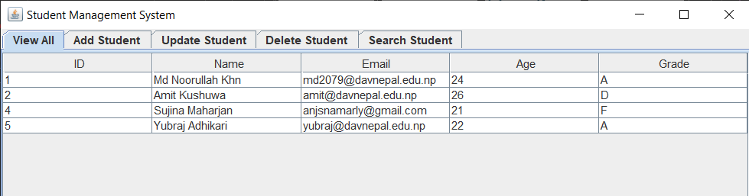
After Delete:

Search:
