OUTPUT:
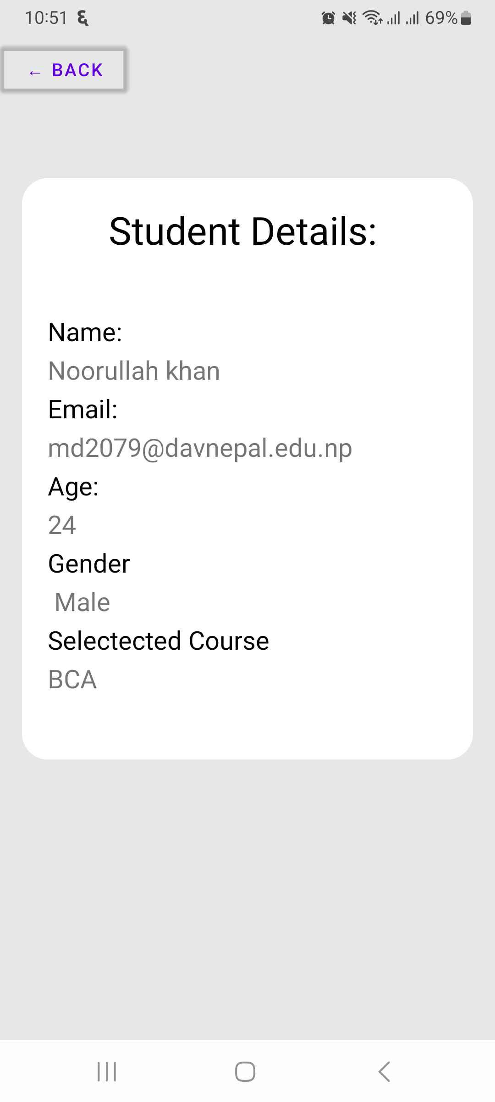
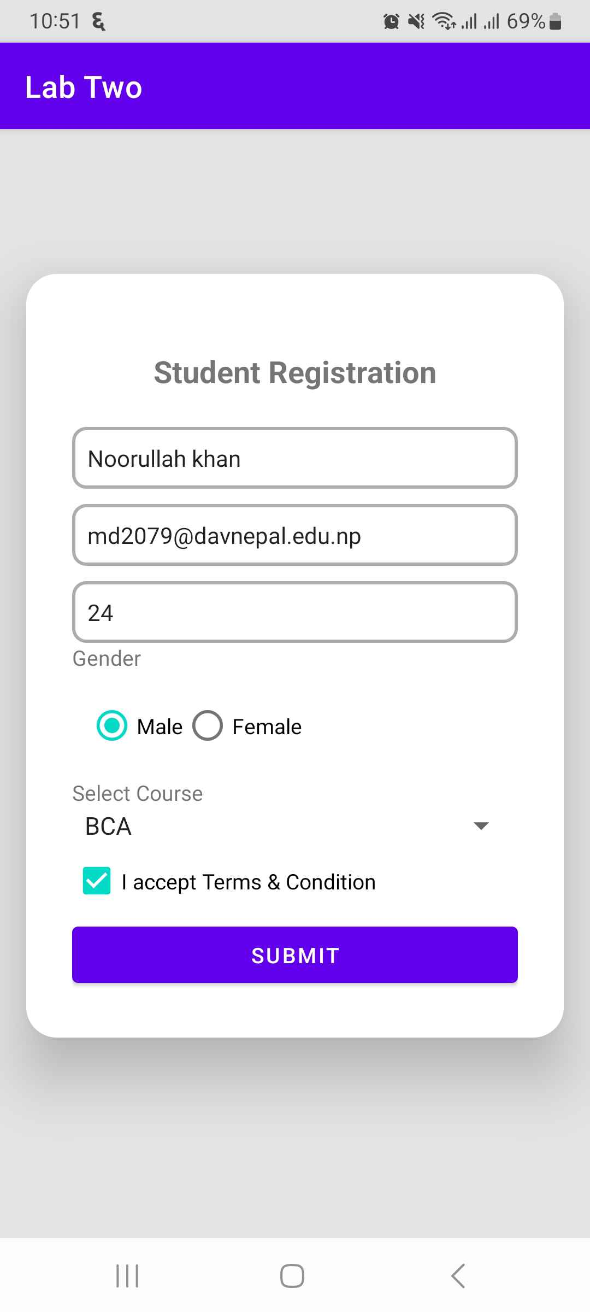

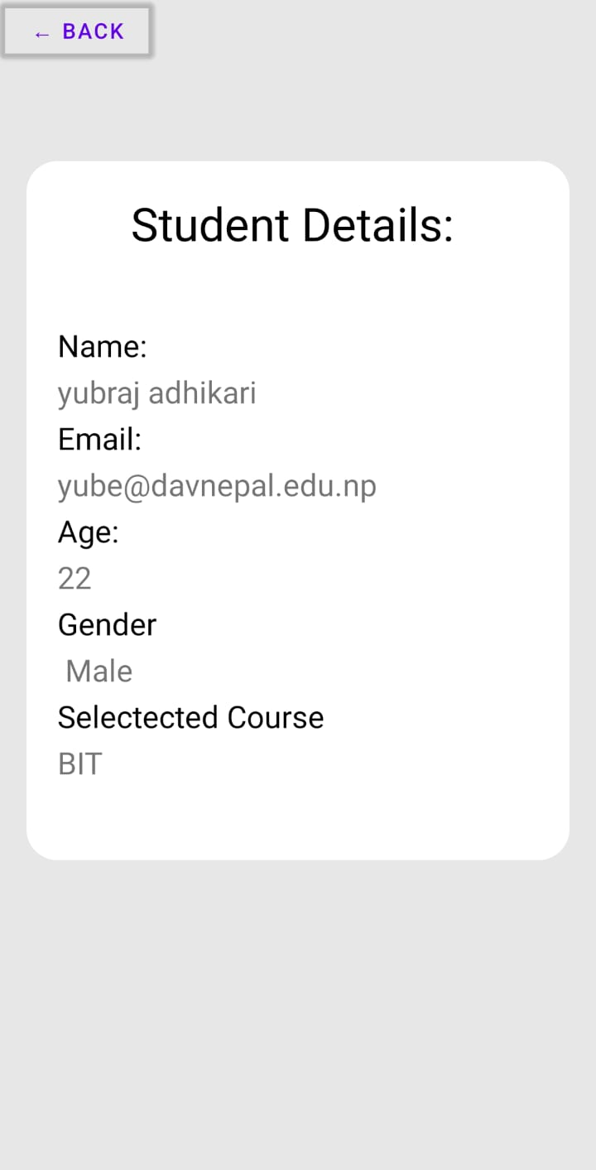
OUTPUT:
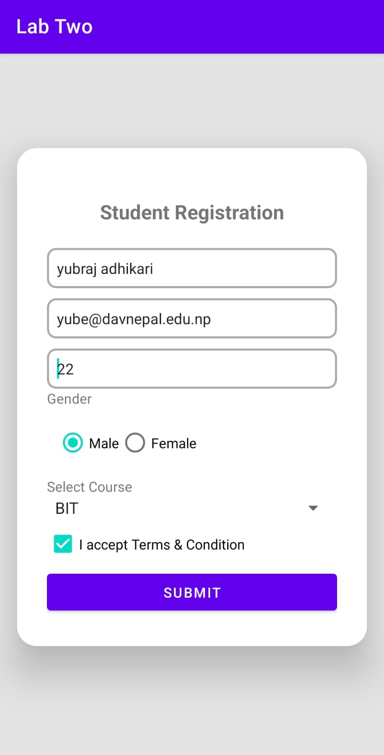

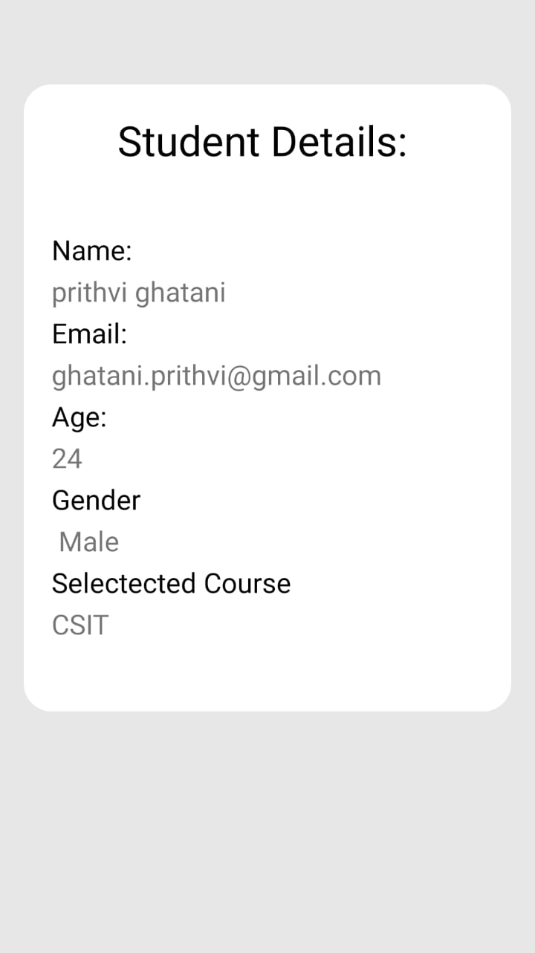
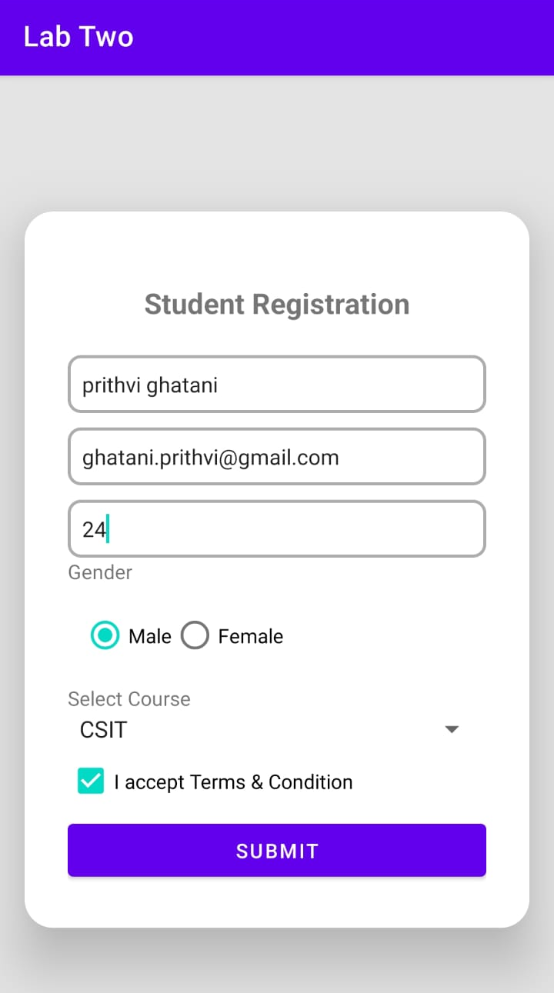
OUTPUT:

DAV COLLEGE
AFFILIATED TO T.U.
JAWALAKHEL, NEPAL

LAB REPORT FOR MOBILE PROGRAMMING(CACS351)
(BCA 6TH SEMESTER)



SUBMITTED BY: SUBMITTED TO:
NAME: MD NOORULLAH KHAN NIHAL SHRESTHA
ROLL NO: 08 LECTURER

DAV COLLEGE
AFFILIATED TO T.U.
JAWALAKHEL, NEPAL

LAB REPORT FOR MOBILE PROGRAMMING(CACS351)
(BCA 6TH SEMESTER)

SUBMITTED BY: SUBMITTED TO:
NAME: YUBRAJ ADHIKARI NIHAL SHRESTHA
ROLL NO: 24 LECTURER

DAV COLLEGE
AFFILIATED TO T.U.
JAWALAKHEL, NEPAL

LAB REPORT FOR MOBILE PROGRAMMING(CACS351)
(BCA 6TH SEMESTER)

SUBMITTED BY: SUBMITTED TO:
NAME: PRITHVI GHATANI NIHAL SHRESTHA
ROLL NO: 10 LECTURER

