

Tribhuvan University
Faculty of Humanities and Social Sciences
D.A.V College

Supervisor’s Recommendation

I hereby recommend that this project prepared under my supervision by MD NOORULLAH KHAN entitled “ONLINE BIKE RENTAL SYSTEM” in partial fulfillment of the requirements for the degree of Bachelor of Computer Applications is recommended for the final evaluation.

Pesal Rai
SUPERVISOR
Lecturer
The Department of Bachelor of Computer Applications
Jawalakhel, Lalitpur

Tribhuvan University
Faculty of Humanities and Social Sciences
D.A.V College

LETTER OF APPROVAL

This is to certify that this project prepared by MD NOORULLAH KHAN entitled “ONLINE BIKE RENTAL SYSTEM” in partial fulfillment of the requirements for the degree of Bachelor of Computer Applications has been evaluated. In our opinion it is satisfactory in the scope and quality as a project for the required degree.

Pesal Rai, Lecturer  Department of Bachelor of Computer Applications  Jawalakhel, Lalitpur | Mr. Sudip Adhikari, Head of Department  Department of Bachelor of Computer Applications  Jawalakhel, Lalitpur
Internal Examiner | External Examiner  Er. Kumar Prasun  Asst. Professor  Tribhuvan University

Abstract
An online bike rental system is a web-based platform that enables customers to search, book, and manage their bike rentals online. This Bike Rental System deals with various activities related to the rental or booking systems. In the current existing firms manual record keeping is highly in practice, which is very difficult to organize. Adapting the advancement of technology, Online Bike Rental System can help discard such traditional way of maintaining records. Online Bike Rental System has been designed to computerize the operations performed over the information about the customer, vehicles and bookings, and other operations. This computerization of the rental system helps in many instances of its maintenance. It reduces the workload of management as most of the manual work done is reduced.

Keywords: Online Bike Rental System, booking, traditional, operations.

Acknowledgement
I am very grateful to the department of computer application, DAV college for providing me an opportunity to work on a minor project as part of Project ‘I’. I am delighted to express my deep sense of gratitude and gratefulness to our academic sir Pesal Rai for his invaluable guidance, encouragement, and even monitoring to spare time despite his busy schedule for project progress reviews.

Furthermore, I would like to thank Mr. Sudip Adhikari for his guidance and motivation throughout the project. In addition, I would like to thank my friends, who have willingly shared their precious time, advice, and encouragement during planning of this project.

My special thanks go to our college department and everyone who directly and indirectly extended their hands in making this project successful.

Table of Contents
Supervisor’s Recommendation i
Letter of Approval ii
Abstract iii
Acknowledgement iv
List of Abbreviations vii
List of Figures viii
List of Tables ix
CHAPTER 1 INTRODUCTION 1
1.1. Introduction 1
1.2. Problem Statement 2
1.3. Objective 2
1.4. Scope and Limitation 2
1.5. Report Organization 3
CHAPTER 2 BACKGROUND STUDY AND LITERATURE REVIEW 4
2.1. Background Study 4
2.2. Literature Review 4
CHAPTER 3 SYSTEM ANALYSIS AND DESIGN 6
3.1. System Analysis 6
3.1.1. Requirement Analysis 6
3.1.2. Feasibility Analysis 8
3.1.3.Data Modeling (ER-Diagram) 10
3.1.4. Process Modeling (DFD) 11
3.2. System Design 12
3.2.1. Architecture Design 12
3.2.2. Database Schema Design 13
3.2.3. Interface Design (UI Interface/Interface Structure Design) 14
CHAPTER 4: IMPLEMENTATION AND TESTING 16
4.1. Implementation 16
4.1.1. Tools Used: 16
4.1.2. Implementation Details of Modules: 16
4.2.Testing 17
4.2.1.Test Case for Unit Testing 18
4.2.2. Test Cases for System Testing 20
CHAPTER 5 CONCLUSION AND FUTURE RECOMMENDATION 23
5.1. Lesson Learnt/Outcome 23
5.2. Conclusion 23
5.3. Future Recommendations 23
REFERENCES 24
APPENDICES 25

List of Abbreviations
CRUD Create, Read, Update, Delete
DFD Data Flow Diagram
ERD Entity Relationship Diagram
PHP Hypertext Preprocessor
SQL Structured Query Language
VS Visual Studio

List of Figures

Figure 3.1 Waterfall Model for Online Bike Rental System 6

Figure 3.2 Use Case Diagram for Online Bike Rental System 7

Figure 3.3 Gantt Chart for Online Bike Rental System 9

Figure 3.4 ERD for Online Bike Rental System 10

Figure 3.5 level 0 DFD for Online Bike Rental System 11

Figure 3.6 level 1 DFD for Online Bike Rental System 11

Figure 3.7 3-tier Architecture Design for Online Bike Rental System 12

Figure 3.8 Database Schema for Online Bike Rental System 13

Figure 3.9 Login Page 14

Figure 3.10 Register Page 14

Figure 3.11 Customer Dashboard 15

Figure 3.12 Admin Dashboard 15

List of Tables

Table 4.1 Admin Login Test 18

Table 4.2 Customer Registration Test 18

Table 4.3 Customer Login Test 19

Table 4.4 Add and Request Bike Test 19

Table 4.5 Test Cases for System Testing 20

CHAPTER 1 INTRODUCTION

1.1. Introduction
Online Bike Rental System is the service by which users can directly rent a motorcycle and confirm rental services for various purpose over internet. Since technology has advanced, more and more buyers are willing to skip physically visiting the showroom in favor of riding an expensive motorcycle and using a computer and the internet. This is the result of the World Wide Web's development. Businesses have tried to rent out their pricey motorcycles to web surfers. Thus, with the aid of a computer and the internet, people can rent almost anything that meets their needs online.
The main purpose of this project is to develop an online bike rental system that will rent out motorcycles via the internet. Additionally, the system's development has made it dependable, safe, and easy to use. It is the system that maintains number of motorcycles and can book and rent them out for a set amount of time. A bike rental is a rented vehicle that can be used temporarily for a fee during a specified period. Getting a rental bike helps people get around despite the fact they do not have access to their own personal vehicle or don't own a vehicle at all.
The main target audience of this system is bike enthusiasts. Owning a high-end motorcycle is expensive. Most people appreciate the idea of renting a bike and riding it whenever they want. Bike rental services are used by people for many purposes, one of which is transportation.
Not just for tourism, but also for personal and work commutes, people are turning to bike rental services. Nepal’s market for two-wheeler rental services is ripe with opportunities, and new rental platforms are igniting a new passion among city dwellers. People can rent a variety of bikes for different periods depending on their needs and preferences.

1.2. Problem Statement
All of us have a fascination for motorcycles. The number of bike lovers is increasing day by day. Since a motorcycle is an expensive product, so it is not possible to purchase for everyone in terms of financial condition. However, it is possible to fulfill their desire to ride bikes through rental services. In this way the customer will be able to rent a bike according to his needs. Although this service is available outside our country, this service has not yet been fully launched in Nepal. However, this business has immense growth potential. So, it will become very popular in this country very soon.
The proposed solution involves the development of a robust online platform that integrates user-friendly interfaces, booking functionalities and bike listings. The Online Bike Renting System is reliable for the customers as it provides customer register and login portal for the registration process. The customers can easily view the list of different motorcycles and also can view the status of vehicle and easily apply for rent. They do not have to visit the sites for the confirmation process as, clients can receive confirmation as soon as they apply or book bike for rent through the web application. The admin can also easily view the reservation history and update the bike status. Most importantly, there is less probability of data loss.

1.3. Objective
The primary goals of this system are:
- To develop a web-based system to reserve bike online.
- To provide customers platform for easy browsing, booking, and renting of bike.

1.4. Scope and Limitation
Every application has its unique feature and its limitation. This system offers the following
scope and lacks the following things:
Scopes:
- User-friendly environment.
- Users can easily view book details in their dashboard.
- Unauthorized users cannot access the system.
- Users of any or no experience can easily browse through the website.
- User can easily view the availability status.
Limitations:
- No online payment available, only cash on site is preferred.
- Since it is online based, internet is required. The location of vehicles or customers who booked the vehicles cannot be tracked.

1.5. Report Organization
The report on “Online Bike Rental System” is organized into Five chapters.
Chapter 1:
Includes the introduction of whole project in brief.
Chapter 2:
Describes the background study of the present system available related to rental system.
Includes overview of related existing systems and their pros and cons.
Chapter 3:
Describes the analysis and design of the system which consists of the functional and non-
functional requirements of the system along with use case diagrams. It also explains the
feasibility analysis of the system.
Chapter 4:
Presents the Implementation, Testing, and debugging part of the system.
Chapter 5:
Provides brief explanation that Conclusion, Limitations, and Future Enhancement of the system.

CHAPTER 2 BACKGROUND STUDY AND LITERATURE REVIEW

2.1. Background Study
This online bike rental system is a web-based system for the users or customers that rents bike. This system enables the bike rental firms to make their services available to the public through the internet and also keep records about their services. This is a platform that allows renting bike for a short period of time for a few days or week This system can be used to make service more popular and accessible to the public as it has been transformed into a web-based system and connected to the internet were everyone can be able to have access to it [1]. In today’s world, the use and access to the internet are so high so most people are busy with their job so, this system is developed so that users or customers can create and access their accounts through the use of the internet and general concept and terminologies are mentioned below:
1. Create New Account: A user can register an account through the registration process and the user can create an account when there is access to the internet through this module.
2. Login: After the creation of the account user can log in through their valid details and
can access to customer dashboard of this system.
3. Book Bike: After logging in, customers can book the desired bike based on some terms and conditions.
4. Approves the booking: Admin can approve the rental request sent by a customer.

2.2. Literature Review
While surfing through some of the rental-based websites, and observed those and compared the features with this system. One of them is Self-Drive Nepal. The online bike rental system offers two distinct portals to cater to its users: the Client-side Portal and the Admin Portal. The Client-side Portal provides a range of features aimed at facilitating the user experience. Firstly, it offers User Management capabilities, allowing users to create accounts and log in securely. Additionally, the portal enables Rental Management by sending vehicle booking requests to the admin along with customer information and booking details. Customers can also submit inquiries through the Enquiry feature, which forwards these to the administrative site for handling. The portal further allows clients to browse and view the available vehicles through the 'Show vehicle list' feature, aiding them in making informed booking decisions. An integrated chatbot is also available, allowing customers to communicate with the admin, with automatic replies being generated for user queries. Furthermore, customers can track their rental history through the 'Total bookings' feature and view detailed booking information, including renting dates, locations, and request statuses, via the 'Show booking details' section in their dashboard [1].
On the other hand, the Admin Portal is designed to streamline the administrative tasks associated with managing the rental system. It provides a clear overview of the booking requests received from clients, displaying the client's renting request alongside their booking details. The administrator has the authority to update and expand the rental vehicle list through the 'Add vehicles to the list' feature, ensuring that the system's offerings remain up-to-date. The portal also facilitates communication by displaying and allowing responses to the inquiries sent from the client side through the 'Show enquiries' section. Additionally, the Admin Portal maintains a comprehensive 'Show users list' that records all users who have utilized the system for renting purposes, aiding in effective user management [1].
Limitation of this system, the user could book any vehicle without adding any documents like license. This “Online Bike Rental” system will ask to add license photo along with sign up and later again with bike rental so that admin can verify it and approve the rental. Another system is Maharjan Bikes Rental . The system in that website only had vehicle data and their rates and we could only enter our name and email in their system. This system offered Bikes Rental Rate, Vehicle gallery and their contact information. Limitation of this Existing system: Maharjan Bikes Rental did not have any kind of authentication or authorization. Image of citizenship and passport could not be uploaded in it even though the system had mentioned about citizenship and passport [2].
This “Online Bike Rental” system will add authentication and authorization.

CHAPTER 3 SYSTEM ANALYSIS AND DESIGN

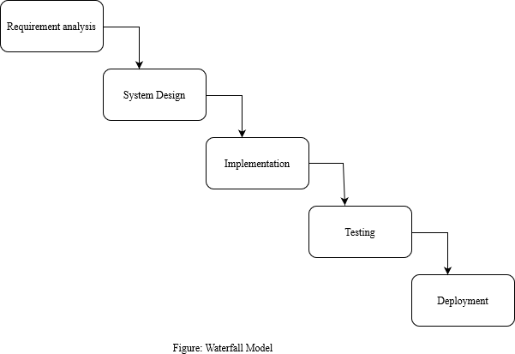
3.1. System Analysis

Figure 3.1 Waterfall Model for Online Bike Rental System
The waterfall model is ideal for developing this project because all the requirements are known and there is not much time left for development. The requirements analysis, system design, implementation, testing, and deployment phases make up the project's five stages.

3.1.1. Requirement Analysis
i. Functional Requirements
- Customer Login/Registration Module:
This system allows customers to establish and manage accounts, including personal information.
- Customer Dashboard:
It shows different varieties of bike to apply for rent to the customers.
It allows customer to see the availability status of vehicles.
- Admin Dashboard:
Administrator has the access of viewing details of rented vehicles.
Admin has an option to add list of vehicles and change the vehicle status.
- Bike Selection:
The system allows customers to select any bike from the varieties of bikes to rent.
- Availability Status:
This system provides accurate details about bikes, bike availability status and pricing to customers.
- Rental Management:
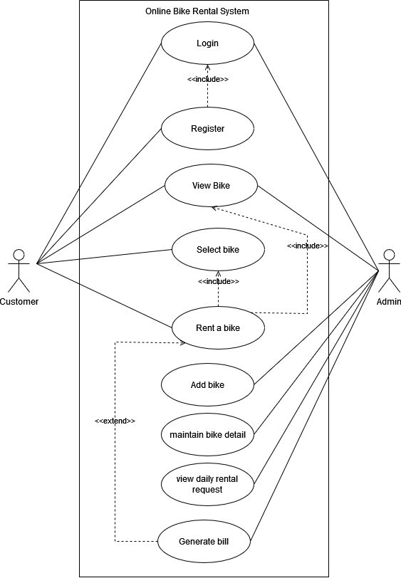
Customers can use this system to reserve and cancel a rental online.

Figure 3.2 Use Case Diagram for Online Bike Rental System

This use case diagram shows that it has two users i.e., customer and the admin. Here admin and customer both have their own respective roles. The customer needs to register and customer as well as admin both need to login to the system . The admin has the authority to maintain all the bike related details such as bike rate , booking status etc. whereas the customers also have total authority in renting bikes with their choices.
ii. Non-Functional Requirement
- Usability:
The system has a user-friendly design so that it will be easy to
navigate and understand for the clients.
- Security:
The system is quite secured as all the rental details are recorded.
- Reliability:
The system is available at all times.

3.1.2. Feasibility Analysis
    - Technical Feasibility:
This project can simply run in the web browser easily. The programming language used in this system is PHP and since this is the easy to implement there is less possibility of system failure. Hence, the system is technically feasible.
    - Operational Feasibility:
The major goal of this project is to provide a system that is valuable and beneficial to client. This system provides the convenience of online renting. This project has manageable design which is reliable for the users or clients for the interaction. Hence, we can say that this project is operationally feasible.
    - Economic Feasibility:
It is the measure of cost effectiveness of the project. All the procedure is done online, customer do not have to visit vehicle rental companies’ site which reduces the cost as well as time. Since we are using PHP and other free applications to develop this system it is economically feasible.
    - Schedule
The development of the project is completed under the time criteria with every aspect necessarily implemented and documents properly presented. The time schedule of the different parts of the project can be seen below in the following Gantt chart.
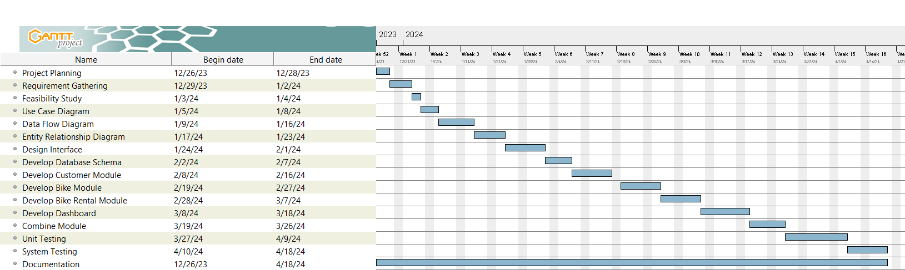

Figure 3.3 Gantt Chart for Online Bike Rental System
The Gantt chart outlines the timeline and progression of various tasks for a project from late 2023 to mid-April 2024. It begins with project planning on December 6, 2023, followed by requirement gathering and feasibility study in December 2023 and January 2024. Subsequent tasks include developing use case diagrams, data flow diagrams, and entity relationship diagrams through January and February 2024. Design interface and database schema development occur in February 2024. The project then transitions to developing different modules (customer, bike, bike rental, dashboard) from February to March 2024. The final stages include combining modules, system testing, and documentation, culminating on April 16, 2024. Each task is visually represented with a horizontal bar, indicating its duration and overlap with other tasks.

3.1.3.Data Modeling (ER-Diagram)
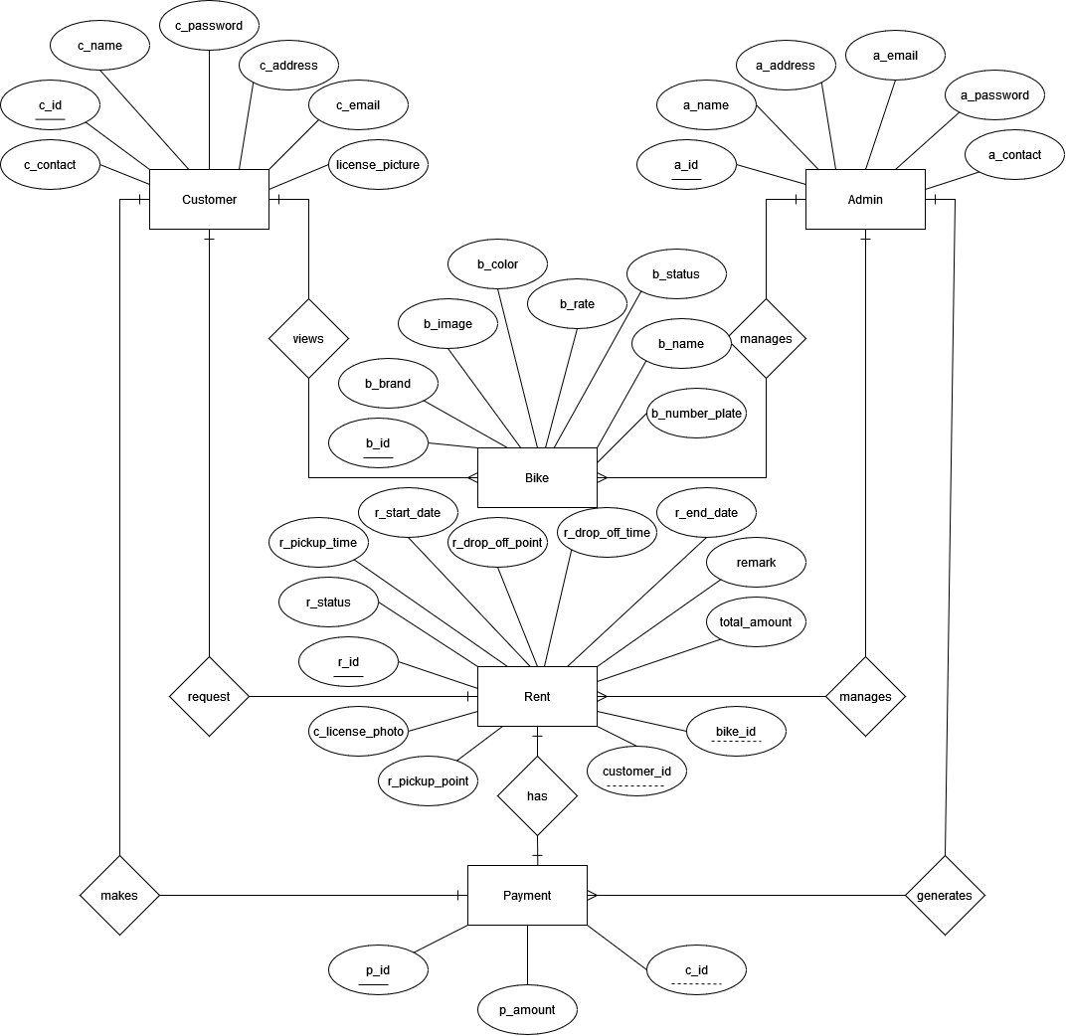

Figure 3.4 ERD for Online Bike Rental System
This system consists of five entities along with their respective attributes. The relationship has been developed within those entities. Here the entities are customer, admin, bike, rent and payment. The relationship that exists between the entities are one to many and one to one. The relationship is symbolized with diamond shape, entities with rectangular shape and attributes with oval shape. Here, the primary keys are all unique and well identified and underlined. The foreign key also has been well defined.

3.1.4. Process Modeling (DFD)

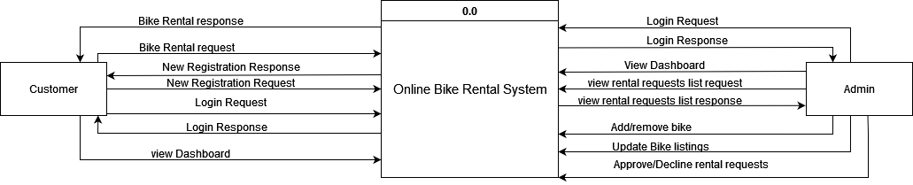

Figure 3.5 level 0 DFD for Online Bike Rental System

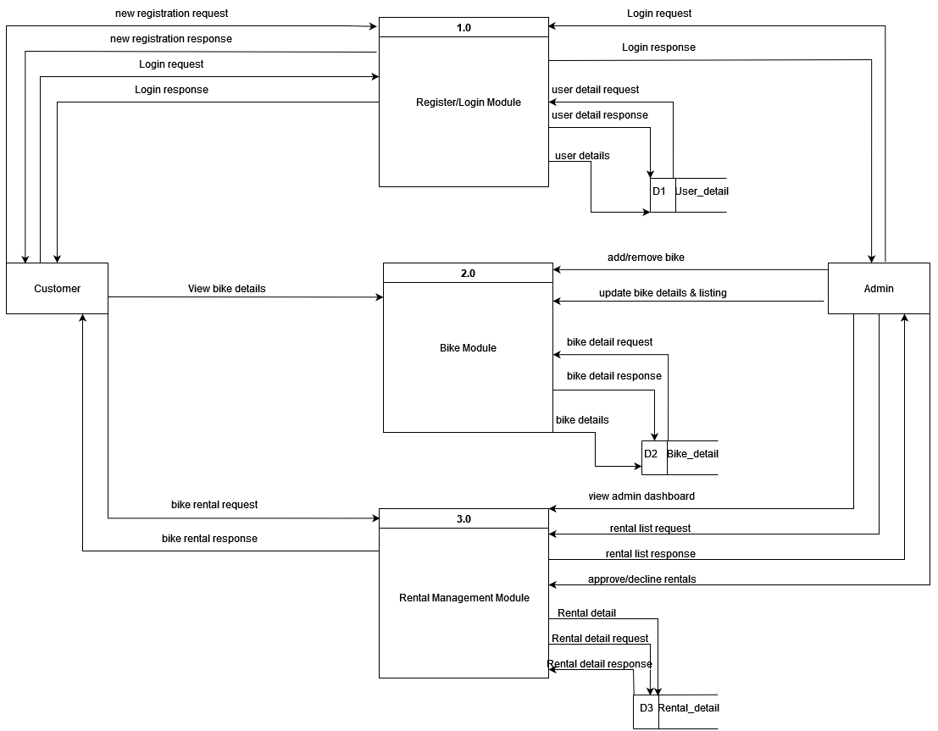

Figure 3.6 level 1 DFD for Online Bike Rental System

3.2. System Design

3.2.1. Architecture Design

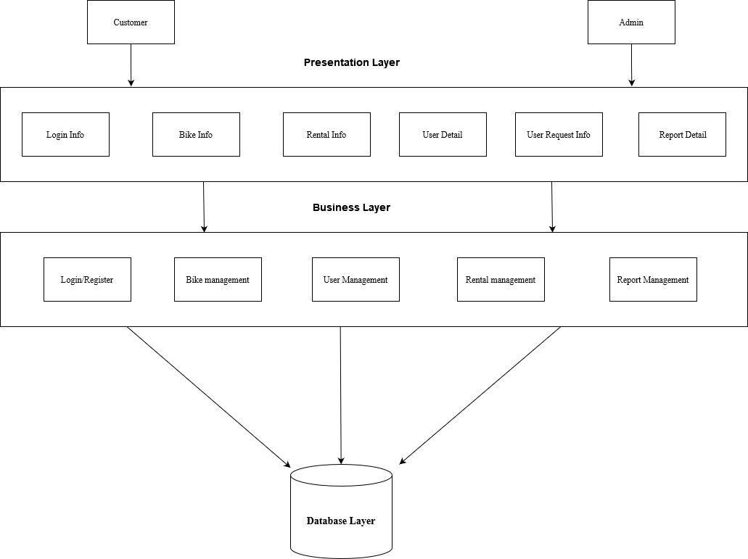

Figure 3.7 3-tier Architecture Design for Online Bike Rental System
The first layer is presentation layer in which interfacing with the users (Customers and Admins). It includes modules for displaying login information, bike details, rental information, user details, user requests, and report details. The second layer is business layer handles the core functionality and business logic. It includes modules for managing login and registration, bike management, user management, rental management, and report management. The last layer is database layer that is for data storage and retrieval. It interacts with the business layer to manage the data.

3.2.2. Database Schema Design

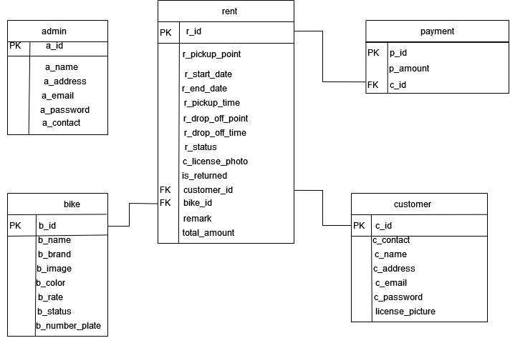

Figure 3.8 Database Schema for Online Bike Rental System
This represent the database schema diagram of the system in which we can see 5 tables for this system in which first is admin with its own primary key(PK) i.e. a_id and other attributes a_name, a_address, a_email, a_password, and a_contact. Similarly, all other table has their own unique key, attributes and some table consist of foreign key(FK) which are referenced from another table.

3.2.3. Interface Design (UI Interface/Interface Structure Design)

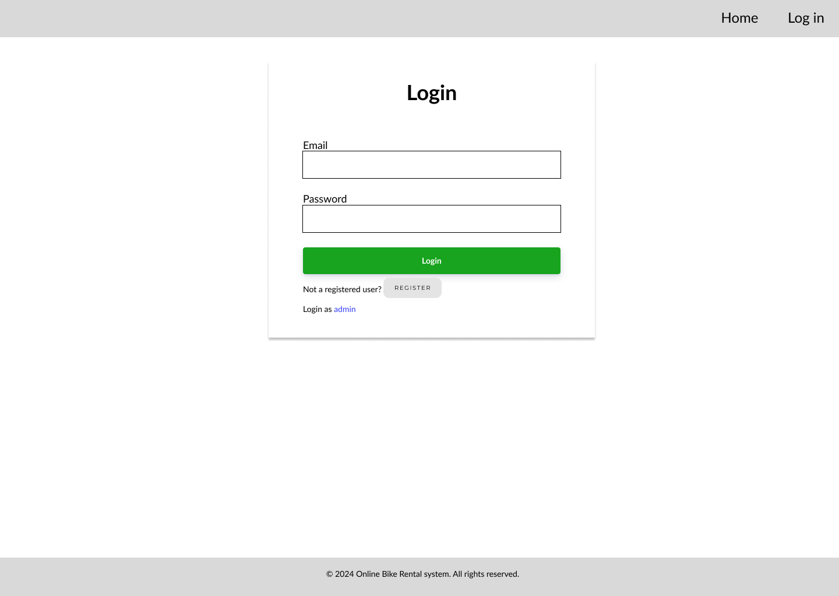

Figure 3.9 Login Page

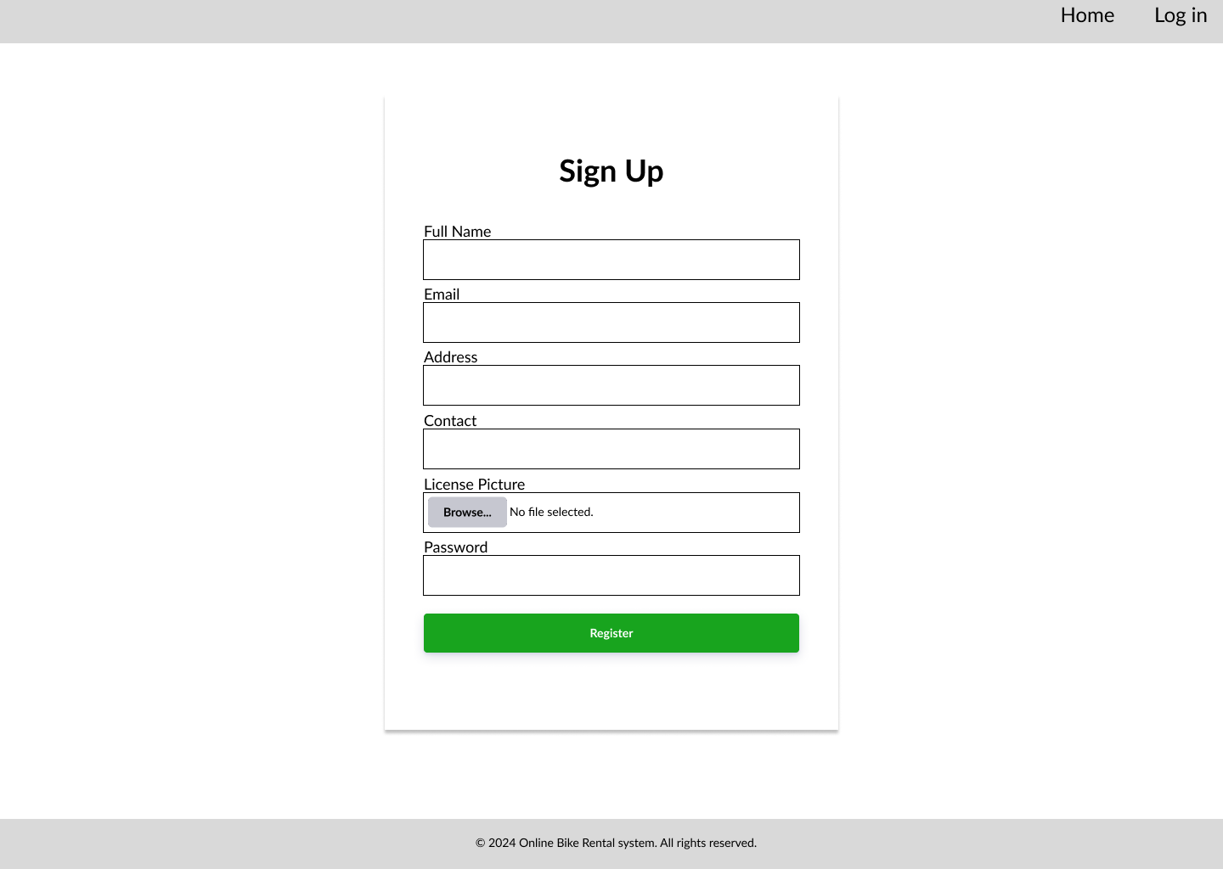
Figure 3.10 Register Page
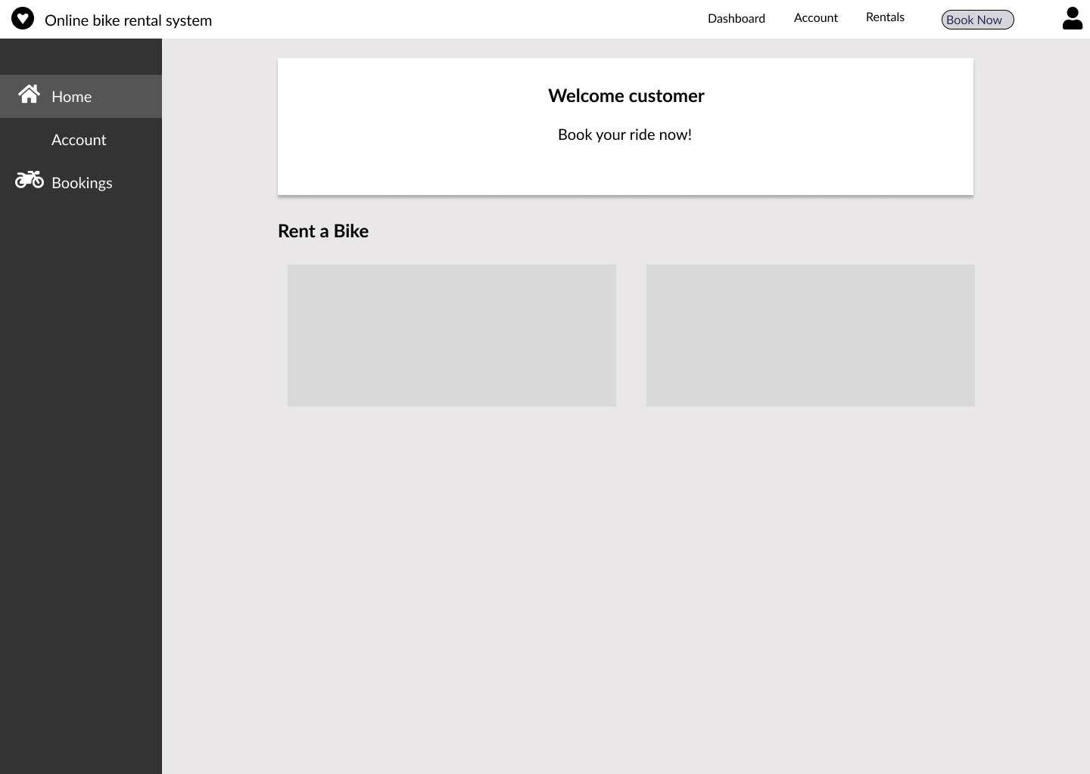

Figure 3.11 Customer Dashboard
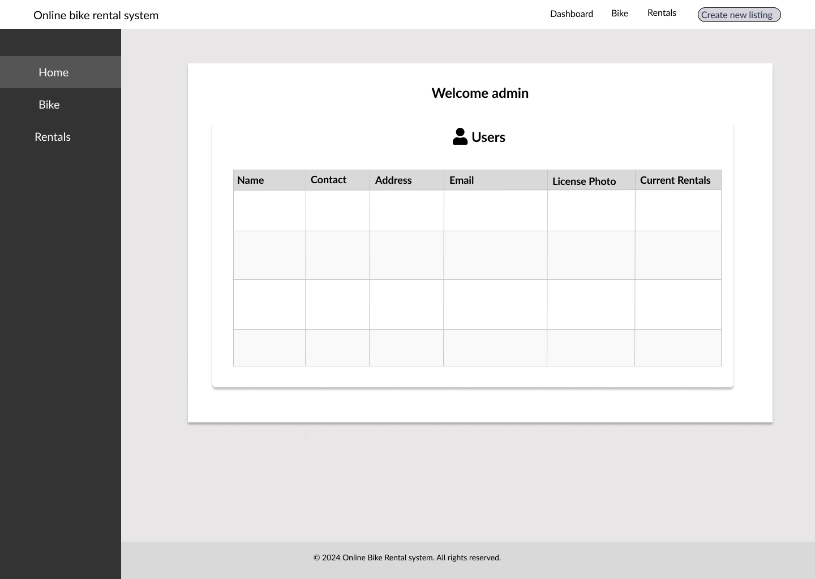

Figure 3.12 Admin Dashboard

CHAPTER 4: IMPLEMENTATION AND TESTING

4.1. Implementation

4.1.1. Tools Used:
- Draw.io
This tool was used to design the waterfall model, use case, ERD, DFD, 3-tier Architecture Design and Database Schema of online bike rental system.
- Gantt Project
It was used to create Gantt chart for this project.
- PHP
It was used to perform all the backend functionalities of this system.
- MySQL
It was used to store the data and information for this system.
- Java script
It was used to add events for some buttons and redirect pages.
- Xampp
To test and run our code locally on personal system.
- VS code
To edit the codes with an ease.
- Figma
To design the different modules of this system.

4.1.2. Implementation Details of Modules:
After the design was built, it was time to start implementing the application. The major aspects of the implementation, some modules of the Online Bike Rental system are listed below:
- Registration Module:
It is used to register new users to the system. It contains fields like name, email, address, contact, License Picture and password. The information entered is further stored to use on the login page. If the account is already registered it will not allow users to register again, it will display a box with already registered message. Also checks if an email or phone number already registered.
- Login Module
This module requires the user or customer and admin to meet the login credentials i.e., email and Password that matches with the registered data to login to the system. If the details are entered without any registration, then the login page will redirect to the registration page for registering information.
- Customer Module:
This module is built for the customer site, where customer can view the available bikes, rent bikes, view rental status, and edit their information. The customers can see details of the bikes easily.
- Admin Module:
This module is built for the admin users, where admin can keep record or view all the registered customer details, add, edit or delete bikes to rent, approve or reject requested bikes. The admin can only edit and delete bike to the list whereas this feature is not available for customers site module.
- Bike Renting Module:
This module is for the customers in order to display the available bikes only and view the details then. It hides the bike that are approved for other customers or are in pending state.

4.2.Testing
The aim of program testing is to help realize/identify all defects in a program. However, in practice, even after satisfactory completion of the testing phase, it is not possible to guarantee that a program is error free. This is because the input data domain of most programs is very large, and it is not practical to test the program exhaustively with respect to each value that the input can assume. The primary goal of software testing is to identify defects, errors, or bugs in the software and ensure that it behaves as intended. Testing is an integral part of the software development life cycle, helping to deliver quality and reliable product to end-users.

4.2.1.Test Case for Unit Testing

Table 4.1 Admin Login Test
S.N | Test Case | Test Data | Expected Result | Result
1. | Admin enter valid username and password | Email:test@gmail.com  Password:test | Redirects to admin dashboard | Pass
2. | Admin enter invalid  Email and password | Email:testabc@gmail.com  Password:123 | Invalid credentials | Pass

Table 4.2 Customer Registration Test
S.N. | Test Case | Test Data | Expected Result | Result
1. | Customer registers to the system | Full name: test  Email:  test2@gmail.com  Address:  teku  Contact: 1234567891  Password: test123 | Redirects to  customer login  module | Pass
2. | Customer registers  to the system with  same name, email,  address, contact,  password | Full name: test  Email:  test2@gmail.com  Address:  teku  Contact: 1234567891  Password: test123 | Cannot register: User already exists | Fail
3. | Customer registers  to the system with  same name, email,  address, contact,  password | Full name: test  Email:  test2@gmail.com  Address:  teku  Contact: 1234567891  Password: test123 | Cannot register: User already exists | Pass

Table 4.3 Customer Login Test
S.N. | Test Case | Test Data | Expected Result | Result
1. | Customer logs in  with registered data. | Email:test2@gmail.com  Password:test123 | Redirects to customer dashboard | Pass
2. | Customer logs in  with unregistered  data | Email:test3@gmail.com  Password:test1234 | Invalid Credentials | Pass

Table 4.4 Add and Request Bike Test
S.N. | Test Case | Test Data | Expected Result | Result
1. | Admin adds  vehicle through  form | Bike Name: hunter 350  Bike brand: royal enfield  Bike color: red  Bike rate: 125  Bike photo:  Bike number plate Photo: | New row is added  to the list of  bike table. | Pass
2. | Customer request  Bike through  booking form with  all field filled. | Pickup point:  Start Date:  End Date:  Pickup Time:  Drop Off Point:  Drop Time:  License Photo: | show booking  successful &  the details is sent  to the admin in  rental management  for  approval/rejection. | Pass

4.2.2. Test Cases for System Testing

Table 4.5 Test Cases for System Testing
S.N. | Test Case | Test Data | Expected Result | Result
1. | Customer registers to the system | Full name: test  Email:  test2@gmail.com  Address:  teku  Contact: 1234567891  Password: test123 | Redirects to  customer login  module | Pass
2. | Customer register with the already registered email | Email: test2@gmail.com | Displays user already exists | Pass
3. | Customer logs in  with registered data. | Email:test2@gmail.com  Password:test123 | Redirects to customer dashboard approval/rejection. | Pass
4. | Customer logs in with not registered data | Email:hellow@gmail.com  Password:123123 | Display invalid credentials | Pass
5. | Admin adds new bike. | Bike Name: hunter 350  Bike brand: royal enfield  Bike color: red  Bike rate: 125  Bike photo:  Bike number plate Photo: | Displays bike  in admin  dashboard and also  displays in  customer dashboard. | Pass
6. | Customer request bike | Pickup point: dhobighat  Start Date: 5/5/2024  End Date: 5/6/2024  Pickup time:12:00 PM  Drop time: 12:00 PM  License Picture: | Booking successful pop up and redirect to bookings | Pass
7. | Admin approves / reject  Booking request | Admin clicks approve button to approve vehicles or reject button to reject vehicles. | Displays approved or rejected status after clicking. | Pass
8. | Customer Returns the vehicles after Rental Period is over. | Admin clicks on returned button | Displays the status of vehicle as returned after updated by  admin. | Pass
9. | Customer can choose specified time and date | Start date: 2024-03-28  End date: 2024-03-29  Start Time:6:00  End Time:12:00 | It sends the request to admin for approval | Pass
10. | Customer chooses wrong date and time | Start date: 2024-04-28  End date: 2024-03-25 | It gives error message dates cannot be selected before started date | Pass
11. | Customer cancels the bike rental | Press the cancel button on pending | It confirms cancellation and cancels the booking | Pass
12. | Admin edits bike | Edits bike info | Displays update bike info | Pass
13. | Admin deletes bike | Press delete bike | Removes the bike from database | Pass
14. | Inserting javascript or html codes on forms | <script>console.log  (‘Hello’);  </script> | It displays it into plain text and wont run the code in it | Fail
15. | Inserting javascript or html codes on forms | <script>console.log  (‘Hello’);  </script> | It displays it into plain text and wont run the code in it | Pass
16. | Trying to delete a bike with link in different pages after log out | Press delete | Shouldnot delete the bike if session destroyed | Fail
17. | Trying to delete a bike with link in different pages after log out | Press delete | Shouldnot delete the bike if session destroyed | Pass
18. | Changing the id of get method from url to get others detail | Change id from url of edit page | Block access to access others id | Pass

CHAPTER 5 CONCLUSION AND FUTURE RECOMMENDATION

5.1. Lesson Learnt/Outcome
After the completion of Online Bike Rental System project, the following things were achieved while constructing this project:
- Learned about HTML, CSS, PHP, JavaScript and MySQL.
- Learned about research and literature review of system.
- Learned to solve problems while testing.
- Learned to implement a CRUD operation in a system.

5.2. Conclusion
The Online Bike Rental system is simply a web-based application that provides facility of renting bikes online. All the modules required to build this system have been implemented successfully. After the successful completion of Online Bike Rental System Project, the customers can perform easy bike rental transactions. This web application has been developed with all the objectives fulfilled. All the specifications have been followed strictly. After completion of Online Bike Rental System project, the customers will now be able to view the available bikes in their dashboard. Customers will be able to request various bikes to rent. Admin can now easily add and remove bikes to the list. Admin have the authority to approve or reject the rental request based upon the certain defined credentials. Admin can now insert, update, delete the vehicle that will be shown in the customer dashboard. Hence this system has been developed to provide reliable services to the customer to book or rent bike anywhere and at any time.

5.3. Future Recommendations
There is a lot that can be added to enhance the features of this web application. Other extra modules can be added to make this system more realistic. Some future recommendations that can be added in this system are:
- Accessing the online payment method.
- GPS Bike Tracking.
- Implementation of graph report of rental history for admin dashboard.

REFERENCES
[1] | "selfdrivenepal," [Online]. Available: https://selfdrivenepal.com/. [Accessed 26 12 2023].
[2] | "Maharjan Bikes Rental," [Online]. Available: https://maharjanbikesrental.com/. [Accessed 27 12 2023].
[3] | R. Mall, Fundamentals of Software Engineering, Delhi, 2014.
[4] | J. R. G. a. P. N. Weinberg, The complete Reference SQL, 2007.
[5] | D. Flanagan, JavaScript: The Definitive Guide, O' Reilly Media, 2011.

APPENDICES
