Table of Contents
List of Abbreviations iii
List of Figure iv
List of Tables v
CHAPTER 1 INTRODUCTION 1
1.1. Introduction 1
1.2. PROBLEM STATEMENT 2
1.3. Objective 2
1.4. Scope and Limitation 2
1.5. Report Organization 3
CHAPTER 2 BACKGROUND STUDY AND LITERATIRE REVIEW 4
2.1. Background Study 4
2.2. Literature Review 4
CHAPTER 3 SYSTEM ANALYSIS AND DESIGN 6
3.1. System Analysis 6
3.1.1. Requirement Analysis 6
3.1.2. Feasibility Analysis 9
3.1.3. Data Modeling (ER-Diagram) 11
3.1.4. Process Modeling (DFD) 12
3.2. System Design 13
3.2.1. Architecture Design 13
3.2.2. Database Schema Design 14
3.2.3. Interface Design (UI Interface/Interface Structure Design) 15
CHAPTER 4: IMPLEMENTATION AND TESTING 17
4.1. Implementation 17
4.1.1. Tools Used: 17
4.2. Testing 17
4.2.1. Test Case for Unit Testing 17
REFERENCES 21

List of Abbreviations
CRUD - Create, Read, Update, Delete
DFD - Data Flow Diagram
ERD - Entity Relationship Diagram
PHP- Hypertext Preprocessor
VS- Visual Studio
SQL- Structured Query Language

List of Figure
Figure 3.1 Waterfall Model 6
Figure 3.2 Use Case Diagram 8
Figure 3.3 Gantt Chart 10
Figure 3.4 ERD 11
Figure 3.5 level 0 DFD 12
Figure 3.6 level 1 DFD 12
Figure 3.7 3-tier Architecture Design 13
Figure 3.8 Database Schema 14
Figure 3.9 Login Page 15
Figure 3.11 Customer Dashboard 16
Figure 3.12 Admin Dashboard 16

List of Tables
Table 4.1 Admin Login Test 18
Table 4.2 Customer Registration Test 18
Table 4.3 Customer Login Test 18
Table 4.4 Add and Request Bike Test 19

CHAPTER 1 INTRODUCTION

1.1. Introduction
Online Bike Rental System is the service by which users can directly rent a motorcycle and confirm rental services for various purpose over internet. Since technology has advanced, more and more buyers are willing to skip physically visiting the showroom in favor of riding an expensive motorcycle and using a computer and the internet. This is the result of the World Wide Web's development. Businesses have tried to rent out their pricey motorcycles to web surfers. Thus, with the aid of a computer and the internet, people can rent almost anything that meets their needs online.
The main purpose of this project is to develop an online bike rental system that will rent out motorcycles via the internet. Additionally, the system's development has made it dependable, safe, and easy to use. It is the system that maintains number of motorcycles and can book and rent them out for a set amount of time. A bike rental is a rented vehicle that can be used temporarily for a fee during a specified period. Getting a rental bike helps people get around despite the fact they do not have access to their own personal vehicle or don't own a vehicle at all.
The main target audience of this system is bike enthusiasts. Owning a high-end motorcycle is expensive. Most people appreciate the idea of renting a bike and riding it whenever they want. Bike rental services are used by people for many purposes, one of which is transportation.
Not just for tourism, but also for personal and work commutes, people are turning to bike rental services. Nepal’s market for two-wheeler rental services is ripe with opportunities, and new rental platforms are igniting a new passion among city dwellers. People can rent a variety of bikes for different periods depending on their needs and preferences.

1.2. PROBLEM STATEMENT
All of us have a fascination for motorcycles. The number of bike lovers is increasing day by day. Since a motorcycle is an expensive product, so it is not possible to purchase for everyone in terms of financial condition. However, it is possible to fulfill their desire to ride bikes through rental services. In this way the customer will be able to rent a bike according to his needs. Although this service is available outside our country, this service has not yet been fully launched in Nepal. However, this business has immense growth potential. So, it will become very popular in this country very soon.
The proposed solution involves the development of a robust online platform that integrates user-friendly interfaces, booking functionalities and bike listings. The Online Bike Renting System is reliable for the customers as it provides customer register and login portal for the registration process. The customers can easily view the list of different motorcycles and also can view the status of vehicle and easily apply for rent. They do not have to visit the sites for the confirmation process as, clients can receive confirmation as soon as they apply or book bike for rent through the web application. The admin can also easily view the reservation history and update the bike status. Most importantly, there is less probability of data loss.

1.3. Objective
The primary goals of this system are:
- To develop a web-based system to reserve bike online.
- To provide customers a user-friendly platform for easy browsing, booking, and renting of bike.

1.4. Scope and Limitation
Every application has its unique feature and its limitation. This system offers the following
scope and lacks the following things:
Scopes:
- User-friendly environment.
- Users can easily view book details in their dashboard.
- Unauthorized users cannot access the system.
- Users of any or no experience can easily browse through the website.
- User can easily view the availability status.
Limitations:
- No online payment available, only cash on site is preferred.
- Since it is online based, internet is required. The location of vehicles or customers who booked the vehicles cannot be tracked.

1.5. Report Organization
The report on “Online Bike Rental System” is organized into Five chapters.
Chapter 1:
Includes the introduction of whole project in brief.
Chapter 2:
Describes the background study of the present system available related to rental system.
Includes overview of related existing systems and their pros and cons.
Chapter 3:
Describes the analysis and design of the system which consists of the functional and non-
functional requirements of the system along with use case diagrams. It also explains the
feasibility analysis of the system.
Chapter 4:
Presents the Implementation, Testing, and debugging part of the system.

CHAPTER 2 BACKGROUND STUDY AND LITERATIRE REVIEW

2.1. Background Study
This online bike rental system is a web-based system for the users or customers that
rents bike. This system enables the bike rental firms to make their services available
to the public through the internet and also keep records about their services. This is a
platform that allows renting bike for a short period of time for a few days or week This
system can be used to make service more popular and accessible to the public as it has been transformed into a web-based system and connected to the internet were everyone can be able to have access to it. In today’s world, the use and access to the internet are so high so most people are busy with their job so, this system is developed so that users or customers can create and access their accounts through the use of the internet and general
concept and terminologies are mentioned below:
1. Create New Account: A user can register an account through the registration process and the user can create an account when there is access to the internet through this module.
2. Login: After the creation of the account user can log in through their valid details and
can access to customer dashboard of this system.
3. Book Bike: After logging in, customers can book the desired bike based on some terms and conditions.
4. Approves the booking: Admin can approve the rental request sent by a customer.

2.2. Literature Review
We have surfed through some of the rental-based websites, and we observed those and compared the features with this system. One of them is Self-Drive Nepal.
The online bike rental system offers two distinct portals to cater to its users: the Client-side Portal and the Admin Portal.
The Client-side Portal provides a range of features aimed at facilitating the user experience. Firstly, it offers User Management capabilities, allowing users to create accounts and log in securely. Additionally, the portal enables Rental Management by sending vehicle booking requests to the admin along with customer information and booking details. Customers can also submit inquiries through the Enquiry feature, which forwards these to the administrative site for handling. The portal further allows clients to browse and view the available vehicles through the 'Show vehicle list' feature, aiding them in making informed booking decisions. An integrated chatbot is also available, allowing customers to communicate with the admin, with automatic replies being generated for user queries. Furthermore, customers can track their rental history through the 'Total bookings' feature and view detailed booking information, including renting dates, locations, and request statuses, via the 'Show booking details' section in their dashboard [1].
On the other hand, the Admin Portal is designed to streamline the administrative tasks associated with managing the rental system. It provides a clear overview of the booking requests received from clients, displaying the client's renting request alongside their booking details. The administrator has the authority to update and expand the rental vehicle list through the 'Add vehicles to the list' feature, ensuring that the system's offerings remain up-to-date. The portal also facilitates communication by displaying and allowing responses to the inquiries sent from the client side through the 'Show enquiries' section. Additionally, the Admin Portal maintains a comprehensive 'Show users list' that records all users who have utilized the system for renting purposes, aiding in effective user management.
Limitation of this system, the user could book any vehicle without adding any documents like license. This “Online Bike Rental” system will ask to add license photo along with sign up and later again with bike rental so that admin can verify it and approve the rental.
Another system is Maharjan Bikes Rental [2]. The system in that website only had vehicle data and their rates and we could only enter our name and email in their system. This system offered Bikes Rental Rate, Vehicle gallery and their contact information. Limitation of this Existing system: Maharjan Bikes Rental did not have any kind of authentication or authorization. Image of citizenship and passport could not be uploaded in it even though the system had mentioned about citizenship and passport.
This “Online Bike Rental” system will add authentication and authorization.

CHAPTER 3 SYSTEM ANALYSIS AND DESIGN

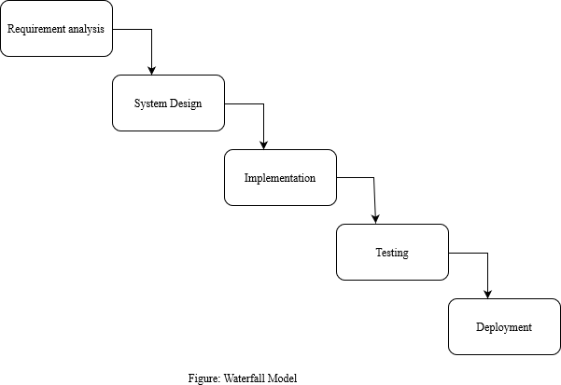
3.1. System Analysis

Figure 3.1 Waterfall Model
The waterfall model is ideal for developing this project because all the requirements are known and there is not much time left for development. The requirements analysis, system design, implementation, testing, and deployment phases make up the project's five stages.

3.1.1. Requirement Analysis
I. Functional Requirements
- Customer Login/Registration Module:
This system allows customers to establish and manage accounts, including personal information.
- Customer Dashboard:
It shows different varieties of bike to apply for rent to the customers.
It allows customer to see the availability status of vehicles.
- Admin Dashboard:
Administrator has the access of viewing details of rented vehicles.
Admin has an option to add list of vehicles and change the vehicle status.
- Bike Selection:
The system allows customers to select any bike from the varieties of bikes to rent.
- Availability Status:
This system provides accurate details about vehicles, vehicle availability status and pricing to customers.
- Rental Management:
Customers can use this system to reserve and cancel a rental online.

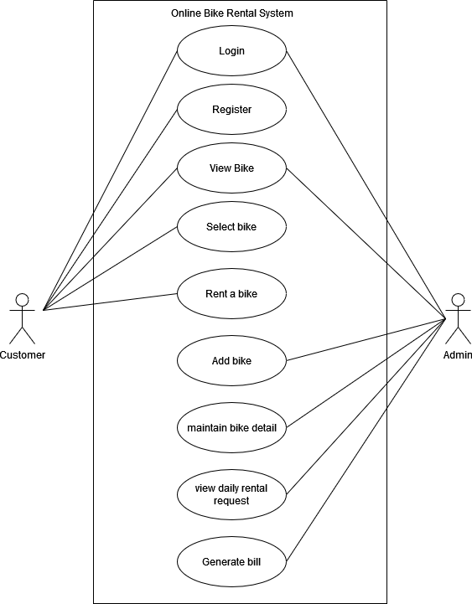

Figure 3.2 Use Case Diagram
The use case diagram of this rental system is as shown above. This system has two users i.e., customer and the admin. Here admin and customer both have their own respective roles. The customer needs to register and customer as well as admin both need to login to the system . The admin has the authority to maintain all the bike related details such as bike rate , booking status etc. whereas the customers also have total authority in renting bikes with their choices.

II Non-Functional Requirement
- Usability:
The system has a user-friendly design so that it will be easy to
navigate and understand for the clients.
- Security:
The system is quite secured as all the rental details are recorded.

- Reliability:
The system is available at all times.

3.1.2. Feasibility Analysis

    - Technical Feasibility:
This project can simply run in the web browser easily. The programming language used in this system is PHP and since this is the easy to implement there is less possibility of system failure. Hence, the system is technically feasible.
    - Operational Feasibility:
The major goal of this project is to provide a system that is valuable and beneficial to client. This system provides the convenience of online renting. This project has manageable design which is reliable for the users or clients for the interaction. Hence, we can say that this project is operationally feasible.
    - Economic Feasibility:
It is the measure of cost effectiveness of the project. All the procedure is done online, customer do not have to visit vehicle rental companies’ site which reduces the cost as well as time. Since we are using PHP and other free applications to develop this system it is economically feasible.

    - Schedule
The development of the project is completed under the time criteria with every aspect necessarily implemented and documents properly presented. The time schedule of the different parts of the project can be seen below in the following Gantt chart.
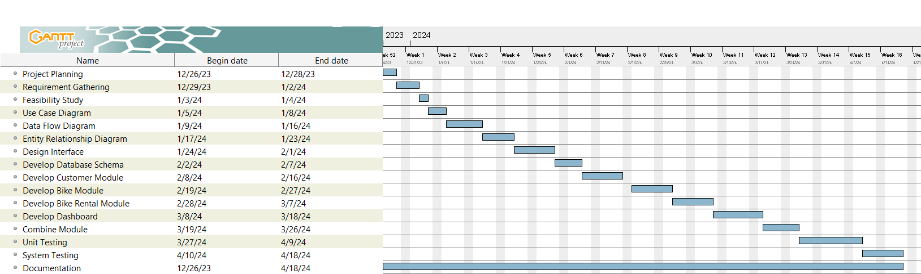

Figure 3.3 Gantt Chart
The above figure replicates the time schedule for online bike rental project. The project period has been scheduled from the project planning phase till the documentation phase. The documentation has been carried on since the first day of the project. The Gantt chart of this project has been planned as per the waterfall model. The project was started on 26th of December and will be completed by 4th of April. The project will be completed with duration of about four months.

3.1.3. Data Modeling (ER-Diagram)
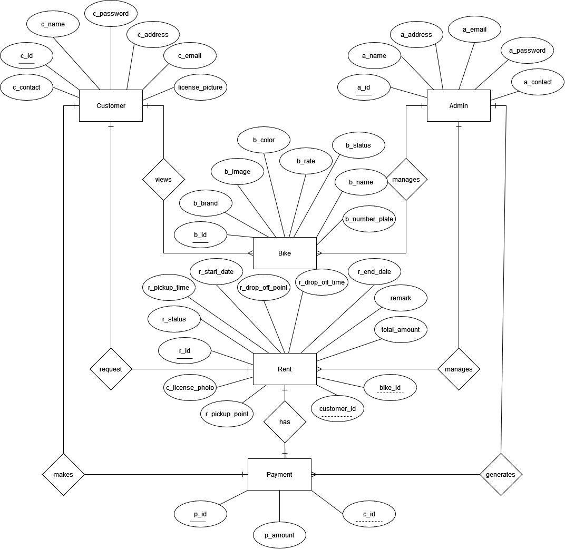

Figure 3.4 ERD
The above figure replicates the entity relationship diagram of the online bike rental system. This system consists of five entities along with their respective attributes. The relationship has been developed within those entities. Here the entities are customer, admin, bike, rent and payment. The relationship that exists between the entities are one to many and one to one. The relationship is symbolized with diamond shape, entities with rectangular shape and attributes with oval shape. Here, the primary keys are all unique and well identified and underlined. The foreign key also has been well defined.

3.1.4. Process Modeling (DFD)

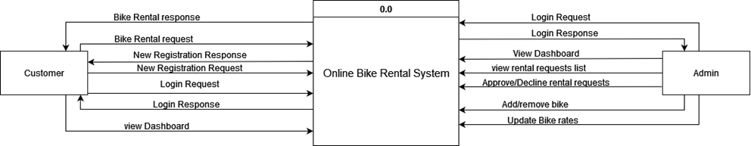

Figure 3.5 level 0 DFD

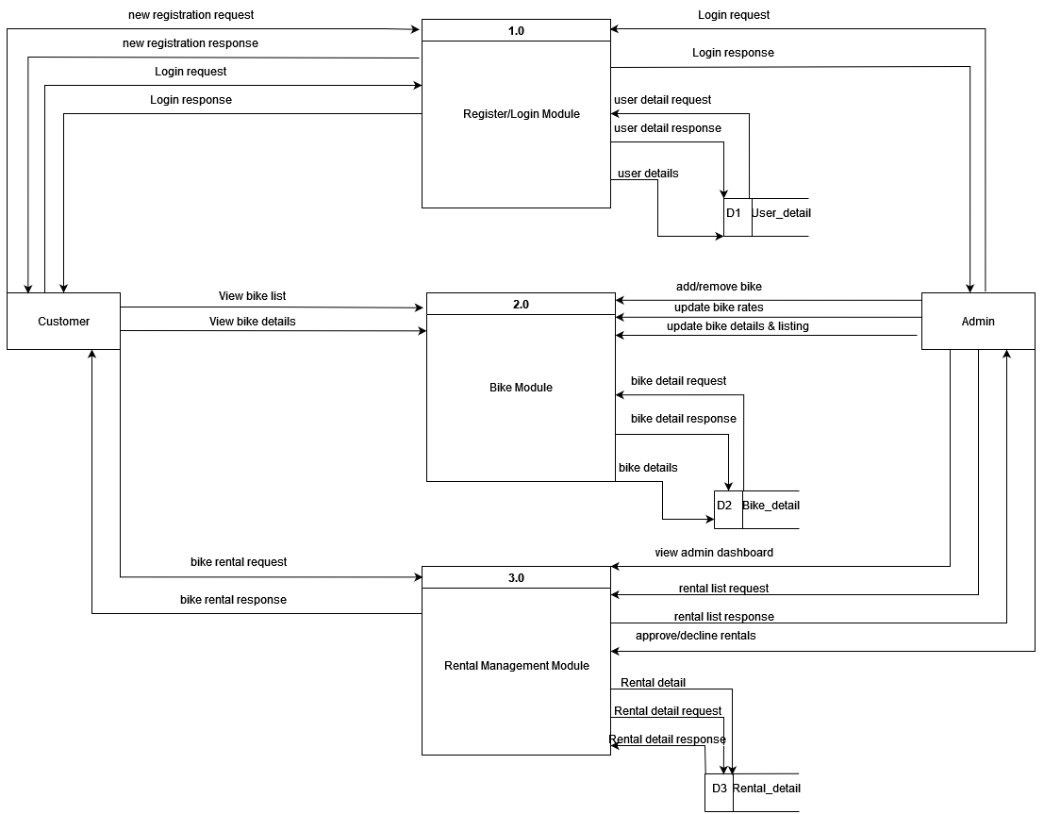

Figure 3.6 level 1 DFD

3.2. System Design

3.2.1. Architecture Design

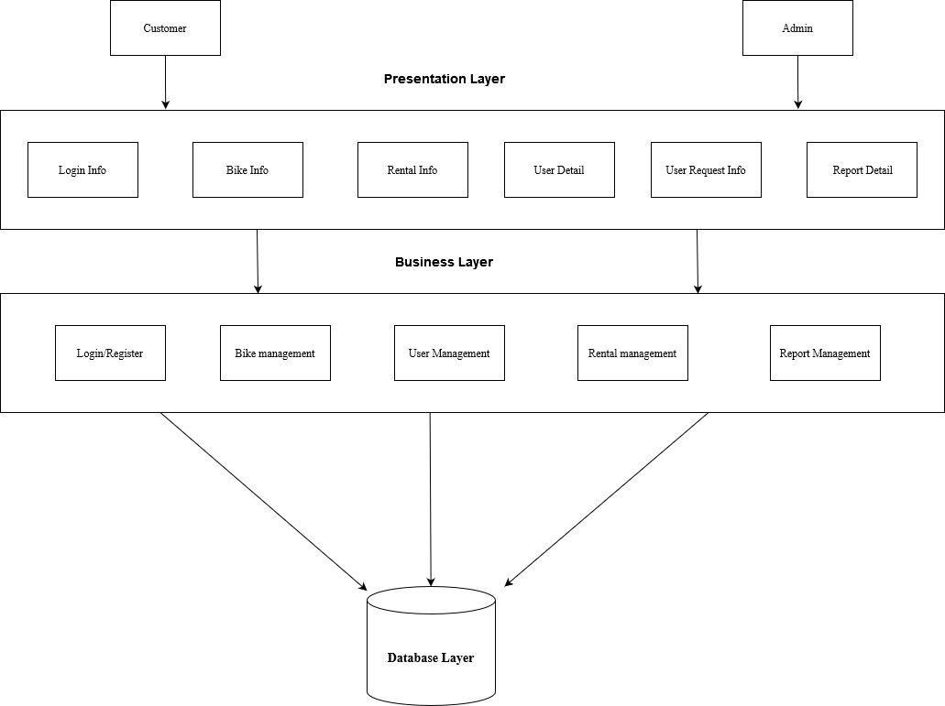

Figure 3.7 3-tier Architecture Design

3.2.2. Database Schema Design

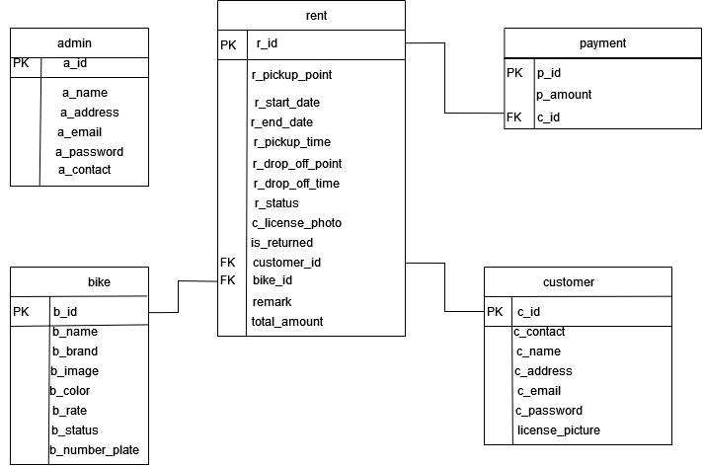

Figure 3.8 Database Schema

3.2.3. Interface Design (UI Interface/Interface Structure Design)

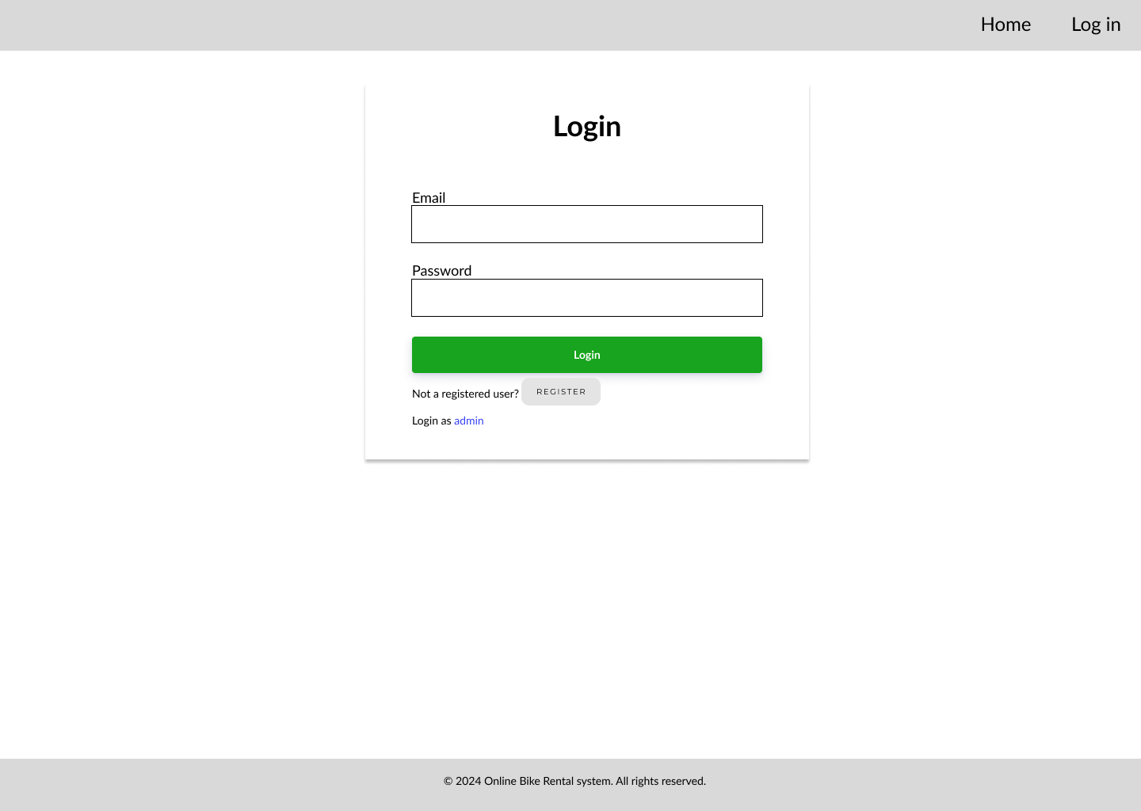Figure 3.9 Login Page
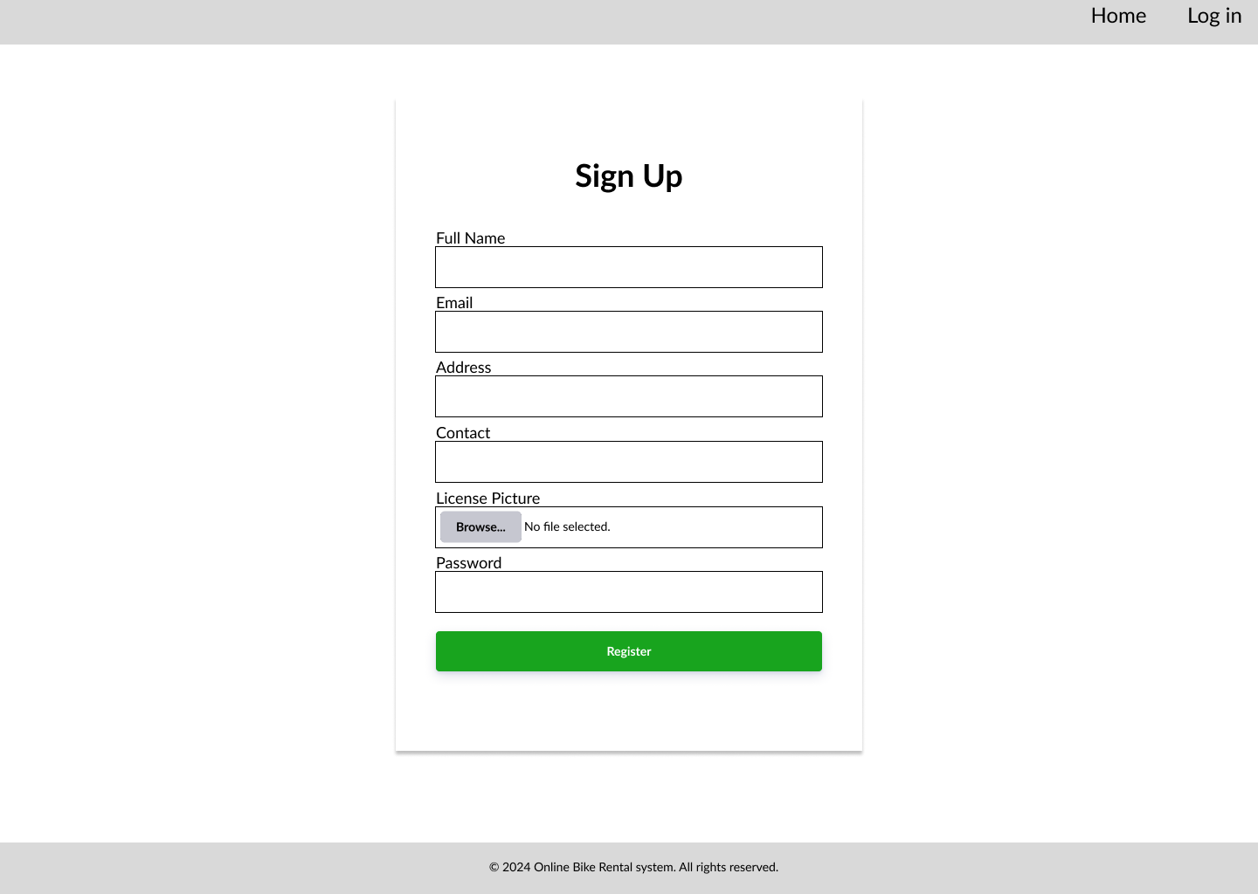
Figure 3.10 Register Page
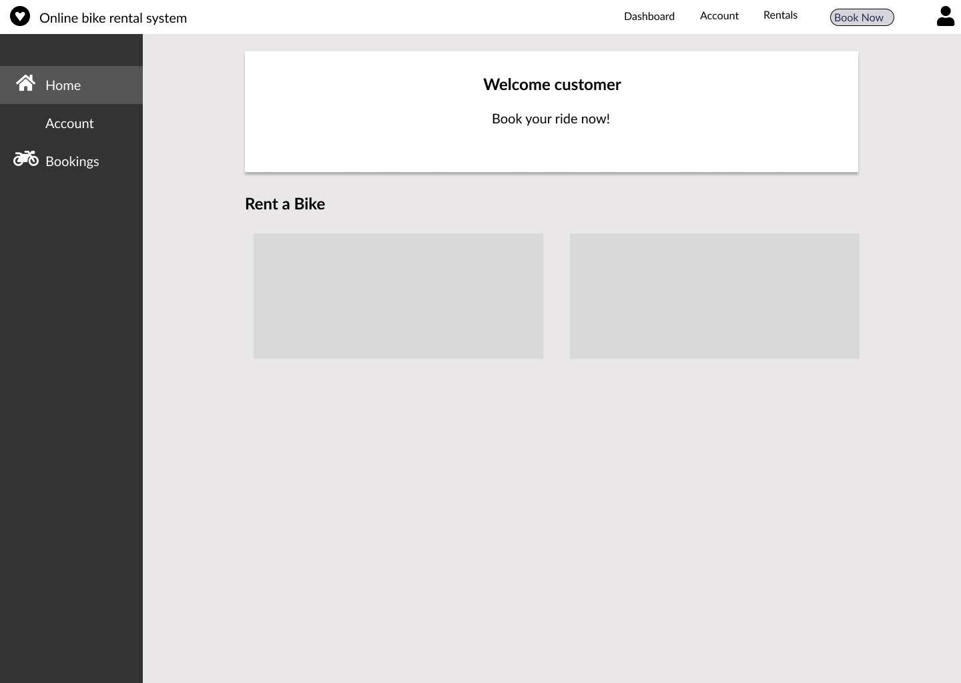

Figure 3.11 Customer Dashboard

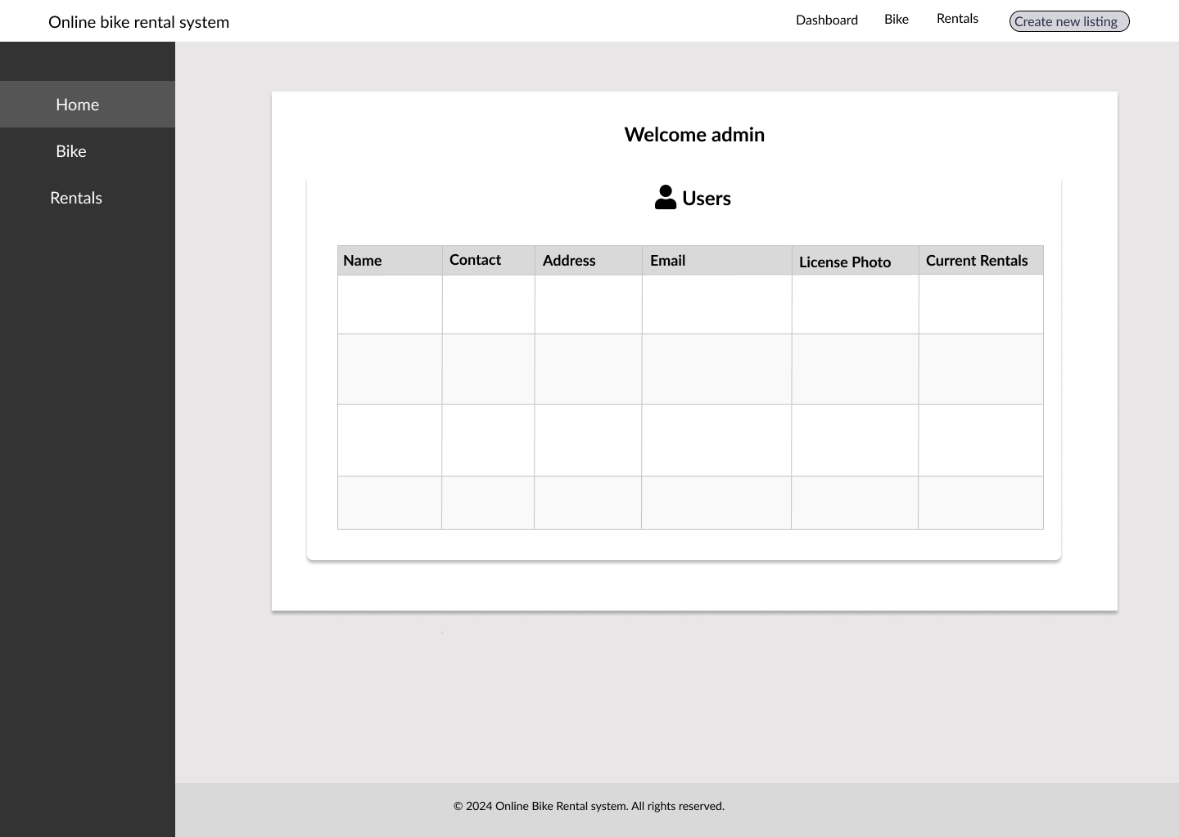

Figure 3.12 Admin Dashboard

CHAPTER 4: IMPLEMENTATION AND TESTING

4.1. Implementation

4.1.1. Tools Used:
- Draw.io
- Gantt Project
- PHP
- MySQL
- Java script
- Xampp
- VS code

4.2. Testing
The primary goal of software testing is to identify defects, errors, or bugs in the software and ensure that it behaves as intended. Testing is an integral part of the software development life cycle, helping to deliver quality and reliable product to end-users.

4.2.1. Test Case for Unit Testing
A test case for unit testing includes input data, expected output, and a set of conditions or actions to be tested. Individual components or functions of a program in a software are tested in isolation to ensure that they work as expected.

Table 4.1 Admin Login Test
S.N. | Test Case | Test Data | Expected Result | Result
1. | Admin enter valid username and password | Email:test@gmail.com  Password:test | Redirects to admin dashboard | Pass
2. | Admin enter invalid  Email and password | Email:testabc@gmail.com  Password:123 | Invalid credentials | Pass

Table 4.2 Customer Registration Test
S.N. | Test Case | Test Data | Expected Result | Result
1. | Customer registers to the system | Full name: test  Email:  test2@gmail.com  Address:  teku  Contact: 1234567891  Password: test123 | Redirects to  customer login  module | Pass
2. | Customer registers  to the system with  same name, email,  address, contact,  password | Full name: test  Email:  test2@gmail.com  Address:  teku  Contact: 1234567891  Password: test123 | Cannot register: User already exists | Fail

Table 4.3 Customer Login Test
S.N. | Test Case | Test Data | Expected Result | Result
1. | Customer logs in  with registered data. | Email:test2@gmail.com  Password:test123 | Redirects to customer dashboard | Pass
2. | Customer logs in  with unregistered  data | Email:test3@gmail.com  Password:test1234 | Invalid Credentials | Pass

Table 4.4 Add and Request Bike Test
S.N. | Test Case | Test Data | Expected Result | Result
1. | Admin adds  vehicle through  form | Bike Name: hunter 350  Bike brand: royal enfield  Bike color: red  Bike rate: 125  Bike photo:  Bike number plate Photo: | New row is added  to the list of  bike table. | Pass
2. | Customer request  Bike through  booking form with  all field filled. | Pickup point:  Start Date:  End Date:  Pickup Time:  Drop Off Point:  Drop Time:  License Photo: | show booking  successful &  the details is sent  to the admin in  rental management  for  approval/rejection. | Pass

Progress so far:
- Admin Login Module:
- Customer Login and Registration Module
- Admin Dashboard
- Admin can add bikes.
- Admin can edit or delete bikes.
- Admin can approve or reject requests.
- Customer Dashboard
- Customer views Bikes.
- Customer can book Bike.
- Customer can view their pending request.
Remaining works:
- Admin sends bill amount.
- Customer view that bill amount.
- Terms and conditions while booking a bike.
- Customer detail edit page.
- Bike availability Status.

REFERENCES

[1] | "selfdrivenepal," [Online]. Available: https://selfdrivenepal.com/. [Accessed 26 12 2023].
[2] | "Maharjan Bikes Rental," [Online]. Available: https://maharjanbikesrental.com/. [Accessed 27 12 2023].

