Table of Contents
List of Abbreviations iii
List of Figure iv
List of Table v
CHAPTER 1: INTRODUCTION 6
1.1. Introduction 6
1.2. Problem Statements 7
1.3. Objectives 7
1.4. Scopes and Limitation 7
1.5. Report Organization 8
CHAPTER 2 BACKGROUND STUDY AND LITERATIRE REVIEW 9
2.1 Background Study 9
2.2 Literature Review 9
CHAPTER 3 SYSTEM ANALYSIS AND DESIGN 11
3.1 System Analysis: 11
3.1.1. Requirement Analysis 11
3.1.2. Feasibility Analysis 13
3.1.3. Data Modeling 15
3.1.4. Process Modeling 16
3.1 System Design 17
3.2.1 Architectural Design 17
3.2.3. Interface Design 19
CHAPTER 4: IMPLEMENTATION AND TESTING 22
4.1 Implementation 22
4.1.1 Tools and Technology 22
4.1.2. Implementation of Modules 23
4.2. Testing 24
4.2.1. Test Case for Unit Testing 24
References 26

List of Abbreviations
CRUD - Create, Read, Update, Delete
DFD - Data Flow Diagram
ERD - Entity Relationship Diagram

List of Figure
Figure 1: Waterfall Model 11
Figure 2: Use Case Diagram 12
Figure 3: Gantt Chart of College Event Management System 14
Figure 4: ER-diagram 15
Figure 5: Level 0 DFD 16
Figure 6: Level 1 DFD 16
Figure 7:Architectural Design 17
Figure 8: Database Schema 18
Figure 9 Interface Design 19
Figure 10 Login Page 19
Figure 11 Admin Dashboard 20
Figure 12 Event List 20
Figure 13 Edit Event 21

List of Table
Table 1 Admin and Student login test 24
Table 2 Admin create test 25
Table 3 request test 25

CHAPTER 1: INTRODUCTION

1.1. Introduction
College life is made exciting by events like sports tournaments, festivals, and conferences. These events bring energy to campus and make the academic experience richer. However, organizing these events can be complicated. That's where the College Event Management System comes in. It's a tool designed to make event planning and management in colleges easier and better. Our research is based on user feedback and real-life examples, shows how this tool can make students more involved, improve communication, and help to coordinate events efficiently on college. The insights from our study are meant to guide colleges in making their event management processes better and enhancing the overall campus experience.
College life has changed a lot over the years, and now both students and teachers see how important events are for creating a lively campus. These events not only give students a break from studying but also let them explore their interests, showcase their talents, and connect with other students who share their passions. However, organizing events has become more challenging due to their increasing complexity and variety. To tackle these challenges, the College Event Management System has become a helpful solution. It promises to bring modernization and efficiency to event planning in college, marking a new way of doing things.
Our research will take a closer look at the College Event Management System, examining how it works, its features, and how it is used in real life. By analyzing feedback from users and studying actual cases, we aim to show how this system can change event management. Looking at the experiences, our research will highlight how it positively affects student involvement, communication, and the overall success of college events.

1.2. Problem Statements
Many colleges organize events, but the entire process is currently handled manually. The event details have been finalized, and students are either approached individually or the notice is posted on the noticeboard to facilitate coordination. All information is then documented in physical files. While some colleges have event websites, these are primarily used to display information to other students. Unfortunately, students lack a centralized platform to discover events that could enhance their resumes. Currently, there's no dedicated Android or web application for event management. We need a system that automates record-keeping, allows online applications for participants, and streamlines the organization of events.
Because of the above problems, it is desired to have a system which can digitalize all the works of the event such as informing the students about the event, record-keeping of events.

1.3. Objectives
• To manages student’s event.

1.4. Scopes and Limitation
Scopes:
- Event Planning and Scheduling:
Create a system where people can see when and where events are happening to plan and avoid conflicts.
- Venue Management:
Make a system that helps keep track of all the places available in college where events can happen, and let people reserve the right spots for their events.
- Participant Registration:
The system should facilitate the registration of participants for different events.

Limitation:
- Limited Functionality:
The system will only allow basic operations like creating, updating, deleting events, and registration. More advanced features like communication or analytics won’t be available.
- Scalability Challenges:
As the system grows more events are added, it may become harder to manage and navigate through the increasing amount of event data.
- Restriction to student :
Within the system, participation is restricted to students who can only assume roles as volunteers or participants.

1.5. Report Organization
Chapter 1: This chapter includes brief introduction bout whole college event management system.
Chapter 2: This involves the background study of the current existing system and research regarding it.
Chapter 3: This includes system analysis and design of college event management system which includes all the functional and non-functional requirements, feasibility analysis etc.
Chapter 4: This chapter is about implementing and testing of the system which includes system testing, unit testing.

CHAPTER 2 BACKGROUND STUDY AND LITERATIRE REVIEW

2.1 Background Study

In today's world, colleges are all about technology, but some things, like organizing events, still happen the old-fashioned way. At our college, we're still using manual methods to handle event, which causes problems. These old ways lead to issues like repeating information, conflicts in scheduling, and not using our resources well. To solve these problems, we need to bring in a digital system for managing events. This would make everything smoother, help us communicate better, and make sure things run more efficiently. Switching to a digital system would transform how we manage events at our college, making things easier for everyone involved.

2.2 Literature Review
The event management system provided by Fox Events Nepal offers a diverse array of event organization services, encompassing live events, corporate functions, and entertainment events. Additionally, the system facilitates access to event photos and provides multiple communication channels for users to reach out, including email, phone calls, and physical visits. However, identified limitations include the absence of direct contact options for users, a lack of a login page which could potentially offer personalized experiences and enhanced security, and a user interface that could be more intuitive and user-friendly. By addressing these limitations, the system could potentially improve user engagement, streamline communication processes, and enhance overall user satisfaction, ultimately contributing to its effectiveness and success in serving its clientele.[1]
The open accessibility of event creation on the "Parchar"[2] website raises notable security and integrity concerns. With unrestricted event creation, there's a significant risk of users misleading others by fabricating events or promoting fraudulent activities. This lack of oversight not only undermines the credibility of the platform but also jeopardizes user trust and safety. Security measures such as user verification, content moderation, and real-time monitoring are imperative to mitigate these risks and uphold the platform's reliability. Failure to address these concerns could result in reputational damage and deter genuine users from engaging with the platform. Thus, implementing stringent security protocols is crucial to fostering a trustworthy and secure environment for event organizers and attendees alike.

CHAPTER 3 SYSTEM ANALYSIS AND DESIGN

3.1 System Analysis:
Given all the requirements for the project are well-defined and there is limited time available for development, the Waterfall model is an ideal choice for the development process. The project is structured into 5 distinct phases: Requirement Analysis, System Design, Implementation, Testing, and Deployment.
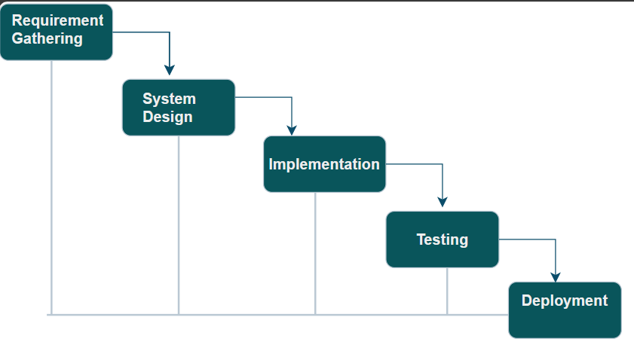
Figure 1: Waterfall Model
The waterfall model is ideal for developing this project because all the requirements are known and there is not much time left for development. The requirements analysis, system design, implementation, testing, and deployment phases make up the project's five stages.

3.1.1. Requirement Analysis
- Functional Requirements
- User Management
- Event Management
- Show upcoming events
- User Authentication and Authorization
- Venue Management

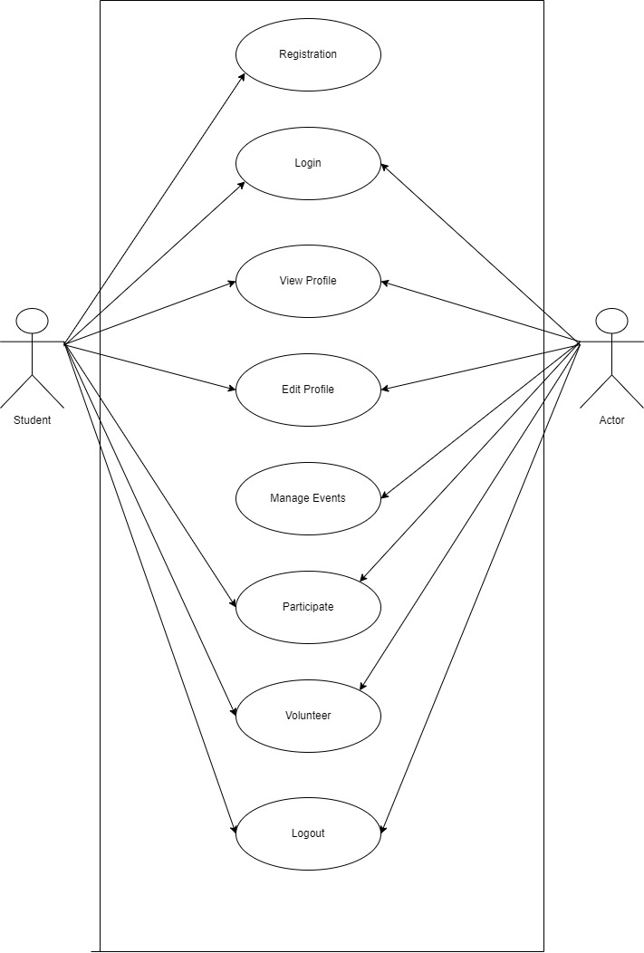

Figure 2: Use Case Diagram

In this project, there are three types of users i.e. Admin and Student. The admin can access to all the features of the system, whereas student can only register, login, participate, volunteer and logout.
- Non-Functional Requirements
- Data security
- User friendly UI
- Data Backup

3.1.2. Feasibility Analysis

- Technical Feasibility:
The front end of the project will be developed using HTML, CSS, and JavaScript, while PHP will be employed for server-side programming. MySQL is chosen as the database technology. These widely own technologies make the project technically feasible. Additionally, the project requires only a standard desktop or laptop, readily available in the market, ensuring practicality. So , this project can be said technically feasible.
- Operational Feasibility:
The college event management system is operationally feasible because it simplifies event organization and increases efficiency. It features user-friendly interfaces and communication tools that promote coordination among students and administrators. Overall, it enhances organizational workflows and communication, making event management more effective and coordinated.
- Economic Feasibility:
This project determines the positive economic benefit to the organization that the proposed system will provide. It typically involves a cost/benefits analysis and it’s the most frequently used method for evaluating the effectiveness of a new proposed system. We have also established the low-cost estimation for the development of this website. This system can be said economically feasible.
- Schedule Feasibility:
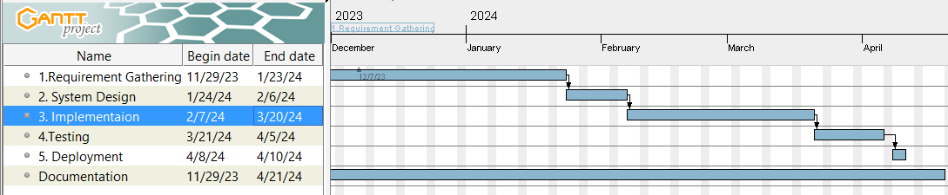
The time schedule of the different stages of the project that can be seen below in the following Gantt chart.

Figure 3: Gantt Chart of College Event Management System

The above Gantt chart has the project plan for nearly 5 months. The Gantt chart of the project is shown in the above figure. The project is based on the waterfall model. So, The project follows the steps of the waterfall model. Project starts from the requirement gathering, the most of the time is separated for the implementing part where the documentation goes from starting to end of the project.

3.1.3. Data Modeling

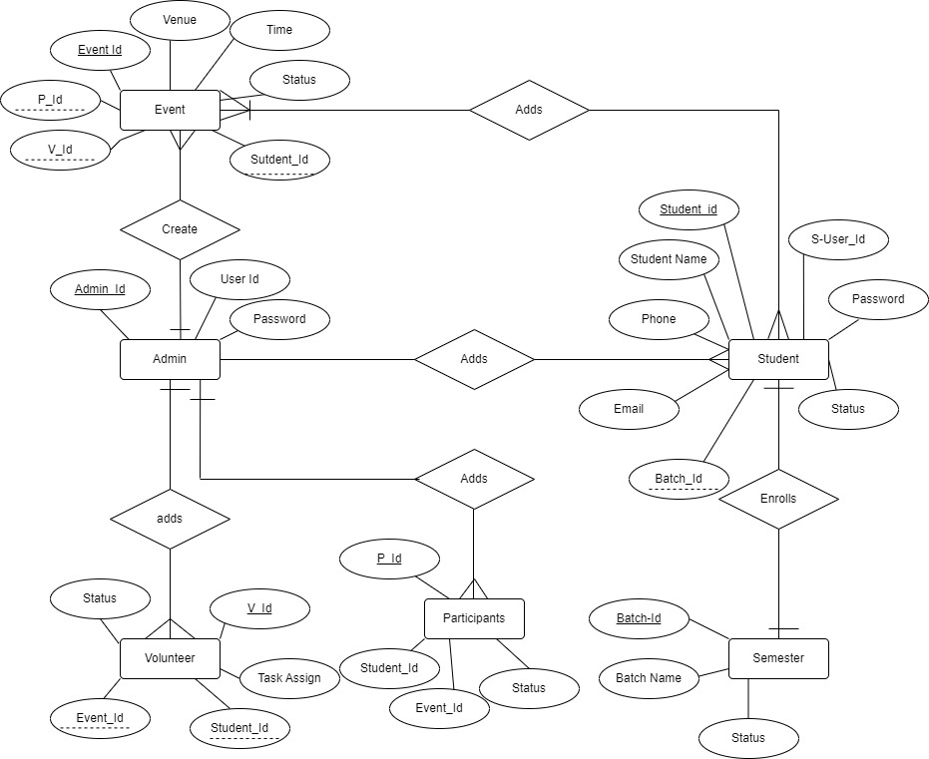
Figure 4: ER-diagram

The ER diagram for the project, College Event Management System is shown in figure above in this project there are 6 entities presents .i.e. events are created by admins and can have multiple volunteers and participants. Admins are responsible for managing events and can add students as volunteers or participants. Students can enroll in different semesters, and during each semester, they may volunteer for or participate in various events.

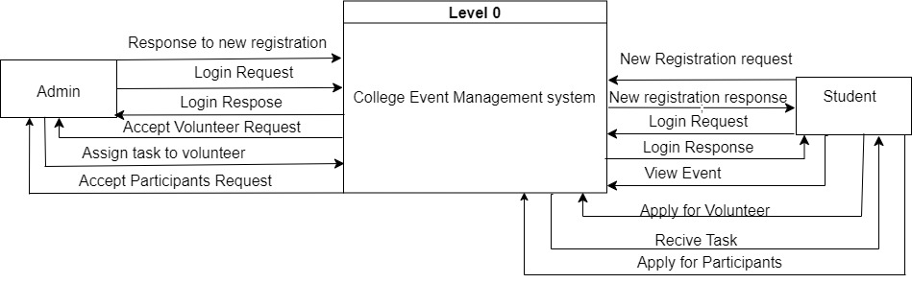
3.1.4. Process Modeling

Figure 5: Level 0 DFD

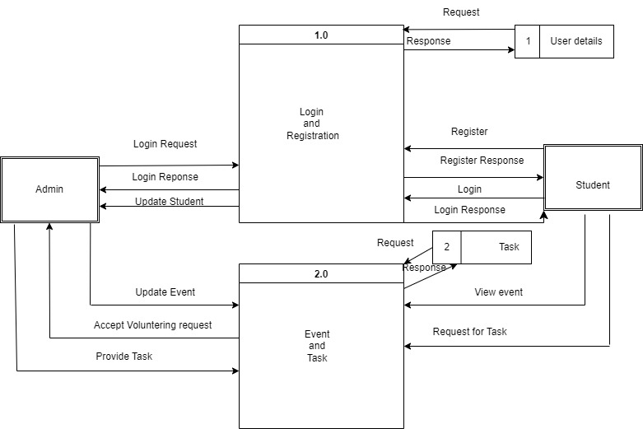
Figure 6: Level 1 DFD

System Design

3.2.1 Architectural Design

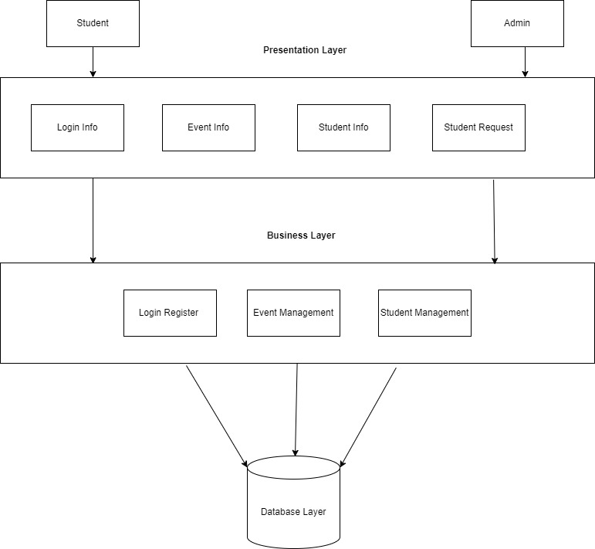
Figure 7:Architectural Design

3.2.2. Database Schema
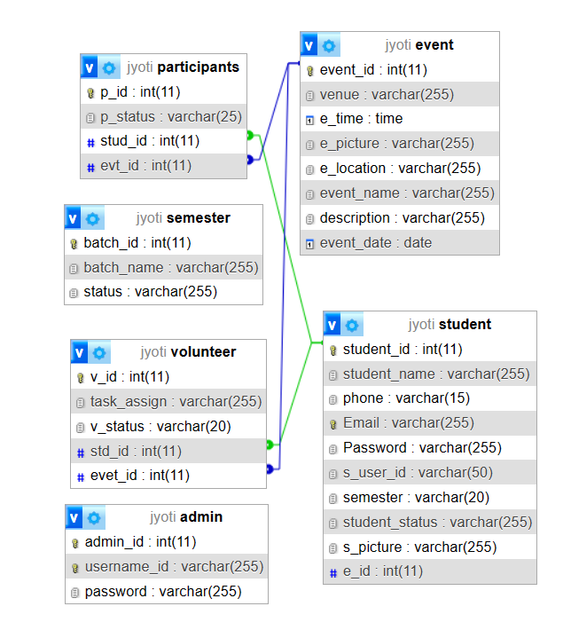
Figure 8: Database Schema

3.2.3. Interface Design
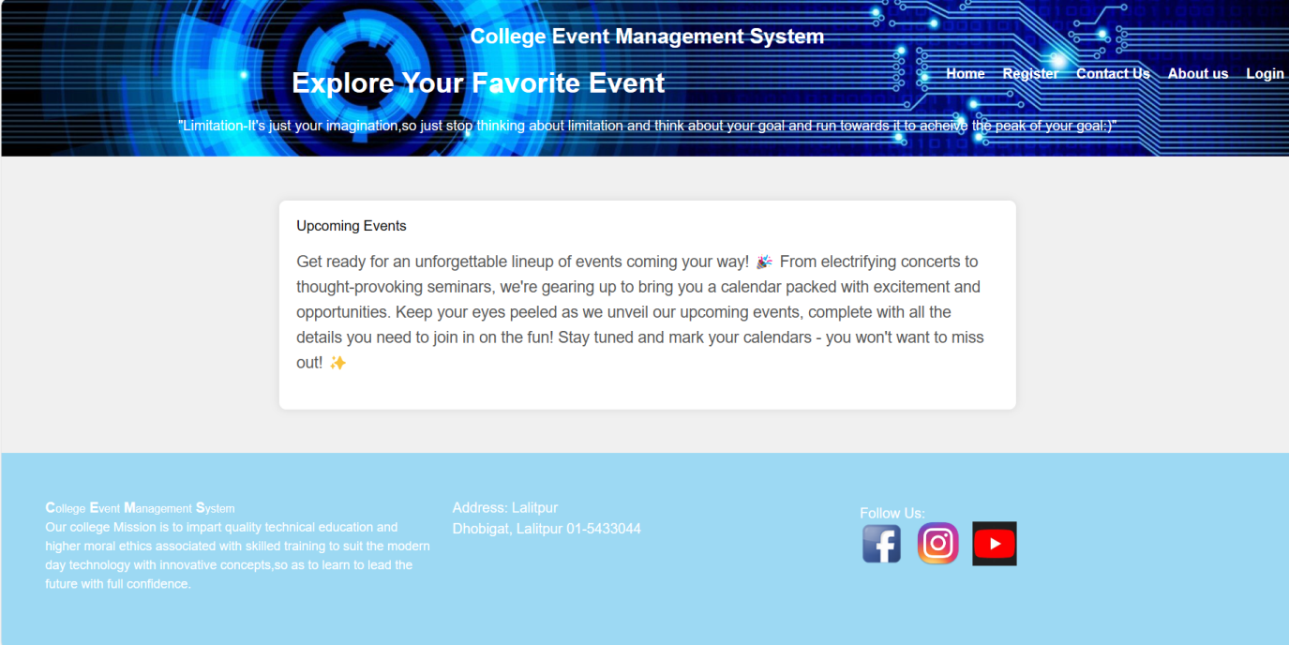
Figure 9 Interface Design

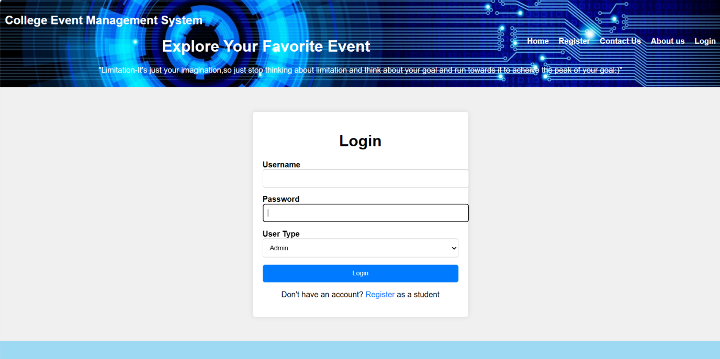
Figure 10 Login Page

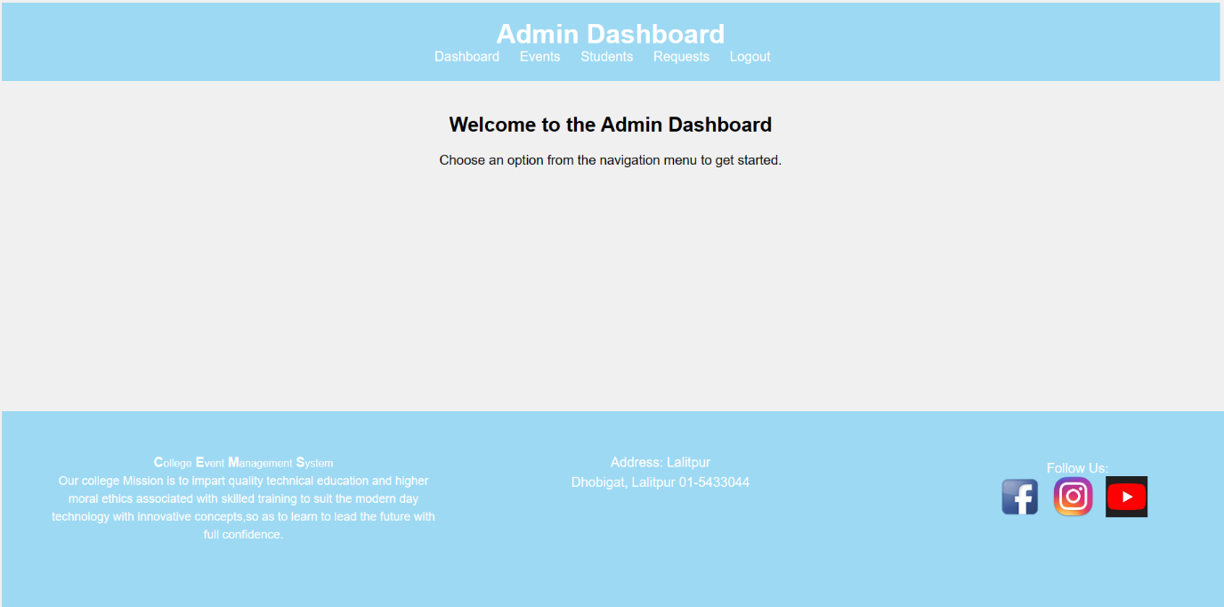
Figure 11 Admin Dashboard

. 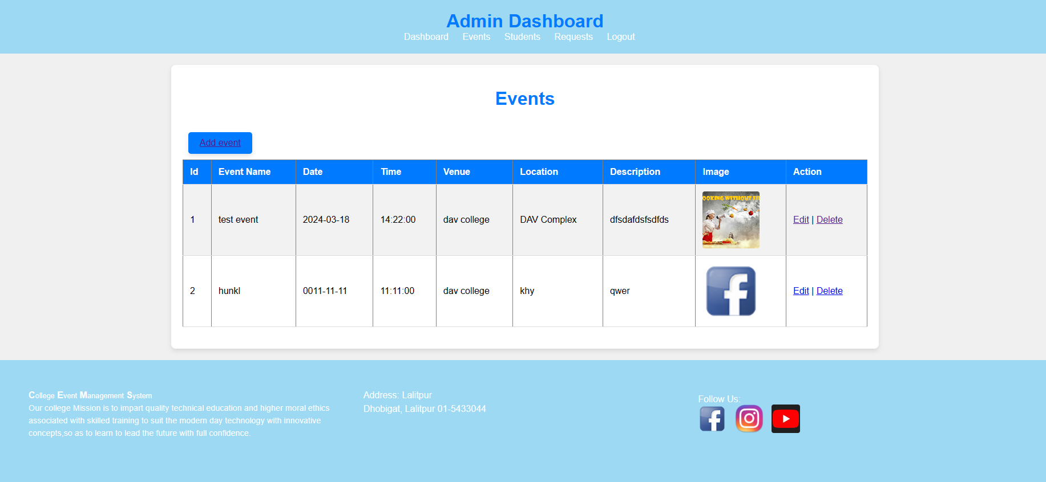
Figure 12 Event List

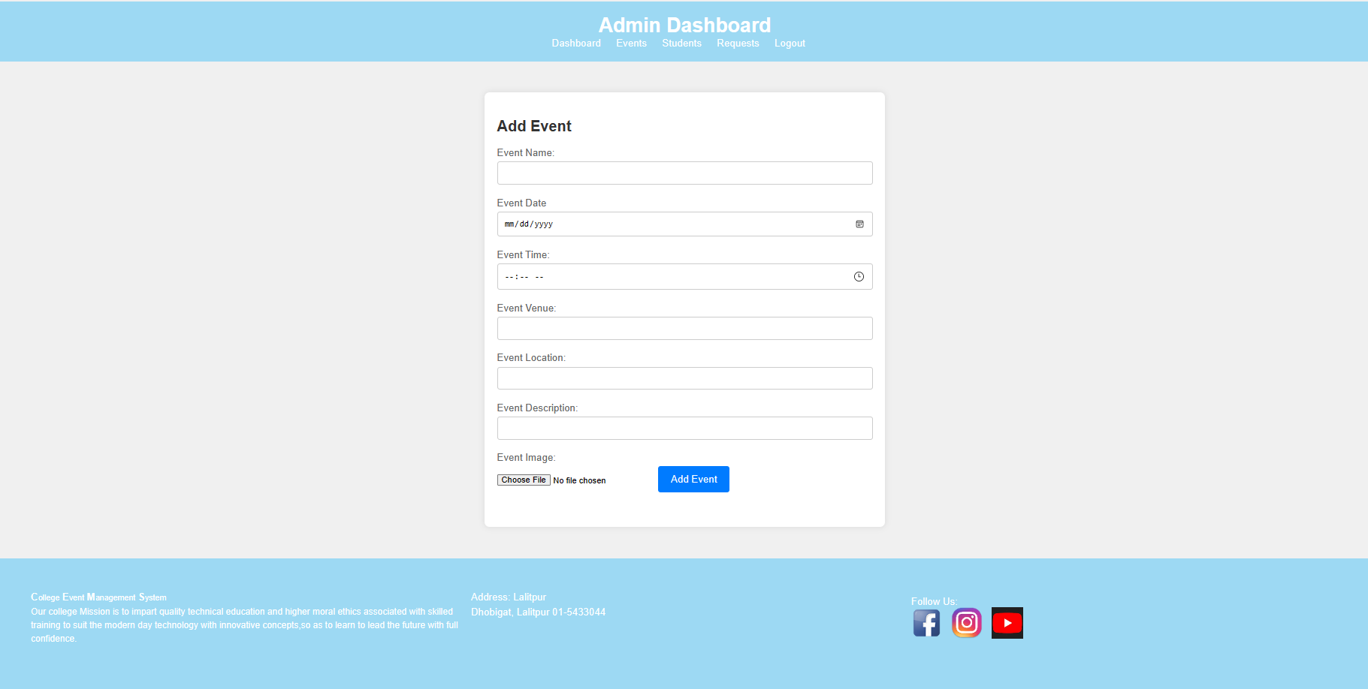
Figure 13 Edit Event

CHAPTER 4: IMPLEMENTATION AND TESTING

4.1 Implementation
Implementing a college event management system involves a series of important steps. First, we talk to everyone to understand exactly what they need from the system. Then, we make a plan for how it will work and what it will look like. After that, we actually build the system, making sure it does everything we planned. We test it a lot to make sure it works right and fix any problems we find. Once it's all good, we put it where people can use it. We teach everyone how to use it, officially start using it, and keep an eye on it to make sure it stays working well. Finally, we listen to what people say and make changes to make it even better.

4.1.1 Tools and Technology
The various system tools and technologies that have been used in developing the project, College Event Management System for both the front-end and backend of the project are:
Front-end:
HTML5 (Hyper Text Markup Language): HTML is a syntax used to design and format a text document on the web.
CSS3 (Cascading Style Sheets): Cascading Style Sheets (CSS) is a style sheet language used to describe the presentation. CSS is among the core languages of the open web and is standardized across Web browsers.
JavaScript: It is most commonly used as part of web browsers. It is a dynamic programming language. Implementations are done to interact with the user, control the browser and communicate asynchronously, and alter the document content that is displayed.
Back-end:
PHP: It is a server-side scripting language designed for web development. PHP commands can be embedded directly into an HTML source document rather than calling an external file to process data..
MySQL: It is the used for open-source relational database management system and many high-profile, large-scale websites. The SQL phrase stands for Structured Query Language.
Draw.io: This site is used to design the system Use Case Diagram, ER-Diagram, flowchart and Data Flow diagram for the system.
Visual Studio Code: It is the code editor used in this project.

4.1.2. Implementation of Modules
- Student Management:
In the student management module, students can easily view upcoming events, update their profiles securely, and register for events or express interest in volunteering. The system ensures data security through user authentication, keeps students informed with event notifications, and gathers feedback for continuous improvement. This module empowers students to actively engage in college events while maintaining the integrity of their information.
- Event Management:
In the event management module, both administrators and students can seamlessly view, add, edit, and delete events. Administrators have full control over event management tasks, including creating new events, updating event details, and removing outdated events. Students can conveniently browse upcoming events, participate in those of interest, and volunteer for various roles. The system ensures smooth event management operations while providing an intuitive interface for both administrators and students.
- Admin Management:
In the admin management part, admins can do a lot with events. They can add new events, change details of existing ones, or remove events if they're not needed anymore. Admins can also check out all the event info and keep an eye on how things are going with events in general. The system makes it easy for admins to handle events smoothly and keep everything organized.

4.2. Testing

The primary goal of software testing is to identify defects, errors, or bugs in the software
and ensure that it behaves as intended. Testing is an integral part of the software
development life cycle, helping to deliver quality and reliable product to end-users.

4.2.1. Test Case for Unit Testing
A test case for unit testing includes input data, expected output, and a set of condition or
action to be tested. Individual components or functions of a program in software are
tested in isolation to ensure that they work as expected.
The testing is done on stage by stage of each module and tested as it is working as
expected or not and analyzed data’s had recorded.

Table 1 Admin and Student login test
S.N | Test Case | Test Data | Expected Result | Result
1. | Admin enter valid username and password | Username: jyoti  Password: 123 | Requires to Admin Dashboard | Pass
2. | Student enter valid username and password | Username: jyotii  Password:123 | Requires to Student Dashboard | Pass
3. | Admin and Student enter invalid username and password | Username: vivek  Password:098 | Login fails | Pass

Table 2 Admin create test
SN | Test Case | Test Data | Expected Result | Result
1 | Admin Create Event | Event Name:  Singing | Creating of New Event | Pass

Table 3 request test
SN | Test Case | Test Data | Expected Result | Result
1. | Apply for Volunteer or  participant | Volunteer or participant | Send the request to admin dashboard | pass

Further progress to work on Remaining Parts that are:
- volunteer and participants list.
- Student edit detail page.

References

[1] | [Online]. Available: https://foxeventnepal.com/. [Accessed 29 12 2023].
[2] | [Online]. Available: https://www.arkoevent.com/blogs/. [Accessed 28 12 2023].

