Table of Contents
List of Abbreviations ii
List of Figure iii
CHAPTER 1 INTRODUCTION 1
1.1. Introduction 1
1.2. PROBLEM STATEMENT 2
1.3. Objective 2
1.4. Scope and Limitation 2
1.5. Report Organization 3
CHAPTER 2 BACKGROUND STUDY AND LITERATIRE REVIEW 4
2.1. Background Study 4
2.2. Literature Review 4
CHAPTER 3 SYSTEM ANALYSIS AND DESIGN 7
3.1. System Analysis 7
3.1.1. Requirement Analysis 7
3.1.2. Feasibility Analysis 10
3.1.3. Data Modeling (ER-Diagram) 12
3.1.4. Process Modeling (DFD) 13
3.2. System Design 14
3.2.1. Architecture Design 14
3.2.1. Database Schema Design 15
REFERENCES 16

List of Abbreviations
CRUD - Create, Read, Update, Delete
DFD - Data Flow Diagram
ERD - Entity Relationship Diagram

List of Figure
Figure 3.1 Waterfall Model 7
Figure 3.2 Use Case Diagram 9
Figure 3.3 Gantt Chart 11
Figure 3.4 ERD 12
Figure 3.5 level 0 DFD 13
Figure 3.6 level 1 DFD 13
Figure 3.7 3-tier Architecture Design 14
Figure 3.8 Database Schema 15
Figure 3.9 Login Page 16
Figure 3.11 Customer Dashboard 17
Figure 3.12 Admin Dashboard 17

CHAPTER 1 INTRODUCTION

1.1. Introduction
Online Bike Rental System is the service by which users can directly rent a motorcycle and confirm rental services for various purpose over internet. Since technology has advanced, more and more buyers are willing to skip physically visiting the showroom in favor of riding an expensive motorcycle and using a computer and the internet. This is the result of the World Wide Web's development. Businesses have tried to rent out their pricey motorcycles to web surfers. Thus, with the aid of a computer and the internet, people can rent almost anything that meets their needs online.
The main purpose of this project is to develop an online bike rental system that will rent out motorcycles via the internet. Additionally, the system's development has made it dependable, safe, and easy to use. It is the system that maintains number of motorcycles and can book and rent them out for a set amount of time. A bike rental is a rented vehicle that can be used temporarily for a fee during a specified period. Getting a rental bike helps people get around despite the fact they do not have access to their own personal vehicle or don't own a vehicle at all.
The main target audience of this system is bike enthusiasts. Owning a high-end motorcycle is expensive. Most people appreciate the idea of renting a bike and riding it whenever they want. Bike rental services are used by people for many purposes, one of which is transportation.
Not just for tourism, but also for personal and work commutes, people are turning to bike rental services. Nepal’s market for two-wheeler rental services is ripe with opportunities, and new rental platforms are igniting a new passion among city dwellers. People can rent a variety of bikes for different periods depending on their needs and preferences.

1.2. PROBLEM STATEMENT
All of us have a fascination for motorcycles. The number of bike lovers is increasing day by day. Since a motorcycle is an expensive product, so it is not possible to purchase for everyone in terms of financial condition. However, it is possible to fulfill their desire to ride bikes through rental services. In this way the customer will be able to rent a bike according to his needs. Although this service is available outside our country, this service has not yet been fully launched in Nepal. However, this business has immense growth potential. So, it will become very popular in this country very soon.
The proposed solution involves the development of a robust online platform that integrates user-friendly interfaces, booking functionalities and bike listings. The Online Bike Renting System is reliable for the customers as it provides customer register and login portal for the registration process. The customers can easily view the list of different motorcycles and also can view the status of vehicle and easily apply for rent. They do not have to visit the sites for the confirmation process as, clients can receive confirmation as soon as they apply or book bike for rent through the web application. The admin can also easily view the reservation history and update the bike status. Most importantly, there is less probability of data loss.

1.3. Objective
The primary goals of this system are:
- To develop a web-based system to reserve bike online.

1.4. Scope and Limitation
Every application has its unique feature and its limitation. This system offers the following
scope and lacks the following things:
Scopes:
- User-friendly environment.
- Users can easily view book details in their dashboard.
- Unauthorized users cannot access the system.
- Users of any or no experience can easily browse through the website.
- User can easily view the availability status.
Limitations:
- No online payment available, only cash on site is preferred.
- Since it is online based, highspeed internet is required. The location of vehicles or customers who booked the vehicles cannot be tracked.

1.5. Report Organization
The report on “Online Bike Rental System” is organized into Five chapters.
Chapter 1:
Includes the introduction of whole project in brief.
Chapter 2:
Describes the background study of the present system available related to rental system.
Includes overview of related existing systems and their pros and cons.
Chapter 3:
Describes the analysis and design of the system which consists of the functional and non-
functional requirements of the system along with use case diagrams. It also explains the
feasibility analysis of the system.

CHAPTER 2 BACKGROUND STUDY AND LITERATIRE REVIEW

2.1. Background Study
This online bike rental system is a web-based system for the users or customers that
rents bike. This system enables the bike rental firms to make their services available
to the public through the internet and also keep records about their services. This is a
platform that allows renting bike for a short period of time for a few days or week This
system can be used to make service more popular and accessible to the public as it has been transformed into a web-based system and connected to the internet were everyone can be able to have access to it. In today’s world, the use and access to the internet are so high so most people are busy with their job so, this system is developed so that users or customers can create and access their accounts through the use of the internet and general
concept and terminologies are mentioned below:
1. Create New Account: A user can register an account through the registration process and the user can create an account when there is access to the internet through this module.
2. Login: After the creation of the account user can log in through their valid details and
can access to customer dashboard of this system.
3. Book Bike: After logging in, customers can book the desired bike based on some terms and conditions.
4. Approves the booking: Admin can approve the rental request sent by a customer.

2.2. Literature Review
We have surfed through some of the rental-based websites, and we observed those and compared the features with this system. One of them is Self-Drive Nepal [1].
This system provides two portals i.e.
Client-side Portal:
The client-side portal has following features:
- User Management
It includes user account creation and user login.
- Rental Management
Sends the vehicle booking request to admin portal with customers information booking details.
- Enquiry
Transmits the customer's inquiry to the administrative site.
- Show vehicle list
Clients can view the list of vehicles while booking or renting the vehicle.
- Integrated chat bot
Customers can send messages to the admin and automatic reply is generated.
- Total bookings
Customers can view total number of their bookings in their dashboard.
- Show booking details
shows the renting date, renting location and status of the request.
Admin Portal:
The admin portal has following features:
- Show the booking request
Shows the client’s renting request with their booking details.
- Add vehicles to the list
The administrator has the facility to update and add new rental vehicles list.
- Show enquiries
The enquiries that are sent from the client side can be seen and reply can also be sent to the users.
- Show users list
Shows all the users list that have been using the system for renting purpose.
Limitation of this system, the user could book any vehicle without adding any documents like license. This system will ask to add license photo along with sign up and later again with bike rental so that admin can verify it and approve the rental.
Another system is Maharjan Bikes Rental [2]. The system in that website only had vehicle data and their rates and we could only enter our name and email in their system. This system offered:
a) Bikes Rental Rate
b) Vehicle gallery
Limitation of Existing system: Maharjan Bikes Rental did not have any kind of authentication or authorization. Image of citizenship and passport could not be uploaded in it even though the system had mentioned about citizenship and passport.
This system will add authentication and authorization.

CHAPTER 3 SYSTEM ANALYSIS AND DESIGN

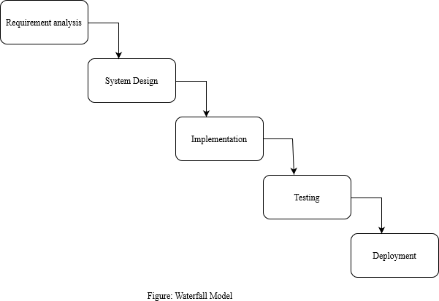
3.1. System Analysis

Figure 3.1 Waterfall Model
The waterfall model is ideal for developing this project because all the requirements are known and there is not much time left for development. The requirements analysis, system design, implementation, testing, and deployment phases make up the project's five stages.

3.1.1. Requirement Analysis
I. Functional Requirements
- Customer Login/Registration Module:
This system allows customers to establish and manage accounts, including personal information.
- Customer Dashboard:
It shows different varieties of vehicles like car, bike to apply for rent to the customers.
It allows customer to see the availability status of vehicles.
- Admin Dashboard:
Administrator has the access of viewing details of rented vehicles.
Admin has an option to add list of vehicles and change the vehicle status.
- Bike Selection:
The system allows customers to select any vehicle from the varieties of vehicles to rent which includes cars and motorbikes.
- Availability Status:
This system provides accurate details about vehicles, vehicle availability status and pricing to customers.
- Rental Management:
Customers can use this system to reserve, modify, and cancel a rental online.

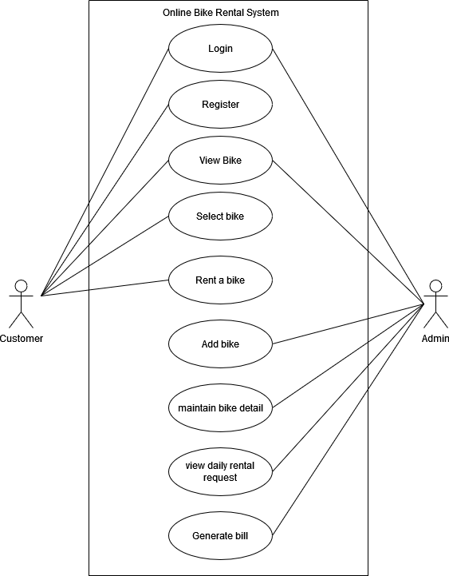

Figure 3.2 Use Case Diagram
The use case diagram of this rental system is as shown above. This system has two users i.e., customer and the admin. Here admin and customer both have their own respective roles. The customer needs to register and customer as well as admin both need to login to the system . The admin has the authority to maintain all the bike related details such as bike rate , booking status etc. whereas the customers also have total authority in renting bikes with their choices.

II Non-Functional Requirement
- Usability:
The system has a user-friendly design so that it will be easy to
navigate and understand for the clients.
- Security:
The system is quite secured as all the rental details are recorded.

- Reliability:
The system is available at all times.
- Maintainability:
The system is easy to maintain and u

3.1.2. Feasibility Analysis

    - Technical Feasibility:
This project is since a web-based renting system with advance technology, it won’t fade in the future. It can be simply run in the web browser easily. The programming language used in this system is easily understandable to the user and since this is the current based system there is less possibility of system failure. Hence, the system is technically feasible.
    - Operational Feasibility:
The major goal of this project is to provide a system that is valuable and beneficial to client. This system provides the convenience of online renting. This project has manageable design which is reliable for the users or clients for the interaction. Hence, we can say that this project is operationally feasible.

    - Economic Feasibility:
It is the measure of cost effectiveness of the project. All the procedure is done online, customer do not have to visit vehicle rental companies’ site which reduces the cost as well as time. It involves all the cost related benefits expected by the customers and resources required for developing this system is also under budget. So, the system is economically feasible.
    - Schedule
The development of the project is completed under the time criteria with every aspect necessarily implemented and documents properly presented. The time schedule of the different parts of the project can be seen below in the following Gantt chart.
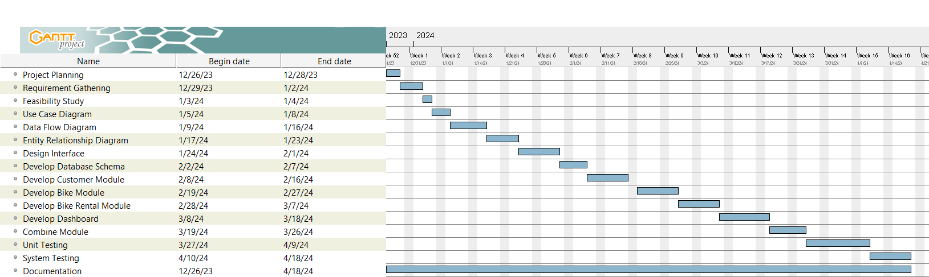

Figure 3.3 Gantt Chart
The above figure replicates the time schedule for online bike rental project. The project period has been scheduled from the project planning phase till the documentation phase. The documentation has been carried on since the first day of the project. The Gantt chart of this project has been planned as per the waterfall model. The project was started on 26th of December and will be completed by 4th of April. The project will be completed with duration of about four months.

3.1.3. Data Modeling (ER-Diagram)
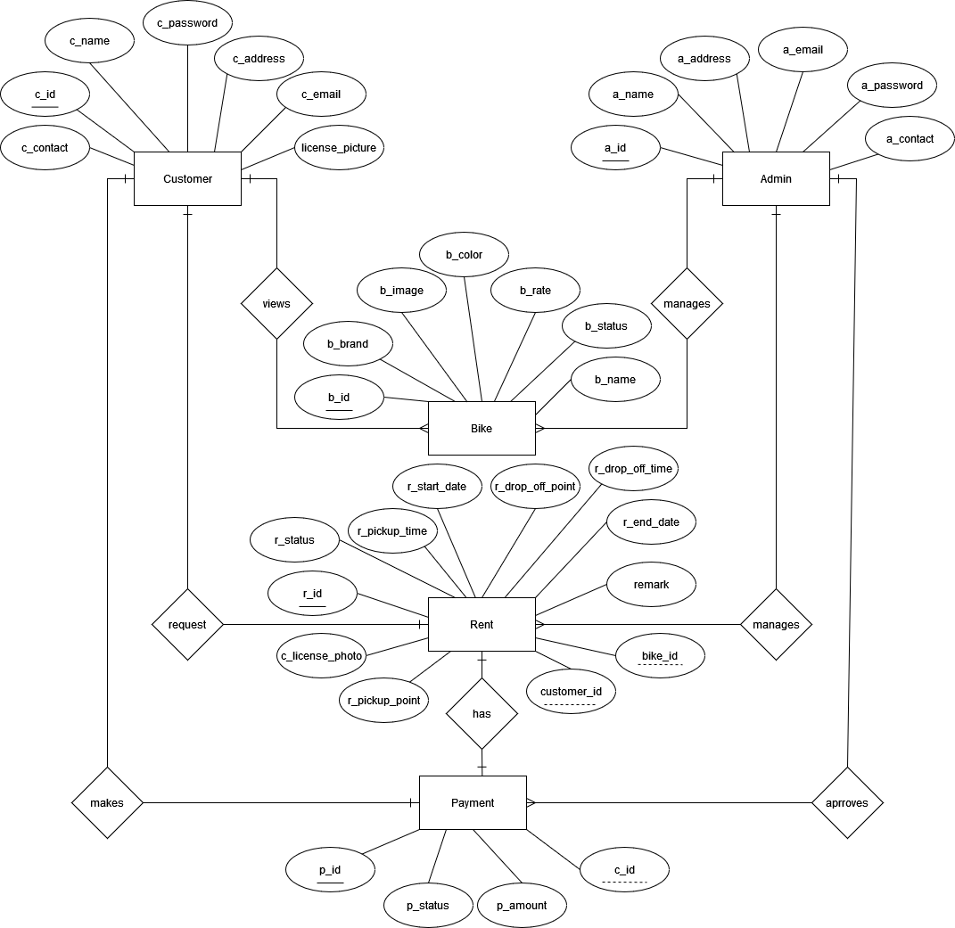

Figure 3.4 ERD
The above figure replicates the entity relationship diagram of the online bike rental system. This system consists of five entities along with their respective attributes. The relationship has been developed within those entities. Here the entities are customer, admin, bike, rent and payment. The relationship that exists between the entities are one to many and one to one. The relationship is symbolized with diamond shape, entities with rectangular shape and attributes with oval shape. Here, the primary keys are all unique and well identified and underlined. The foreign key also has been well defined.

3.1.4. Process Modeling (DFD)

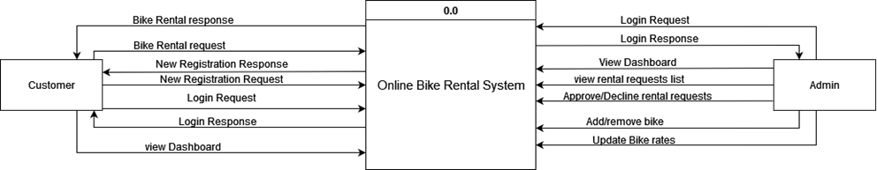

Figure 3.5 level 0 DFD

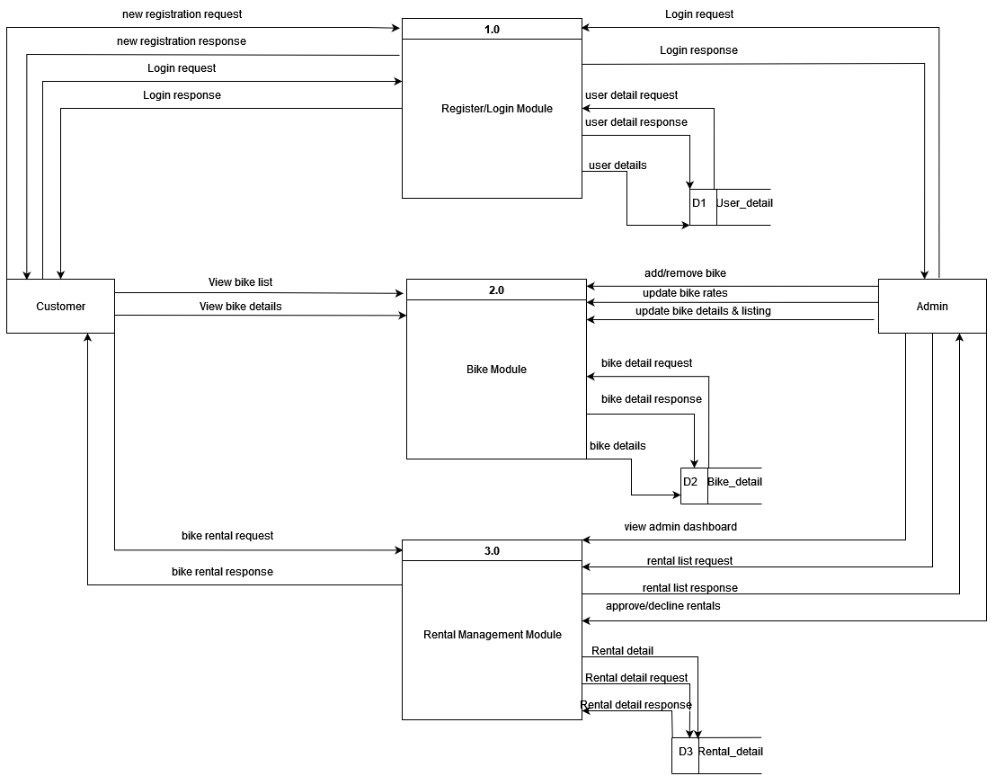

Figure 3.6 level 1 DFD

3.2. System Design

3.2.1. Architecture Design

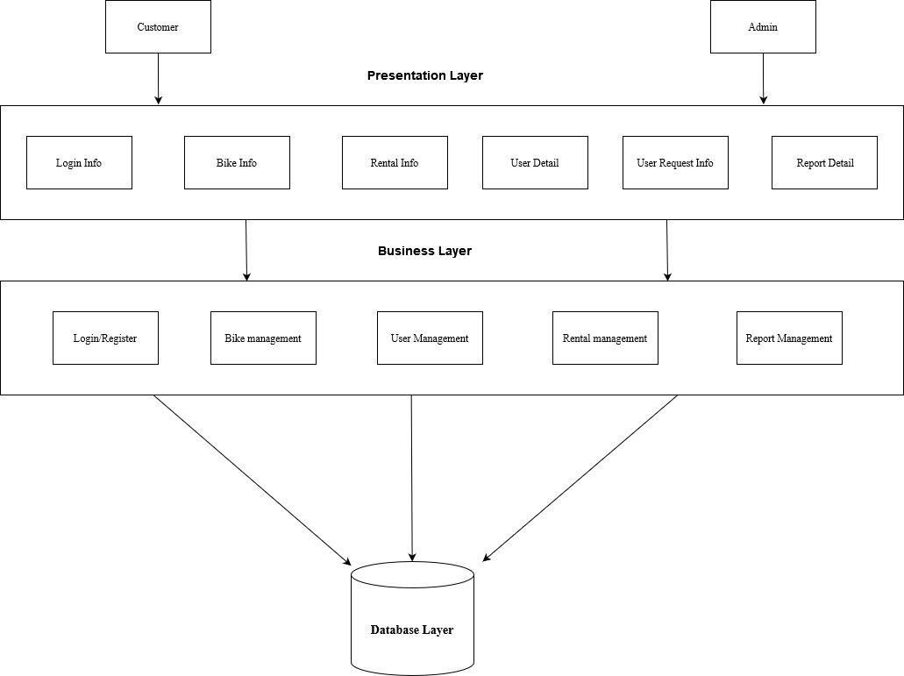

Figure 3.7 3-tier Architecture Design

3.2.2. Database Schema Design
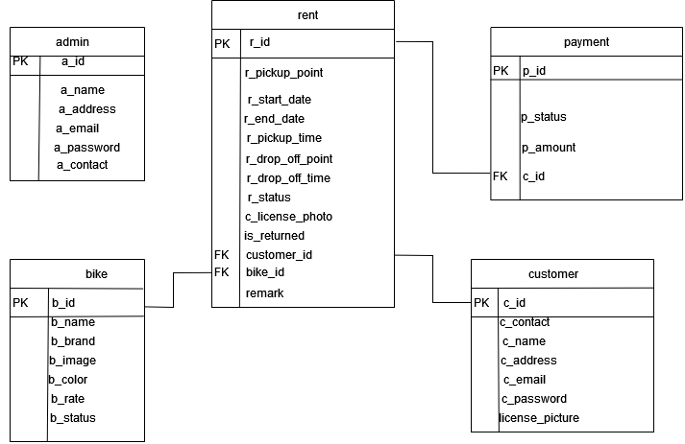

Figure 3.8 Database Schema

3.2.3. Interface Design (UI Interface/Interface Structure Design)

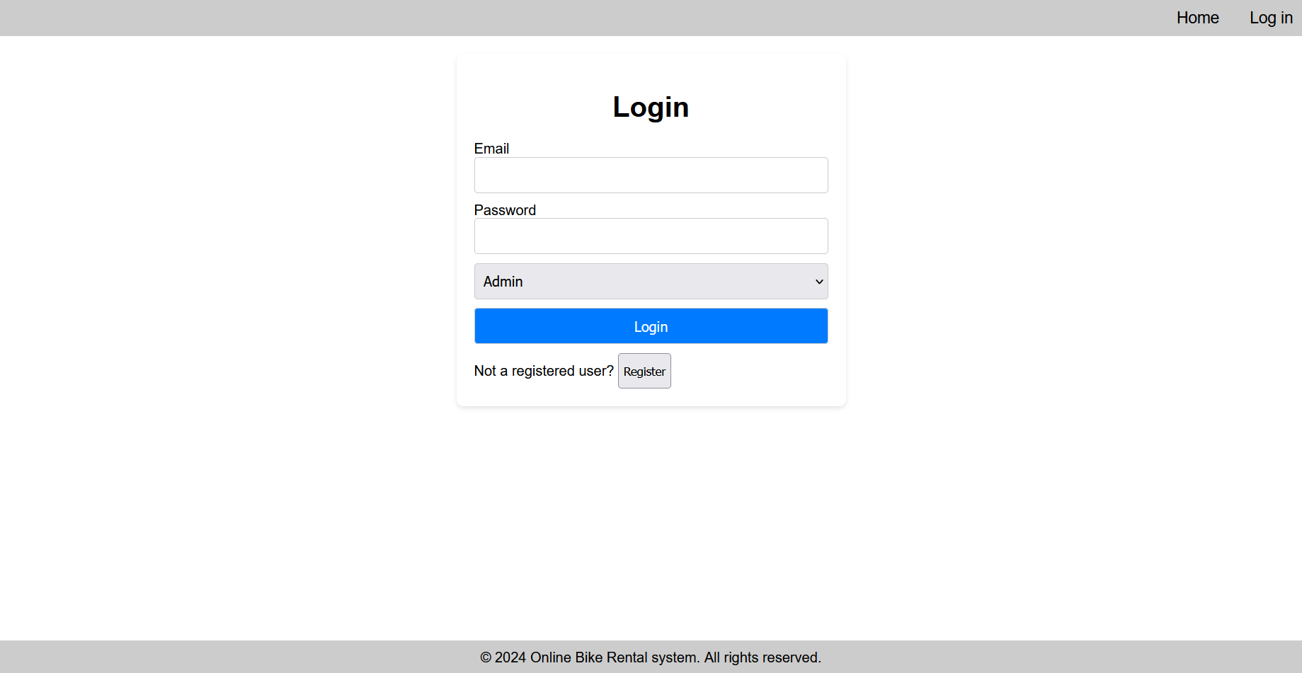

Figure 3.9 Login Page

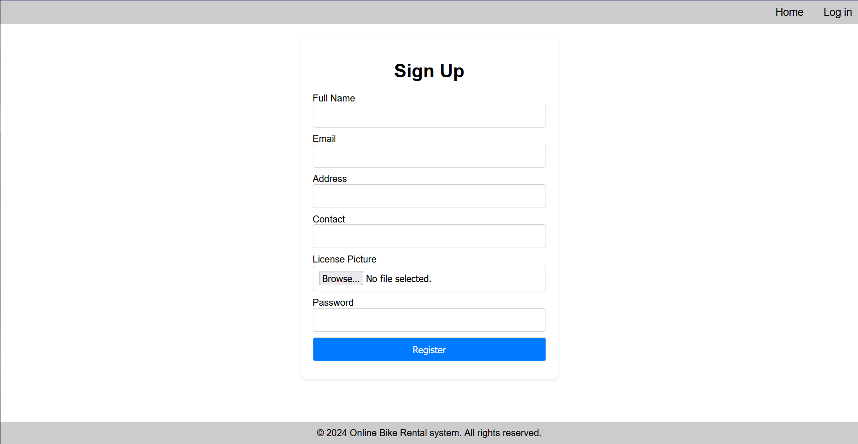Figure 3.10 Register Page
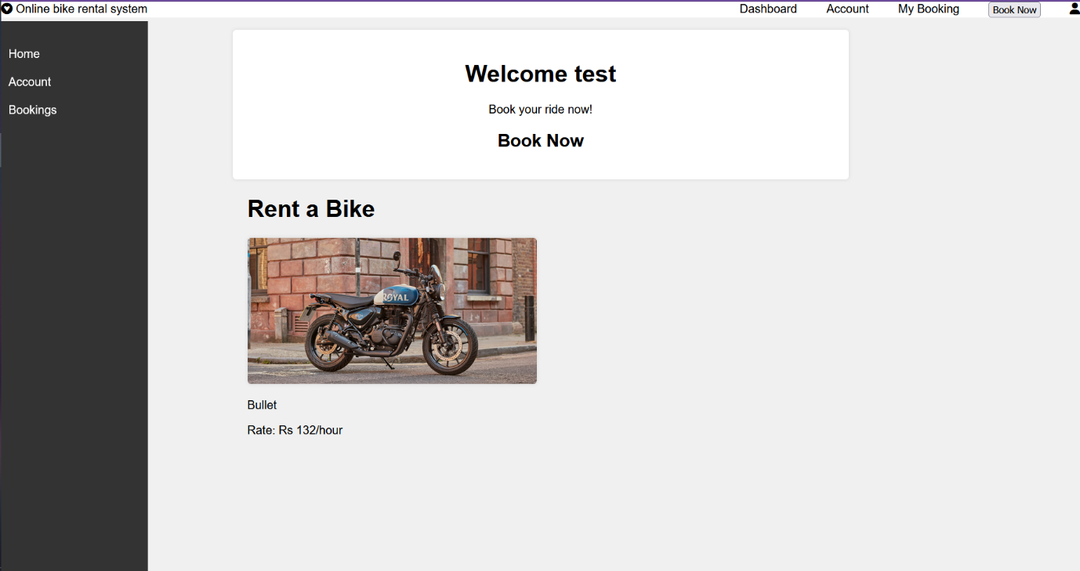

Figure 3.11 Customer Dashboard

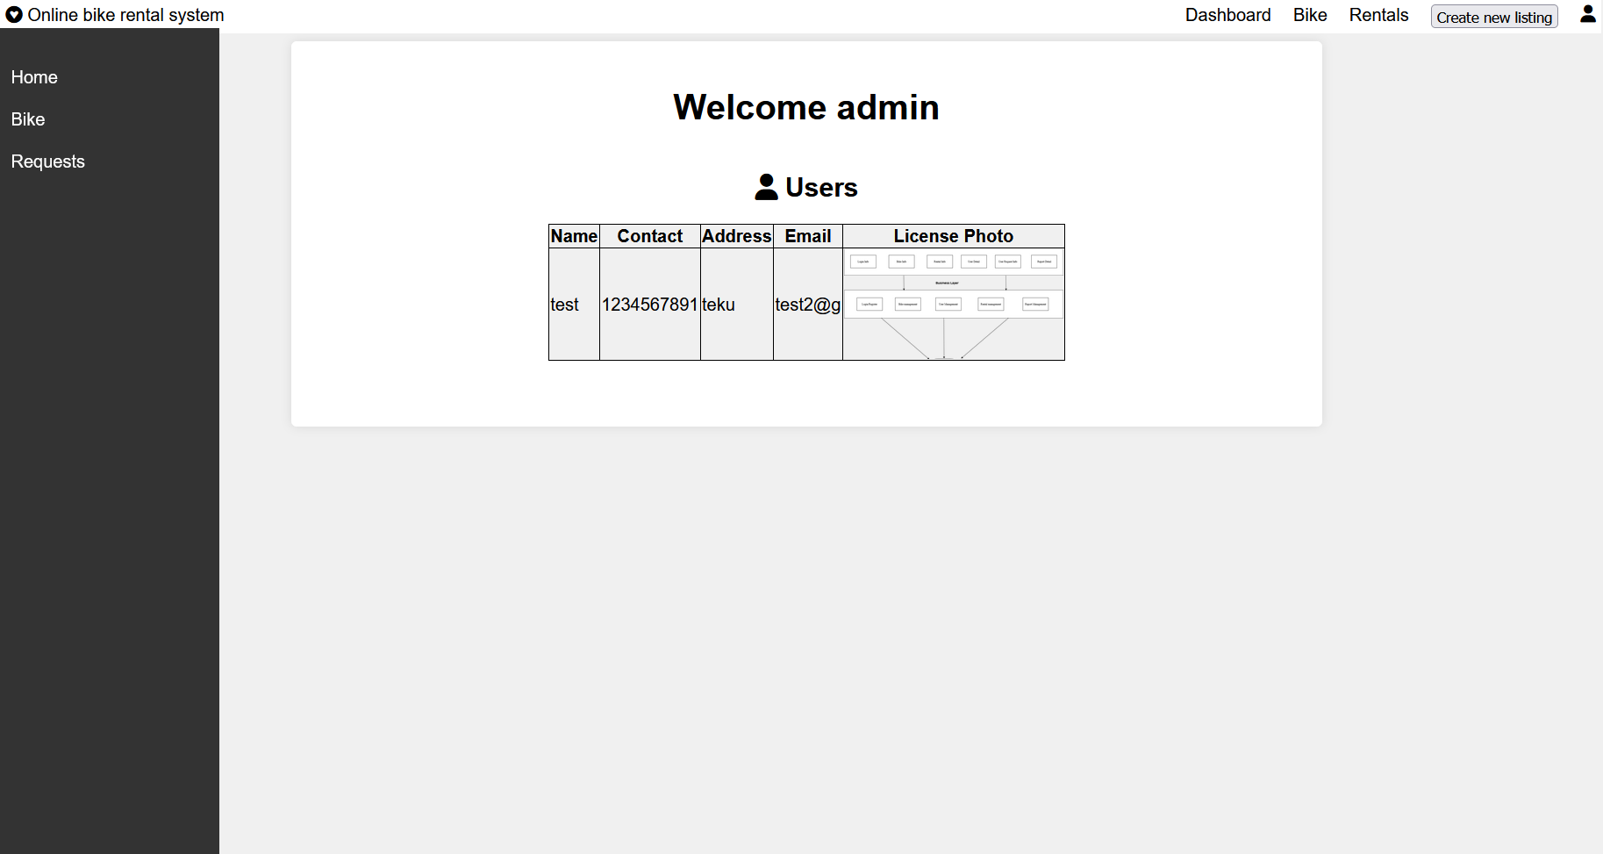

Figure 3.12 Admin Dashboard

REFERENCES

[1] | "selfdrivenepal," [Online]. Available: https://selfdrivenepal.com/. [Accessed 26 12 2023].
[2] | "Maharjan Bikes Rental," [Online]. Available: https://maharjanbikesrental.com/. [Accessed 27 12 2023].

