Database Management Systems

Lab 5 Exercise: Simple SQL DDL, DML and Constraint Statements

# What To Do

1. 下载**Lab5**课程材料**，Lab3Exercise**文件夹中包含三个SQL脚本文件**，Lab5DB.sql**, **Lab5AddConstraints.sql** and **Lab5TestConstraints.sql**.
2. **Place** your **InsertMyself.sql** script file inside the **Lab5Exercise** folder. 在该文件中增加插入下列5个纪录的语句。

|  |  |  |
| --- | --- | --- |
| **studentId** | **courseId** | **grade** |
| <your student id> | COMP3311 | 97.6 |
| <your student id> | COMP4021 | 88.3 |
| <your student id> | ELEC3100 | 95.1 |
| <your student id> | HUMA1020 | 89.4 |
| <your student id> | MATH2421 | 92.5 |

1. **Execute** the **Lab5DB.sql** script file in **SQL Developer**.
2. **Edit** the **Lab5AddConstraints.sql** script file by editing the **alter table** statements to do the following.
   1. For the **Student**, **Course**, **Facility** and **EnrollsIn** tables, add foreign key referential integrity constraints.
   2. For the **Department** table, add a constraint to check that **departmentId** has only a value in the set {BUS, COMP, ELEC, HUMA, MATH}.
   3. For the **Student** table, add constraints to
      1. enforce the uniqueness of **email** values;
      2. check that **studentId** and **phoneNo** have exactly 8 digits only;
      3. check that **cga** has a value between 0 and 4; and
      4. check that **admissionYear** begins with a 2 and has exactly 4 digits only.
   4. For the **Course** table, add a constraint to check that **courseId** follows the pattern of exactly four uppercase letters followed by exactly four digits.
   5. For the **EnrollsIn** table, add a constraint to check that **grade** has a value between 0 and 100.

**Note:** 你可以逐条实现和测试上述约束。在实现第i个约束后，你可以在**Lab5AddConstraint.sql**上把光标挪到改行，然后点击**Run**按钮仅运行该行。随后，执行**Lab5TestConstraints.sql**上测试第i个约束的语句。但要注意，假如你的约束没有正确实现，**Lab5TestConstraints**就会插入不合法的纪录，修改了你的数据库。所以在每次测试后，重新运行**Lab5DB.sql**，让数据库恢复原来的状态。

1. When all your constraints are correctly specified, **execute** the **Lab5TestConstraints.sql** script file in **SQL Developer**. 把输出结果复制粘贴到一个文本文件中，命名为**Lab5TestConstraintsResults.txt.**

# What To Submit

1. Your modified **Lab5AddConstraints.sql** script file containing the completed **alter table** statements.
2. A text file named **Lab5TestConstraintsResults.txt** containing the result of executing the **Lab5TestConstraints.sql** script file. The **Lab5TestConstraintsResults.txt** file can be created by saving the **SQL Developer Script Output tab** to a file with this name. The expected result of executing the **Lab5TestConstraints.sql** script file is shown in Figure 1 and Figure 2.

# How To Submit

在下次实验课之前（周二下午10点前），将上述文件打包（以为名字+学号命名）发给学委，学委再打包邮件发给我（zhenglb6@mail.sysu.edu.cn）。

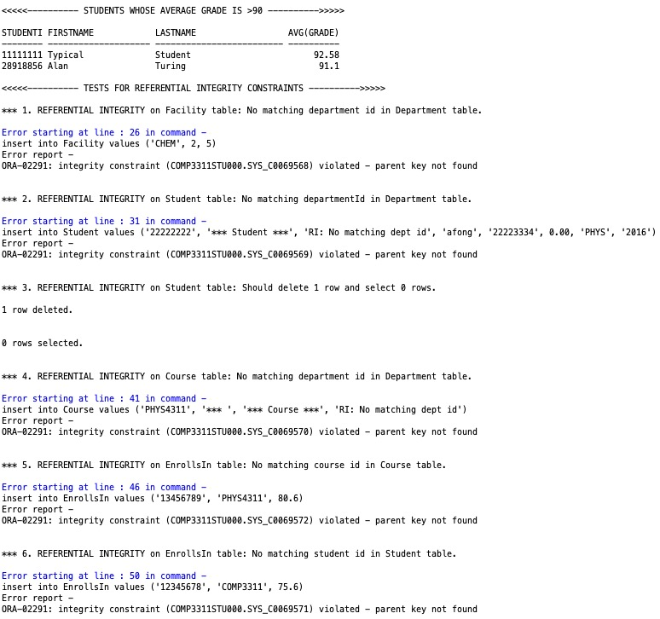

**Your information should be shown in the result of this query.**

Figure 1: Example Script Output tab showing the result of executing the referential integrity constraints.

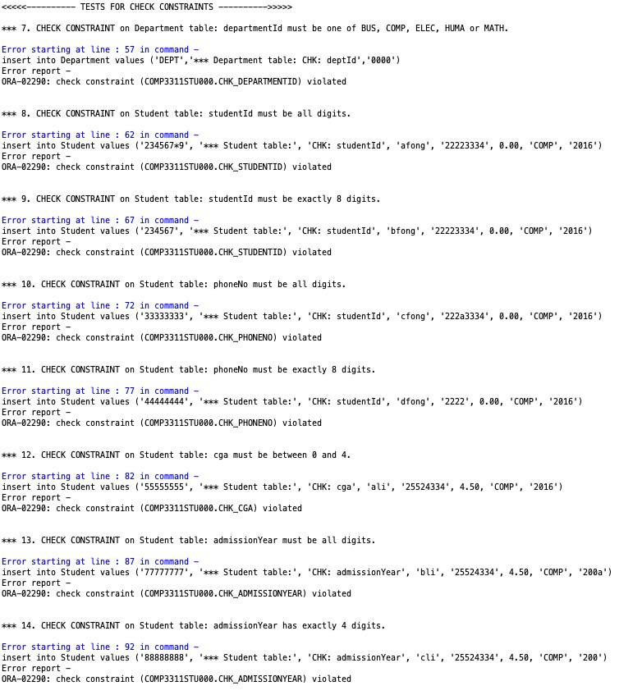

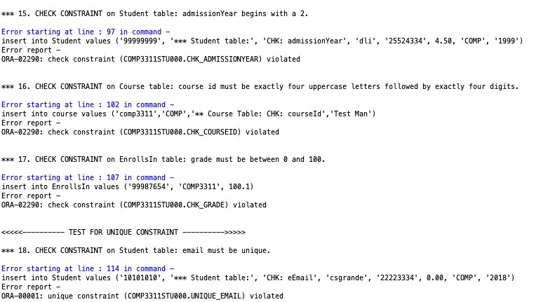

Figure : Example Script Output tab showing the result of executing the check constraints.