Database Management Systems

Lab 6 Exercise: Oracle PL/SQL and Stored Procedures

# What To Do

1. 下载**Lab6**课程材料**，Lab6Exercise**文件夹中包含2个SQL脚本文件， **Lab6DB.sql**和**Lab6Queries.sql**， 以及一个文本文件 **Lab6CgaCalculations.txt**.
2. 将你**Lab5**完成的**InsertMyself.sql**文件放置在 **Lab6Exercise** 中，修改该文件使得其插入纪录的CGA属性值为 **null**。← **IMPORTANT!**
3. **Execute** the **Lab6DB.sql** script file in **SQL Developer**.
4. 在你当前数据库连接的面板下，新建一个**Procedures（过程），**并将其命名为**Lab6CgaCalculations**（新建“过程”参考ppt 20-22页）。
5. 将**Lab6CgaCalculations.txt**中的代码全部复制，然后粘贴覆盖掉**Lab6CgaCalculations**过程中的代码**。**
6. **Complete** the **TODOs** in the **Lab6CgaCalculations** procedure to do the following.
   1. 在第一个**TODO**处声明（定义）计算CGA所需要的其他变量；在第二个**TODO**处把不正确的**cursor**定义替换为正确的，正确定义的**cursor**指向了**studentId**为**currentStudentId**（这是已经定义好的变量）的**EnrollsIn**纪录。
   2. 对于**studentCursor**获取的每个**student**纪录，完成：
      1. 获取该学生关联的**EnrollsIn**纪录，以及对于每个**EnrollsIn**纪录，获取该课程的**credit**（学分），以便于后续计算**CGA**。
      2. 计算该学生的**CGA**（课程成绩的加权平均，公式在本页末尾）,将计算结果用于更新**Student** 表格里该学生的**CGA**。
      3. 如果该学生的**CGA**小于**studentLowCga**（定义好的变量，值为2），则将该学生纪录插入到**Lowcga**表中。

**解释1：**The command **dbms_output.put_line**(*<string>*)outputs *<string>* to the Script Output tab.

1. ***After your Lab6CgaCalculations procedure executes correctly*, execute** the **Lab6Queries.sql** script file in **SQL Developer**. **解释2：**The **Lab6Queries.sql** script file contains the following code.

clear screen

The **set** commands do the following:

* **set serveroutput on** - enables display of the **dbms_output.put_line** command argument;
* **set pagesize 30** - sets the output page size to 30 lines;
* **set termout off** - disables display to the Script Output tab;
* **set termout on** - enables display to the Script Output tab.

set serveroutput on

set pagesize 30

set termout off

@Lab6DB

set termout on

set feedback off

exec Lab6CgaCalculations;

select studentId, firstName, lastName, cga from Student order by cga desc;

select studentId, firstName, lastName, cga from LowCga order by cga desc;

The third last line executes your **Lab6CgaCalculations** procedure. The final two lines display the result of calculating each student’s CGA as well as those students whose CGA is less than or equal to 2.

## CGA CALCULATION

A student’s cga is calculated according to the following formula:

$$cga= \frac{\sum{(course credit × course grade point)}}{\sum{course credit}}$$

For each course in which the student is enrolled, multiply the course credit by the course grade point and sum these values for all courses. Then, divide the previous sum by the sum of the course credit of all the courses in which the student is enrolled.

To obtain the grade point for a course, convert the course grade to a grade point according to the following formula:

course grade point = maximum((grade / 20) – 1, 0)

The above grade point conversion has been already done in the file **Lab6CgaCalculations**.

# What To Submit

1. Your completed **Lab6CgaCalculations** procedure code as a text file. You can copy and paste your code from **SQL Developer** into a text (txt) file.
2. A screenshot截图 of the **SQL Developer** window or a text file that shows the result of running the **Lab6Queries.sql** script file in the Script Output tab as shown in Figure 1.

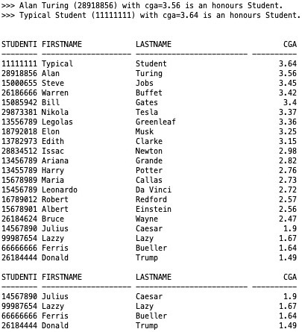

**Your record should be shown in the top message and in the result of the first query.**

Figure 1: Example **SQL Developer** Script Output tab showing  
the result of executing the **Lab6Queries.sql** script file.

# How To Submit

在下次实验课之前（周二下午10点前），将上述文件打包（以为名字+学号命名）发给学委，学委再打包邮件发给我（zhenglb6@mail.sysu.edu.cn）。