the SU Internal Management System

A guide and instructions for how to navigate and set up the system.

By: Jason Wang

**Document Version Log:**

|  |  |
| --- | --- |
| Version: | Changes: |
| 1.0.0 | Initial description of all of the sections except regarding events. |
| 1.0.1 | Added description of events functionality. |
| 1.0.2 | Updated formatting. |
| 2.0.0 | Added information about v2.0.0 and v2.0.1 as well as technical details about the software. |
| 2.1.0 | Added setup information. |

The software and this document are available at the GitHub repo: <https://github.com/chungchunwang/Student-Union-System>. Refer there for the latest version.

Please report any errors or inconsistencies in this document [wangchongjun@hanvos-kent.com](mailto:wangchongjun@hanvos-kent.com)

Table of Contents

About 4

System Guide 5

Setup 6

Home 7

Admin Dashboard 8

Review Project Proposals 9

Review Questions 10

User Reference 11

Groups 12

Create Awards 13

Create Tasks 14

My Groups 15

Add Task 16

My Tasks 17

Completed Tasks 17

Profile 18

Awards 19

Leaderboard 20

My Project Proposals 21

Report 23

My Events 24

Create New Event (Create new button) 25

Review absences (Review absense button) 26

edit (Edit button) 26

View (View Button) 27

Edit Required Attendance (Edit Required Attendance Button) 27

Log Attendance (Log Attendance Button) 28

End Attendance 28

Events 29

Event Page (View Button) 29

Questions 31

Files 32

Bug Reports 32

Documents 33

Software Version Log 34

Known bugs and issues 38

About the software & its design 38

Why low code? 38

Why MYSQL? 38

How is it hosted? 38

System Setup 38

# About

This document covers the SU Internal Management System, a system used to manage tasks, events, questions, project proposals, users and other vital data in everyday student union management. Besides data management, it also facilitates the concept of “points”, allowing users to earn credit for taking part in tasks, events, and project proposals.

For those looking for instructions on how to use the system, you can refer to the system guide section.

For those looking to understand the software, you can refer to the about the software section.

For those looking for instructions on how to setup the system, you can refer to the setup guide section.

# System Guide

This is the one stop shop for tasks, events, and much more! Read this short guide to be able to use it effectively.

Before we dive into an explanation of each page, lets understand the different account types within the system. The SU Dashboard is a closed internal system. This means that it is meant for only members. Outsiders will not be able to see its content.

For members, there are 3 different account types, in descending order of permission level:

1. Admin
2. Power
3. Basic

Per design, Basic accounts should be assigned to regular members, Power accounts should be assigned to group leaders and subleaders, and Admin accounts should be given to SU leaders.

Some features are only available for certain members. In the following documentation such features (or entire sections!) will be marked with For Access level: _________ to indicate this.

Now, let’s take a look at what is in each page.

## Setup

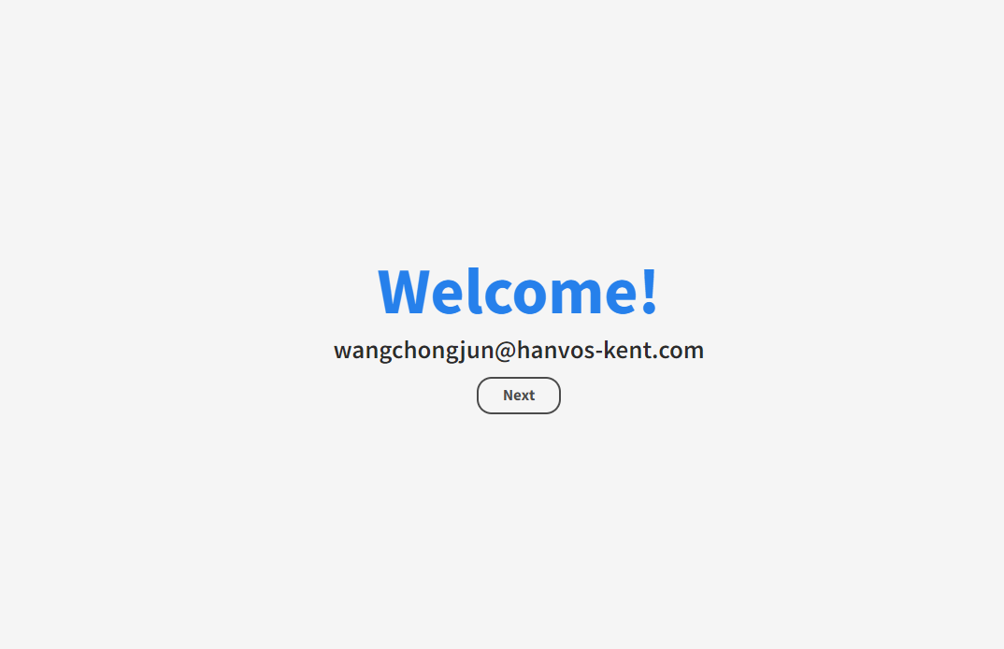

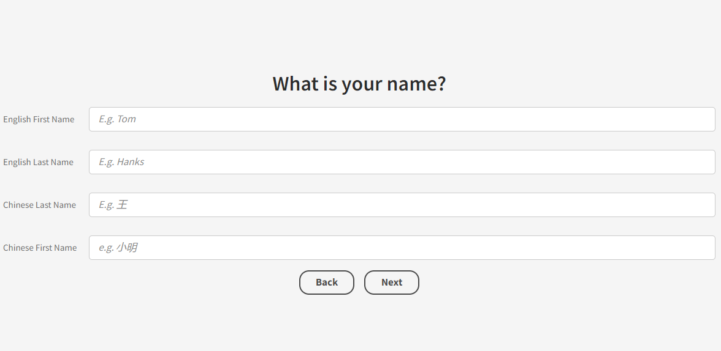

When you first login into the system, you will be met with a setup page, where you will have to fill in details about yourself (name, class, etc.). Enter this information accurately and honestly as they will affect how you are represented within the system.

## Home

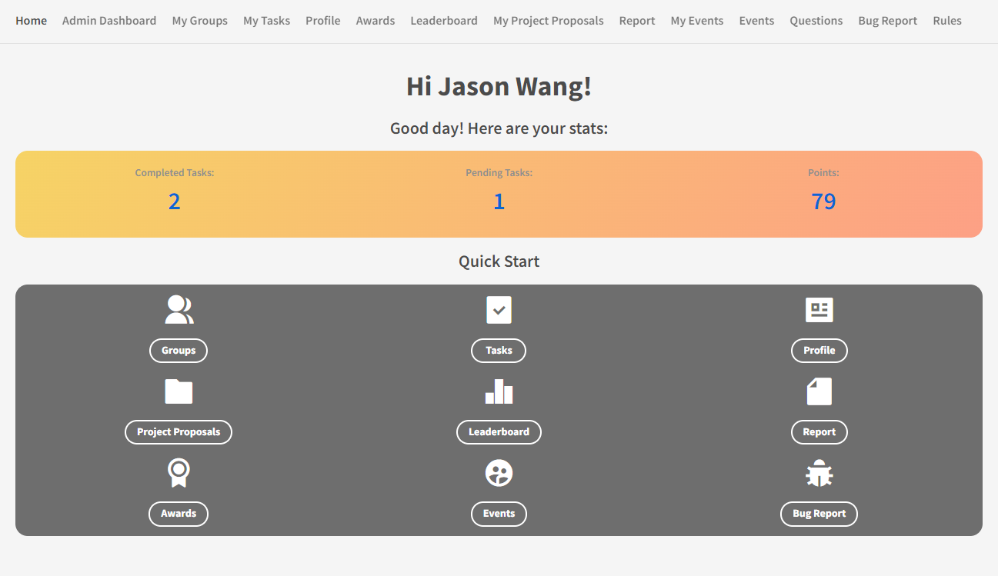

This is the page you see when you login. Here, you will see a quick overview of your statistics, as well as a couple of quick access buttons. All of these though, are accessible from the top bar as well!

## Admin Dashboard

For Access level: admin only

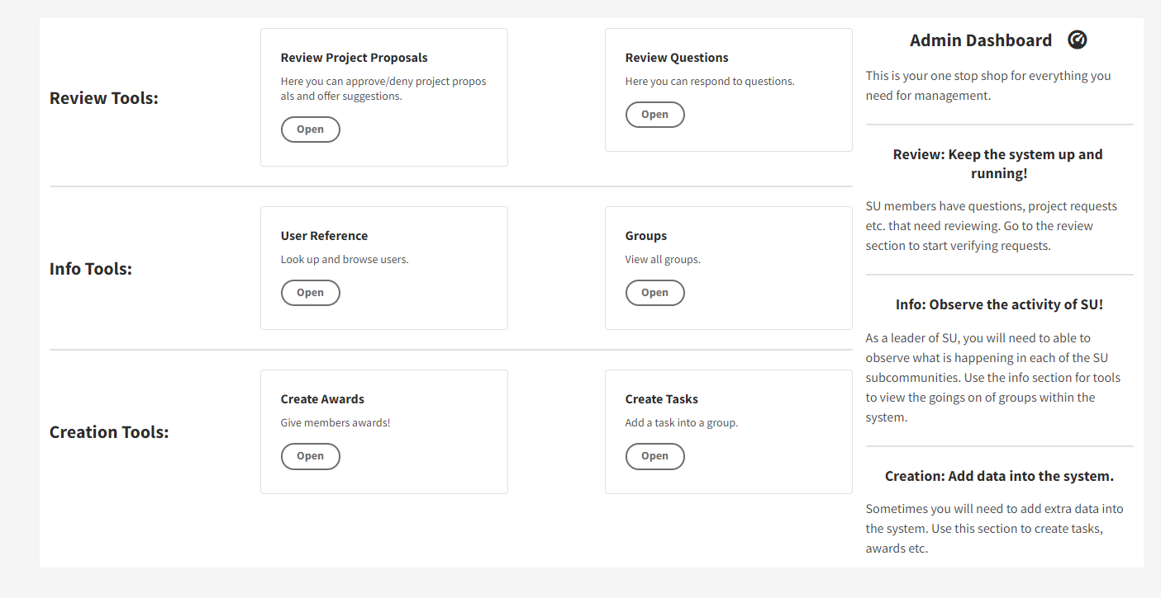

Here you will find a variety of tools to manage the system. Be careful though[1], as you are free to change almost anything. These are a number of subpages for each of the tools.

### Review Project Proposals

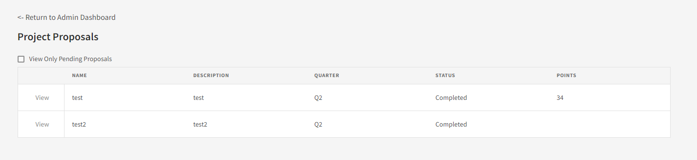

Here, administrators can review project proposals submitted by SU members. Click “View” to approve/disapprove and to make changes.

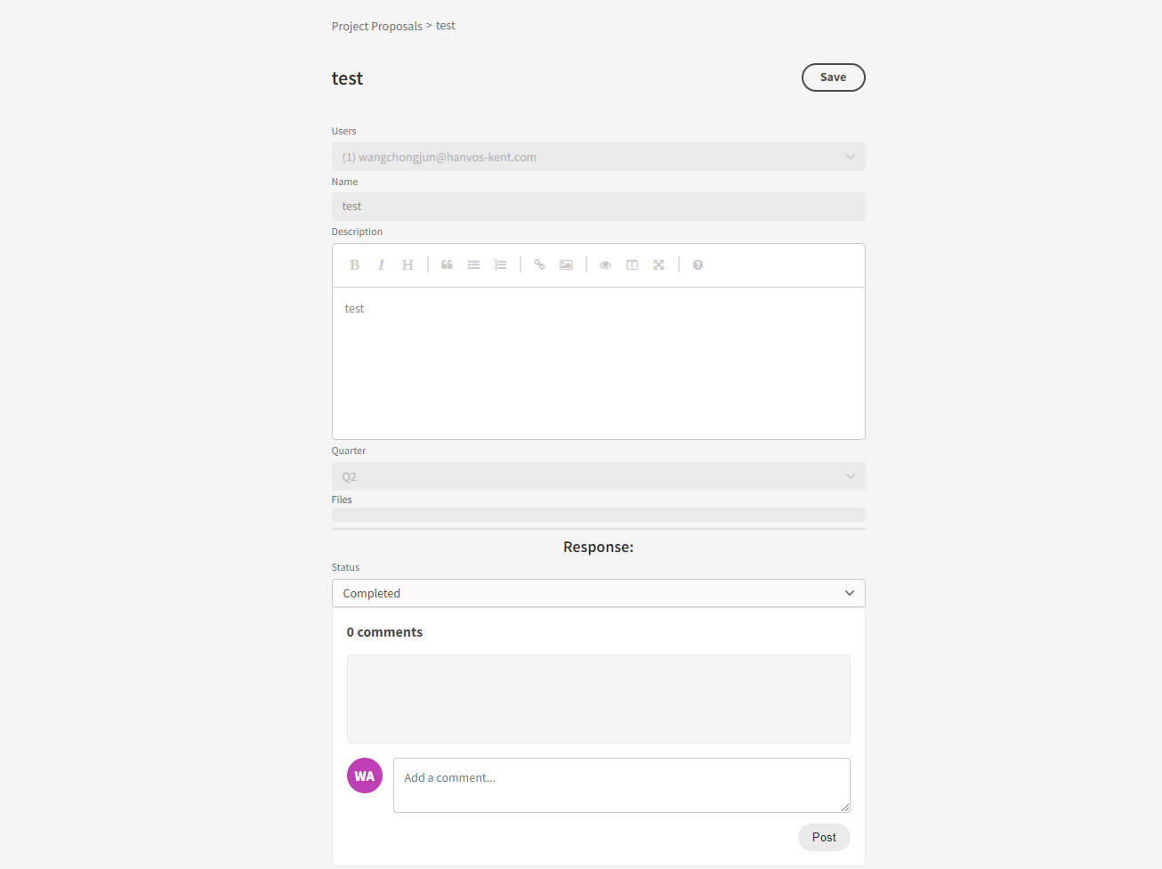

Here, submit the status of the proposal (whether you approve or deny it), and add a comment if you like.

### Review Questions

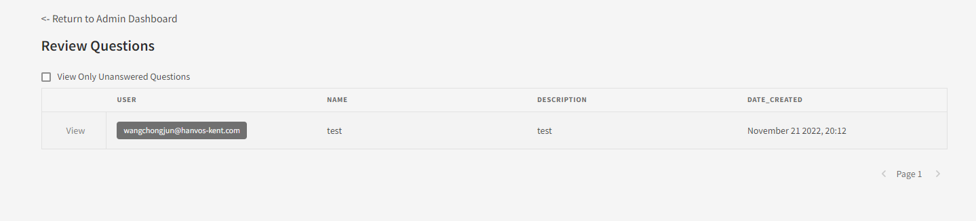

All members are able to submit questions. On this page, you can respond to them. To do so, press view on a question.

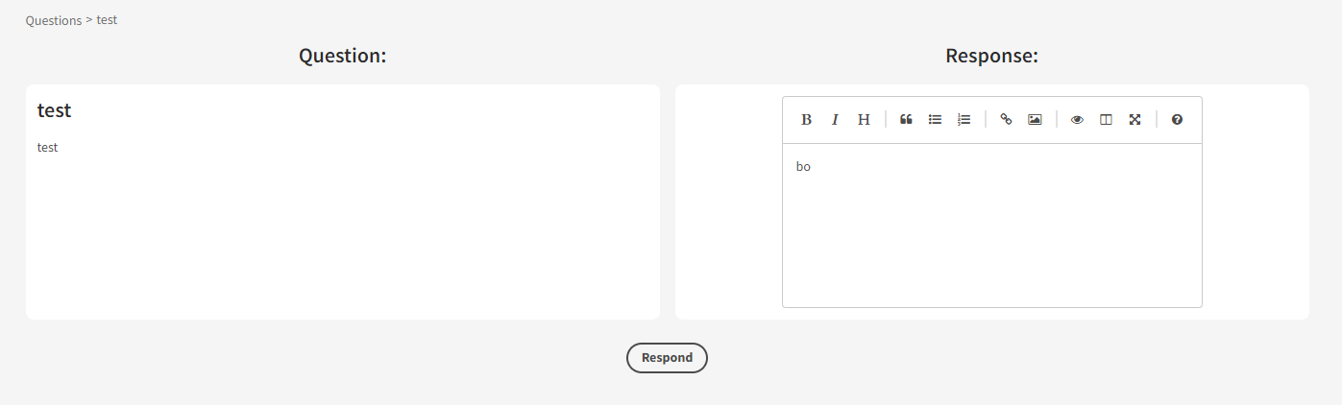

Respond the question on this page, and then press Respond.

### User Reference

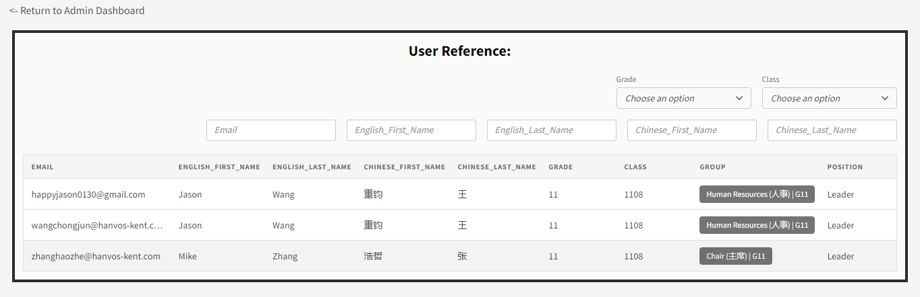

Use this page to search though all users in the system. You can filter by a variety of variables.

### Groups

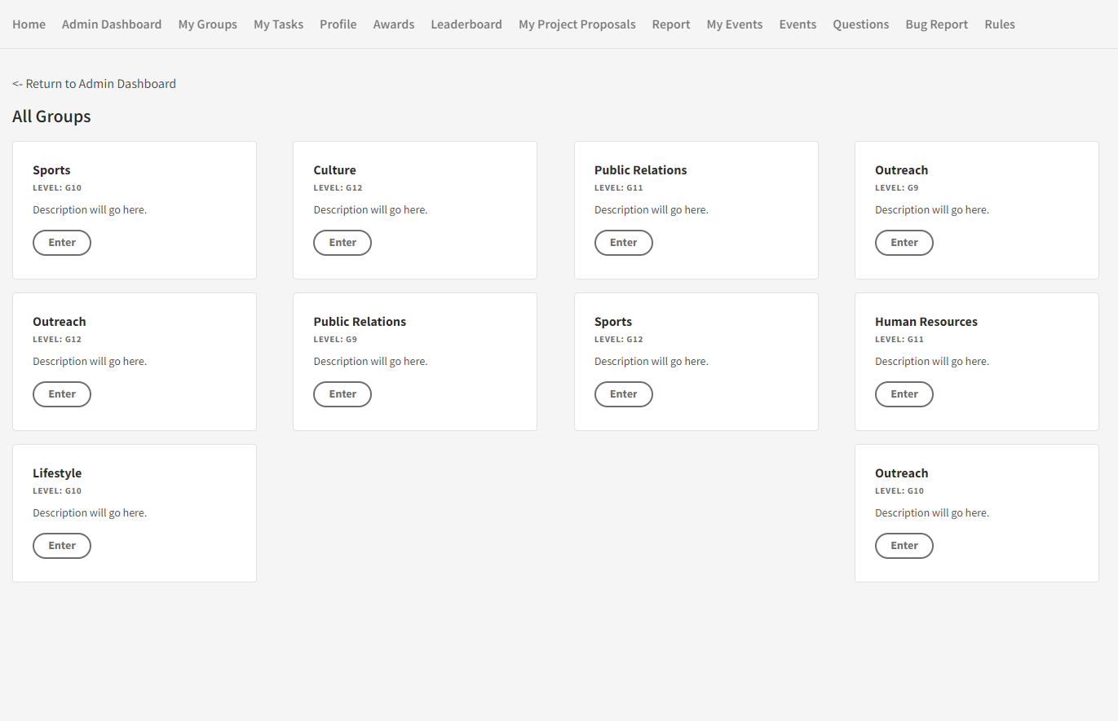

This is a powerful admin tool that allows you to access the group page of any of the groups in the system. You can make changes just as if you were a power user within the group. View the My Group section for more information.

### Create Awards

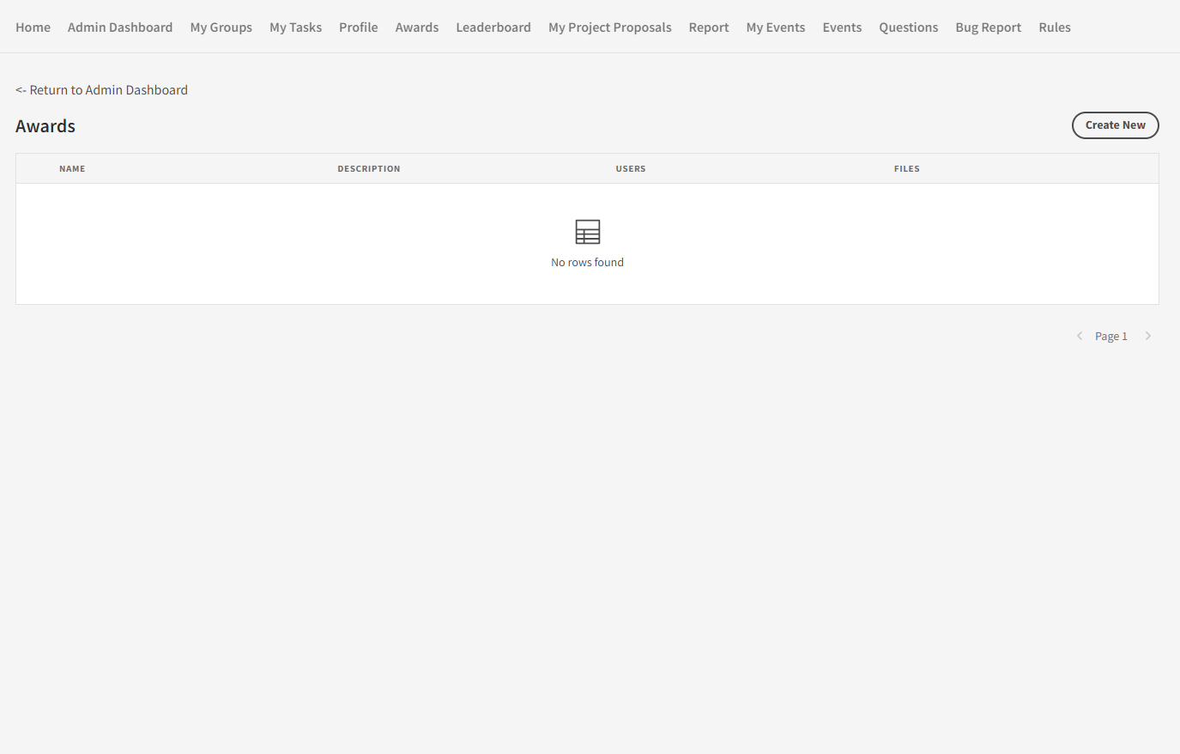

On this page, you can grant awards to users. Press Create New to generate a new award.

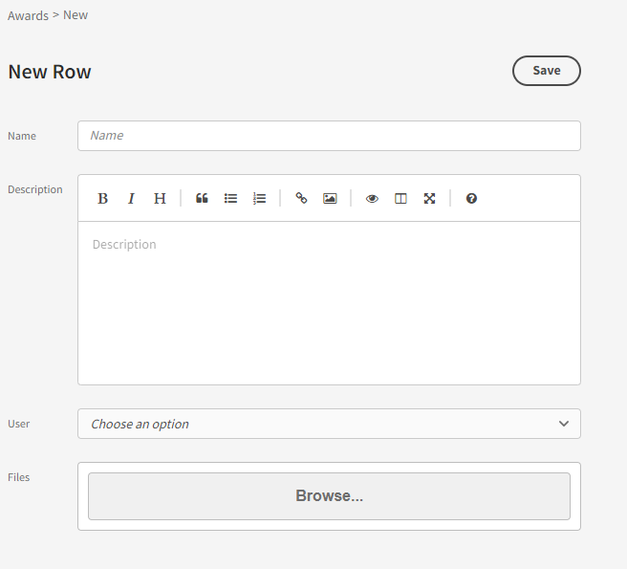

Here, fill in the relevant information and press Save to create the award. If you have a digital document for the award, add it in the files section. To see what an award in the system looks like, view the Awards section.

### Create Tasks

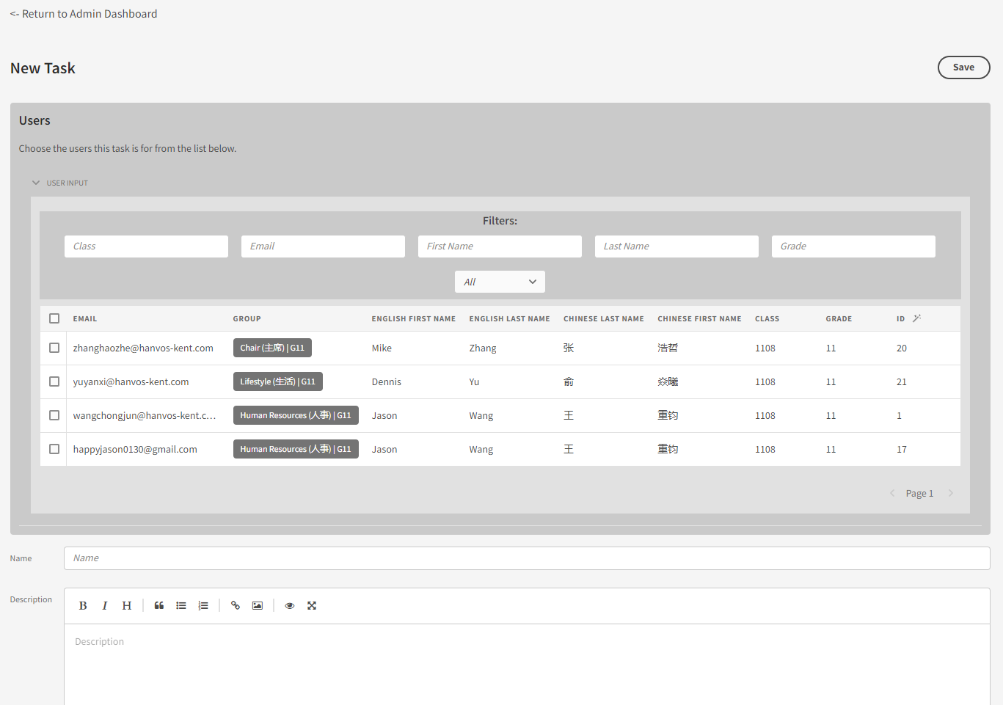

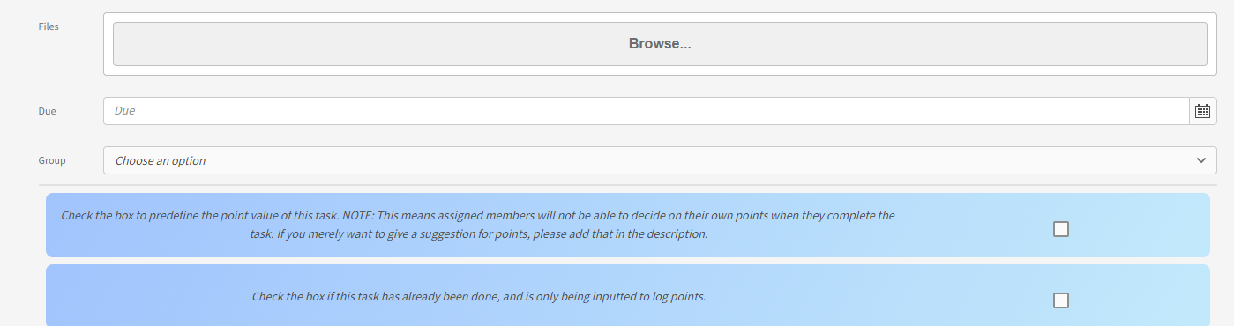

On this page, you can arbitrarily create tasks and drop them into any group. It is recommended, however, that you instead create tasks using the Groups feature of the Admin Dashboard. View the Add Task section to see what each of the fields do.

## My Groups

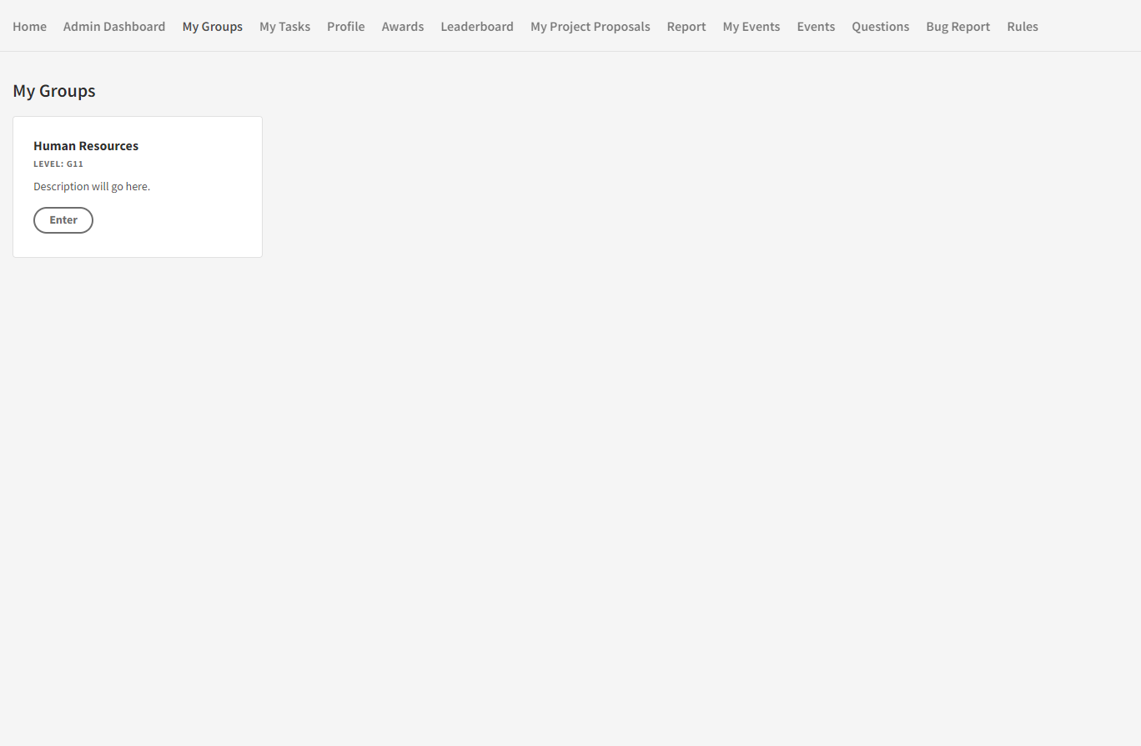

Here you will be able to access the group you are a part of. Click on the group to enter.

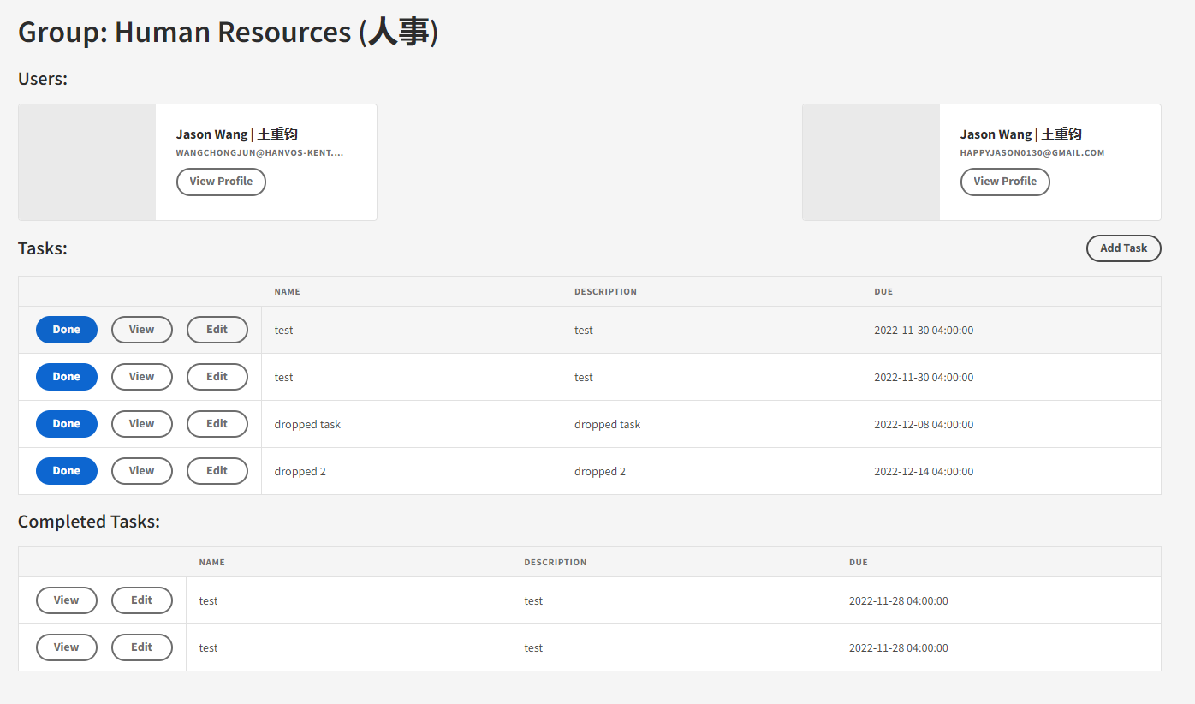

On this page, you will see the members of your group as well as completed and pending tasks.

### Add Task

For Access level: Power and Above

Click the Add Tasks button to create a new task for group members.

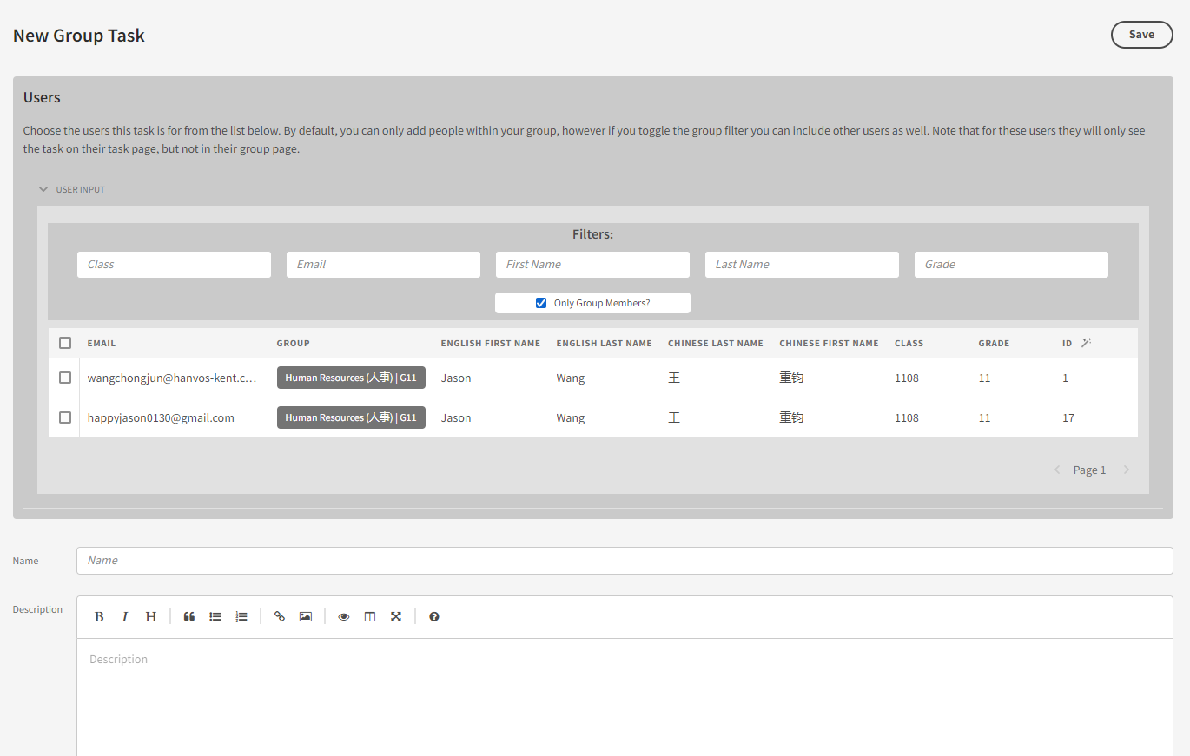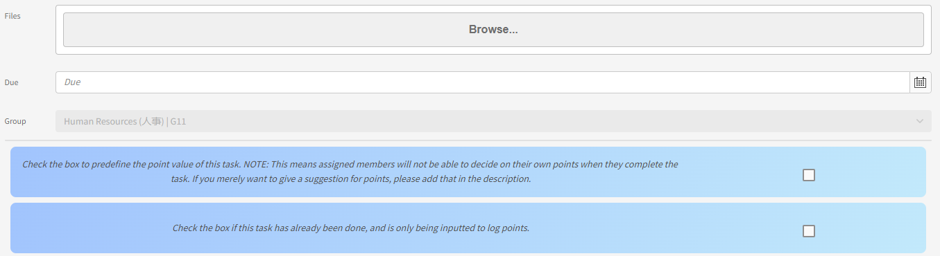

**Form Field Description:**

|  |  |
| --- | --- |
| Field | Description |
| Name | The name of the task. |
| description | The description of the task. Can be written in markdown. |
| file | Files you wish to attach to the task. |
| Due | The due date of the task. |
| Group | What group the task is in (You cannot change this). |
| Predefined Points (blue Checkbox 1) | Used to add preset points for a task. This will prevent users from manually inputting points for themselves when they complete the task. |
| already completed (blue checkbox 2) | Select if the task is already completed, and is only being used to log the task for points and future reference. A field will appear for you to input points in. |

## My Tasks

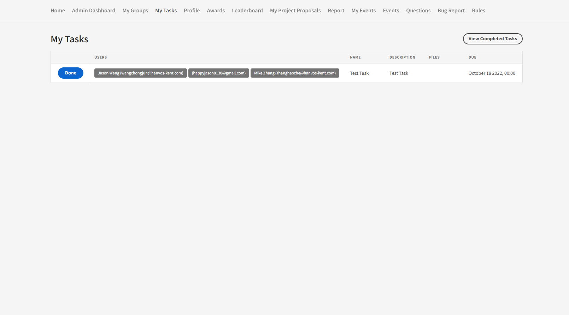

This is a faster way to access the tasks from your group. Here you can see all list of all these tasks you need to do.

### Completed Tasks

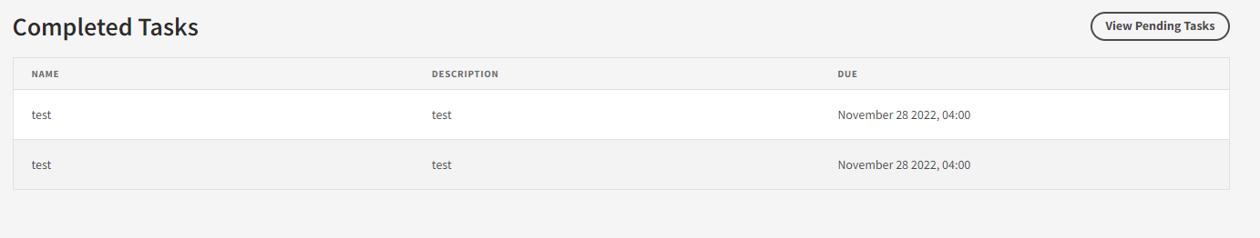

Click View Completed Tasks to see all of the tasks you have completed.

## Profile

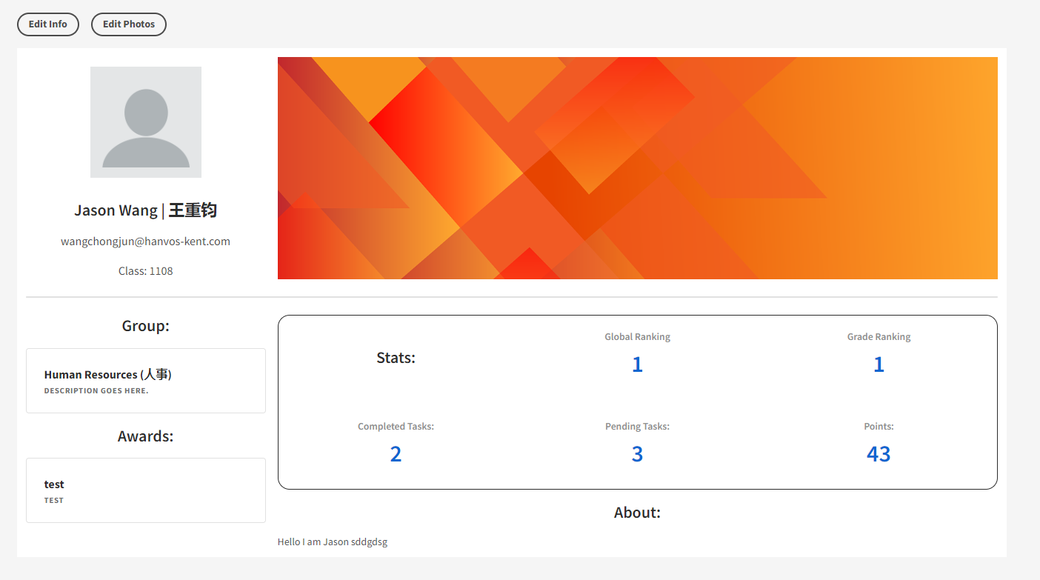

Here users can create custom profile pages that are viewable to all members of the organization. Click Edit Info to change your account information and click edit photo to change your profile and banner image.

## Awards

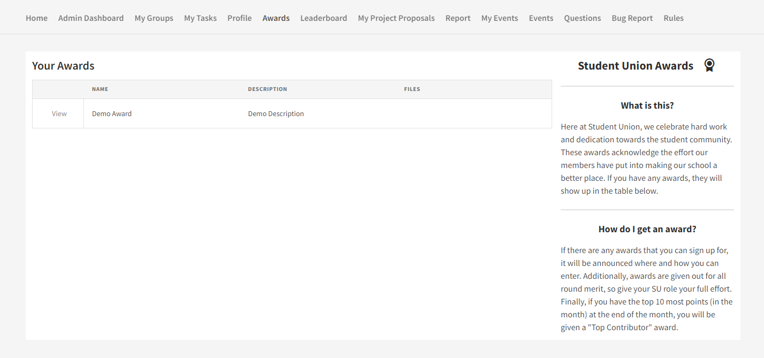

Here users can see award given to oneself. You can view the award and download its provided certificate document (if provided).

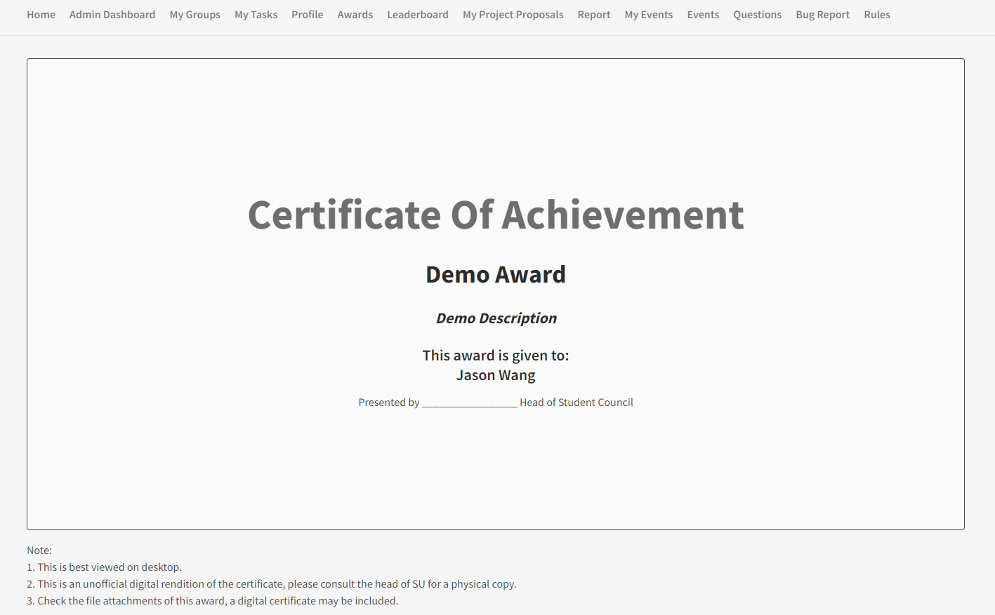

This is the page you see when you open an award.

## Leaderboard

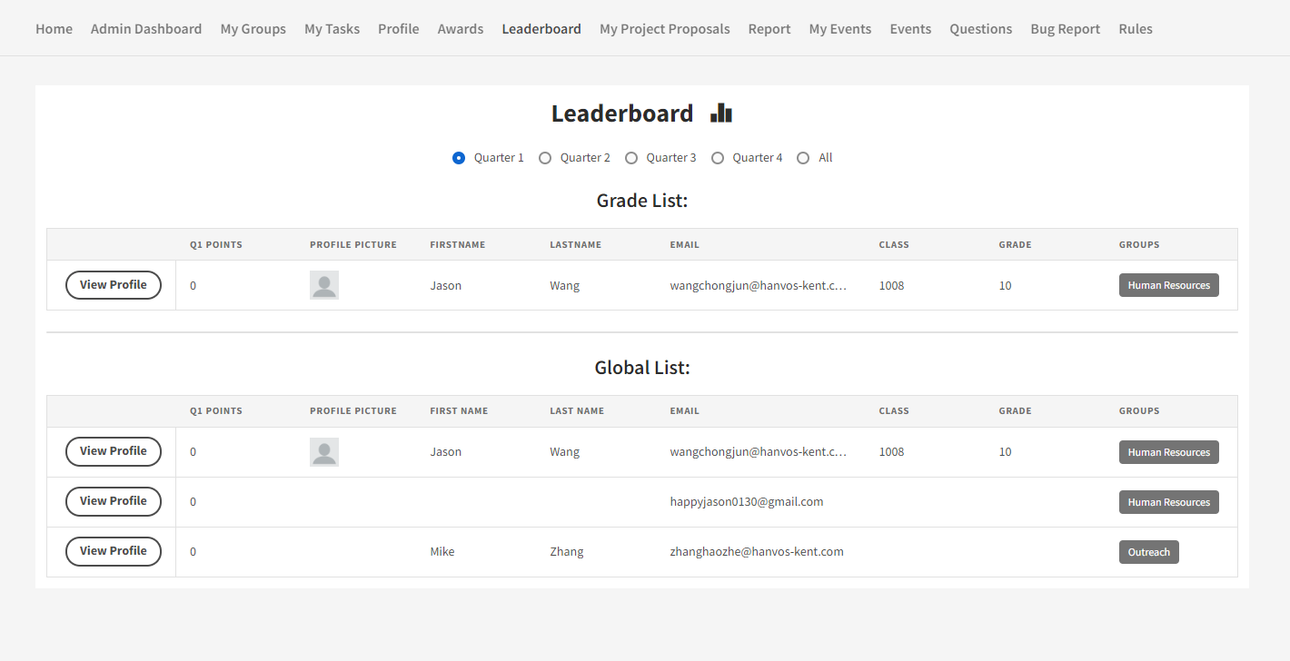

Here you can see global rankings of members of the organization based on points. You can filter by quarter or all.

## My Project Proposals

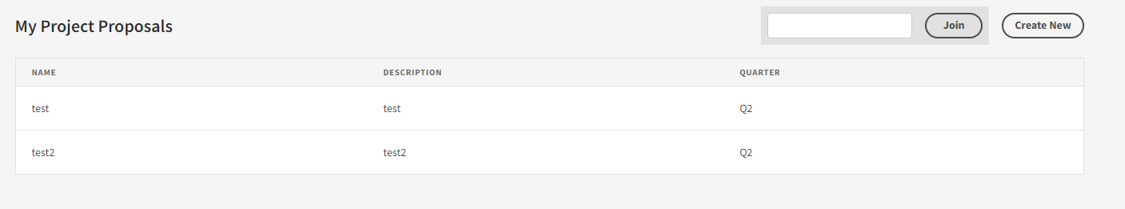

Here you can manage and create project proposals. Click on Create New to do so.

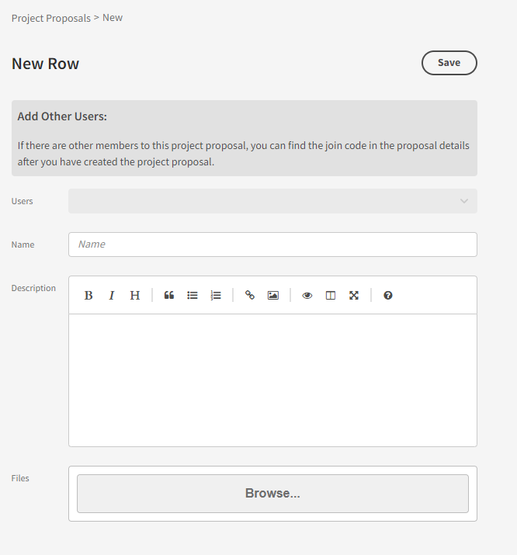

Fill in the relevant information and then Save.

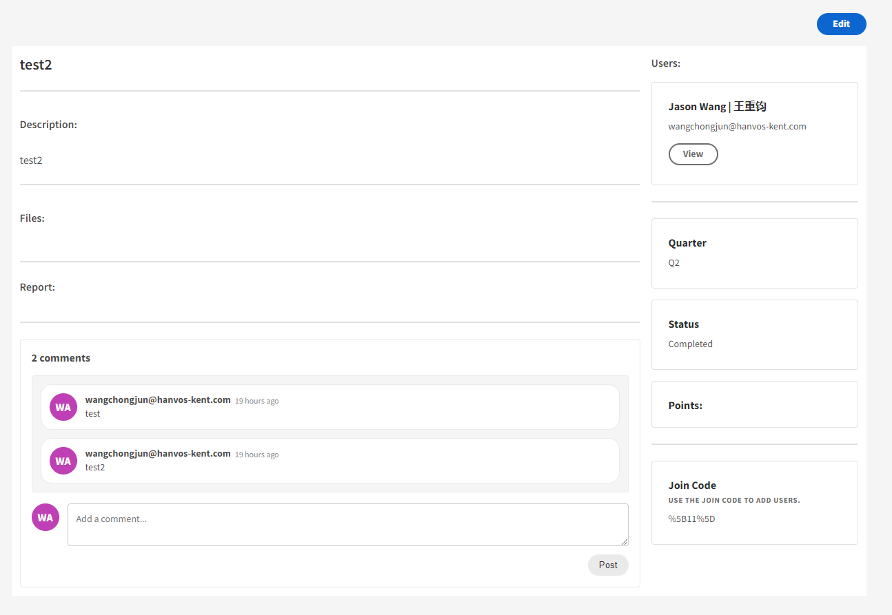

You can check on your proposal by clicking View. Here you will see a list of all of the information relating to the proposal. If you would like to add other users to the task, provide them with the join code on the right, and they can input it the join box of the My Project Proposal page.



You can also edit your project proposal info by clicking the edit button.

## Report

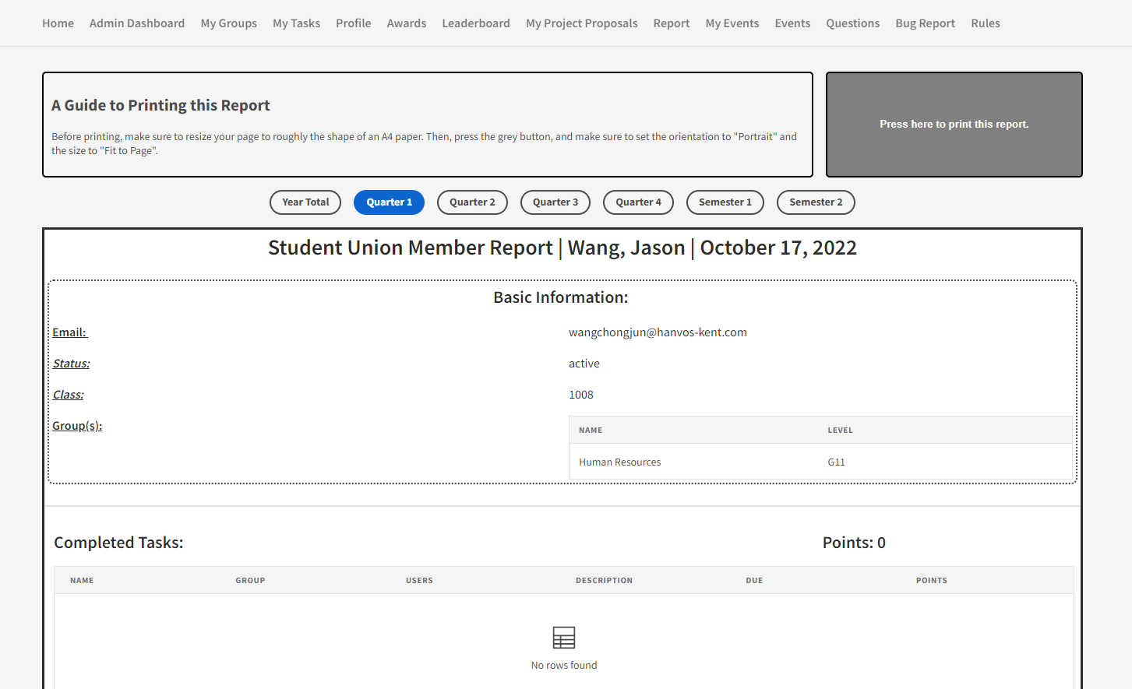

Here you can see a report of all the work you have done in the organization. You can filter this report by different time frames. To print the page, follow the instructions at the top of the page.

## My Events

For Access level: Power and Above

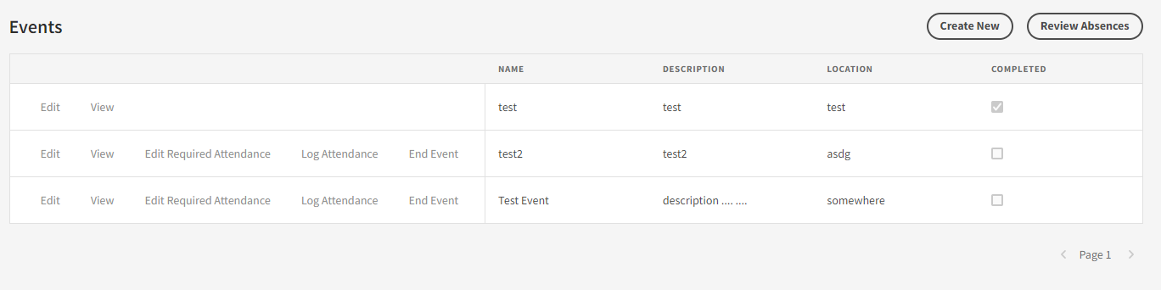

This section allows you to host events.

### Create New Event (Create new button)

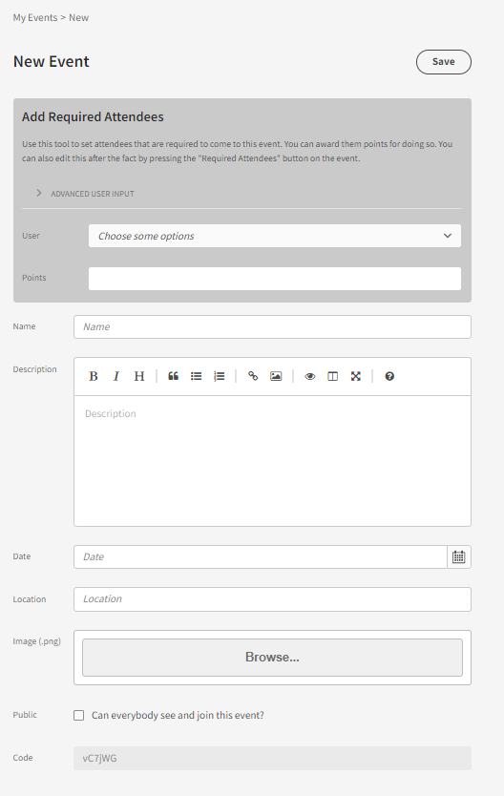

Here you can edit the settings for your event. Give it a name, date, description, location and even banner image. Select required attendee for your event (users who will be automatically signed up for the event and cannot cancel). Also make sure to select whether you want the event to be public or not. Public events are listed in the events section of everyone within the system, and they are free to sign up for the event on their own. Private events will only be visible to users who you add as required attendees to the event. Click save when you are done. Note that when users are added to an event, they will receive an email notification about it.

### Review absences (Review absense button)

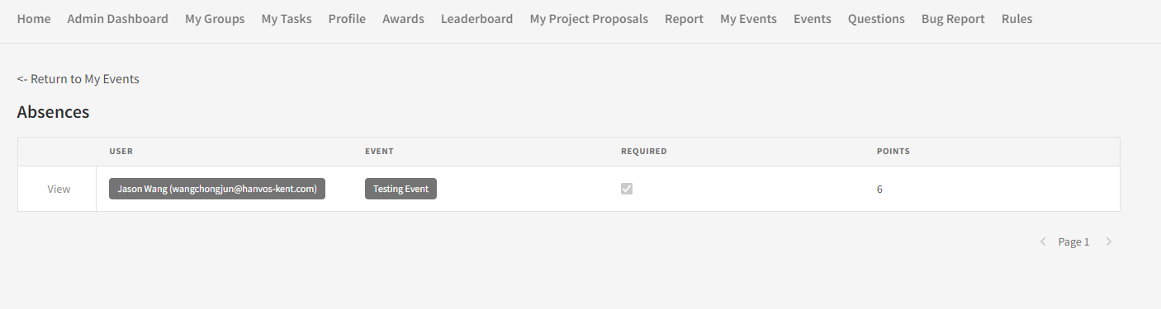

If you have members who are absent to any of your events, you can review them here. Users are able to submit an absence request to explain why they are absent.

### edit (Edit button)

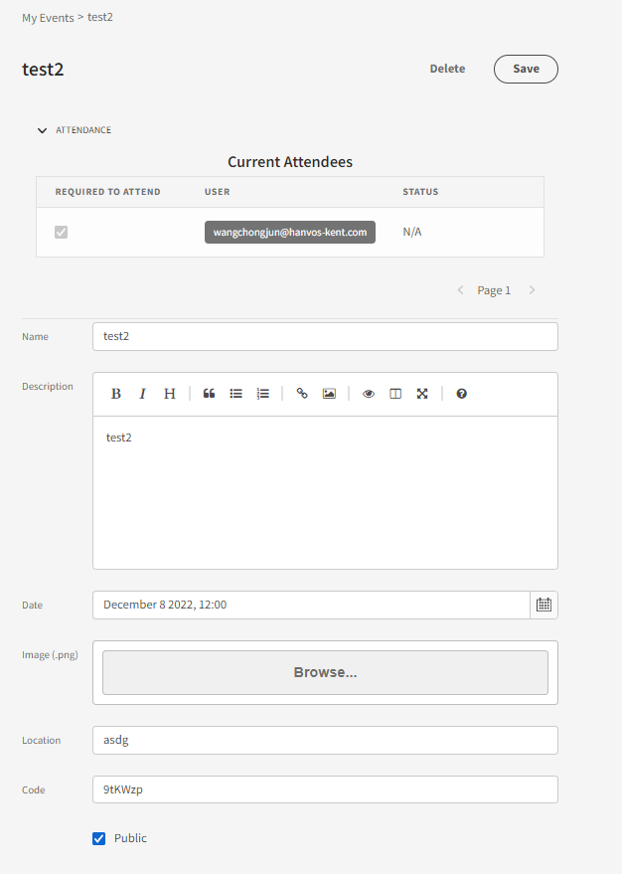

Here you can edit details about your event.

### View (View Button)

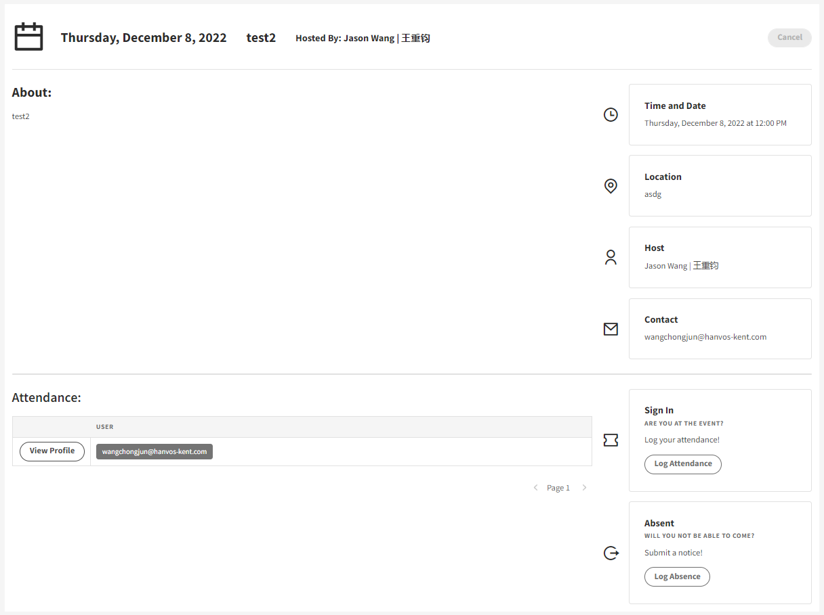

Here you can see the event page for your event. This is what is seen by attendees.

### Edit Required Attendance (Edit Required Attendance Button)

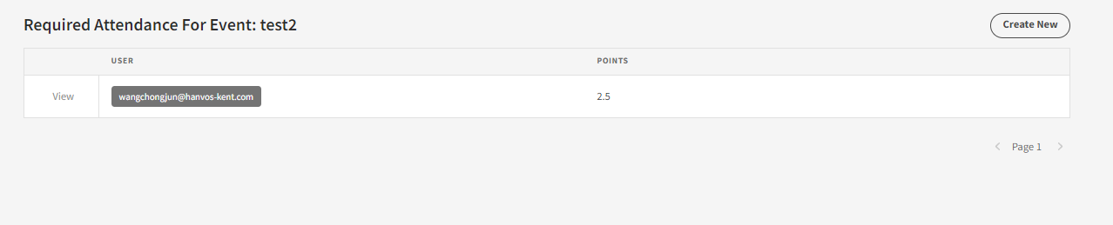

Here you can edit who is required to come to your event. Either add new people with “Create New” or remove people by clicking on an attendance with the “View” button and clicking delete on the info page.

### Log Attendance (Log Attendance Button)

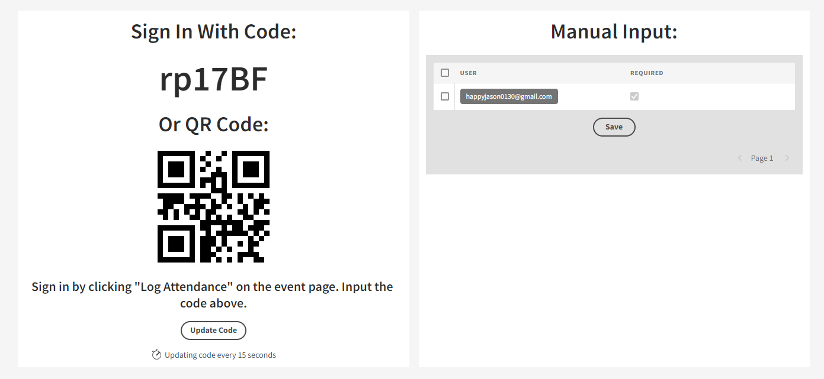

This is the page you show during your event to allow people to log their attendance.

### End Attendance

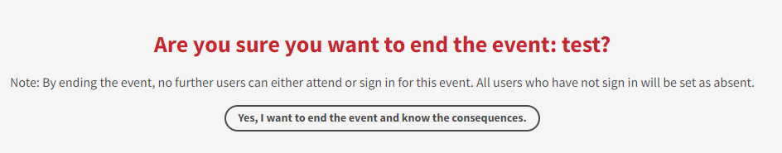

On this page, you can end your event. This has a couple of effects. Firstly, no further people can sign up or sign in for your event after you end it. Secondly, all users who have not signed in will be marked as absent.

## Events

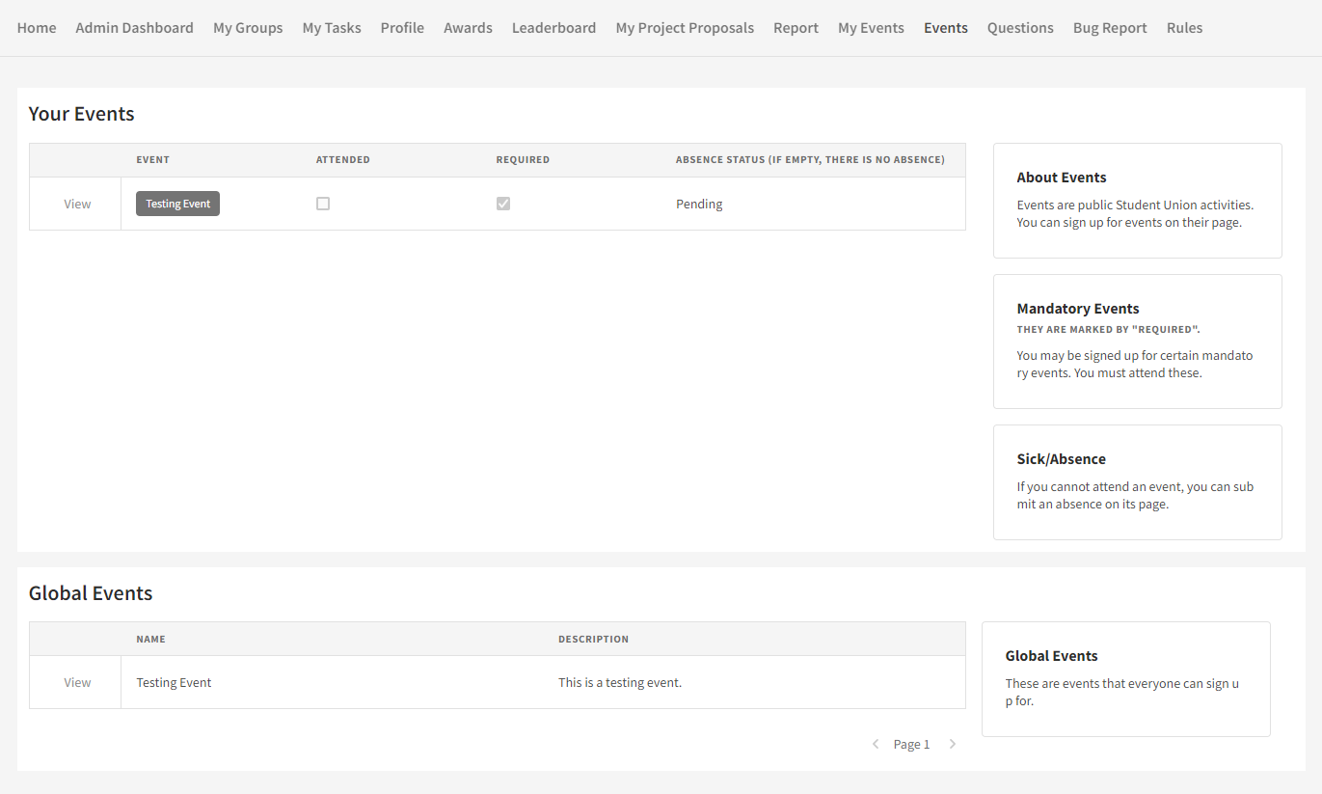

Under Your Events, you can see all of the events you have signed up for. If you are required to join an event, it will show up here. Global Events are events that are open to everybody. You are free to join these events.

### Event Page (View Button)

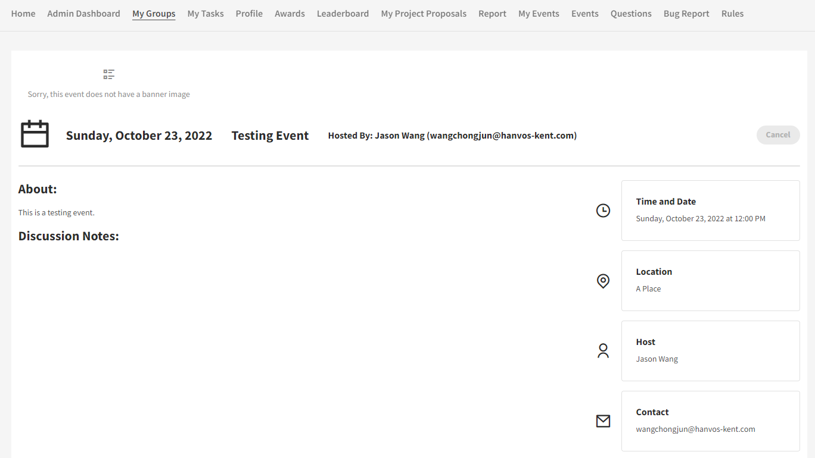

Each event has its own page. Here you can see all the important information about the event. You are also able to sign up for events on this page.

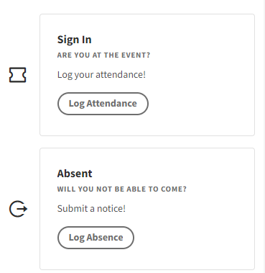

If you have signed up for an event, you will see a button to either sign in or to request an absence. To sign in, you will need to scan the QR code provided by the event organizer.

## Questions

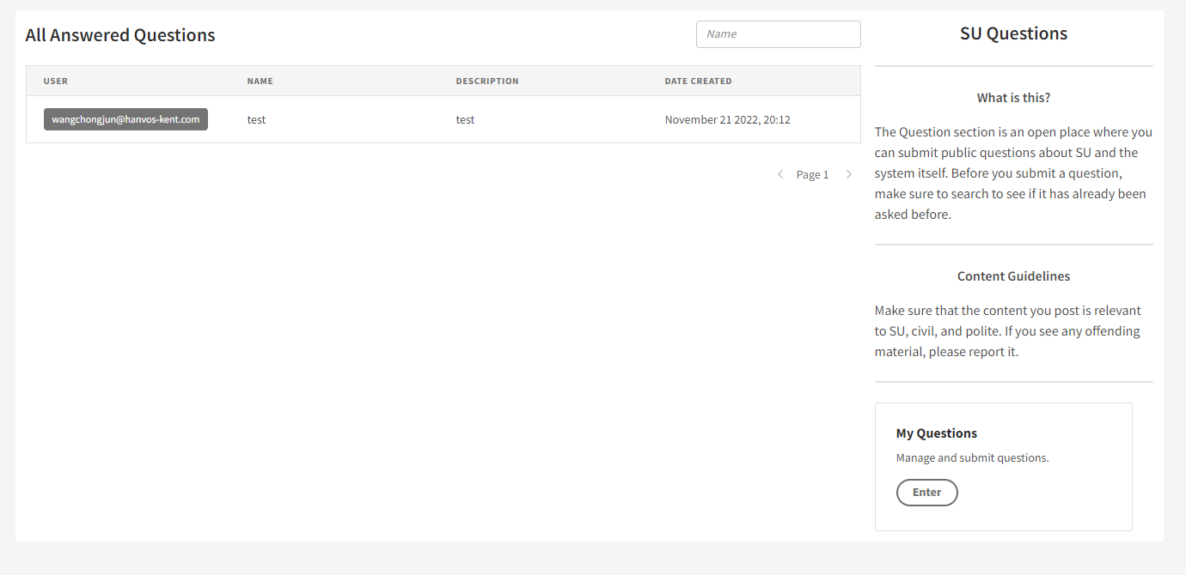

Here you view questions and answers about SU and the system. You can search the questions using the search bar at the top.  
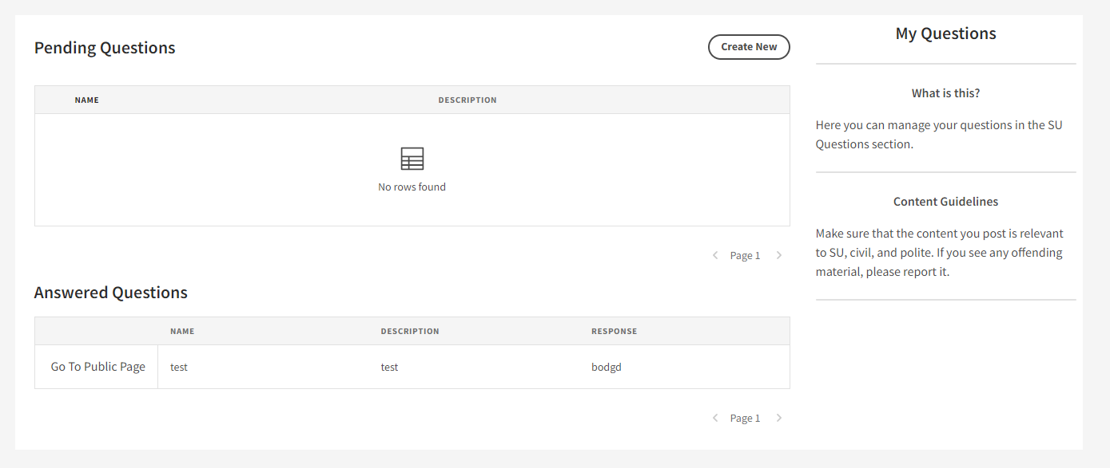

You can also ask your own questions by going the My Questions page. Note that all questions you ask are publicly viewable. Before you ask a question, make sure that it has not been asked already. Click Create New to ask a new question. Your questions that have not been responded to will be seen in the pending questions table. Responded questions will be displayed in answered questions table. Click on a question there to see the response.

## Files

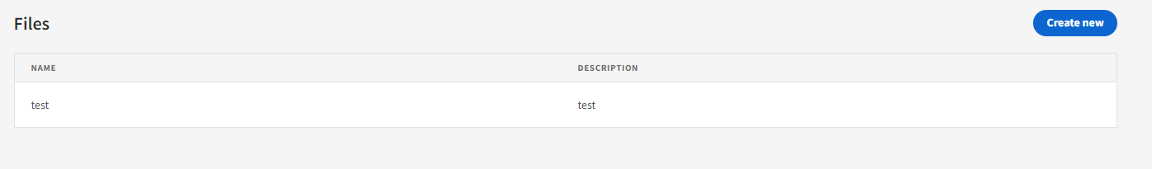

This is a system to upload and manage files. The purpose of this is to allow users to reference and share files in chatboxes. Users can upload files on this page, which will generate a unique file link for them to send as text. Any existing files you have uploaded will show up in the table. Click on them to either edit them or to copy their link. Click create new to upload new files.

Note: Do not use this for any non-SU related files. Furthermore, do not use this for large files such as videos. There is a file upload size limit.

## Bug Reports

Submit bug reports here! We would greatly appreciate if everyone submits a bug report if they encounter one. Please make sure that your submission is as descriptive as possible. Note that this is no longer part of the system and links to an external questionnaire site.

## Documents

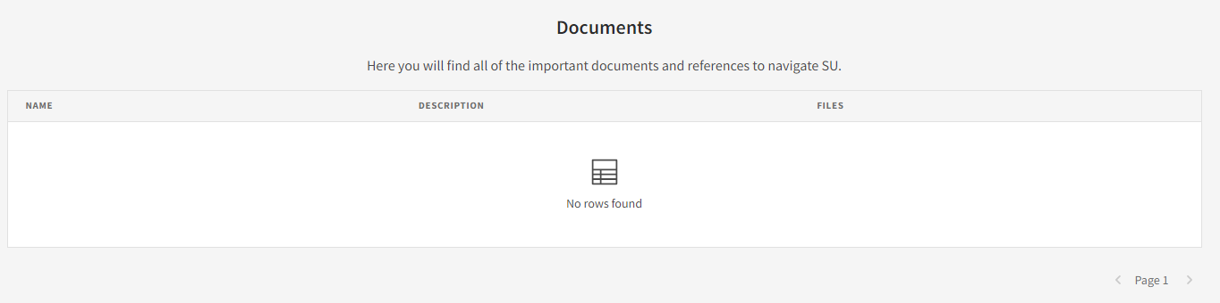

Here you will find files and important documents.

# Software Version Log

|  |  |
| --- | --- |
| Version: | Changes: |
| 1.0.0 (Demo) | Demonstrated functionality using Appsmith platform. |
| 1.0.1 (Rewrite) | Recreate system to allow for extendibility on Budibase.  Functionality:   1. Groups 2. Users 3. Tasks 4. Project Proposals 5. Report 6. Bug Report |
| 1.0.2 (Bug Fixes) | Fixed minor issues pertaining to all categories. |
| 1.1.0 (Big Features Update) | Added new functionality:   1. Admin Dashboard (which includes 7 subpages) 2. Profile Page 3. Awards 4. Leaderboard 5. My Events/Events 6. Questions 7. Rules |
| 1.1.1 (Bug Fixes) | Fixed minor issues pertaining to all categories. |
| 1.1.2 (Event Update) | Fixed bug issues pertaining to Events, and added new functionality:   1. Bug Fix: Resolved “Document Update Conflict” when reloading code in event attendance page. 2. Bug Fix: Resolved links in breadcrumbs pointing to undefined URLs. 3. Bug Fix: Resolved 4. Functionality: Added Review Absences page to allow event owners to review absences on their own events. 5. Functionality: Added QR Scanning as an option to verify attendance. 6. Functionality: Added Required Attendance page to allow event owners to set and delete required attendees an event. 7. Compatibility Breaking Changes: The URL paths of some of the event related pages has been changed. 8. Other minor changes. |
| 1.1.3 (Tasks Update) | Added new functionality:   1. Updated UI on view tasks to be more user friendly. 2. Added view button for those with edit permissions. Previously edit and view was either or. 3. Added a chat box to the bottom of the View page on a task. This will facilitate conversation about a task. |
| 2.0.0 | Major system rework, changing backend DB from CouchDB to MySQL and reworking a bunch of pages. Pages now load significantly faster.  Features:   1. Reworked all pages to support the new SQL backend. 2. Redesigned DB to be more efficient. 3. New SQL views and queries to reduce redundant information from slowing down load times. 4. Files are now stored in row in DB instead of being hosted on a separate MinIO server. (While this may not sustainable for large system, for an internal system with relatively low milage this maintains the SQL DB as the single source of truth for all the data). 5. Significant updates to the Events system and related pages.    1. Reworked to support the concept of an event ending, marking all unattended as absent.    2. Email notifications for new event attendees.    3. Cleaned up UI.    4. Various bug fixes.    5. Updated sign-in feature. QR code feature hidden for the moment due to http restrictions, and code now automatically updates itself every 15 seconds to curb non-attendees from signing in. Additionally, bugs regarding this feature were fixed. 6. Updates to user data and information.    1. User information is now stored in a SQL table and is related to the internal DB user list via email.    2. Views have been created that allow user ranks and statistics to be easily accessible. 7. Onboarding Experience    1. An all-new one-time setup onboarding experience that allows users to input essential user information. 8. File Upload    1. A system for users to upload files and receive a shareable link (usable only for system users). This enables files to be shared in comment conversations. 9. Questions:    1. Overhaul of UX and the setup of the Question page so that it is more useful. Instead of individual private questions it is now a forum, where questions about the student union and the system are viewable and searchable by all users. This saves admin time answering repeat questions. Additionally, there is a new question management section for users to keep up with the questions they have asked. 10. Project Proposal:     1. Adopts a comment system to replaces various tedious hardcoded phases of back and forth between admin and user.     2. New join code allows users to “share” a project proposal with others and allow them to join in. This replaces a trust-based system of allowing users to select partners from anyone within the system.     3. New status system – not all that important, just how the status is represented in the DB. 11. New Plugins:     1. Implemented 2 new open-source custom plugins, a [file uploader](https://github.com/chungchunwang/Budibase-File-Upload) and a [file repeater](https://github.com/chungchunwang/Budibase-File-Repeater). This has allowed for in-DB file storage, which was previously not possible in Budibase. 12. Miscellaneous:     1. Reworked the selection of Users on many pages. Previously the used of Advanced User Input allows users to inject selections from a more complicated user selection form. Such an injection is unintuitive, so it has been replaced, with the Advanced User Input form being the default on most pages.     2. Bug report is now in Microsoft Forms. Detaching it from the system makes it more accessible when it is most useful (when the system is down or has errors).     3. Rules has been renamed Documents.     4. Most tables and cards that include users now clearly link to their profile page.     5. Reworked the design of the task pages to be prettier.   Other minor details have been omitted for brevity. |
| 2.0.1 | Minor bug fixes, as well as enabling QR Code scanning for events, which will can only be used under https. |

# Known bugs and issues

* None at the moment. Please report any bugs to wangchongjun@hanvos-kent.com.

# About the software & its design

The system is built atop the open-source low-code platform [Budibase](https://github.com/Budibase/budibase), with certain custom components created to fill in for missing functionality. These are written in Svelte. The data stored using MySQL.

## Why low code?

While I initially planned to build the system using React, Tailwind CSS, and other component libraries, I ended up opting for a low-code platform because this project is designed to be maintained into the future. I haven’t found any proficient front-end developers in our student body, so I felt that I would be creating a black box that would be difficult to fix or extend. Low-code platforms make maintenance easy through its drag and drop interface. The problem with a low-code platform, however, is its restrictions on functionality, due to the limitations of drag and drop as well as the relative newness of the software. I have tried to solve these issues by creating custom plugins and submitting bug reports to Budibase.

Update: In hindsight, I now think the system would have been easier to construct with a web framework and code[2]. These low code platforms, despite their seemingly infinite capability, can really just built CRUD applications, so this was like fitting a peg in a square hole. Things like logging in with a QR code for attendance was especially hard. However, hopefully now, with the annotated drag and drop components and the custom plugins, future members will have an easier time patching and extending the system.

## Why MYSQL?

The data for this system is relational, so using a relational database improves performance dramatically. The initial version of the system used the Budibase internal DB (which used CouchDB, see update 2.0.0) and the shift to MySQL improved performance drastically (While I did not do official tests, it cut down load times by a factor of 2, if not more. The main concern raised when the initial system was beta-tested was its slow loading times.).

## How is it hosted?

Everything is run through Docker on an Ubuntu instance running in the cloud. There are just 2 Docker images that need to be loaded to setup a clean system. Nginx is also needed as a reverse proxy and an HTTPS certificate needs to be acquired. However, all this complexity is automated in a script. Instructions will be in the setup section below. The idea is that a new Budibase app + MySQL schema is created for each year, with past years frozen in a read-only mode for reference purposes.

# System Setup

*Note: This following document is a copy of this version* [*available online*](https://github.com/chungchunwang/Student-Union-System/tree/main/docs/setup) *on GitHub. I have tried my best to format it correctly, however please refer to the online version if you encounter any issues.*

*Prerequisite: The following document assumes a basic understanding of how to operate a bash terminal.*

Welcome to the guide for setting up the Student Union Internal Management System!

This comprehensive guide aims to assist Student Union leaders, administrators, and IT professionals in hosting a robust and user-friendly Internal Management System tailored to their specific requirements. By following the steps outlined here, you'll be able to streamline administrative processes, enhance communication and collaboration, and empower your Student Union to thrive.

So, let's dive in and embark on the journey of setting up an efficient and effective Student Union Internal Management System.

## Connecting to a Cloud Server

The Student Union Internal Management System runs on a Linux (Ubuntu) server hosted on a cloud service, eliminating maintenance and hardware costs. Cloud hosting provides a scalable and secure environment, allowing easy access and ensuring data integrity.

There are a variety of different services that offer cloud hosting services, so it does not make sense to identify a particular one here. Choose one that has servers close to your region and is affordable.

You will also need to have purchased a domain that points to the IP address of your server.

|  |
| --- |
| **💡 Tip - Here are some general instructions for how to configure a domain for your server.**  Choose a domain registrar: There are many domain registrars available, such as GoDaddy, Namecheap, and Google Domains. Choose one that suits your needs and budget.  Search for available domains: Use the registrar's search tool to find an available domain that you like. You can search for domains by keyword, or by entering a specific domain name.  Purchase the domain: Once you have found an available domain that you like, follow the registrar's instructions to purchase it. You will need to provide your contact information and payment details.  Access your domain registrar's DNS settings: Once you have purchased your domain, you will need to access your domain registrar's DNS settings to point your domain towards the IP address of your server. The exact steps for doing this will depend on your registrar, but you should be able to find instructions in their documentation.  Add an "A" record: In your DNS settings, add an "A" record that points your domain towards the IP address of your server. The exact steps for doing this will depend on your registrar, but you will typically need to enter the IP address of your server in the "Value" field of the "A" record.  Wait for DNS propagation: Once you have added the "A" record, it may take some time for the changes to propagate across the internet. This can take anywhere from a few minutes to a few hours. |

Once you have purchased a cloud server and a domain, you will need to access its terminal to host the system on it. I recommend the PuTTY SSH tool to do this.

|  |
| --- |
| **💡 Tip - To SSH into a cloud Linux server using PuTTY, follow these simple instructions:**  Download and install PuTTY: Visit the PuTTY website (https://www.putty.org/) and download the appropriate version of PuTTY for your operating system. Install PuTTY by following the on-screen instructions.  Obtain server credentials: The cloud service should provide the IP address and the username and password for your server.  Launch PuTTY: Open PuTTY from your computer's programs or applications menu.  Configure the connection: In the PuTTY configuration window, enter the server IP address in the "Host Name" field. Make sure the "SSH" option is selected, and the port is set to 22 (the default SSH port).  Save the session: Optionally, you can enter a name for your session in the "Saved Sessions" field and click the "Save" button to save these settings for future use.  Connect to the server: Click the "Open" button to initiate the SSH connection.  Provide login credentials: A new terminal window will open. Enter the username provided by your cloud service provider and press "Enter." If you are using a password for authentication, enter it when prompted. If you are using an SSH key, refer to the next step.  Configure SSH key authentication (if applicable): If you are using an SSH key instead of a password, follow these additional steps: a. Click "Connection" in the left panel of the PuTTY configuration window. b. Expand the "SSH" section and select "Auth." c. Click the "Browse" button and locate your private key file on your local machine. d. Click "Open" to return to the main configuration window.  Complete the login process: After providing the appropriate credentials (either password or SSH key), press "Enter" to log in to the cloud Linux server via SSH using PuTTY. Once connected, you can execute commands and perform administrative tasks on the cloud Linux server through the PuTTY terminal window. |

## Setting Up the Program

Download the setup script using the following line.

***curl -o setup.sh https://raw.githubusercontent.com/chungchunwang/Student-Union-System/main/app/scripts/setup.sh***

Execute the setup script using the following. Make sure to follow the on-screen instructions.

***bash setup.sh***

## Configuring the Systems

### MySQL

First, install MySQL Workbench at https://dev.mysql.com/downloads/workbench/. Connect to your server.

|  |
| --- |
| **💡 Tip - Here are the steps to connect to a MySQL server via MySQL Workbench:**  Open MySQL Workbench.  Click on the "+" icon in the "MySQL Connections" section of the home screen.  Enter a name for the connection in the "Connection Name" field.  Enter the domain of your sever in the "Hostname" field.  Click on the "Store in Vault" button to securely store the password for the root user.  Click on the "Test Connection" button to test the connection to the MySQL server. If the connection is successful, click on the "OK" button to save the connection.  Once you have saved the connection, you can double-click on it in the "MySQL Connections" section to connect to the MySQL server. |

Download the base MySQL setup for Budibase [here](https://github.com/chungchunwang/Student-Union-System/blob/main/app/sql/base.sql).

Click Server->Data Import, and select Import from Self-Contained File. Next to Default Target Schema, select New and input the name of the schema (database) you wish to create. It is recommended convention that you name the schema after the particular school year this system is for. Thus, you can have multiple copies of the database for different years. Select the setup file you downloaded. To begin the import, click the Start button at the bottom of the page.

Navigate to the Global_Variables table, and click the rightmost button to view its contents. Notice that there is a row entitled Quarter. This is used by the system to determine the current quarter of the school year. Its possible values are Q1, Q2, Q3, and Q4. Make sure to update this variable as necessary.

[Image of Global Variables table](https://github.com/chungchunwang/Student-Union-System/blob/main/docs/setup/assets/Global_Variables_Screenshot.png)

### Budibase

If you access your domain at the port you provided during the setup process, you should see a running, blank Budibase instance. Follow the onscreen instructions to setup an admin account. We will not need to build an app from scratch, we just have to load in the saved app file.

#### Configure Budibase

Go to the dashboard. We will now configure the global Budibase settings.

**Email**

Go to Email, and configure the SMTP settings for an email address for the system to send automated emails with. You may have to create a free online email for this step, or contact your school administrator to obtain another school email.

Below you can set email templates. You can use the defaults there. Slightly modified versions of the defaults that are recommended can be found [here](https://github.com/chungchunwang/Student-Union-System/blob/main/app/email-templates).

**Organization**

Go to Organization, and input the name of your student union. Also upload its logo. Add the URL of your site to Platform URL. Make sure to include the port if necessary (eg. example.com:100). Save your changes.

**Plugins**

Go to Plugins, and click add plugin. Choose URL as the source, and add the following urls:

*https://github.com/chungchunwang/Budibase-File-Upload/releases/download/v1.1.8/Budibase-File-Upload-1.1.8.tar.gz*

*https://github.com/chungchunwang/Budibase-File-Repeater/releases/download/v1.1.3/Budibase-File-Repeater-1.1.3.tar.gz*

*https://github.com/andz-bb/budibase-component-accordion/releases/download/v1.2.0/accordion-1.2.0.tar.gz*

*https://github.com/MartinPicc/budibase-interval-plugin/releases/download/v1.1.1/Interval-1.1.1.tar.gz*

*https://github.com/rosnerdev/bb-qr-code/releases/download/v1.0.0/bb-qr-code-1.0.0.tar.gz*

*https://github.com/aptkingston/budibase-comment-box/releases/download/v1.0.2/comment-box-1.0.2.tar.gz*

*https://github.com/chungchunwang/Budibase-QR-Code-Scanner/releases/download/v1.0.2/QR-Code-Scanner-1.0.2.tar.gz*

**Install App**

Go to https://github.com/chungchunwang/Student-Union-System/tree/main/app/budibase/exports and download the latest version of the app. On the dashboard, click Create new app, and then Import app. Here, give the app a name and then import the file. It is recommended that you give the app the same name as the database.

After you have logged in, change the configuration for MySQL to have Host be your domain name and Password be the password you set for MySQL during the setup process. Set Database to be the name of your schema. Save your configuration.

**Import Users**

On the dashboard, click on the Users tab, and import the emails of the people you wish to invite to the system. You can make use of a CSV file. Make sure to set regular users as App User, not Dev or Admin.

Then, click Manage on your app, and select the Access tab. Add the users you imported into you app. You will have to specify their level of access between either Admin, Power, and Basic. Consult the user documentation for the Student Union System for more information about what each of these categories entails.

This can be rather tedious if you have a lot of users, however you will only have to do it once a year! Unfortunately an easier method is a paid feature of Budibase. Alternately you can try to setup an automatic script to do this with the Budibase API, though you will have to figure that one out for yourself.

#### Configure App

**Groups**

Go to the Groups section of the MySQL database inside the Data tab of the Budibase app. Here, add all of the different groups that are present in your school. You can save this to a csv and upload it for successive years. [A recommended system of groups used here at Hanvos-Kent can be found here](https://github.com/chungchunwang/Student-Union-System/blob/main/app/groups/export.csv).

**Bug Report**

Go to the Design tab, and view the page for the Bug Report. Click on the Bug Report button component, and change action it triggers to go to a particular page you want bug reports to your system to be reported. If you think this is unnecessary, just delete this page.

### Quick Fix For Budibase Bugs

For some reason, the accordion plugin does not work properly when imported. To fix this, go to /tasks/new/:group in the design tab of the app, select the accordion component (inside the Users section), and toggle the default states to closed and then back to on. This seems to "wake the plugin up".

### Managing the System Over Many Years

The app is designed to work over a particular school year. Over multiple school years, you will need to maintain a new version of the app as detailed in the instructions above (though you will not need to reset up Budibase and MySQL, just add a new app and schema respectively - thus, you DO NOT need to rerun the install script). For archival purposes, it is recommended that you maintain the Budibase app and MySQL schema for past school years, but set the MySQL schema to read only. To do so, use the SQL command:

*ALTER Schema `SCHEMA NAME HERE` READ ONLY = 1;*

### Migrating Servers

If there is any reason that necessitates the movement of servers, you will need to migrate your MySQL schemas and Budibase apps over to the new server.

Firstly, on the new server, run the setup script above to install Budibase and MySQL. Follow the later steps below that if you also need to setup a blank app for a new school year.

### Migrating MySQL Schemas

Just like we loaded a blank MySQL setup to install a blank app, we can also save our schemas to files that can be loaded onto a new server.

In MySQL Workbench, connect to your original MySQL server, and go to Server -> Data Export. Select the schemas you wish to migrate, then select Export to Self-Contained File. At the bottom, check the Include Create Schema checkmark. This means that you will not need to rename each of the schemas as we did for the base schema above - it will import later with the name you have set. Click Start Export to begin the file export.

On the new server, go to Server -> Data Import. Select Import from Self-Contained File, and select the file you just generated in the step above. Then, click Start Import.

Now, your MySQL schemas should be moved to the new server.

### Migrating Budibase apps

Migrating Budibase apps is quite straightfoward. For each of the apps you wish to migrate, click on Manage, then the ... button, then Export Published. This should download to your device a file that represents the app. On the new Budibase server, click Create New App, then Import app. Drag your exported file into the File to import section, and type in the name of your file.

1. For example, don’t accidentally delete someone’s task!
2. If anybody decides to rework the system in the future, I think you can use a server-side rendered site (possibly NextJS), which makes querying the DB for data simpler and reduces complications due to security concerns. Given we already have a cloud server to host Budibase, this would not incur additional costs.