Operations Research Case 3 Assignment

1. (40 points) Please formulate an integer program that may ﬁnd an optimal allocation of CSRs. As always, please formulate a mixed linear integer program. Except having integer variables, do not have nonlinear constraints.

For this problem, please write down a compact mathematical formulation. Do not submit a computer program.

Step 1: Define Variables and Parameters

Define Variables

Define Parameters

Shift arrangement

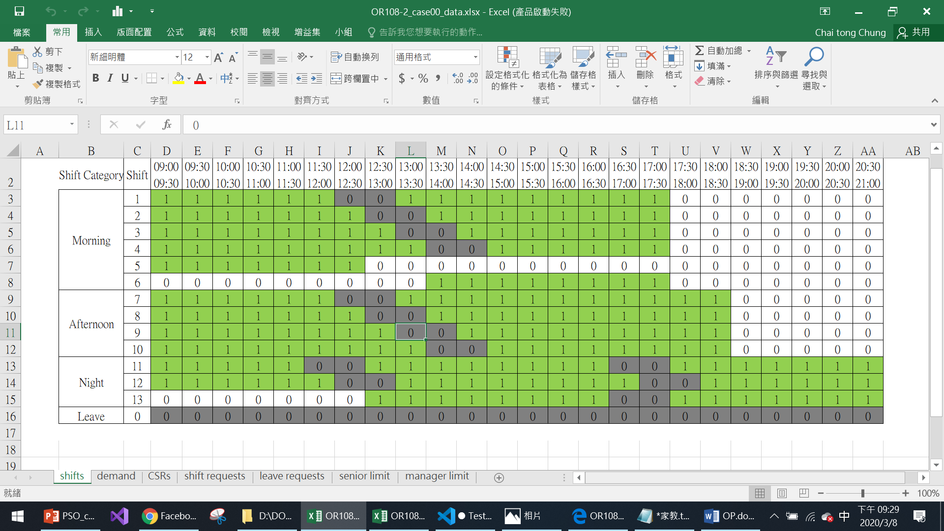

Shift working in every period

Demands estimation

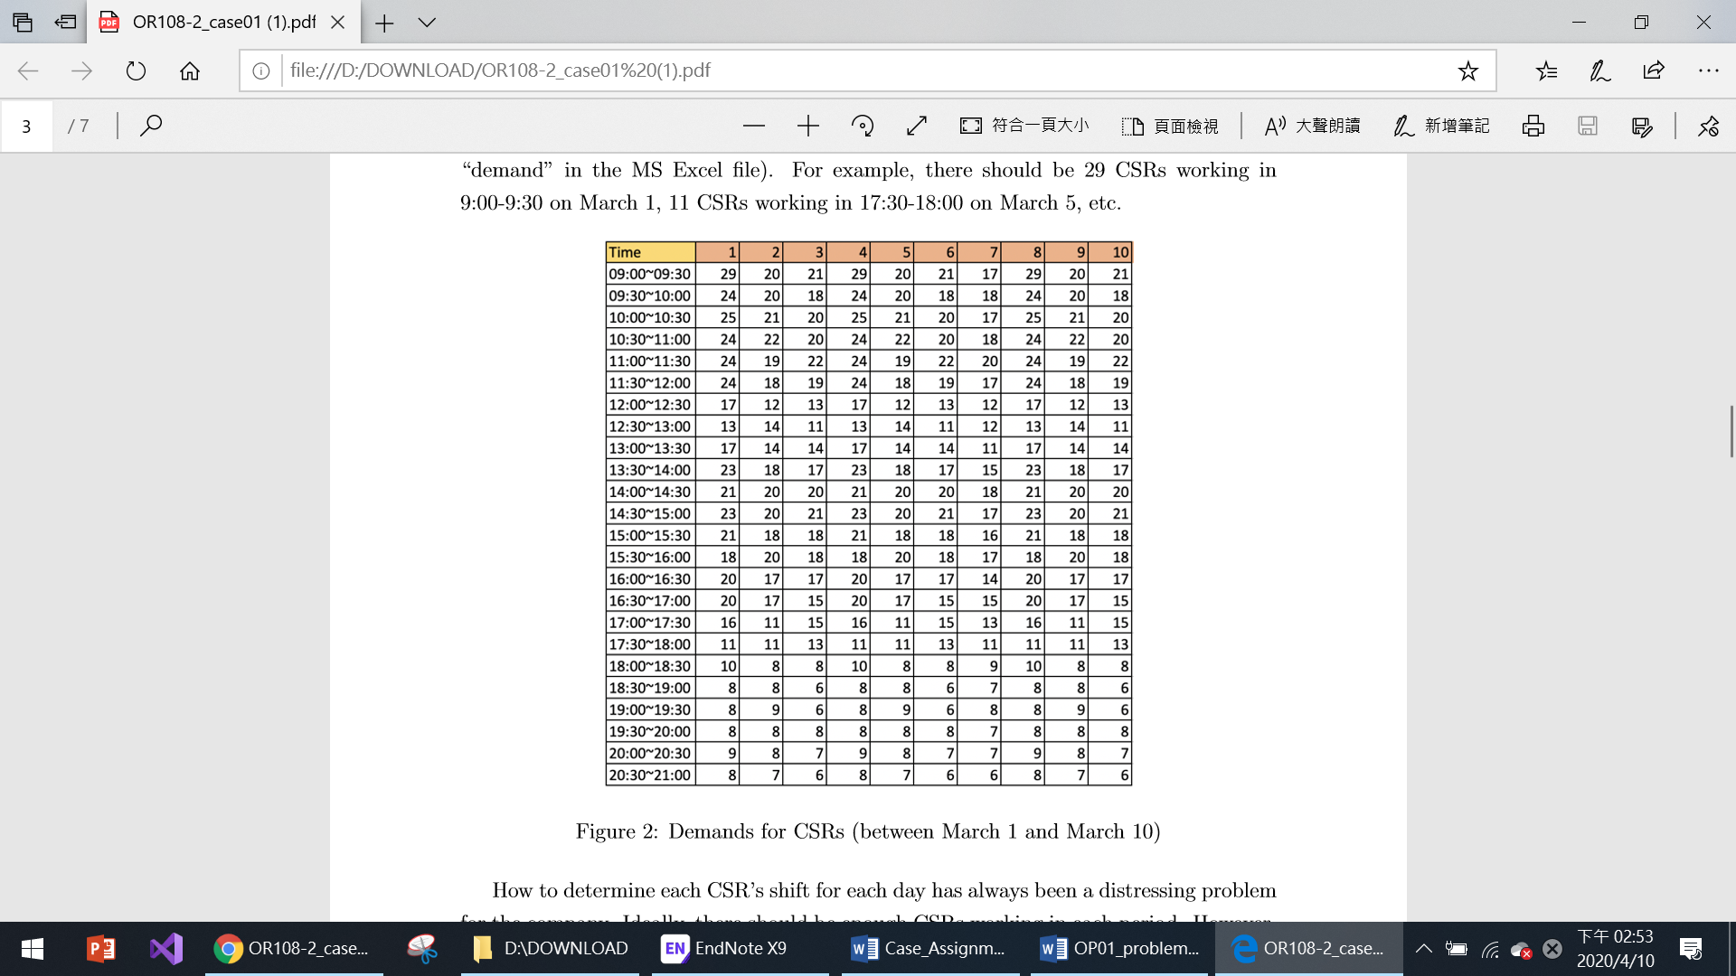

Demand in day 1 to day 7 in the following month

CSRs parameters

Step 2: Define Objective Function

The main idea of this task is to minimize the “Lack” of CSRs’ supply, which “lack” means we care only about the insufficient of supplements instead of over supplements. Therefore, objective function has to detect those “lack” periods that lack numbers’ summation. So that objective function may be designed as follows.

However, we only care the “lack” of supplements, so we only need positive .

To Linearize the problem, we have to add additional constraints.

So the objective function becomes as followed

Step 3: Define CSRs allocation’s constraint

1. Number of shifts summation
2. Everyone should be assign to one shift each day.
3. At least 8 day-off per month
4. At most one night-shift and two afternoon shifts per week.

For night shift

1. At least one day off in seven consecutive days.
2. Leave and shift requests

If CSR i request for shift k in date j

If CSR i request leave in date j1 to j2

1. Manager limits

If date j night shift has manager limit, and require q CSRs who are Assistant Managers or above.

If date j afternoon shift has manager limit, and require q CSRs who are Managers.

1. Senior limits

Assume that we know that date I = 1 ‘s weekday.

We define the following table:

|  |  |  |  |  |  |  |  |
| --- | --- | --- | --- | --- | --- | --- | --- |
| weekday | Mon | Tue | Wed | Thu | Fri | Sat | Sun |
| index | 0 | 1 | 2 | 3 | 4 | 5 | 6 |

If during daytime D in period p1 to p2, there is a senior limit of working experience of y years that is above a ratio of r.

Define L as a huge number

2. (30 points) Submit a (set of) computer program that may solve the integer program you formulated in Problem 1. You may submit an AMPL model ﬁle and an AMPL data ﬁle. Alternatively, you may submit a (set of) Python or C++ programs that invoke gurobi to solve this problem.

1. Please put “solution.py” and “OR108-2_case00_data.xlsx” in the same folder
2. When running the program, please do not open “OR108-2_case00_data.xlsx”.
3. This program takes around 5 sec, after that you can open “OR108-2_case00_data.xlsx”, there you can see three additional data sheet.
4. CSRs test place

It has each CSR’s allocation data in the hole month, and there are summations of day-offs, night, afternoons shifts and the end of each CSR’s line. Also you can see that different shifts have different colors, green is for day-offs, yellow is for morning shifts, red is for afternoon shifts and blue is for night shifts.

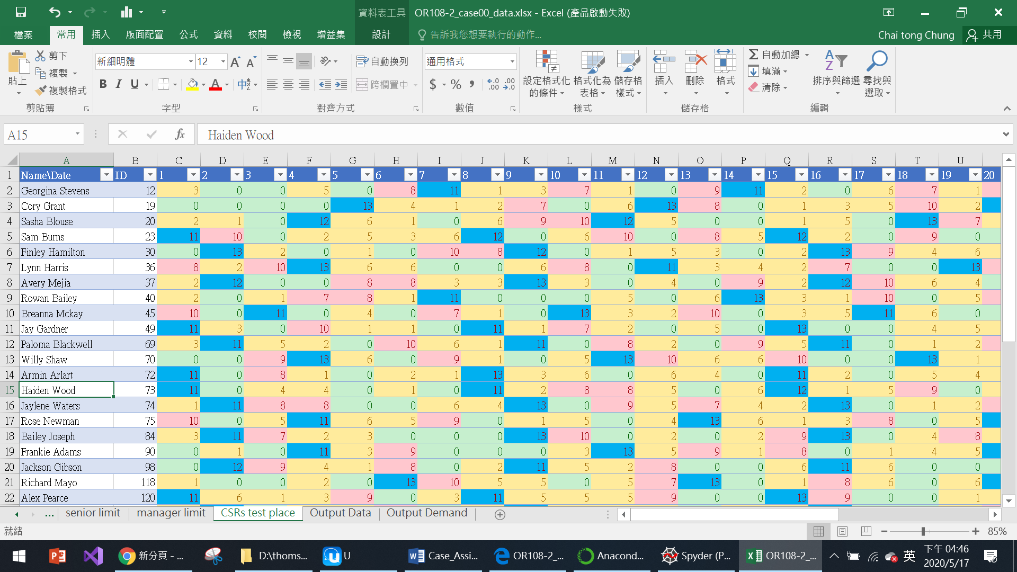

1. Output Data

It’s about the total shifts number in each day.

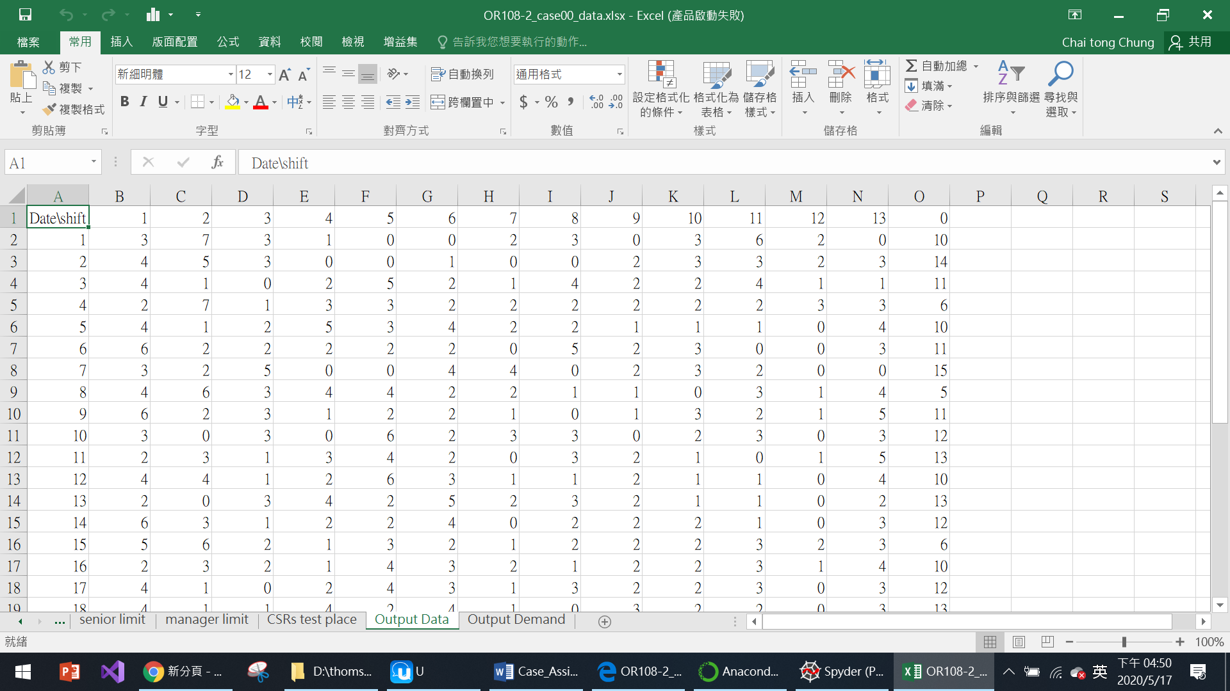

1. Output Demand

It’s about the total demand minus supply in each day, so that positive means the lack of supply, negative means over supply.

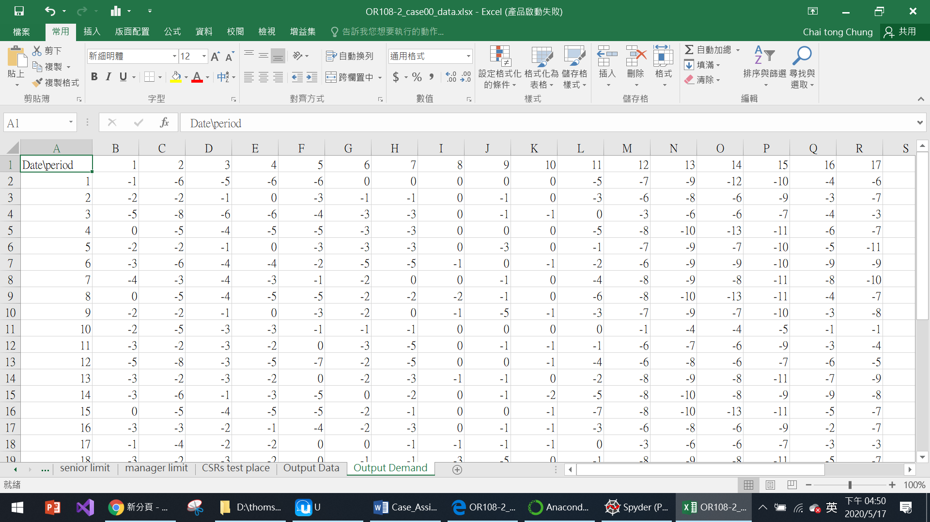

3. (10 points) Please summarize the optimal solution you obtain with your computer programs submitted in Problem 2. You should at least summarize the allocation of CSRs and the total lack amount returned by your computer programs. If you believe that there is other information that will be useful for executive/managers, you want provide them.

4. (20 points) This problem is designed to give you some free points. Please write down your opinions and thoughts for the three case assignments. You may say that you learned a lot, you learned nothing, you think the case assignments help you get a feeling about real-world applications of Operations Research, you think the whole approach is useless, you think it is more interesting than homework, you think it is less interesting than homework, etc. As long as you write down something, regardless of the length and content, you get 20 points