DSD Final Project Scores
1. BrPred
(1) Total execution cycles of given I_mem_BrPred:
截圖:
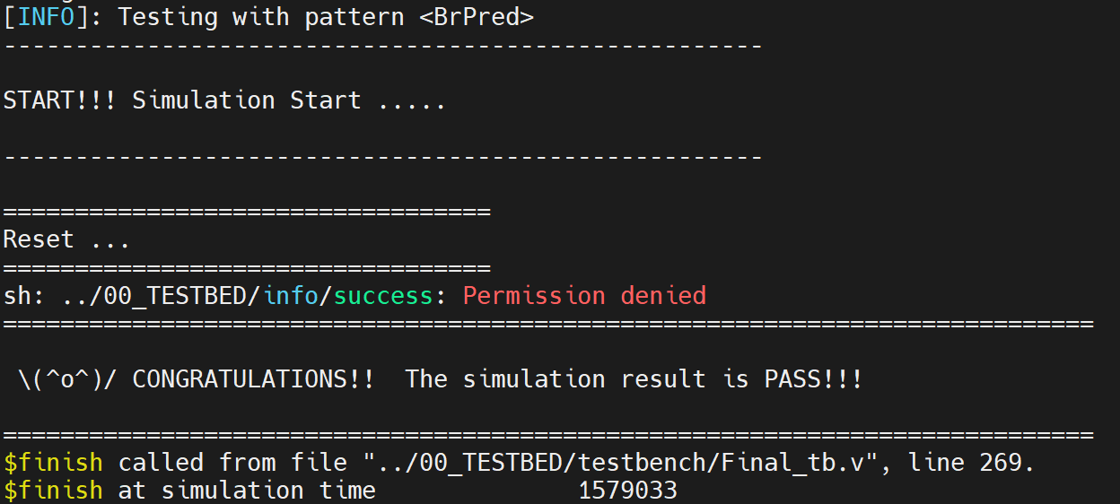
(2) Total execution cycles of given I_mem_hasHazard:
截圖:
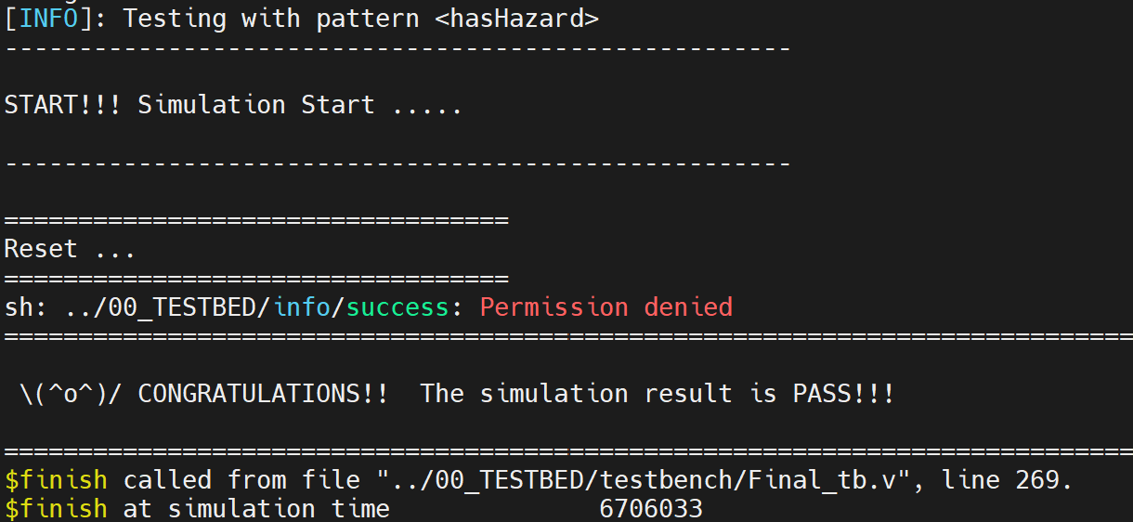
(3) Clock cycle for post-syn simulation (cycle in testbench, not cycle in sdc): (ns)
3ns
2. Compressed instructions
(1) Total Simulation Time of given I_mem_compression: (ns)
截圖:
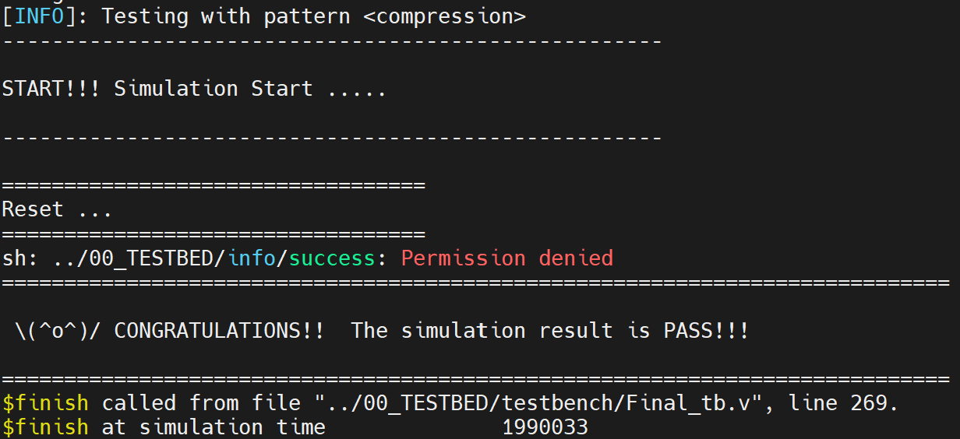
(2) Clock cycle for post-syn simulation (cycle in testbench, not cycle in sdc): (ns)
3ns
3. Multiplication instructions
(1) Total Simulation Time of given Mul/I_mem: (ns)
截圖:
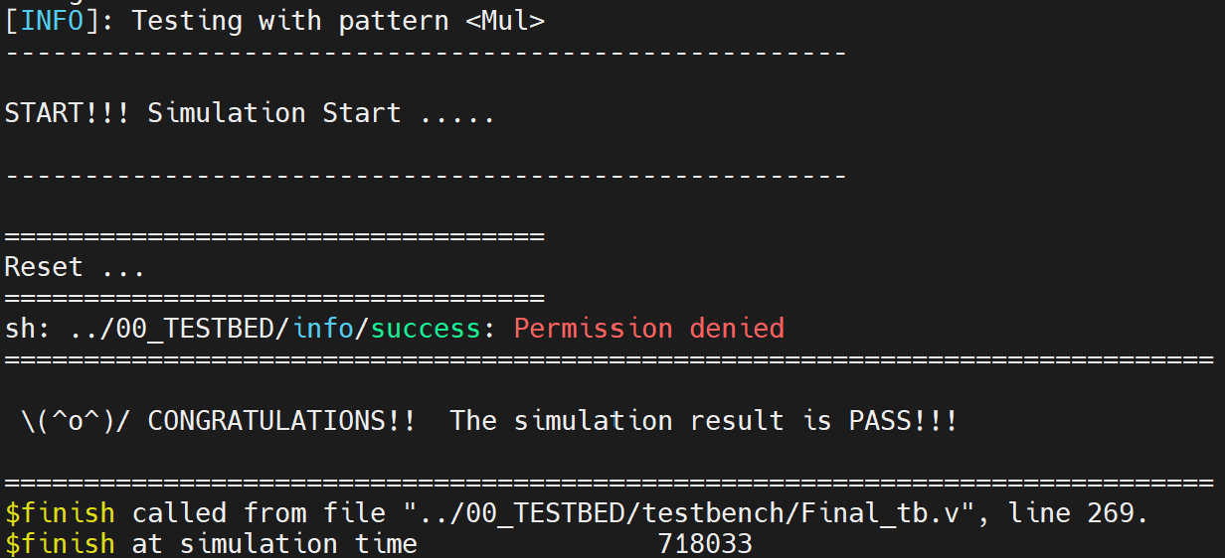
(2) Clock cycle for post-syn simulation (cycle in testbench, not cycle in sdc): (ns)
3ns
4. Q_sort & Conv & LFSR_HIST
(1) Area: (483059um²)
截圖:
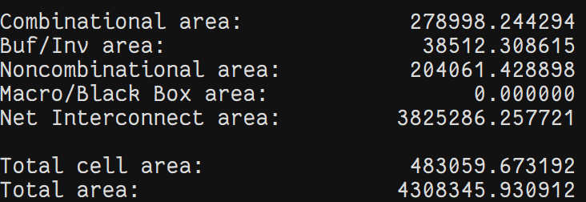
(2) Total Simulation Time of Q_Sort: (316447ns)
(either using compressed or uncompressed instructions)
截圖:
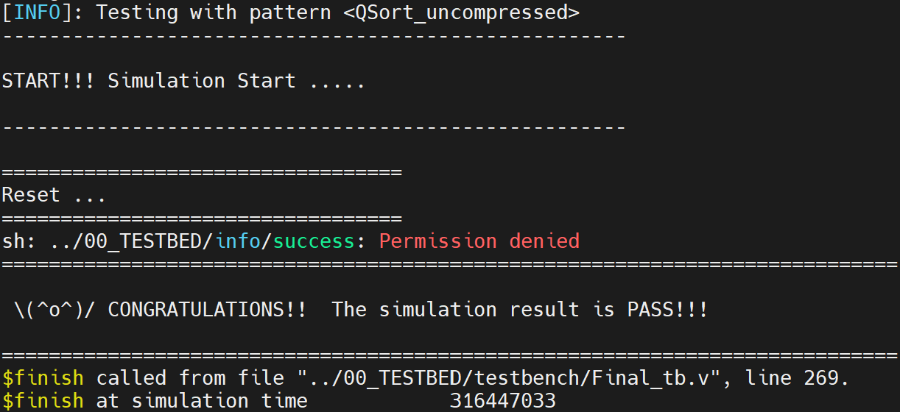
(3) Total Simulation Time of Conv: (58963ns)
(either using compressed or uncompressed instructions)
截圖:
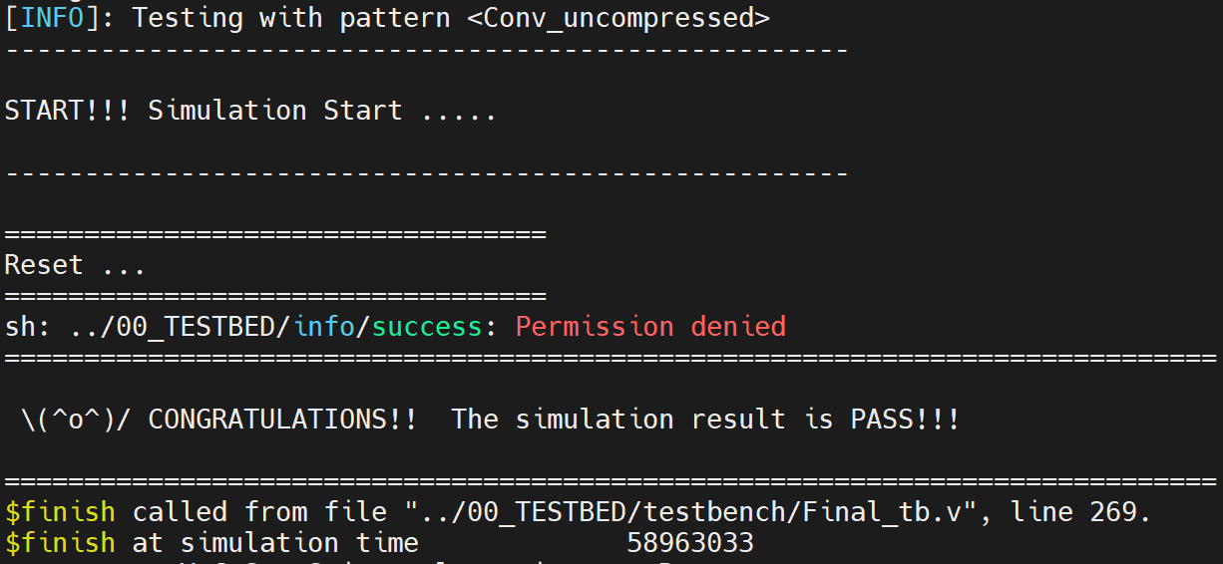
(4) Total Simulation Time of LFSR_HIST: (3250843ns)
截圖:
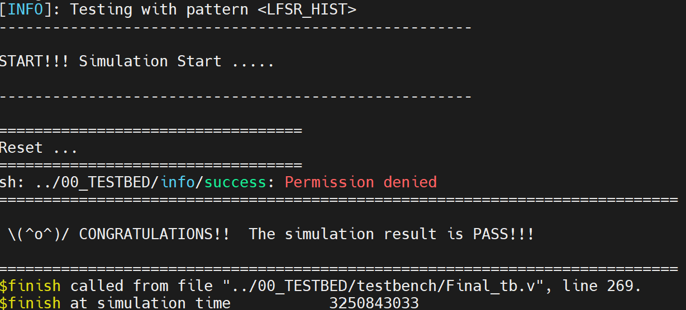

(5) $A×T_{Q_sort}×T_{Conv}×T_{LFSR_HIST}$: (um² * ns³)
2.93 e22

(6) Clock cycle for post-syn simulation (cycle in testbench, not cycle in sdc): (ns)
3ns

