MOBILE SHOP SYSTEM

Table of Contents

1. Use-case Model

2. Use-case Specifications

2.1 Use-case: Add a product to cart

2.2 Use-case: Check out product

2.3 Use-case: Payment-Voucher

2.4 Use-case:Add/Review comment, Rating

3 Architecture Style

4 UML MODEL

# Use-case Model (Mô hình use-case)

## Use Case Diagram

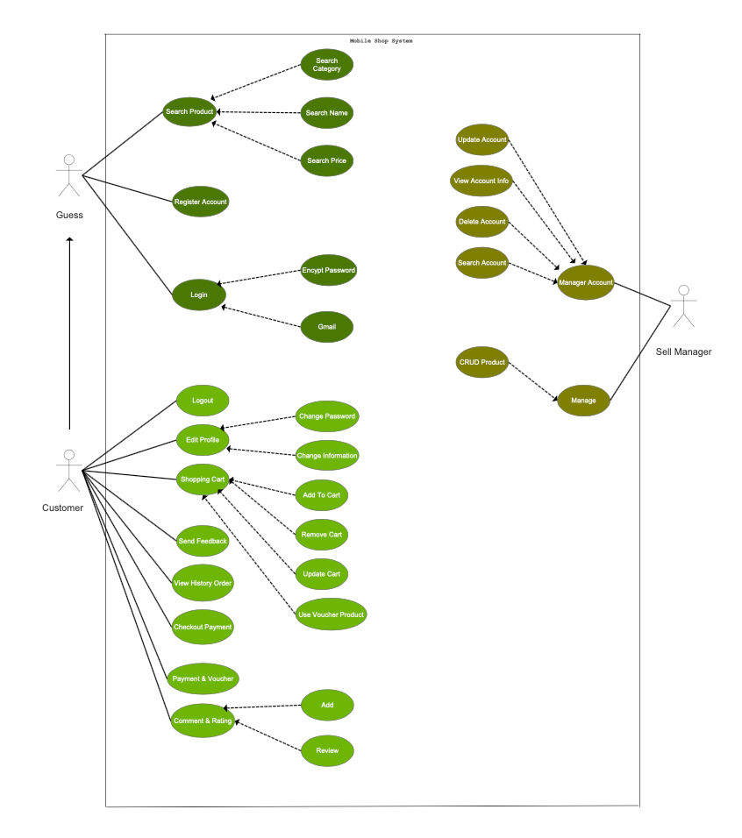

## System Actors

|  |  |  |
| --- | --- | --- |
| **#** | **Actor** | **Description** |
| 1 | Guest | Unauthorized user. |
| 2 | Customer | Use app to view the store’s catalogue. Browse, view and add products to cart. |
| 3 | Admin | User application to manage products and accounts, edit and update products, delete products. |

# Use-case Specifications (Đặc tả use-case)

## Use-case: Add a product to cart

|  |  |
| --- | --- |
| Use case Name  (Tên use-case) | Add a product to cart. |
| Brief description  (Mô tả) | This use case describes how the Customer can buy a product. |
| Actors  (Actors) | Customer |
| Basic Flow  (Luồng cơ bản) | 1. At the homepage, the user enters keywords on the ‘Search’ field 2. Users clicks on ‘Search’ button to start searching a product 3. System displays the products found 4. User clicks ‘Add to cart’ button on the expected product 5. System adds a new product to shopping cart 6. System displays the quantity of all products in the cart to the user |
| Alternative Flows  (Các luồng thay thế) | **Alternative flow 1: User cannot find products searched**   1. From #1 of the basic flow, user enters another term 2. Continue step #2 in the basic flow   **Alternative flow 2: Shopping cart has already had the product**   1. From #5 of the basic flow, system increases the quantity of the product 2. Continue step #6   **Alternative flow 3: …** |
| Pre-conditions  (Điều kiện đầu vào) | User goes to homepage at [www.mobileshop.com.vn](http://www.mobileshop.com.vn) and login user name ,password. |
| Post-conditions  (Điều kiện đầu ra) | The user successfully adds new item to the cart or increases quantity of the existing item in the cart. |

## Use-case: Check out product

|  |  |
| --- | --- |
| Use case Name  (Tên use-case) | Check out product. |
| Brief description  (Mô tả) | A customer can proceed to checkout and select payment for products added to cart. |
| Actors  (Actors) | Customer |
| Basic Flow  (Luồng cơ bản) | 1. At the homepage, the user clicks the Cart button in the top-right corner. 2. System displays all products currently in the user’s cart. 3. User clicks “Proceed to Checkout” button on the cart page. 4. System display a list of products to be checked out along with individual and total cost. |
| Alternative Flows  (Các luồng thay thế) | **Alternative flow 1: Empty cart**   1. From step #1 of the basic flow, the user clicks the Cart button with nothing added to the cart. 2. System displays the “Proceed to Checkout” button as greyed out. |
| Pre-conditions  (Điều kiện đầu vào) | User has already added products to their cart from use-case 2.1. |
| Post-conditions  (Điều kiện đầu ra) | The user successfully checks out and their cart is cleared. |

## Use-case: Payment - voucher

|  |  |
| --- | --- |
| Use case Name  (Tên use-case) | Payment - voucher |
| Brief description  (Mô tả) | How a customer can apply vouchers to their cart and/or proceed to payment. |
| Actors  (Actors) | Customer |
| Basic Flow  (Luồng cơ bản) | 1. At the cart page, user clicks on “Proceed to checkout”. 2. System display a list of products to be checked out along with costs, a field to input voucher codes and multiple payment options, from online (Visa, PayPal, Napas) to offline (cash-on-delivery). 3. User inputs a voucher code for discount. 4. System deducts the discount from the estimated cost and displays accordingly. 5. Users selects an online payment service and clicks “Proceed to Payment”. 6. System sends the user to the associated payment portal. |
| Alternative Flows  (Các luồng thay thế) | **Alternative flow 1: User selects cash-on-delivery payment**   1. From #5 of the basic flow, customer chooses “Cash” as option. 2. System displays a delivery info form and upon completion, displays a confirmation message and sends the customer back to homepage. |
| Pre-conditions  (Điều kiện đầu vào) | User has proceeded to checkout as detailed in use-case 2.2. |
| Post-conditions  (Điều kiện đầu ra) | The user successfully complete payment and the products are added to their purchase history. |

## Use-case: Add review, comment, rating

|  |  |
| --- | --- |
| Use case Name  (Tên use-case) | Add review, comment, rating |
| Brief description  (Mô tả) | How a customer can add their reviews, ratings or comment on a product they purchased. |
| Actors  (Actors) | Customer |
| Basic Flow  (Luồng cơ bản) | 1. At the homepage, the user hover their cursor over their username on the top right corner. 2. System displays a drop-down list with links to account-related pages. 3. User clicks on “Purchase history”. 4. System displays a list of products purchased by the user. 5. User clicks on “Add review” button next to a product name in the list. 6. System displays a form including a Rating field/checkbox and a Comment field. 7. The user inputs accordingly and clicks “Accept”. 8. System sends a confirmation message sends the user back to their purchase history. |
| Alternative Flows  (Các luồng thay thế) | N/A |
| Pre-conditions  (Điều kiện đầu vào) | User has successfully purchased a product before as detailed in use-case 2.2 and 2.3. |
| Post-conditions  (Điều kiện đầu ra) | The relevant product page is updated and display the new user review. |

**ARCHITECTURE STYLE**

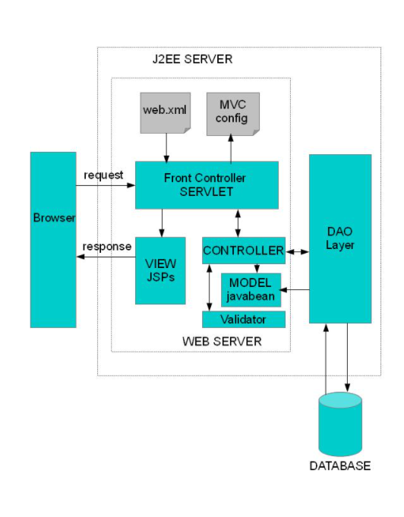

* **Advantage**
* Development of the application becomes fast.
* Easy for multiple developers to collaborate and work together.
* Easier to Update the application.
* Easier to Debug as we have multiple levels properly written in the application.
* **Disadvantage**
* It is hard to understand the MVC architecture.
* Must have strict rules on methods.

# UML MODEL

# Data Structure

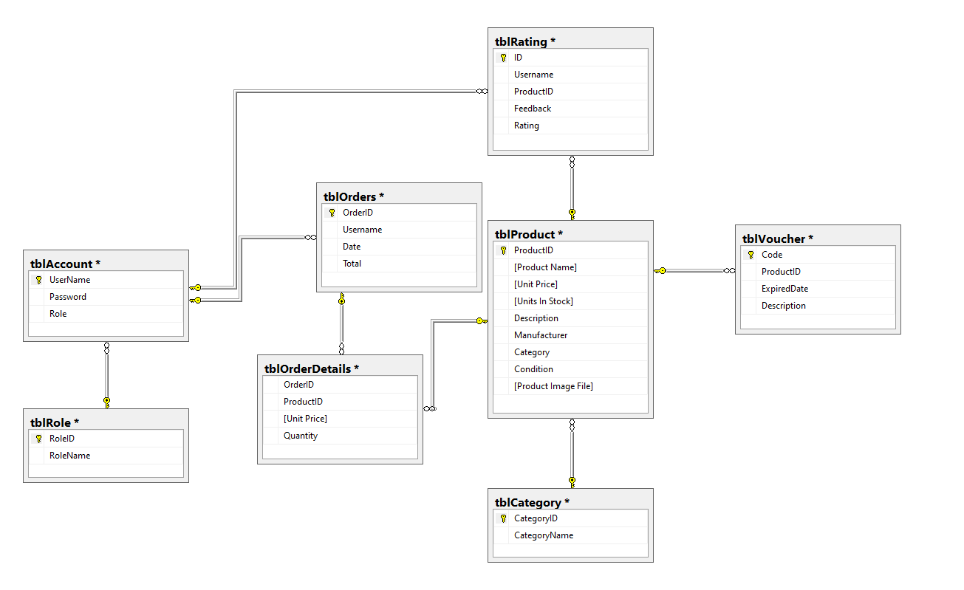

## Class Diagram

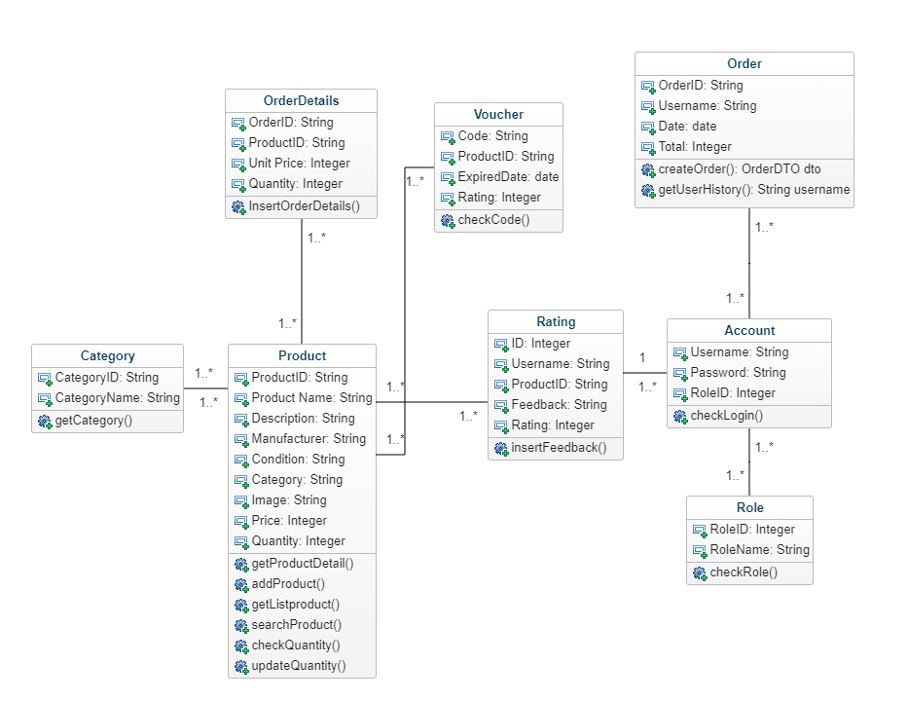

# Sequence Diagram

**AddToCart**

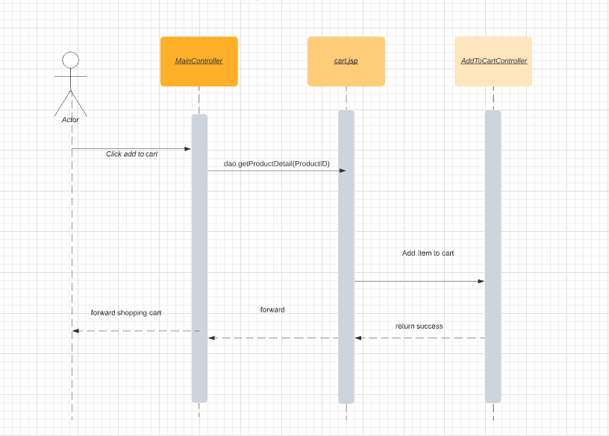

**Check out product**

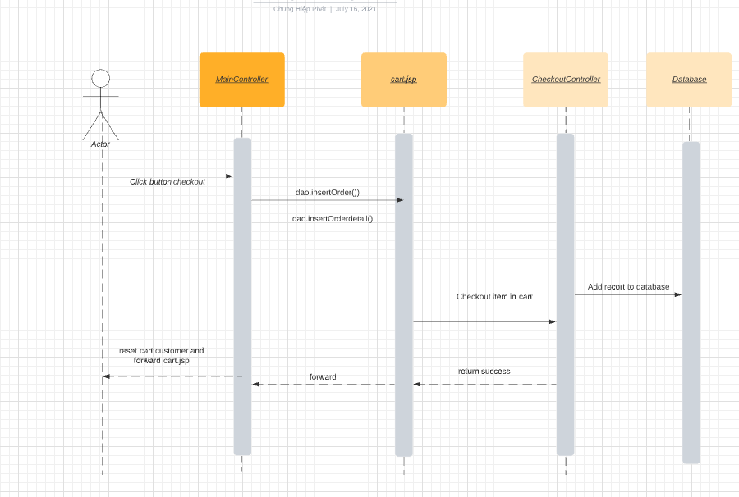

**Payment-Voucher**

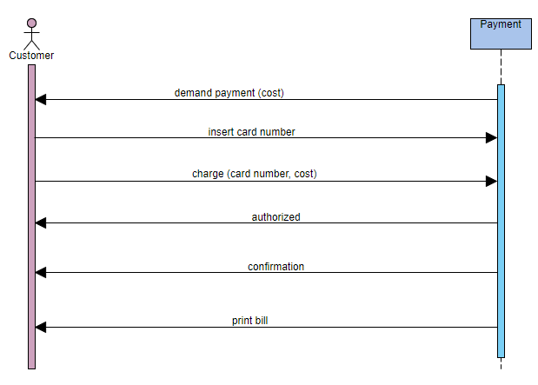

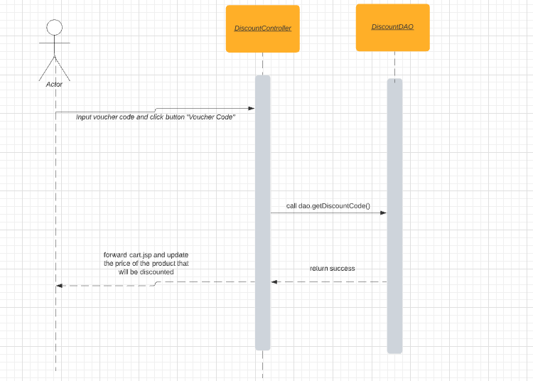

**Feedback(Add/Review, Comment and Rating)**

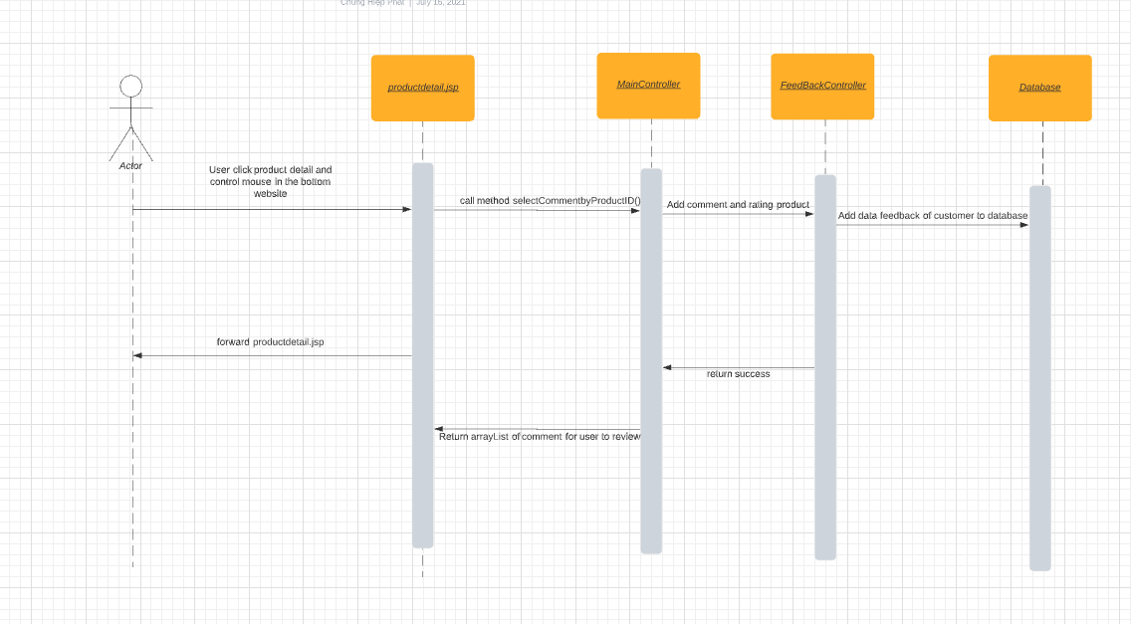

## Conceptual Diagram

