PRODUCT DESCRIPTION

# Product Title

**MOBILE STORE SYSTEM**

# Product Scope

This app help user can shopping mobile online in the website platform , the seller manager will manage all account and product.

# Functional Requirements

As a customer we can :

* Create account for user
* Login to app
* Add to cart
* Remove cart
* Send FeedBack
* Get Voucher Discount
* Search Product
* View Detail Product
* View Order History
* View Suggested Product

As a seller manager we can :

* Login
* Create new product
* View all of user
* Update Product
* Update user information

USE CASE DIAGRAM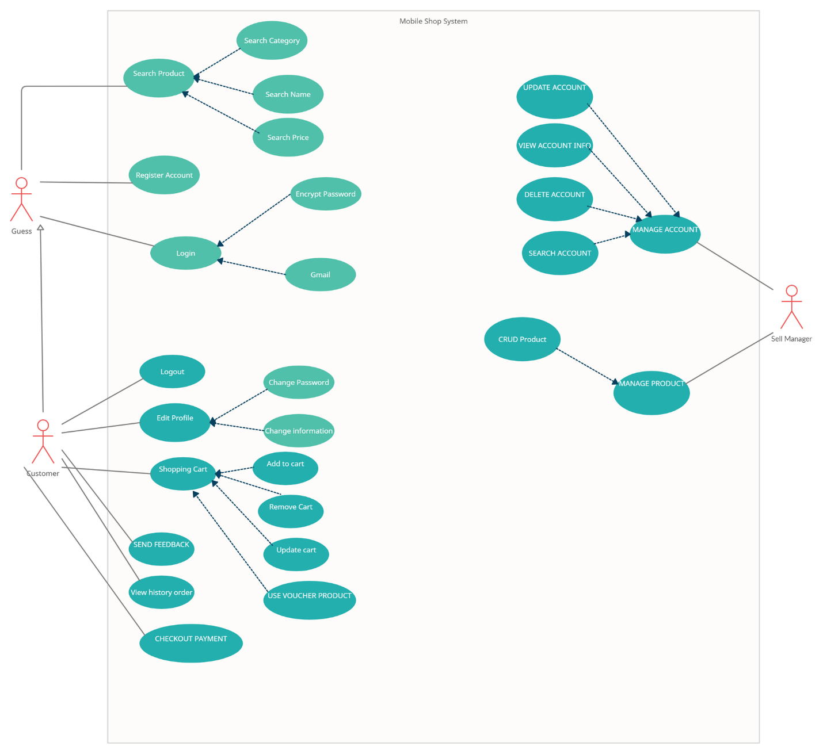

|  |  |  |  |  |  |
| --- | --- | --- | --- | --- | --- |
| Functional Requirement No. | Description | Actor | Who will receive outputs | Input / Output | Condition to start |
| FR 1 | Search product by price, name, category | GUES , CUSTOMER | GUES , CUSTOMER | Input: query string  Output: list of result |  |
| FR 2 | LOGIN WEBSITE | USER, SELLER MANAGER | USER, SELLER MANAGER | Input: User  Put user name and password into text field or login by facebook , google | User is authenticated |
| FR 3 | SHOPPING ONLINE (ADD CART,REMOVE CART, UPDATE CART,USE VOUCHER CODE,CHECKOUT PAYMENT) | CUSTOMER | CUSTOMER | Input: User click add to cart that they want to buy and they can update their cart, if they have voucher code, they can enter it on the textfield and then checkout payment | Customer is authenticated |
| FR 4 | SEND FEEDBACK | CUSTOMER | CUSTOMER | Input: Customer view their order history and they click button send feedback for their product | CUSTOMER is authenticated |
| FR 5 | VIEW HISTORY ORDER | CUSTOMER | CUSTOMER | Customer click button view history and they can see the order history they buyed . | CUSTOMER is authenticated |
| FR 6 | EDIT PROFILE | Customer | Customer | Input: The customer click to their profile and they can edit (phone, address,male, password,name) | CUSTOMER is authenticated |
| FR 7 | LOGOUT | CUSTOMER,SELLER MANAGER | CUSTOMER,SELLER MANAGER | Input: User click to button logout and website will return homepage | Customer, Seller manager is authenticated |
| FR 8 | Add, Update, Delete the account customer | Seller Manager | All actors | Input: seller manager add, update or delete the account and its information  Output: the account and its related information is added, updated or deleted | The seller manager role is required |
| FR 10 | Add, Update, Delete the product | Seller manager | All actors | Input: seller manager add, update or delete the product and its information  Output: the product and its related information is added, updated or deleted | The seller manager role is required |
| FR 11 | Signup | GUEST | GUEST | Input: user click button signup if they don’t have account and form signup will appear. | No account before |

# Non-functional Requirements

*[Describes testable NF requirements]*

## Targeted Platforms

* Web app, working with any modern operating systems.
* Compatible with modern browsers (Edge, Firefox, Chrome…)
* Responsive web front-end scaling to all standard screen sizes.

## Performance

* Instantaneous load times.
* Snappy and responsive interface.

## Security

* Encrypted data transmissions.
* Only users can modify their own account info.

## Availability

* As close to 24/7 availability, 100% uptime as possible.

## Reliability

* Less than 6 hours of downtime per month.

## Localization

* English, with possible Vietnamese support.

## Usability

* Simple, intuitive user interface.
* Sensible navigation.
* Conform to modern web design standards.

# Release Method

*[How product is delivered:*

* *One-shot (waterfall)*
* *Iterations/ incremental*
* *Agile/ Scrum*

*]*