The aim was to generate a workflow that needs minimum manipulation of the DXF files. Nevertheless, some pre-adjustments are indispensable because of the complexity of CAD files and the lack of python libraries that can handle DXF files. Therefore, the workflow starts with the pre-processing of the DXF file, namely:

* Editing the layer names that contain German characters (ä, ö, ü, ß),
* Exploding blocks nested in another block feature,
* Deleting arcs from the door blocks.

Once the pre-processing is completed, layers of interest that keep the wall, door, stairs, and elevator features are extracted using the python library EZDXF. Then, the extracted features are written into a GeoJSON file for the ease of further processing steps.

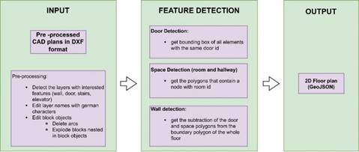

*Figure 1 High-level representation of the automatized workflow to generate 2D floor plans from CAD plans*

The detection of the door, spaces, and wall polygons is respectively applied. In DXF files, a door is often represented as a block feature, a group of features that make a door. Blocks are exploded during the extraction by keeping track of all elements of each door with a door id. Eventually, the bounding box around all elements sharing the same door id is generated and written into a separate GeoJSON file as door polygons of the final floor plan.

The whole extracted plan is polygonised before starting the space (rooms and hallways) detection. Then, two nodes, at around 41 cm (the highest door width value) offset from the centre of the earlier generated door polygons on both sides, are added with a room id. Then a spatial analysis is done to filter the polygons that contain nodes generated on both sides of the doors. These polygons are room and hallway polygons. So far, doors, rooms and hallways have been detected. Next, walls are detected as polygons with a spatial analysis, where the detected feature polygons are subtracted from a boundary polygon of the whole floor. The result is a polygonised 2D floor plan generated from a DXF file (Fig.2).

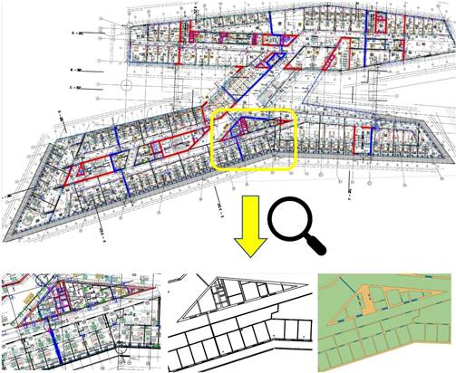

*Figure 2 The 2D floor plan generation from CAD plan. Above is the original CAD plan. Below is the zoomed view, from left to right; pre-processed plan, extracted features, and the final product - 2D floor plan*