Task1

Pre processing with dxf file

Layer name: remove umlaut



Door block

remove arc

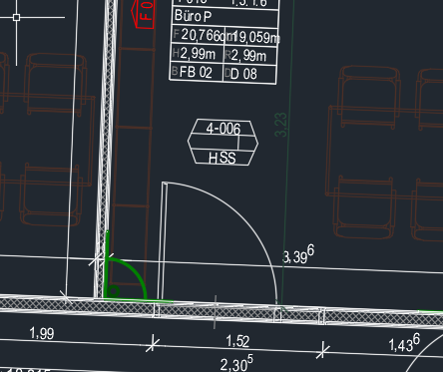 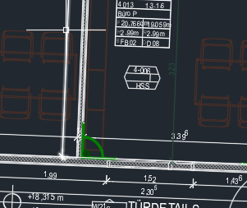

Explode block in block

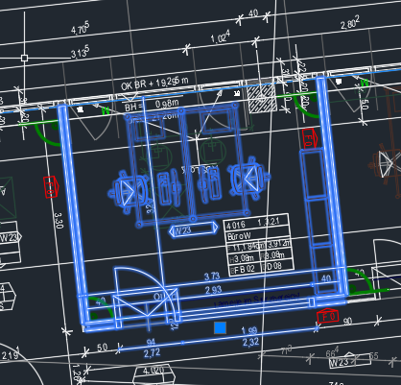

Create wall layers

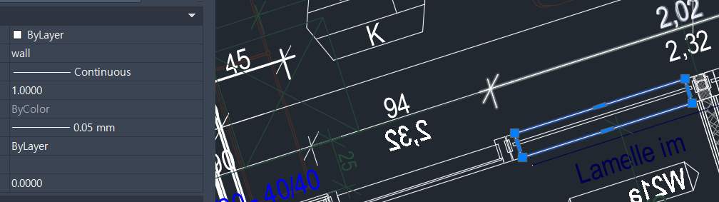

4OG result – room, door, wall

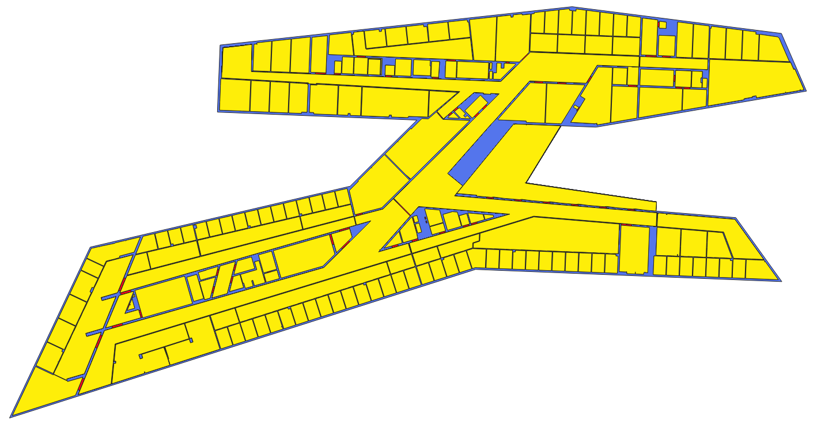

3OG

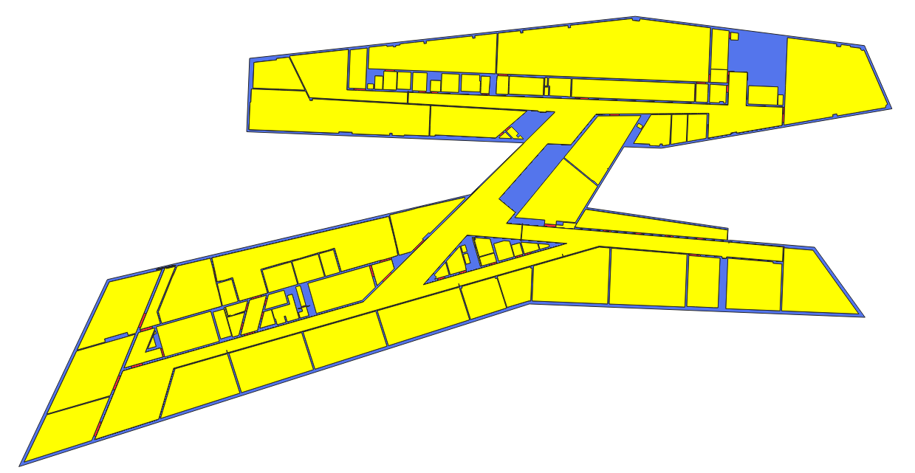

2OG

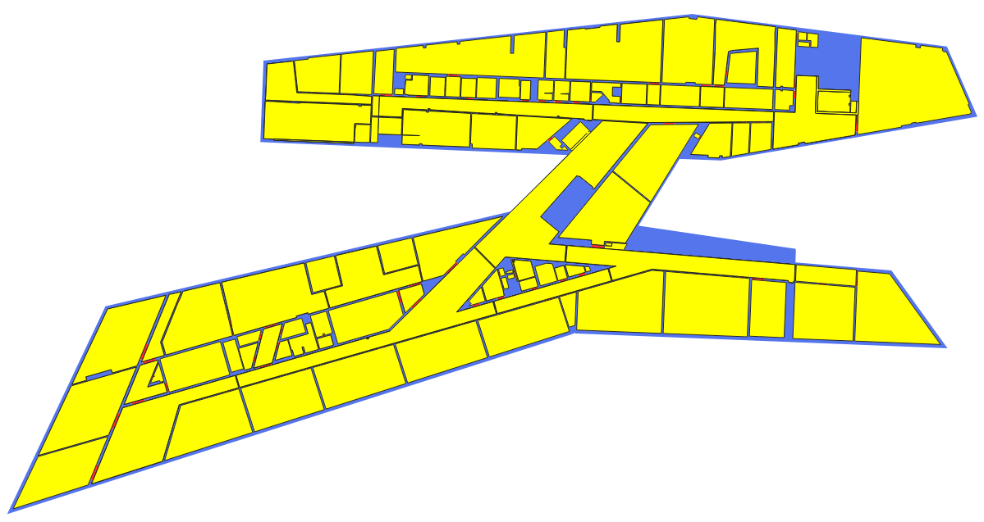

1OG

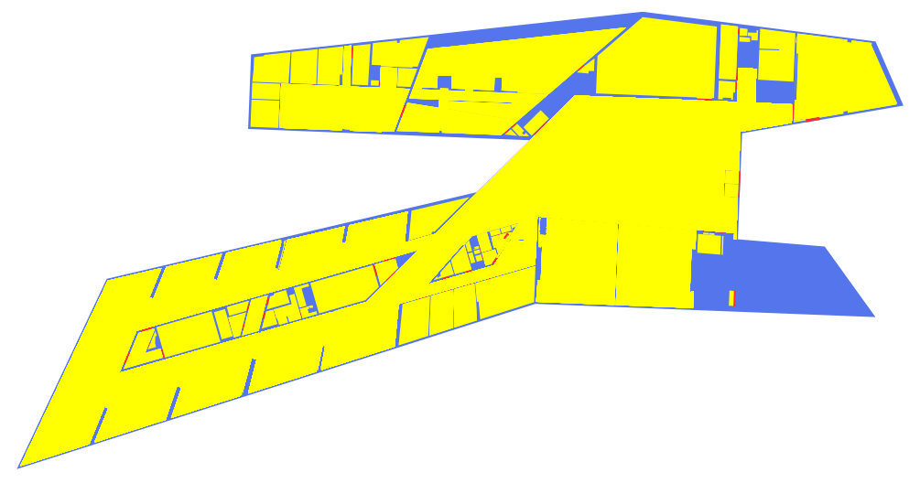

Task2

Main window

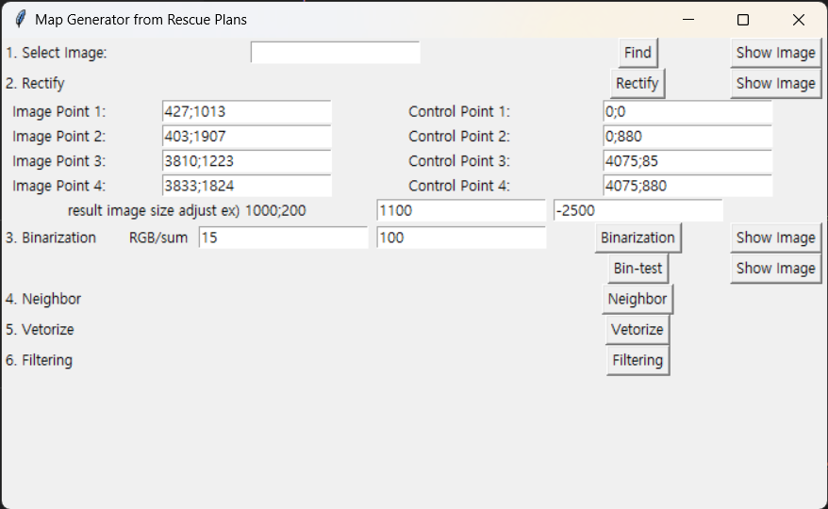

Image window

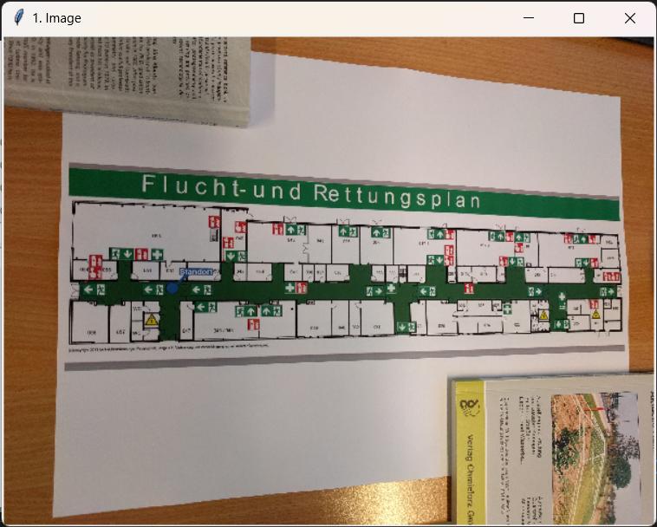

Get coordinate from image window

Rectified image from Rectify window

