Pre processing with dxf file

Layer name: remove umlaut



Door block

remove arc

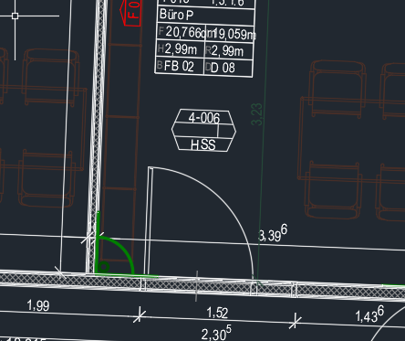 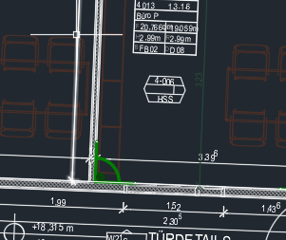

Explode block in block

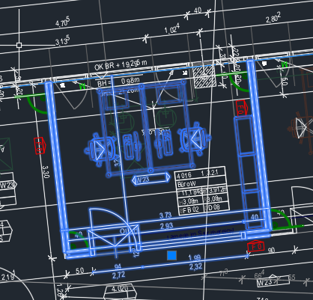

Create wall layers

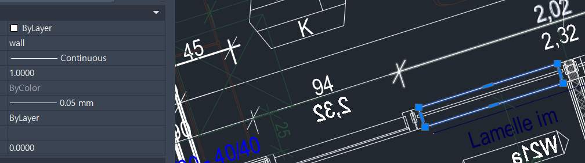

4OG result – room, door, wall

