**Task: Map generation from rescue plan images**

Rescue plans are available in every public building. Therefore these plans are an easy data source that can be used to generate a basic map. The idea is to take pictures of the rescue plans and vectorize these images through an image processing workflow. The basic steps are correcting the projection, removing colors and symbols that are not relevant to our interests, and then detecting lines that depict the floors' geometry.

There is a code available that is written by the previous Hiwi, Karl Leiser. All files from Karl, including a short description of his code, are in the folder.

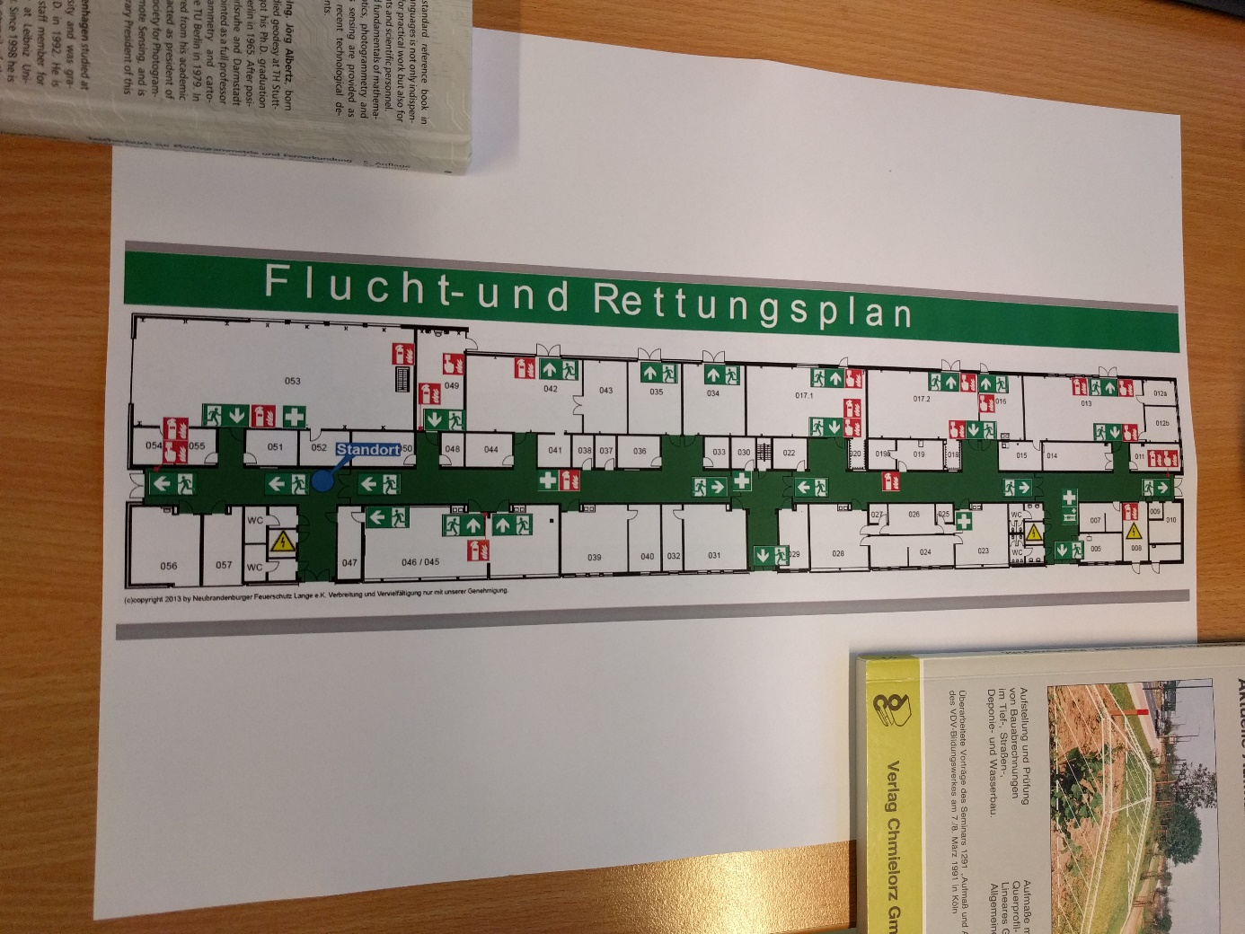

Figure 1 Rescue plan picture

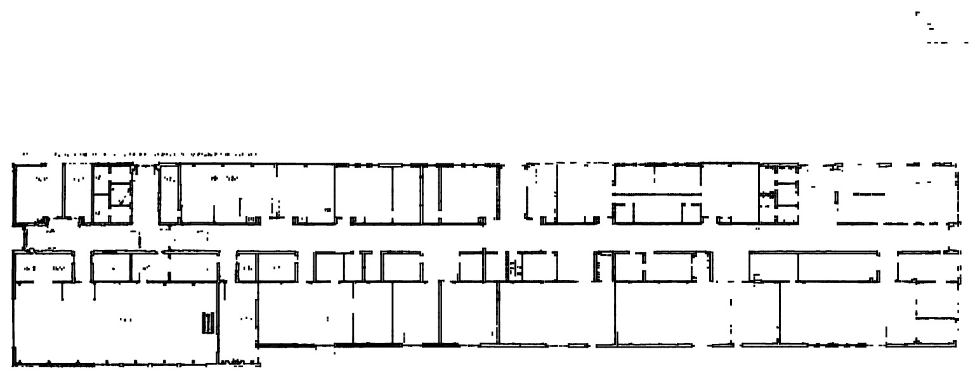

Figure 2 Vectorized floor plan