SUPPLEMENTARY MATERIAL
for
Global meta-analysis shows that immunisation reduces amphibian susceptibility to the chytrid fungus

Meng-Han Joseph Chung¹*, Richard P. Duncan¹, Daniel W. A. Noble², Benjamin C. Scheele³, Simon Clulow¹

- Centre for Conservation Ecology and Genomics, Institute for Applied Ecology, University of Canberra, ACT 2617, Australia
- Division of Ecology and Evolution, Research School of Biology, Australian National University, ACT 2601, Australia
- Fenner School of Environment and Society, Australian National University, ACT 2601, Australia

*Corresponding author: chungmenghan@gmail.com

PART 1 – Supplementary results

Figure S1. PRIMSA flow diagram of the data collection process.

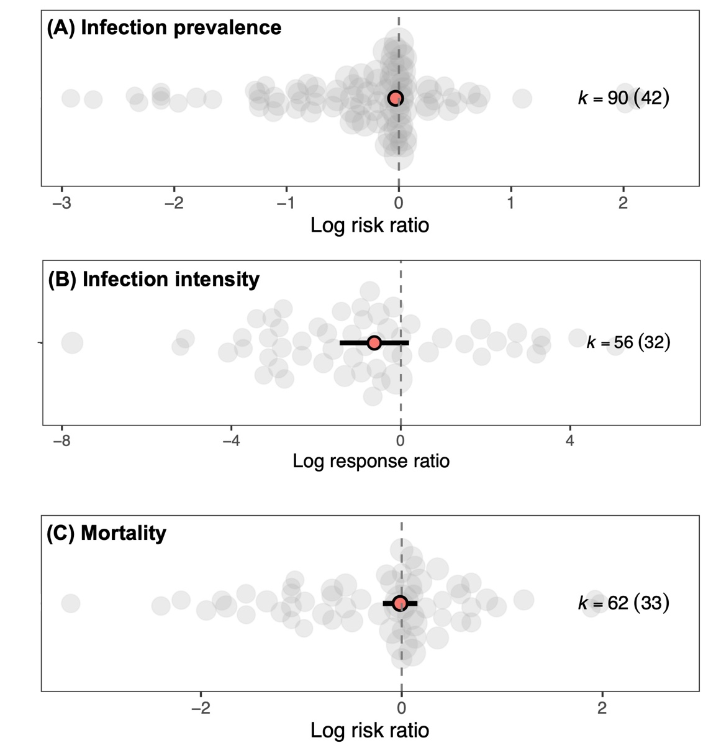
Figure S2. Overall immunisation effects on (a) prevalence, (b) infection intensity and (c) mortality. Red dots and thick lines indicate means and 95% confidence intervals of the estimates, with grey dots showing individual effect sizes. Counts represent the total number of effect sizes, with the number of experiments (in parentheses). Dot sizes indicate the relative precision (1/SE) of each effect size.
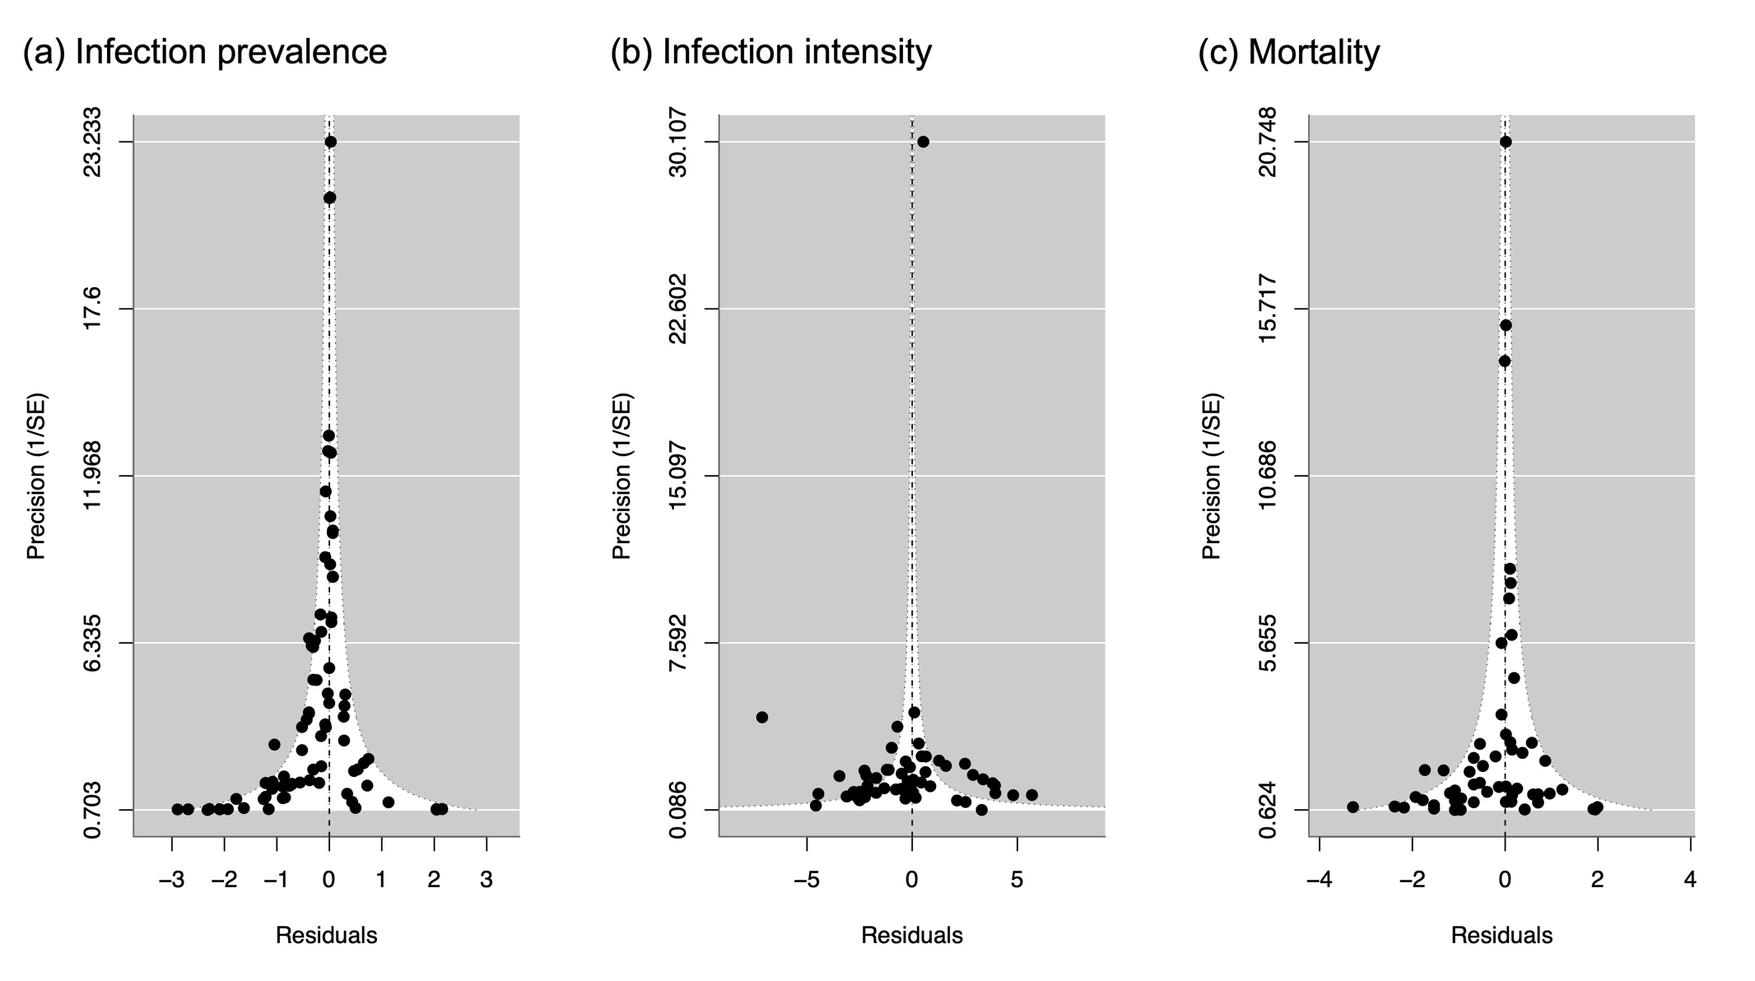
Figure S3. Funnel plots of the meta-analytic residuals and the precision (1/SE) for (a) prevalence, (b) infection intensity and (c) mortality.

Table S1. Moderating effects of immunisation method on treatment effectiveness for each outcome measure. ci.lb = lower confidence limit; ci.ub = upper confidence limit; pi.lb = lower prediction interval limit; pi.ub = upper prediction interval limit. NA = not available. *Note that estimates for categories with k < 5 effect sizes remain exploratory¹.
Trait | Immunisation method | k | Estimate | ci.lb | ci.ub | pi.lb | pi.ub | t | p
(A)  Prevalence | Natural chemical | 29 | -0.312 | -0.518 | -0.106 | -0.522 | -0.102 | -3.02 | 0.003
 | Live pathogen | 23 | -0.031 | -0.080 | 0.017 | -0.097 | 0.034 | -1.28 | 0.21
 | Probiotic | 15 | -0.011 | -0.103 | 0.081 | -0.112 | 0.091 | -0.23 | 0.82
 | Dead pathogen | 10 | -0.021 | -0.121 | 0.079 | -0.130 | 0.088 | -0.42 | 0.68
 | Synthetic antiparasitic | 9 | -0.028 | -0.130 | 0.073 | -0.138 | 0.082 | -0.56 | 0.58
 | Other | 4* | -0.202 | -0.845 | 0.443 | -0.847 | 0.444 | -0.62 | 0.54
(B)  Infection intensity | Natural chemical | 17 | -1.412 | -3.136 | 0.313 | -5.614 | 2.791 | -1.64 | 0.11
 | Live pathogen | 16 | -1.609 | -2.986 | -0.231 | -5.681 | 2.464 | -2.35 | 0.02
 | Probiotic | 3* | -0.727 | -3.067 | 1.612 | -5.218 | 3.763 | -0.62 | 0.54
 | Dead pathogen | 7 | 0.430 | -1.443 | 2.303 | -3.836 | 4.696 | 0.46 | 0.65
 | Synthetic antiparasitic | 9 | 0.808 | -0.795 | 2.410 | -3.346 | 4.962 | 1.01 | 0.32
 | Other | 4* | -0.748 | -3.246 | 1.749 | -5.323 | 3.826 | -0.60 | 0.55
(C)  Mortality | Natural chemical | 15 | 0.208 | -0.225 | 0.640 | -0.382 | 0.797 | 0.96 | 0.34
 | Live pathogen | 19 | -0.296 | -0.598 | 0.005 | -0.798 | 0.205 | -1.97 | 0.054
 | Probiotic | 15 | 0.050 | -0.135 | 0.235 | -0.392 | 0.492 | 0.54 | 0.59
 | Dead pathogen | 8 | 0.003 | -0.358 | 0.365 | -0.537 | 0.543 | 0.02 | 0.99
 | Synthetic antiparasitic | 5 | -0.420 | -0.918 | 0.078 | -1.060 | 0.220 | -1.69 | 0.10
 | Other | 0 | NA | NA | NA | NA | NA | NA | NA

Table S2. Heterogeneity of effect sizes for each outcome measure. I² = the proportion of total variance among effect sizes attributable to true heterogeneity rather than sampling error. CVH² (coefficient of variation for heterogeneity) = heterogeneity relative to the overall mean effect size (a mean-standardised metric). M² (second-order coefficient of variation) = heterogeneity relative to both the overall mean effect and total variance (a variance-mean-standardised metric).

- Prevalence
Stratum | I² (%) | CVH² | M²
Total | 0 | 0 | 0
Phylogeny | 0 | 0 | 0
Between-study | 0 | 0 | 0
Within-study | 0 | 0 | 0

- Infection intensity
Stratum | I² (%) | CVH² | M²
Total | 96 | 10.4 | 0.91
Phylogeny | 0 | 0 | 0
Between-study | 46 | 4.97 | 0.44
Within-study | 50 | 5.40 | 0.47

- Mortality
Stratum | I² (%) | CVH² | M²
Total | 30 | 105.32 | 0.99
Phylogeny | 21 | 74.29 | 0.70
Between-study | 9 | 31.03 | 0.29
Within-study | 0 | 0 | 0

Table S3. Moderating effects of life stage on immunisation effectiveness for each outcome measure. ci.lb = lower confidence limit; ci.ub = upper confidence limit; pi.lb = lower prediction interval limit; pi.ub = upper prediction interval limit. *Note that estimates for categories with k < 5 effect sizes remain exploratory¹.

Trait | Life stage | k | Estimate | ci.lb | ci.ub | pi.lb | pi.ub | t | p
(A)  Prevalence | Larva | 18 | -0.322 | -0.578 | -0.066 | -0.578 | -0.065 | -2.49 | 0.01
 | Juvenile | 51 | -0.029 | -0.067 | 0.009 | -0.067 | 0.009 | -1.52 | 0.13
 | Adult | 21 | -0.019 | -0.069 | 0.031 | -0.069 | -0.031 | -0.74 | 0.46
(B)  Infection intensity | Larva | 12 | -0.945 | -2.611 | 0.721 | -5.367 | 3.477 | -1.14 | 0.26
 | Juvenile | 31 | -0.733 | -1.751 | 0.284 | -4.954 | 3.487 | -1.45 | 0.15
 | Adult | 13 | -0.223 | -1.632 | 1.186 | -4.555 | 4.109 | -0.32 | 0.75
(C)  Mortality | Larva | 1* | 1.830 | -1.333 | 4.992 | -1.358 | 5.017 | 1.16 | 0.25
 | Juvenile | 46 | -0.004 | -0.232 | 0.224 | -0.465 | 0.457 | -0.04 | 0.97
 | Adult | 15 | -0.078 | -0.365 | 0.208 | -0.571 | 0.414 | -0.55 | 0.59

Trait | Life stage | k | Estimate | ci.lb | ci.ub | pi.lb | pi.ub | t | p
(A)  Prevalence | Hylidae | 61 | -0.097 | -0.183 | -0.010 | -0.268 | 0.075 | -2.22 | 0.03
 | Ranidae | 11 | -0.065 | -0.175 | 0.046 | -0.249 | 0.120 | -1.16 | 0.25
 | Bufonidae | 8 | -0.013 | -0.178 | 0.153 | -0.235 | 0.209 | -0.15 | 0.88
 | Alytidae | 4* | -0.010 | -0.308 | 0.287 | -0.342 | 0.322 | -0.07 | 0.95
 | Cryptobranchidae | 4* | 0.038 | -0.174 | 0.249 | -0.220 | 0.296 | 0.36 | 0.72
 | Plethodontidae | 1* | 0.274 | -0.183 | 0.732 | -0.206 | 0.755 | 1.19 | 0.24
 | Sirenidae | 1* | 0.244 | -0.417 | 0.905 | -0.435 | 0.938 | 0.73 | 0.46
 | Ambystomatidae | 0 | NA | NA | NA | NA | NA | NA | NA
 | Pipidae | 0 | NA | NA | NA | NA | NA | NA | NA
(B)  Infection intensity | Hylidae | 32 | -0.825 | -4.645 | 2.996 | -7.738 | 6.089 | -0.43 | 0.67
 | Ranidae | 10 | -1.065 | -5.345 | 3.214 | -8.242 | 6.112 | -0.50 | 0.62
 | Bufonidae | 1* | -0.661 | -6.641 | 5.319 | -8.965 | 7.644 | -0.22 | 0.83
 | Alytidae | 4* | -1.194 | -6.398 | 4.010 | -8.958 | 6.570 | -0.46 | 0.65
 | Cryptobranchidae | 4* | 1.122 | -4.040 | 6.284 | -6.614 | 8.858 | 0.44 | 0.66
 | Plethodontidae | 1* | -0.572 | -6.501 | 5.357 | -8.840 | 7.696 | -0.19 | 0.85
 | Sirenidae | 1* | -0.195 | -6.156 | 5.765 | -8.485 | 8.095 | -0.07 | 0.95
 | Ambystomatidae | 1* | 2.682 | -21.342 | 26.707 | -22.024 | 27.389 | 0.22 | 0.82
 | Pipidae | 2* | -0.775 | -6.429 | 4.880 | -8.848 | 7.298 | -0.28 | 0.78
(C)  Mortality | Hylidae | 38 | -0.054 | -1.092 | 0.984 | -1.598 | 1.490 | -0.10 | 0.92
 | Ranidae | 8 | -0.327 | -1.437 | 0.784 | -1.920 | 1.267 | -0.59 | 0.56
 | Bufonidae | 9 | 0.020 | -1.036 | 1.076 | -1.536 | 1.576 | 0.04 | 0.97
 | Alytidae | 4* | 0.286 | -0.930 | 1.501 | -1.383 | 1.954 | 0.47 | 0.64
 | Cryptobranchidae | 2* | 0.406 | -2.090 | 2.901 | -2.339 | 3.150 | 0.33 | 0.75
 | Plethodontidae | 1* | -0.495 | -2.033 | 1.043 | -2.411 | 1.421 | -0.64 | 0.52
 | Sirenidae | 0 | NA | NA | NA | NA | NA | NA | NA
 | Ambystomatidae | 0 | NA | NA | NA | NA | NA | NA | NA
 | Pipidae | 0 | NA | NA | NA | NA | NA | NA | NA
Table S4. Moderating effects of taxonomic family on immunisation effectiveness for each outcome measure. ci.lb = lower confidence limit; ci.ub = upper confidence limit. pi.lb = lower prediction interval limit; pi.ub = upper prediction interval limit. NA = not available. *Note that estimates for categories with k < 5 effect sizes remain exploratory¹.

Table S5. Moderating effect of inherent susceptibility (i.e., the mortality rate of untreated group) on immunisation effectiveness for each outcome measure. ci.lb = lower confidence limit; ci.ub = upper confidence limit.
- Prevalence
Parameter | Estimate | ci.lb | ci.ub | t₈₂ | p
intercept | -0.057 | -0.113 | -0.001 | -2.01 | 0.047
Baseline mortality rate | 0.0006 | -0.0004 | 0.0016 | 1.24 | 0.22

- Infection intensity
Parameter | Estimate | ci.lb | ci.ub | t₄₇ | p
intercept | -0.289 | -1.408 | 0.831 | -0.52 | 0.61
Baseline mortality rate | -0.012 | -0.042 | 0.017 | -0.84 | 0.41

- Mortality
Parameter | Estimate | ci.lb | ci.ub | t₆₀ | p
intercept | 0.281 | -0.515 | 1.077 | 0.71 | 0.48
Baseline mortality rate | -0.006 | -0.012 | -0.0001 | -2.04 | 0.046

Trait | Origin | k | Estimate | ci.lb | ci.ub | pi.lb | pi.ub | t | p
(A)  Prevalence | Wild-bred | 55 | -0.018 | -0.058 | 0.021 | -0.058 | 0.021 | -0.92 | 0.36
 | Captive-bred | 17 | -0.035 | -0.082 | 0.012 | -0.082 | 0.012 | -1.47 | 0.15
(B)  Infection intensity | Wild-bred | 17 | -0.368 | -2.101 | 1.365 | -5.631 | 4.895 | -0.43 | 0.67
 | Captive-bred | 13 | -1.081 | -3.065 | 0.903 | -6.432 | 4.270 | -1.12 | 0.27
(C)  Mortality | Wild-bred | 43 | -0.021 | -0.314 | 0.272 | -0.547 | 0.506 | -0.14 | 0.89
 | Captive-bred | 18 | -0.041 | -0.340 | 0.258 | -0.571 | 0.489 | -0.28 | 0.78
Table S6. Moderating effects of host origin on immunisation effectiveness for each outcome measure. ci.lb = lower confidence limit; ci.ub = upper confidence limit. pi.lb = lower prediction interval limit; pi.ub = upper prediction interval limit. Effect estimates of host origin were considered adults and juveniles only for (A) prevalence and (C) mortality; and considered juveniles only for (B) infection intensity.

Table S7. Moderating effect on each outcome measure of the following procedural variables (mean-centred): (i) immunisation-to-challenge interval = number of days between immunisation and Bd infection challenge. (ii) challenge-to-measurement interval = number of days between Bd infection challenge and outcome measurement. (iii) measurement effort = total number of trait measurements. Mortality rate was extracted only once at the end of experiment, so the effect of the number of measurements (always n = 1) was not tested. ci.lb = lower confidence limit; ci.ub = upper confidence limit.
- Prevalence
Parameter | Estimate | ci.lb | ci.ub | t₈₆ | p
intercept | -0.048 | -0.089 | -0.007 | -2.31 | 0.02
Immunisation-to-challenge interval | 0.000 | 0.000 | 0.000 | -0.02 | 0.99
Challenge-to-measurement interval | 0.001 | -0.003 | 0.003 | 0.04 | 0.97
Measurement effort | 0.003 | -0.001 | 0.007 | 1.45 | 0.15

- Infection intensity
Parameter | Estimate | ci.lb | ci.ub | t₅₁ | p
intercept | -0.621 | -1.441 | 0.199 | -1.52 | 0.13
Immunisation-to-challenge interval | 0.001 | -0.005 | 0.005 | 0.19 | 0.85
Challenge-to-measurement interval | 0.026 | -0.048 | 0.100 | 0.70 | 0.49
Measurement effort | -0.028 | -0.213 | 0.157 | -0.30 | 0.77

- Mortality
Parameter | Estimate | ci.lb | ci.ub | t₅₈ | p
intercept | -0.030 | -0.201 | 0.141 | -0.35 | 0.73
Immunisation-to-challenge interval | -0.002 | -0.006 | 0.002 | -1.24 | 0.22
Challenge-to-measurement interval | -0.001 | -0.004 | 0.003 | -0.35 | 0.73

Table S8. Outputs of models testing for publication bias. The small-study effect was estimated by the square root of the inverse of effective sample size; and the time-lag bias was tested using the mean-centred publication year².

- Prevalence
Parameter | Estimate | ci.lb | ci.ub | t₈₇ | p
intercept | -0.122 | -0.268 | 0.025 | -1.65 | 0.10
[1/(Effect sample size)]^1/2 | 0.246 | -0.139 | 0.632 | 1.27 | 0.21
Publication year | 0.002 | -0.008 | 0.013 | 0.47 | 0.64

- Infection intensity
Parameter | Estimate | ci.lb | ci.ub | t₅₃ | p
intercept | 0.271 | -2.279 | 2.822 | 0.21 | 0.83
[1/(Effect sample size)]^1/2 | -1.875 | -6.551 | 2.801 | -0.80 | 0.42
Publication year | -0.158 | -0.369 | 0.054 | -1.50 | 0.14

- Mortality
Parameter | Estimate | ci.lb | ci.ub | t₅₉ | p
intercept | -0.114 | -0.577 | 0.350 | -0.49 | 0.63
[1/(Effect sample size)]^1/2 | 0.213 | -0.890 | 1.316 | 0.39 | 0.70
Publication year | -0.007 | -0.035 | 0.020 | -0.51 | 0.61

Table S9. Sensitivity analysis for infection intensity by including experiments that calculated pathogen load using uninfected individuals (i.e., no Bd load; k = 15). These experiments confounded effects on infection intensity with those on prevalence, and were excluded in the main analysis. The sensitivity analysis tested whether the potential confounding effects alter the main conclusion. The table presents effect size estimates and category comparisons within each moderator. Estimates for host origin were based on juvenile datasets only. ci.lb = lower confidence limit; ci.ub = upper confidence limit; pi.lb = lower prediction interval limit; pi.ub = upper prediction interval limit. NA = not available. *Note that estimates for categories with k < 5 effect sizes remain exploratory¹.

Moderator | Category | k | Estimate | ci.lb | ci.ub | pi.lb | pi.ub | t | p
Overall effect |  | 71 | -0.735 | -1.441 | -0.029 | -4.500 | 3.031 | -2.08 | 0.04
Immunisation method | Natural chemical | 17 | -1.604 | -3.227 | 0.020 | -5.542 | 2.335 | -1.97 | 0.053
 | Live pathogen | 24 | -1.190 | -2.314 | -0.066 | -4.951 | 2.571 | -2.11 | 0.04
 | Probiotic | 7 | -0.908 | -2.602 | 0.786 | -4.876 | 3.060 | -1.07 | 0.29
 | Dead pathogen | 10 | -0.550 | -1.984 | 0.885 | -4.414 | 3.315 | -0.77 | 0.45
 | Synthetic antiparasitic | 9 | 0.832 | -0.658 | 2.322 | -3.054 | 4.718 | 1.12 | 0.27
 | Other | 4* | -0.716 | -3.073 | 1.640 | -5.010 | 3.577 | -0.61 | 0.55
Host life stage | Larva | 12 | -1.017 | -2.560 | 0.526 | -5.068 | 3.033 | -1.32 | 0.19
 | Juvenile | 43 | -0.855 | -1.724 | 0.014 | -4.699 | 2.990 | -1.96 | 0.054
 | Adult | 16 | -0.345 | -1.572 | 0.882 | -4.285 | 3.596 | -0.56 | 0.58
Host family | Hylidae | 45 | -1.038 | -4.200 | 2.124 | -6.961 | 4.884 | -0.66 | 0.51
 | Ranidae | 10 | -1.078 | -4.692 | 2.536 | -7.254 | 5.097 | -0.60 | 0.55
 | Bufonidae | 3* | -0.847 | -4.841 | 3.147 | -7.253 | 5.558 | -0.42 | 0.67
 | Alytidae | 4* | -1.201 | -5.711 | 3.310 | -7.940 | 5.539 | -0.53 | 0.60
 | Cryptobranchidae | 4* | 1.115 | -3.349 | 5.578 | -5.593 | 7.823 | 0.50 | 0.62
 | Plethodontidae | 1* | -0.572 | -5.769 | 4.625 | -7.789 | 6.645 | -0.22 | 0.83
 | Sirenidae | 1* | -0.195 | -5.427 | 5.037 | -7.438 | 7.047 | -0.07 | 0.94
 | Ambystomatidae | 1* | 2.682 | -21.028 | 26.393 | -21.551 | 26.916 | 0.23 | 0.82
 | Pipidae | 2* | -0.674 | -5.597 | 4.250 | -7.697 | 6.35 | -0.27 | 0.79
Host origin | Wild-bred | 28 | -0.516 | -1.935 | 0.903 | -5.105 | 4.074 | -0.73 | 0.47
 | Captive-bred | 14 | -1.189 | -2.842 | 0.464 | -5.856 | 3.478 | -1.45 | 0.15
Table S10. Sensitivity analysis for infection intensity excluding experiments using back-transformed values (k = 18). The table presents effect size estimates and category comparisons within each moderator. Estimates for host origin were based on juvenile datasets only. ci.lb = lower confidence limit; ci.ub = upper confidence limit. pi.lb = lower prediction interval limit; pi.ub = upper prediction interval limit. *Note that estimates for categories with k < 5 effect sizes should be interpreted with caution and considered exploratory¹.
Moderator | Category | k | Estimate | ci.lb | ci.ub | pi.lb | pi.ub | t | p
Overall effect |  | 50 | -0.500 | -1.409 | 0.409 | -4.774 | 3.773 | -1.106 | 0.274
Immunisation method | Natural chemical | 16 | -1.166 | -3.113 | 0.781 | -5.635 | 3.303 | -1.21 | 0.23
 | Live pathogen | 14 | -1.575 | -3.168 | 0.017 | -5.902 | 2.752 | -1.99 | 0.052
 | Probiotic | 3* | -0.727 | -3.172 | 1.718 | -5.435 | 3.981 | -0.60 | 0.55
 | Dead pathogen | 7 | 0.460 | -1.508 | 2.427 | -4.019 | 4.938 | 0.47 | 0.64
 | Synthetic antiparasitic | 7 | 0.936 | -0.923 | 2.795 | -3.496 | 5.368 | 1.01 | 0.32
 | Other | 3* | -0.478 | -3.149 | 2.192 | -5.307 | 4.351 | -0.36 | 0.72
Host life stage | Larva | 11 | -0.632 | -2.471 | 1.207 | -5.293 | 4.028 | -0.69 | 0.49
 | Juvenile | 26 | -0.641 | -1.798 | 0.516 | -5.076 | 3.795 | -1.11 | 0.27
 | Adult | 13 | -0.198 | -1.669 | 1.273 | -4.726 | 4.330 | -0.27 | 0.79
Host family | Hylidae | 27 | -0.704 | -4.247 | 2.838 | -7.427 | 6.019 | -0.40 | 0.69
 | Ranidae | 10 | -1.013 | -4.962 | 2.937 | -7.959 | 5.933 | -0.52 | 0.61
 | Bufonidae | 1* | -0.661 | -6.596 | 5.275 | -8.899 | 7.578 | -0.22 | 0.82
 | Alytidae | 4* | -1.193 | -6.319 | 3.933 | -8.870 | 6.483 | -0.47 | 0.64
 | Cryptobranchidae | 4* | 1.123 | -3.961 | 6.206 | -6.525 | 8.771 | 0.45 | 0.66
 | Plethodontidae | 1* | -0.572 | -6.456 | 5.312 | -8.774 | 7.630 | -0.20 | 0.85
 | Sirenidae | 1* | -0.195 | -6.111 | 5.721 | -8.420 | 8.030 | -0.07 | 0.95
 | Ambystomatidae | 1* | 2.682 | -21.419 | 26.784 | -22.087 | 27.452 | 0.22 | 0.82
 | Pipidae | 1* | -0.093 | -5.808 | 5.621 | -8.174 | 7.988 | -0.03 | 0.97
Host origin | Wild-bred | 17 | -0.346 | -2.245 | 1.552 | -6.057 | 5.364 | -0.38 | 0.71
 | Captive-bred | 8 | -1.042 | -3.826 | 1.741 | -7.105 | 5.020 | -0.77 | 0.45

PART 2 - Supplementary methods

Gold-standard papers

- Adams, A. J., Bushell, J., & Grasso, R. L. (2022). To treat or not to treat? Experimental pathogen exposure, treatment, and release of a threatened amphibian. Ecosphere, 13(12), e4294.
- Barnett, K. M., Detmering, S. E., McMahon, T. A., & Civitello, D. J. (2021). Asymmetric cross-strain protection for amphibians exposed to a fungal-metabolite prophylactic treatment. Biology Letters, 17(8), 20210207.
- Barnett, K. M., Hilgendorff, B. A., Civitello, D. J., & McMahon, T. A. (2023). Fungal metabolites provide pre-exposure protection but no postexposure benefit or harm against Batrachochytrium dendrobatidis. The Journal of Wildlife Diseases, 59(2), 217-223.
- Cashins, S. D., Grogan, L. F., McFadden, M., Hunter, D., Harlow, P. S., Berger, L. et al (2013). Prior infection does not improve survival against the amphibian disease chytridiomycosis. PLoS One, 8(2), e56747.
- McMahon, T. A., Garcia, A. M., Malinias, A. J., Monsalve, M., Muldro, L. C., Sisson, E. O. et al (2024). Efficacy of Bd metabolite prophylaxis dose and duration on host defence against the deadly chytrid fungus Batrachochytrium dendrobatidis. Journal of Applied Ecology, 61(12), 3139-3147.
- McMahon, T. A., Sears, B. F., Venesky, M. D., Bessler, S. M., Brown, J. M., Deutsch, K. et al (2014). Amphibians acquire resistance to live and dead fungus overcoming fungal immunosuppression. Nature, 511(7508), 224-227.
- Nordheim, C. L., Detmering, S. E., Civitello, D. J., Johnson, P. T., Rohr, J. R., & McMahon, T. A. (2022). Metabolites from the fungal pathogen Batrachochytrium dendrobatidis (bd) reduce Bd load in Cuban treefrog tadpoles. Journal of Applied Ecology, 59(9), 2398-2403.
- Stice, M. J., & Briggs, C. J. (2010). Immunization is ineffective at preventing infection and mortality due to the amphibian chytrid fungus Batrachochytrium dendrobatidis. Journal of Wildlife Diseases, 46(1), 70-77.
- Waddle, A. W., Clulow, S., Aquilina, A., Sauer, E. L., Kaiser, S. W., Miller, C. et al (2024). Hotspot shelters stimulate frog resistance to chytridiomycosis. Nature, 631(8020), 344-349.
- Waddle, A. W., Rivera, R., Rice, H., Keenan, E. C., Rezaei, G., Levy, J. E., et al (2021). Amphibian resistance to chytridiomycosis increases following low‐virulence chytrid fungal infection or drug‐mediated clearance. Journal of Applied Ecology, 58(10), 2053-2064.
Search strings

Total number of hits: 1608 (WOS = 627, Scopus = 529, ProQuest = 298, ScienceDirect = 154)

WEB OF SCIENCE

Number of hits: 627

Document type: Article, Proceeding Paper, Early Access, Letter

Research Area: Environmental Sciences Ecology, Microbiology, Veterinary Sciences, Zoology, Science Technology Other Topics, Biodiversity Conservation, Fisheries, Biochemistry Molecular Biology, Evolutionary Biology, Immunology, Marine Freshwater Microbiology, Biotechnology Applied Microbiology, Life Science Biomedicine Other Topics, Infectious Diseases, Mycology, Physiology, Toxicology, Cell Biology, Virology, Parasitology, Public Environmental Occupational Health, Water Resources, Pharmacology Pharmacy. Genetics Heredity, Endocrinology Metabolism, Agriculture, Cell Biology, Dermatology,

TS = ("chytrid*"OR "Batrachochytrium dendrobatidis") AND TS = ("amphibia*" OR "frog*" OR "toad*" OR "salamand*" OR "tadpole*" OR "metamorph" OR "metamorphs" OR "hellbender") AND TS = (("Immuni?ation" OR "immune priming" OR "prophylactic" OR "prophylaxis" OR "immunoprophyla*" OR "chemoprophyla*" OR "vaccin*" OR "antifungal*" OR "anti-Bd" OR "fungicide" OR "fungicides" OR "itraconazole" OR "terbinafine" OR "chloramphenicol" OR "metabolite" OR "metabolites" OR "therapy" OR "therapies" OR "risk reduction" OR "disinfect*" OR "reinfect*" OR "re-expos*" ) OR (("salt" OR "salin*" OR "metal*" OR "copper" OR "Cu" OR "Zinc" Or "Zn" OR "heat" OR "warm*" OR "temperature*" OR "thermal" OR "temperatures" OR "pr?biotic" OR "pr?biotics" OR "antimicrobial" OR "microbial" OR "peptide" OR "peptides") AND ("clear*" OR "inhibit*" OR "suppress*" OR "kill*" OR "prevent*" OR "protect*" OR "improve*" OR "resist*")))
SCOPUS

Number of hits: 529

Document type: Article, Note, Conference Paper, Letter, Short Survey

Subject area: Agricultural and Biological Sciences, Environmental Science, Biochemistry, Genetics and Molecular Biology, Immunology and Microbiology, Medicine, Multidisciplinary, Veterinary, Pharmacology, Toxicology and Pharmaceutics, Neuroscience, Earth and Planetary Sciences, Decision Sciences, Neuroscience

TITLE-ABS-KEY ("chytrid*" OR "Batrachochytrium dendrobatidis") AND TITLE-ABS-KEY("amphibia*" OR "frog*" OR "toad*" OR "salamand*" OR "tadpole*" OR "metamorph" OR "metamorphs" OR "hellbender") AND TITLE-ABS-KEY (("Immuni?ation" OR "immune priming" OR "prophylactic" OR "prophylaxis" OR "immunoprophyla*" OR "chemoprophyla*" OR "vaccin*" OR "antifungal*" OR "anti-Bd" OR "fungicide" OR "fungicides" OR "itraconazole" OR "terbinafine" OR "chloramphenicol" OR "metabolite" OR "metabolites" OR "therapy" OR "therapies" OR "risk reduction" OR "disinfect*" OR "reinfect*" OR "re-infect*" OR "re-expos*" OR "reexpos*") OR (("salt" OR "salin*" OR "metal*" OR "copper" OR "Cu" OR "Zinc" Or "Zn" OR "heat" OR "warm*" OR "thermal" OR "temperature*" OR "temperatures" OR "pr?biotic" OR "pr?biotics" OR "antimicrobial" OR "microbial" OR "piptide" OR "piptides") AND ("clear*" OR "inhibit*" OR "suppress*" OR "kill*" OR "prevent*" OR "protect*" OR "improve*" OR "resist*"))) AND (LIMIT-TO ( SUBJAREA,"AGRI" ) OR LIMIT-TO ( SUBJAREA,"ENVI" ) OR LIMIT-TO ( SUBJAREA,"BIOC" ) OR LIMIT-TO ( SUBJAREA,"IMMU" ) OR LIMIT-TO ( SUBJAREA,"MEDI" ) OR LIMIT-TO ( SUBJAREA,"MULT" ) OR LIMIT-TO ( SUBJAREA,"VETE" ) OR LIMIT-TO ( SUBJAREA,"NEUR" ) OR LIMIT-TO ( SUBJAREA,"PHAR" ) OR LIMIT-TO ( SUBJAREA,"EART" ) OR LIMIT-TO ( SUBJAREA,"DECI" ) ) AND ( LIMIT-TO ( DOCTYPE,"ar" ) OR LIMIT-TO ( DOCTYPE,"no" ) OR LIMIT-TO ( DOCTYPE,"cp" ) OR LIMIT-TO ( DOCTYPE,"le" ) OR LIMIT-TO ( DOCTYPE,"sh" ) )

ProQuest

Number of hits: 298

Source type: Conference Papers & Proceedings, Dissertations & Theses, Evidence-Based Medical Resources, Reports, Scholarly Journals, Working Papers

Document type: Annual Report, Article, Case Study, Commentary, Conference, Conference paper, Conference proceeding, Country report, Dissertation/Thesis, Essay, Industry report, Report, Research topic, Technical report, Working/Pre-print

noft("chytrid*" OR "Batrachochytrium dendrobatidis") AND noft("amphibia*" OR "frog*" OR "toad*" OR "salamand*" OR "tadpole*" OR "metamorph" OR "metamorphs" OR "hellbender") AND noft(("Immuni?ation" OR "immune priming" OR "prophylactic" OR "prophylaxis" OR "immunoprophyla*" OR "chemoprophyla*" OR "vaccin*" OR "antifungal*" OR "anti-Bd" OR "fungicide" OR "fungicides" OR "itraconazole" OR "terbinafine" OR "chloramphenicol" OR "metabolite" OR "metabolites" OR "therapy" OR "therapies" OR "risk reduction" OR "disinfect*" OR "reinfect*" OR "re-infect*" OR "re-expos*" OR "reexpos*") OR (("salt" OR "salin*" OR "metal*" OR "copper" OR "Cu" OR "Zinc" OR "Zn" OR "heat" OR "warm*" OR "thermal" OR "temperature*" OR "temperatures" OR "pr?biotic" OR "pr?biotics" OR "antimicrobial" OR "microbial" OR "peptide" OR "peptides") AND ("clear*" OR "inhibit*" OR "suppress*" OR "kill*" OR "prevent*" OR "protect*" OR "improve*" OR "resist*")))

ScienceDirect

Number of hits: 154

Article type: Research article, Case report, Correspondence, Data articles, Short communications

Subject area: Agricultural and Biological Sciences, Immunology and Microbiology, Biochemistry, Genetics and Molecular Biology, Environmental Science, Veterinary Science and Veterinary Medicine, Earth and Planetary Sciences, Medicine and Dentistry, Neuroscience, Energy

("chytrid" OR "Batrachochytrium dendrobatidis") AND ("amphibian" OR "frog" OR "toad" OR "salamander" OR "tadpole" OR "metamorph" OR "hellbender")

NOTE:
- The search string was used in the section “Title, abstract or author-specified keywords”.
- ScienceDirect only allows 8 boolean connectors.

Forward and backward searches from reviews

Total number of hits: 1930 (WOS = 951, Scopus = 979)

- Berger, L., Skerratt, L. F., Kosch, T. A., Brannelly, L. A., Webb, R. J., & Waddle, A. W. (2024). Advances in managing chytridiomycosis for Australian frogs: Gradarius Firmus Victoria. Annual Review of Animal Biosciences, 12(1), 113-133.
Forward: WOS = 126, Scopus = 124
Backward: WOS = 5, Scopus = 4

- Grogan, L. F., Robert, J., Berger, L., Skerratt, L. F., Scheele, B. C., Castley, J. G. et al (2018). Review of the amphibian immune response to chytridiomycosis, and future directions. Frontiers in immunology, 9, 2536.
Forward: WOS = 187, Scopus = 188
Backward: WOS = 112, Scopus = 113

- Turner, A., Wassens, S., Heard, G., & Peters, A. (2021). Temperature as a driver of the pathogenicity and virulence of amphibian chytrid fungus Batrachochytrium dendrobatidis: A systematic review. The Journal of Wildlife Diseases, 57(3), 477-494.
Forward: WOS = 107, Scopus = 108
Backward: WOS = 20, Scopus = 21

- Woodhams, D. C., Bosch, J., Briggs, C. J., Cashins, S., Davis, L. R., Lauer, A. et al (2011). Mitigating amphibian disease: strategies to maintain wild populations and control chytridiomycosis. Frontiers in Zoology, 8, 1-24.
Forward: WOS = 199, Scopus = 212
Backward: WOS = 195, Scopus = 209

References
1 O'Dea, R. E. et al. Preferred reporting items for systematic reviews and meta-analyses in ecology and evolutionary biology: a PRISMA extension. Biol Rev 96, 1695–1722 (2021). https://doi.org/10.1111/brv.12721
2 Nakagawa, S. et al. Methods for testing publication bias in ecological and evolutionary meta-analyses. Methods Ecol Evol 13, 4–21 (2022).
3 Nakagawa, S. et al. A robust and readily implementable method for the meta-analysis of response ratios with and without missing standard deviations. Ecol Lett 26, 232–244 (2023). https://doi.org/10.1111/ele.14144

