**Appendices**

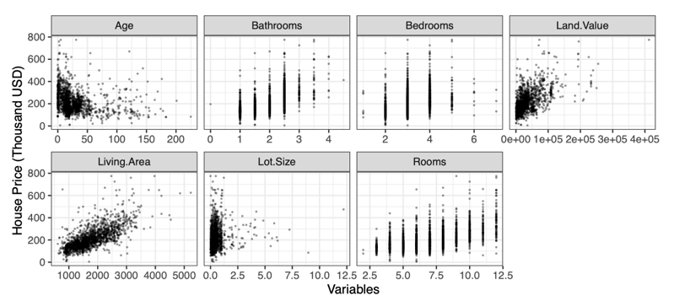

**Figure A1. Scatterplots of Numerical Variables**

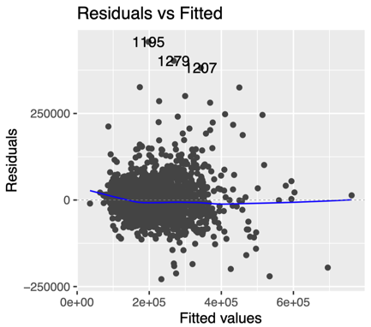

**Figure A3. Backward Assumptions Check 1**

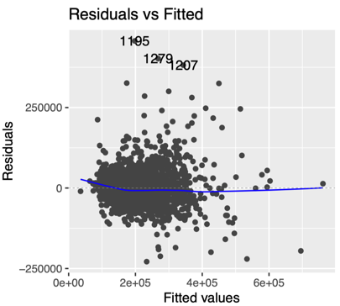

**Figure A5. Forward Assumptions Check 1**

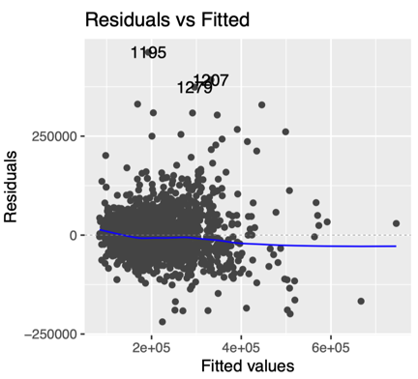

**Figure A7. Stable Assumptions Check 1**

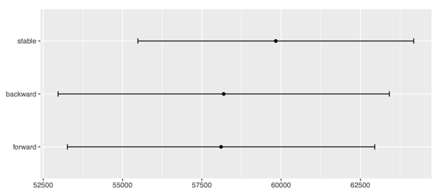

**Figure A9. RMSE**

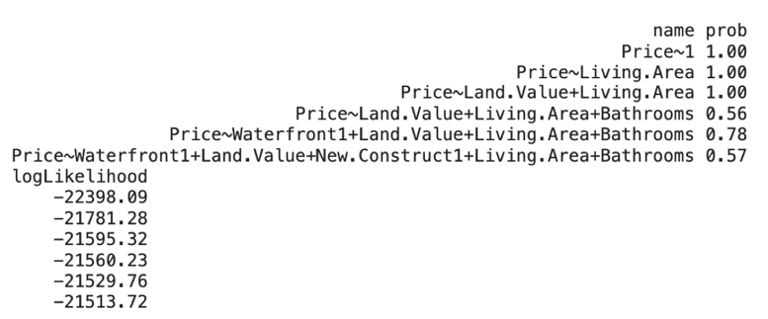

**Figure A2. Model Stability Table**

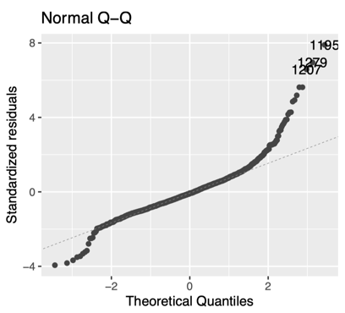

**Figure A4. Backward Assumptions Check 2**

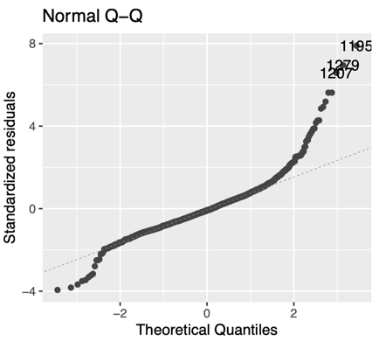

**Figure A6. Forward Assumptions Check 2**

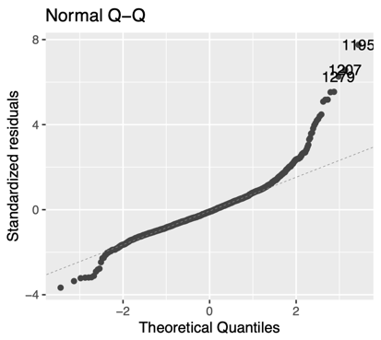

**Figure A8. Stable Assumptions Check 2**

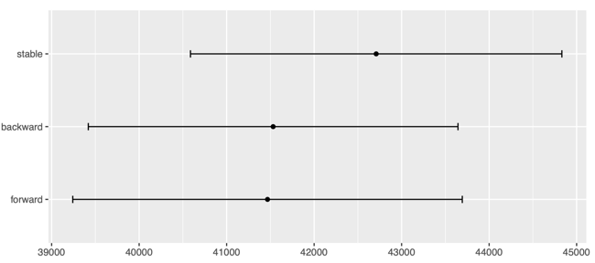

**Figure A10. MAE**