Visual studio code
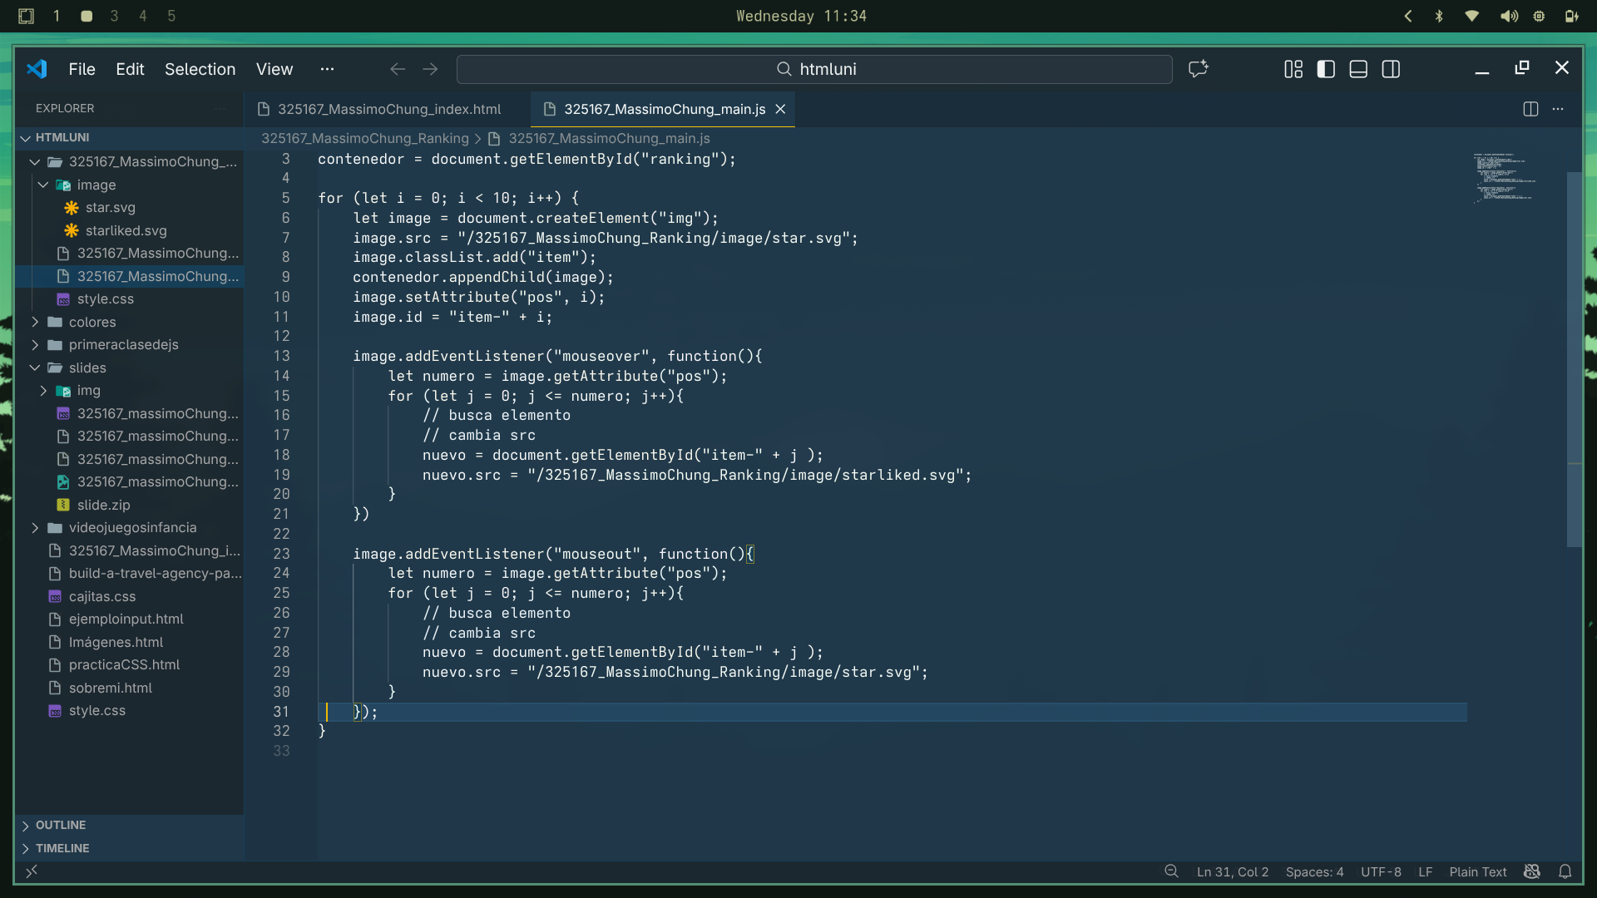
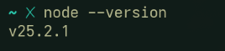
Noded

NPM

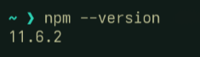

Git
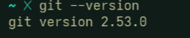

AWS

