# Homework 2

## Due: June 25, 1159PM

## Weight: 10%

## Submission Instructions:

Submit your working AngularJS application a zipped archive to the drop box.

(20% deducted each day this is late.)

Using AngularJS, create a a form which allows a user to enter and submit an email message. A form is valid but only when:

* A valid email address is provided. (1 mark)
* A subject is present. (2 marks)
* A message body with a minimum of 4 characters and a maximum of 255 characters is included. (2 marks)

You may use this element to enforce email validation through AngularJS:

**<input type="email" name="input" ng-model="email.text" required>**

* The validation error messages only appear after the “Send Email” button is clicked at least once and if the related field is invalid. (2 marks).
* Validation error messages will appear or disappear depending on whether the corresponding field is invalid or valid. (5 marks)

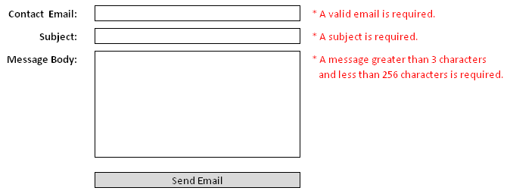

We are not going to use remote services in this assignment. We will use them with Angular later so for now please just implement the following:

When the form has been submitted after valid data is entered, the data is sent to a controller. (1 mark) From the controller, call a service that receives the email and returns a success message below the form which says “Your message has been delivered to [emailaddress@provided.com](mailto:emailaddress@provided.com)” depending on the email address supplied. (2 marks)

Show the success message in green in your html after it is returned back to the controller and then to the form. This success message can only appear if a Boolean value inside the controller is set to true.

(3 marks)

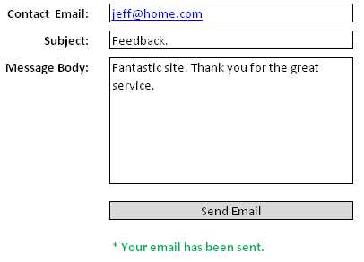

Include an about page with your application which can be navigated to from the parent view. (2 marks)

**Hint:**

**Since this application requires a service, routing and several controllers I recommend starting with example 3 from the day 2 notes.**

**Please use the debugger – it will help a huge amount.**