# Assignment 3

Worth 10%.

Due July 2, 1159PM

This assignment must be coded using the AngularJS 2 framework.

**Submission Instructions:**

1. Submit all folders and files in your project but **do not include the node_modules directory**.

In your application define a class named *FoodItem*. Then, later declare the following array of *FoodItem* objects in your application.

var FOODITEMS: FoodItem[] = [

{ id: 1, name: "Cucumbers", mfg: "Hot House", pkg: "10 KG", qty: 6 },

{ id: 2, name: "Carrots", mfg: "Hot House", pkg: "8 KG", qty: 14 },

{ id: 3, name: "Cheese", mfg: "Hot House", pkg: "5 KG", qty: 20 },

{ id: 4, name: "French Fries", mfg: "McCain", pkg: "15 KG", qty: 8 }

];

Build an Angular2 application that uses routing and that dynamically displays this data. The home page dynamically displays the summary if products. (2 marks)

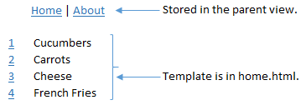

The user can select the id beside an item to display detail. Once again the detail must be populated dynamically based on the user’s selection. Please note you are only allowed to pass the id to the detail view when the user selects the link. For bandwidth and security reasons this is how it normally would be done. (3 marks)

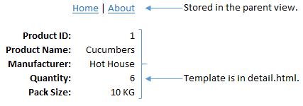

If the user selects the ‘About’ link the about.html partial view is displayed within the application. (1 mark)

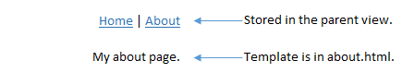

**Hint:** Since routing with parameters is required I recommend you begin your project with example 9 from the day 3 notes.

Read the JSON asynchronously from a separate file using a separate service. I will discuss how to make asynchronous calls and services during day 4. Notes will be posted early next week. (3 marks)